Table S1: Summary of extracted features (PET image features, CT image features, Radiomic Features and clinical parameters)
Category | Subcategory | Features | Number
PET-Derived Metrics | SUV-based metrics | SUVmin, SUVmax, SUVmean, SUVstd | 8
PET-Derived Metrics | Metabolic volumes | MTV, sMTV | 8
PET-Derived Metrics | Combined metabolic metrics | TLG, sTLG | 8
CT-Derived Metrics | Density-based metrics | HUmean, HUmax, HUmin, HUsd | 6
CT-Derived Metrics | Size/shape metric | Dmax-voxels | 6
Radiomic Features | First-order statistics | Mean, median, skewness, kurtosis, entropy, etc. | 26
Radiomic Features | Shape descriptors | Volume, sphericity, surface area, compactness, etc. | 34
Radiomic Features | Textural features (GLCM) | Contrast, correlation, energy, homogeneity, ASM, entropy, etc. | 22
Radiomic Features | Textural features (GLRLM) | SRE, LRE, RP, run variance, etc. | 15
Radiomic Features | Textural features (GLSZM) | Zone entropy, zone variance, size zone emphasis, etc. | 15
Radiomic Features | Textural features (NGTDM) | Coarseness, contrast, busyness, complexity, etc. | 5
Clinical Parameters | Demographics | Age, sex | 12
Clinical Parameters | Anthropometrics | Height, weight | 12
Clinical Parameters | Metabolic/biochemical | Fasting blood glucose level, diabetes status | 12
Clinical Parameters | Treatment history | Chemotherapy history, radiotherapy history, surgery | 12
Clinical Parameters | Cardiovascular/physiologic | Blood pressure, Anemia | 12
Clinical Parameters | Lifestyle risk factors | Smoking status | 12

Table S2: Calibration performance metrics of the top-performing machine learning models on the independent test set.
Model | Brier Score | Calibration Intercept | Calibration Slope
Logistic Regression | 0.143 | 0.151 | 0.692
Neural Network | 0.161 | -0.412 | 0.631
XGBoost | 0.119 | -0.21 | 0.823

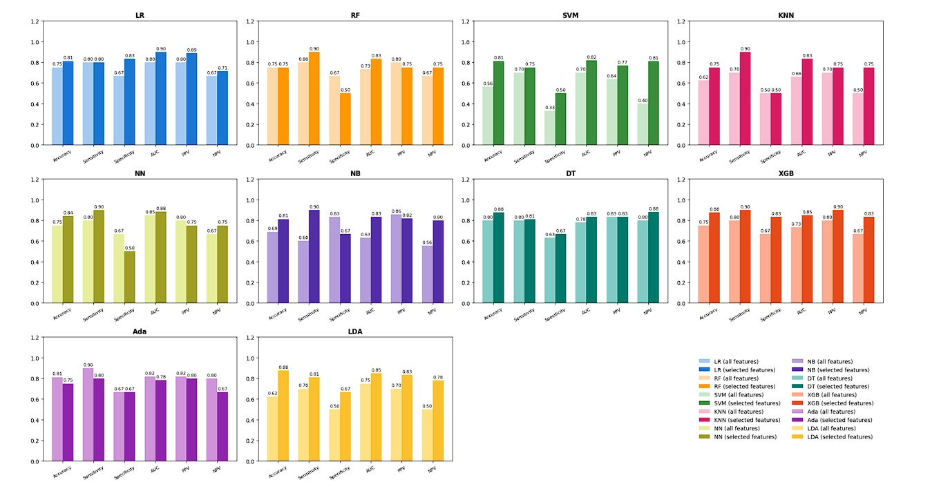
Figure S1 : Comparative performance of ten machine learning classifiers before and after feature selection. Bars represent classification performance across six evaluation metrics on the independent test set.

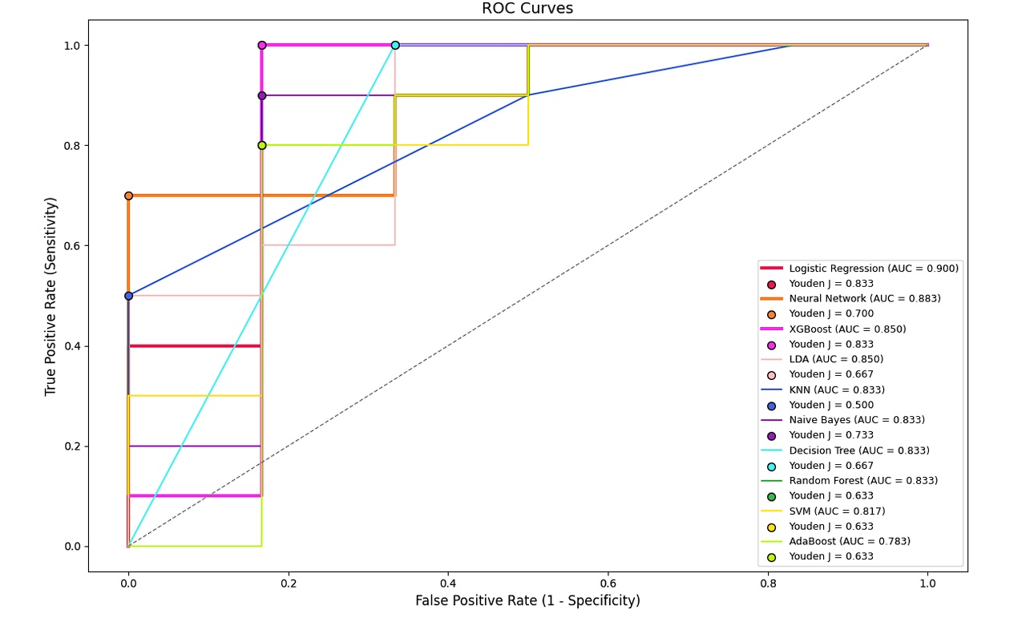
Figure S2: Receiver Operating Characteristic (ROC) curves for ten machine learning models evaluated on the test set using selected features

