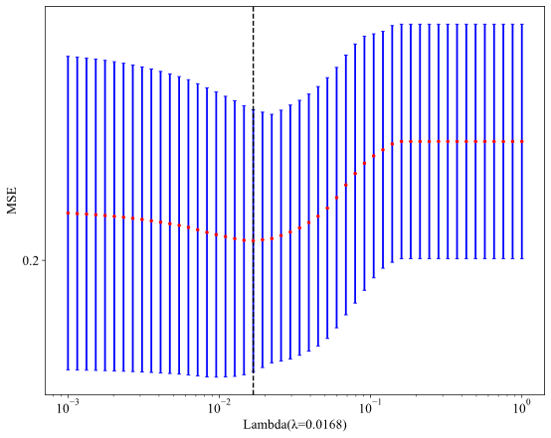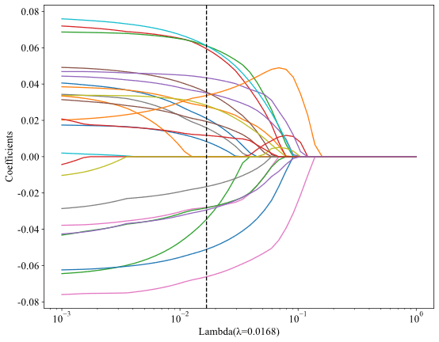
Supplementary figure 1. Selection of radiomics features by Lasso regression in the training cohort.
- Selection of the tuning parameter (λ) in the Lasso regression model via 10-fold cross-validation depended on the 1 standard error of the minimum criteria. A dotted vertical black line was depicted at the optimal value by using the 1 standard error of the minimum and minimum criteria. The optimal λ value of 0.0168 was selected.
- Lasso coefficients profiles through the 1561 features. Features with 25 nonzero coefficients were selected in the plot.

Supplementary figure 2. Habitat clustering results.

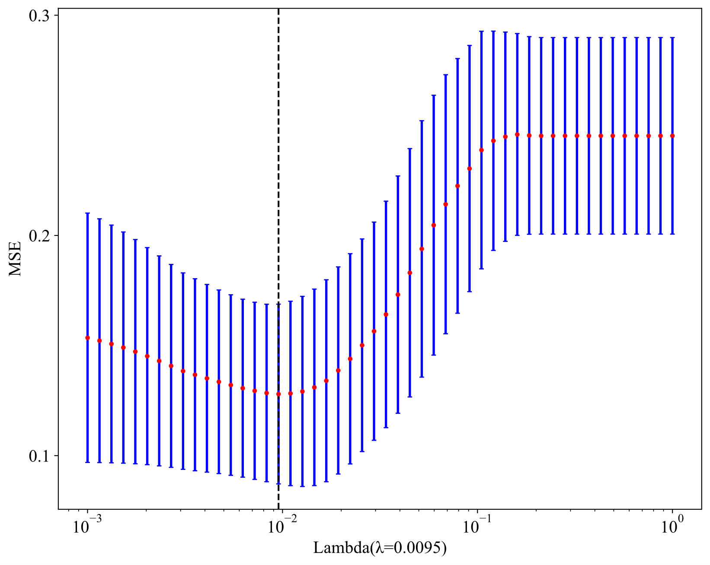
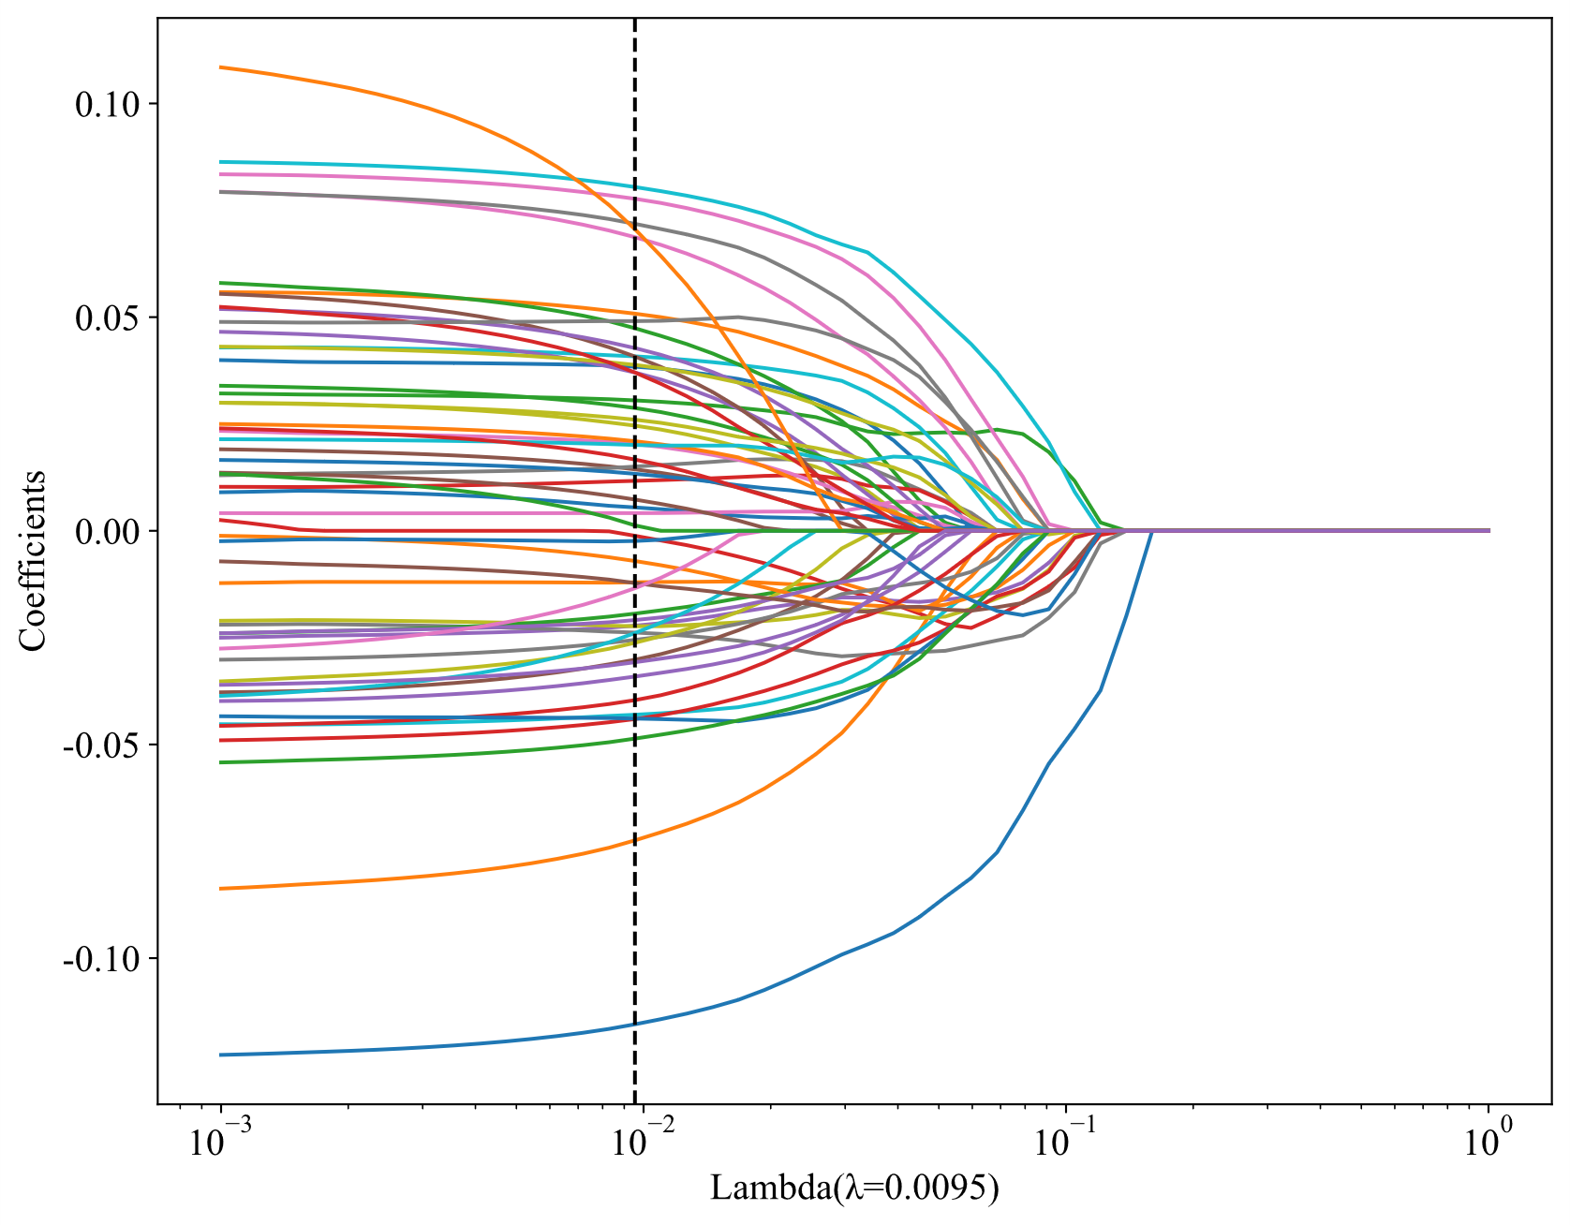
Supplementary figure 3. Selection of habitat features by Lasso regression in the training cohort.
- Selection of the tuning parameter (λ) in the Lasso regression model via 10-fold cross-validation depended on the 1-standard-error of the minimum criteria. A dotted vertical black line was depicted at the optimal value by using the 1 standard error of the minimum and minimum criteria. The optimal λ value of 0.0095 was selected.
- Lasso coefficients profiles through the 7805 features. Features with 55 nonzero coefficients were selected in the plot.

Supplementary Table 1. Hyperparameter settings of the logistic regression models for the four predictive models.
Clinical model: | Radiomics model: | Habitat model: | DL model:
C: 10 | C: 8 | C: 3 | C: 0.5
class_weight: None | class_weight: None | class_weight: None | class_weight: None
dual: False | dual: False | dual: False | dual: False
fit_intercept: True | fit_intercept: True | fit_intercept: True | fit_intercept: True
intercept_scaling: 1 | intercept_scaling: 1 | intercept_scaling: 1 | intercept_scaling: 1
l1_ratio: None | l1_ratio: None | l1_ratio: None | l1_ratio: None
max_iter: 100 | max_iter: 100 | max_iter: 1000 | max_iter: 100
n_jobs: None | n_jobs: None | n_jobs: None | n_jobs: None
penalty: l2 | penalty: l1 | penalty: l1 | penalty: l1
random_state: None | random_state: None | random_state: None | random_state: None
solver: liblinear | solver: liblinear | solver: liblinear | solver: liblinear
tol: 0.0001 | tol: 0.0001 | tol: 0.0001 | tol: 0.0001
verbose: 0 | verbose: 0 | verbose: 0 | verbose: 0
warm_start: False | warm_start: False | warm_start: False | warm_start: False

