Supplementary Table 1. Baseline characteristic.
Feature Name | ALL | Train | Test | P
Age | 51.92±13.62 | 52.11±13.53 | 51.48±13.91 | 0.716
BMI | 20.26±3.04 | 20.27±2.79 | 20.25±3.58 | 0.643
CD3 | 776.87±501.90 | 819.04±519.42 | 680.20±448.14 | 0.059
CD4 | 239.02±256.42 | 255.53±268.36 | 201.18±224.05 | 0.241
CD8 | 526.68±460.53 | 559.29±505.48 | 451.94±326.85 | 0.08
CD4/CD8 | 0.63±0.78 | 0.65±0.81 | 0.61±0.72 | 0.717
WBC | 6.25±3.19 | 6.38±3.44 | 5.96±2.51 | 0.719
RBC | 3.77±0.99 | 3.76±1.00 | 3.81±0.96 | 0.725
Hemoglobin | 103.38±29.99 | 104.26±29.76 | 101.38±30.66 | 0.667
Platelet | 229.52±91.56 | 227.97±92.64 | 233.08±89.64 | 0.724
Neutrophil | 6.21±22.59 | 4.86±4.48 | 9.30±40.47 | 0.81
Lymphocyte | 1.63±7.20 | 1.90±8.61 | 1.00±0.58 | 0.036
Monocyte | 0.45±0.23 | 0.46±0.26 | 0.44±0.16 | 0.786
Eosinophils | 0.15±0.20 | 0.14±0.19 | 0.16±0.21 | 0.484
Basophilia | 0.03±0.02 | 0.03±0.02 | 0.03±0.02 | 0.995
CRP | 33.81±43.44 | 32.63±42.40 | 36.54±45.95 | 0.258
Gender |  |  |  | 0.95
Famale | 57(26.64) | 39(26.17) | 18(27.69)
Male | 157(73.36) | 110(73.83) | 47(72.31)
Syphilis |  |  |  | 0.715
No | 197(92.06) | 136(91.28) | 61(93.85)
Yes | 17(7.94) | 13(8.72) | 4(6.15)
Hepatitis B |  |  |  | 0.822
No | 178(83.18) | 125(83.89) | 53(81.54)
Yes | 36(16.82) | 24(16.11) | 12(18.46)
Hypertension |  |  |  | 0.894
No | 175(81.78) | 121(81.21) | 54(83.08)
Yes | 39(18.22) | 28(18.79) | 11(16.92)
Heart disease |  |  |  | 1.0
No | 188(87.85) | 131(87.92) | 57(87.69)
Yes | 26(12.15) | 18(12.08) | 8(12.31)
Diabetes |  |  |  | 0.689
No | 192(89.72) | 135(90.60) | 57(87.69)
Yes | 22(10.28) | 14(9.40) | 8(12.31)
Smoke |  |  |  | 1.0
No | 164(76.64) | 114(76.51) | 50(76.92)
Yes | 50(23.36) | 35(23.49) | 15(23.08)
Drink |  |  |  | 0.829
No | 181(84.58) | 125(83.89) | 56(86.15)
Yes | 33(15.42) | 24(16.11) | 9(13.85)
Fever |  |  |  | 0.658
No | 125(58.41) | 89(59.73) | 36(55.38)
Yes | 89(41.59) | 60(40.27) | 29(44.62)

Supplementary Table 2. Univariable and multivariable Analysis of clinical features.
Feature Name | OR_UNI | 95% CI_UNI | P UNI | OR_MULTI | 95% CI_MULTI | P_MULTI
Basophilia | 0.054 | 0.0030~0.9830 | 0.098
Syphilis | 0.781 | 0.6150~0.9910 | 0.088
CD4/CD8 | 0.844 | 0.7780~0.9150 | <0.05 | 0.826 | 0.7390~0.9230 | <0.05
Heart disease | 0.869 | 0.7060~1.0700 | 0.267
RBC | 0.896 | 0.8390~0.9570 | <0.05 | 0.97 | 0.8890~1.0590 | 0.565
Fever | 0.936 | 0.8150~1.0750 | 0.428
Diabetes | 0.970 | 0.7680~1.2240 | 0.828
BMI | 0.973 | 0.9490~0.9970 | 0.062
Hemoglobin | 0.996 | 0.9940~0.9980 | <0.05 | 0.996 | 0.9920~0.9990 | <0.05
WBC | 0.997 | 0.9770~1.0170 | 0.799
CD3 | 1.000 | 1.0000~1.0000 | 0.35
Platelet | 1.000 | 1.0000~1.0010 | 0.501
CD4 | 1.000 | 0.9990~1.0000 | <0.05 | 1.0 | 1.0000~1.0010 | 0.082
CD8 | 1.000 | 1.0000~1.0000 | 0.123
CRP | 1.001 | 0.9990~1.0030 | 0.308
Age | 1.003 | 0.9980~1.0080 | 0.299
Lymphocyte | 1.005 | 0.9970~1.0130 | 0.301
Neutrophil | 1.006 | 0.9910~1.0210 | 0.515
Monocyte | 1.044 | 0.7990~1.3630 | 0.792
Hypertension | 1.055 | 0.8870~1.2560 | 0.61
Hepatitis B | 1.163 | 0.9680~1.3980 | 0.175
Smoke | 1.252 | 1.0700~1.4650 | <0.05 | 1.054 | 0.8510~1.3050 | 0.685
Drink | 1.285 | 1.0710~1.5400 | <0.05 | 1.127 | 0.8830~1.4380 | 0.418
Eosinophils | 1.286 | 0.9000~1.8370 | 0.245
Gender | 1.311 | 1.1290~1.5230 | <0.05 | 1.322 | 1.1330~1.5420 | <0.05

Supplementary Table 3. Metrics of different model in radiomics signature.
Model name | AUC | 95% CI | Sensitivity | Specificity | PPV | NPV | Cohort
SVM | 0.932 | 0.895~0.969 | 0.750 | 0.963 | 0.944 | 0.821 | train
RandomForest | 0.905 | 0.858~0.951 | 0.882 | 0.790 | 0.779 | 0.889 | train
ExtraTrees | 0.893 | 0.845~0.942 | 0.662 | 0.951 | 0.918 | 0.770 | train
XGBoost | 0.923 | 0.880~0.966 | 0.706 | 0.988 | 0.980 | 0.800 | train
LightGBM | 0.933 | 0.897~0.969 | 0.735 | 0.963 | 0.943 | 0.812 | train
SVM | 0.922 | 0.854~0.990 | 0.867 | 0.914 | 0.897 | 0.889 | test
RandomForest | 0.900 | 0.816~0.983 | 0.867 | 0.857 | 0.839 | 0.882 | test
ExtraTrees | 0.881 | 0.804~0.959 | 0.833 | 0.771 | 0.758 | 0.844 | test
XGBoost | 0.909 | 0.836~0.982 | 0.900 | 0.886 | 0.871 | 0.912 | test
LightGBM | 0.920 | 0.854~0.987 | 0.900 | 0.886 | 0.871 | 0.912 | test

Supplementary Table 4. Metrics of different model in Peri1mm signature.
Model name | AUC | 95% CI | Sensitivity | Specificity | PPV | NPV | Cohort
SVM | 0.826 | 0.757~0.894 | 0.691 | 0.877 | 0.825 | 0.772 | train
RandomForest | 0.938 | 0.903~0.972 | 0.868 | 0.864 | 0.843 | 0.886 | train
ExtraTrees | 0.815 | 0.748~0.881 | 0.691 | 0.815 | 0.758 | 0.759 | train
XGBoost | 0.829 | 0.766~0.891 | 0.676 | 0.840 | 0.780 | 0.756 | train
LightGBM | 0.915 | 0.871~0.959 | 0.912 | 0.753 | 0.756 | 0.910 | train
SVM | 0.782 | 0.671~0.892 | 0.733 | 0.714 | 0.687 | 0.758 | test
RandomForest | 0.776 | 0.662~0.889 | 0.867 | 0.571 | 0.634 | 0.833 | test
ExtraTrees | 0.800 | 0.695~0.905 | 0.733 | 0.743 | 0.710 | 0.765 | test
XGBoost | 0.731 | 0.623~0.840 | 0.433 | 0.886 | 0.765 | 0.646 | test
LightGBM | 0.827 | 0.722~0.932 | 0.800 | 0.771 | 0.750 | 0.818 | test

Supplementary Table 5. Metrics of different model in Peri3mm signature.
Model name | AUC | 95% CI | Sensitivity | Specificity | PPV | NPV | Cohort
SVM | 0.958 | 0.931~0.985 | 0.882 | 0.914 | 0.896 | 0.902 | train
RandomForest | 0.902 | 0.855~0.949 | 0.941 | 0.741 | 0.753 | 0.937 | train
ExtraTrees | 0.915 | 0.872~0.957 | 0.853 | 0.877 | 0.853 | 0.877 | train
XGBoost | 0.895 | 0.846~0.945 | 0.882 | 0.802 | 0.789 | 0.890 | train
LightGBM | 0.883 | 0.830~0.936 | 0.971 | 0.704 | 0.733 | 0.966 | train
SVM | 0.911 | 0.843~0.979 | 0.767 | 0.914 | 0.885 | 0.821 | test
RandomForest | 0.820 | 0.712~0.929 | 0.600 | 0.971 | 0.947 | 0.739 | test
ExtraTrees | 0.827 | 0.723~0.930 | 0.767 | 0.829 | 0.793 | 0.806 | test
XGBoost | 0.732 | 0.609~0.856 | 0.567 | 0.829 | 0.739 | 0.690 | test
LightGBM | 0.752 | 0.632~0.872 | 0.467 | 0.971 | 0.933 | 0.680 | test

Supplementary Table 6. Metrics of different model in Peri5mm signature.
Model name | AUC | 95% CI | Sensitivity | Specificity | PPV | NPV | Cohort
SVM | 0.863 | 0.804~0.922 | 0.662 | 0.926 | 0.882 | 0.765 | train
LightGBM | 0.922 | 0.879~0.964 | 0.868 | 0.864 | 0.843 | 0.886 | train
RandomForest | 0.906 | 0.859~0.954 | 0.897 | 0.802 | 0.792 | 0.903 | train
ExtraTrees | 0.832 | 0.767~0.898 | 0.765 | 0.802 | 0.765 | 0.802 | train
XGBoost | 0.924 | 0.883~0.965 | 0.765 | 0.926 | 0.897 | 0.824 | train
SVM | 0.856 | 0.763~0.950 | 0.700 | 0.943 | 0.913 | 0.786 | test
LightGBM | 0.826 | 0.720~0.933 | 0.833 | 0.771 | 0.758 | 0.844 | test
RandomForest | 0.836 | 0.728~0.943 | 0.767 | 0.829 | 0.793 | 0.806 | test
ExtraTrees | 0.814 | 0.708~0.921 | 0.633 | 0.914 | 0.864 | 0.744 | test
XGBoost | 0.800 | 0.691~0.910 | 0.867 | 0.714 | 0.722 | 0.862 | test

Supplementary Table 7. DeLong test AUC comparison results (training cohort).
Comparison | Raw P | Bonferroni-adjusted P | BH-adjusted P | Significant (Bonferroni) |  | Significant (BH)
Combined vs. Clinical | <0.001 | <0.001 | <0.001 | Yes | Yes
Combined vs. Radiomics | 0.002 | 0.03 | 0.004 | Yes | Yes
Combined vs. Peri1mm | <0.001 | <0.001 | <0.001 | Yes | Yes
Combined vs. Peri3mm | 0.018 | 0.27 | 0.027 | No | Yes
Combined vs. Peri5mm | <0.001 | <0.001 | <0.001 | Yes | Yes
Peri3mm vs. Clinical | <0.001 | <0.001 | <0.001 | Yes | Yes
Peri3mm vs. Radiomics | 0.001 | 0.015 | 0.002 | Yes | Yes
Peri3mm vs. Peri1mm | <0.001 | <0.001 | <0.001 | Yes | Yes
Peri3mm vs. Peri5mm | <0.001 | <0.001 | <0.001 | Yes | Yes
Radiomics vs. Clinical | 0.003 | 0.045 | 0.005 | Yes | Yes
Radiomics vs. Peri1mm | 0.421 | 1 | 0.468 | No | No
Radiomics vs. Peri5mm | 0.089 | 1 | 0.134 | No | No
Peri1mm vs. Clinical | 0.006 | 0.09 | 0.009 | No | Yes
Peri1mm vs. Peri5mm | 0.245 | 1 | 0.306 | No | No
Peri5mm vs. Clinical | <0.001 | 0.002 | <0.001 | Yes | Yes

Supplementary Table 8. DeLong test AUC comparison results (testing cohort).
Comparison | Raw P | Bonferroni-adjusted P | BH-adjusted P | Significant (Bonferroni) | Significant (BH)
Combined vs. Clinical | 0.001 | 0.015 | 0.002 | Yes | Yes
Combined vs. Radiomics | 0.312 | 1 | 0.416 | No | No
Combined vs. Peri1mm | 0.008 | 0.12 | 0.012 | No | Yes
Combined vs. Peri3mm | 0.198 | 1 | 0.283 | No | No
Combined vs. Peri5mm | 0.045 | 0.675 | 0.064 | No | No
Peri3mm vs. Clinical | 0.002 | 0.03 | 0.004 | Yes | Yes
Peri3mm vs. Radiomics | 0.528 | 1 | 0.594 | No | No
Peri3mm vs. Peri1mm | 0.089 | 1 | 0.134 | No | No
Peri3mm vs. Peri5mm | 0.156 | 1 | 0.234 | No | No
Radiomics vs. Clinical | 0.004 | 0.06 | 0.006 | No | Yes
Radiomics vs. Peri1mm | 0.067 | 1 | 0.101 | No | No
Radiomics vs. Peri5mm | 0.198 | 1 | 0.283 | No | No
Peri1mm vs. Clinical | 0.089 | 1 | 0.134 | No | No
Peri1mm vs. Peri5mm | 0.312 | 1 | 0.416 | No | No
Peri5mm vs. Clinical | 0.012 | 0.18 | 0.018 | No | Yes

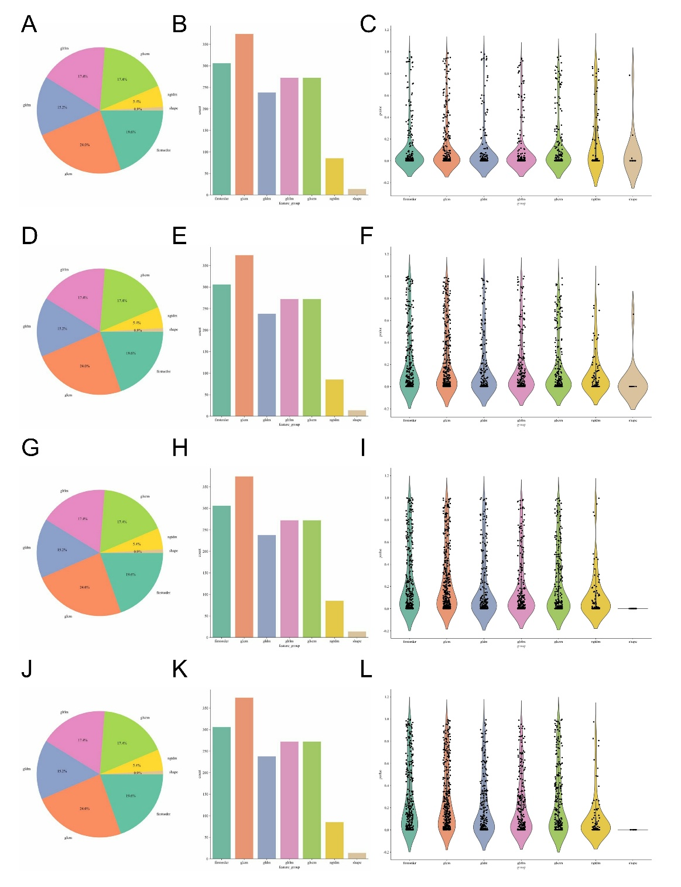
Supplementary Figure 1. LASSO regression feature selection and radiomics signature construction across intratumoral and peritumoral regions. (A-C. Intratumoral region: A. Pie chart showing the distribution of selected features by feature class; B. Bar plot showing the count of selected features by feature class firstorder, glcm, gldm, glrlm, glszm, ngtdm, shape.; C. Violin plot with individual data points showing the radiomics score Rad score. distribution for the selected features. D-F. 1 mm peritumoral region: D. Pie chart of feature class distribution; E. Bar plot of feature counts by class; F. Violin plot of Rad score distribution. G-I. 3 mm peritumoral region: G. Pie chart of feature class distribution; H. Bar plot of feature counts by class; I. Violin plot of Rad score distribution. J-L. 5 mm peritumoral region: J. Pie chart of feature class distribution; K. Bar plot of feature counts by class; L. Violin plot of Rad score distribution.)

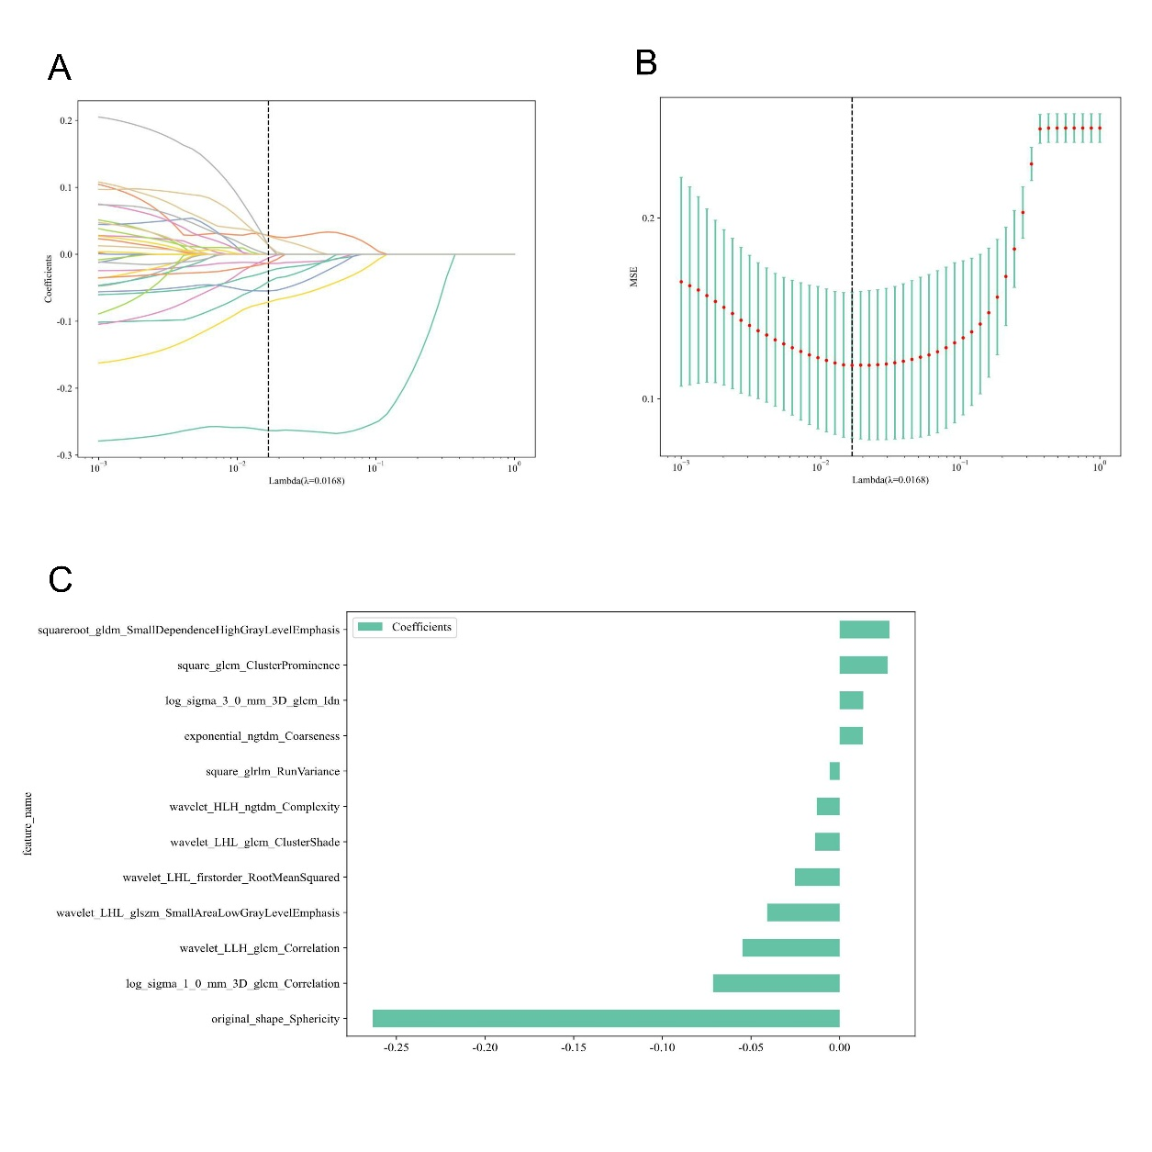
Supplementary Figure 2. Workflow for extracting tumor internal region radiomics features (A. 10-fold cross-validation coefficient of tumor internal region features; B. Mean square error of 10-fold cross-validation of tumor internal region features; C. Histogram of Rad score of tumor internal region features)
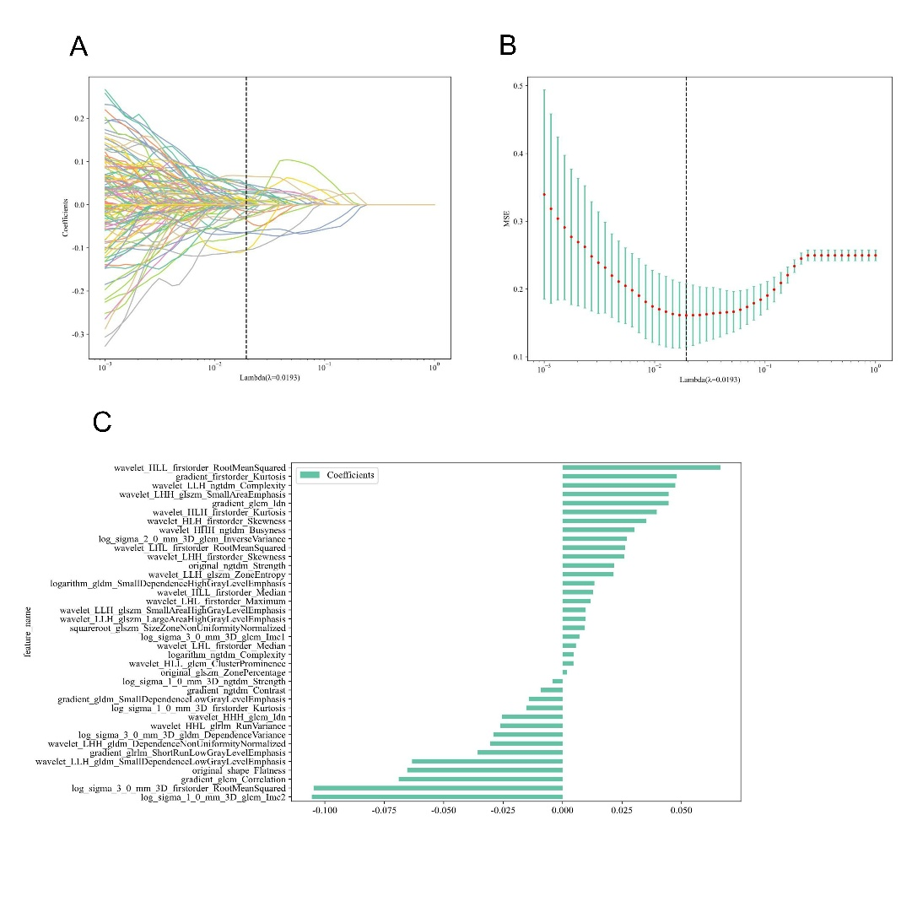
Supplementary Figure 3. Workflow for extracting tumor periphery 1mm region radiomics features (A. 10-fold cross-validation coefficient of tumor periphery 1mm region features; B. Mean square error of 10-fold cross-validation of tumor periphery 1mm region features; C. Histogram of Rad score of tumor periphery 1mm region features)

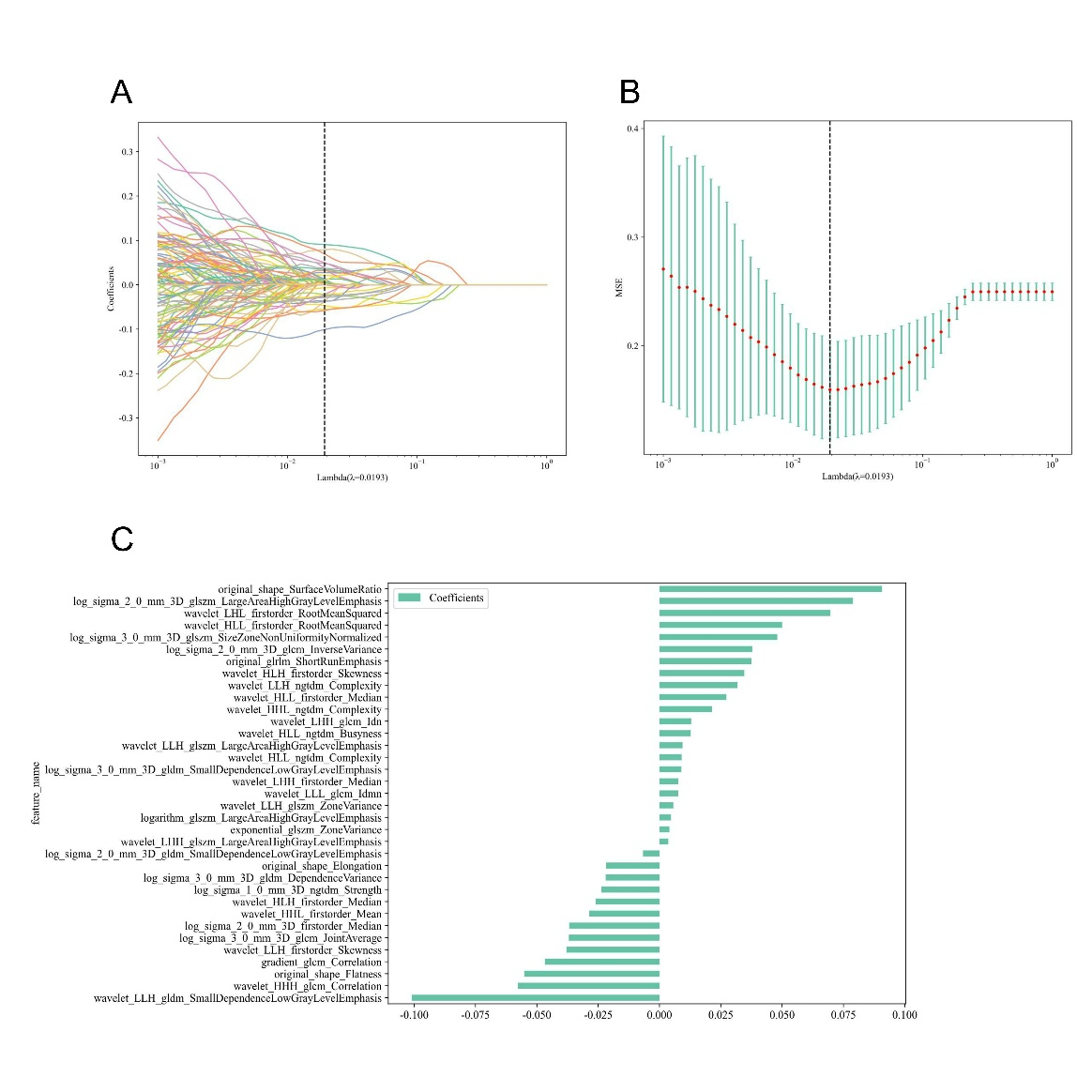
Supplementary Figure 4. Workflow for extracting tumor periphery 3mm region radiomics features (A. 10-fold cross-validation coefficient of tumor periphery 3mm region features; B. Mean square error of 10-fold cross-validation of tumor periphery 3mm region features; C. Histogram of Rad score of tumor periphery 3mm region features)

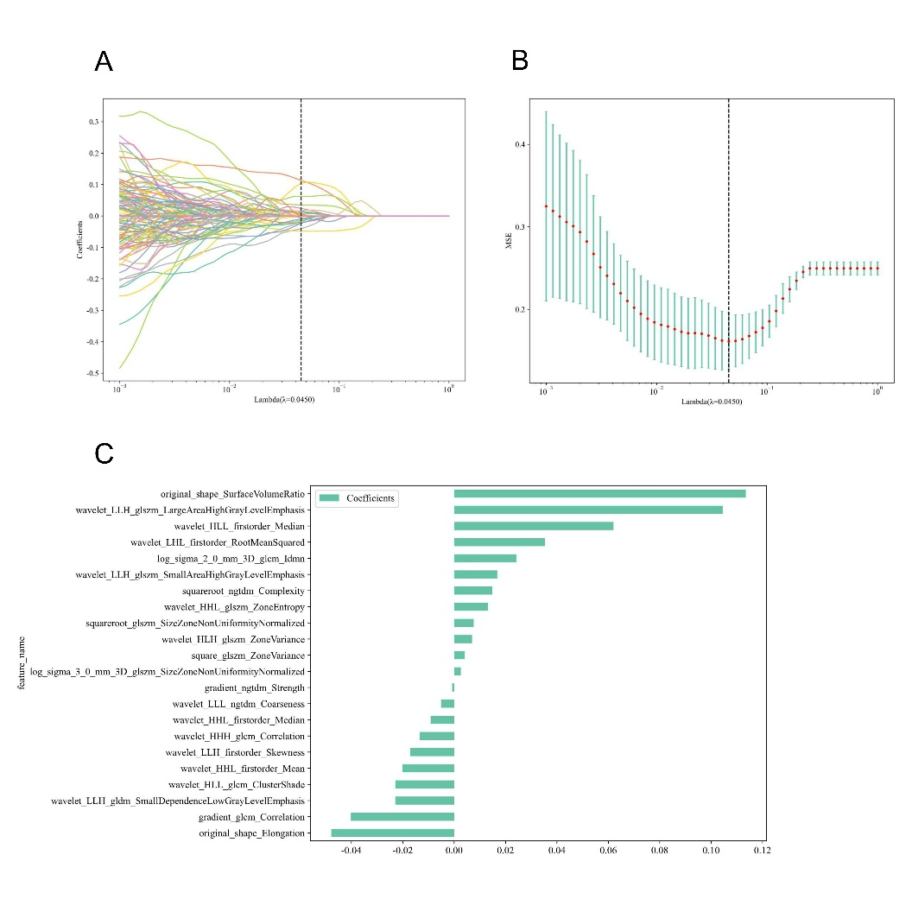
Supplementary Figure 5. Workflow for extracting tumor periphery 5mm region radiomics features (A. 10-fold cross-validation coefficient of tumor periphery 5mm region features; B. Mean square error of 10-fold cross-validation of tumor periphery 5mm region features; C. Histogram of Rad score of tumor periphery 5mm region features)

