Statistical comparison between the Multimodal Transformer Model and baseline models using DeLong test on combined datasets (Test1 + Test2). Color intensity represents -log₁₀(p-value). All comparisons showed significant differences (** p<0.01,***p<0.001).

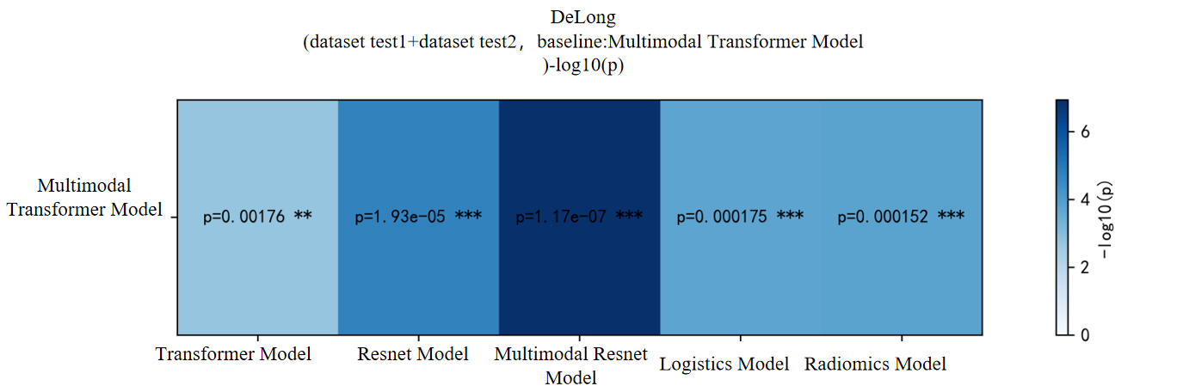

Performance comparison of six models across training set (green), test set (blue), and independent external test set (orange).

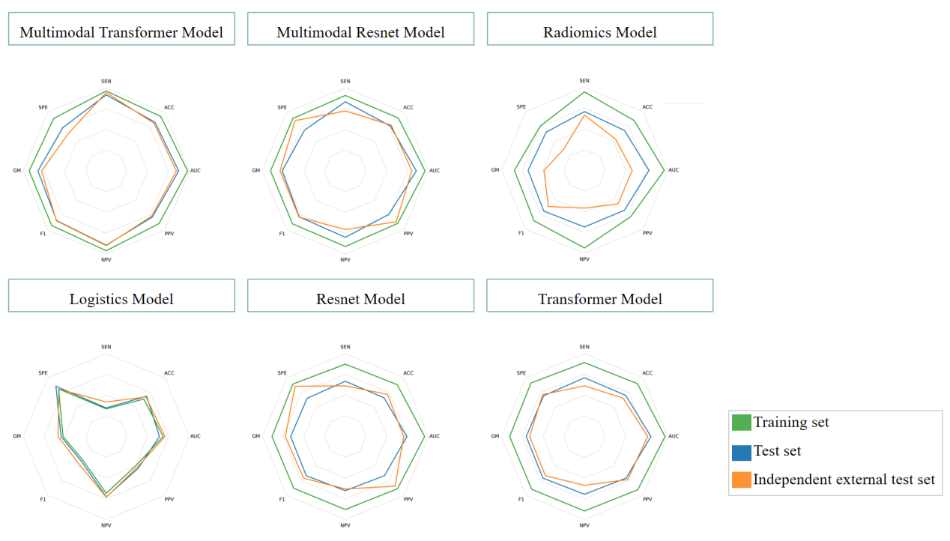

Brier scores of six models across training, internal test, and independent external test sets. Brier score ranges from 0 to 1, with lower values indicating better calibration.
 | Multimodal transformer model | Multimodal resnet model | Radiomics model | Logistics model | Resnet model | Transformer model
Training set | 0.0896 | 0.0942 | 0.0629 | 0.2065 | 0.0975 | 0.0878
Test set | 0.1510 | 0.1674 | 0.2569 | 0.2021 | 0.2092 | 0.1857
Independent external test set | 0.1660 | 0.1846 | 0.2564 | 0.2146 | 0.2386 | 0.2105

