Supplementary table
Table S1. The criteria of OAR for radiotherapy planning
OARs | criteria
Left/right lens | Dmax < 8Gy
Left/right optic nerves | Dmax < 54 Gy
Optic chiasm | Dmax < 54 Gy
Brainstem | Dmax < 60 Gy
Spinal cord | Dmax < 45 Gy
Left/right parotid | Dmean < 30 Gy  V30 < 50%
Thyroid | V40 < 80%

Table S2. Feature categories considered for model development
Model | Feature type
Radiomics | First_order(18)/Shape(14)/GLCM(24)/GLRLM(16)/GLSZM(16)/GLDM(14)/NGTDM
Dosiomics | First_order(18)/Shape(14)/GLCM(24)/GLRLM(16)/GLSZM(16)/GLDM(14)/NGTDM
DVH | Dmax/Dmin/Dmean/D_{1,2...10cc} (10)/V_{5,10....65} (13)
Clinical | Age/Sex/T/N/TNM/Thyroid volume

Table S3. Calibration performance of the seven models across cohorts
Model | Cohort | Intercept (95% CI) | Slope (95% CI) | Brier score (95% CI)
Clinical | Training | 0.498 (0.035 to 0.988) | 1.683 (1.046 to 2.406) | 0.222 (0.206 to 0.239)
Radiomics | Training | 1.106 (0.702 to 1.600) | 3.630 (2.831 to 4.672) | 0.196 (0.182 to 0.209)
Dosiomics | Training | 1.602 (0.907 to 2.972) | 12.249 (9.743 to 20.444) | 0.141 (0.134 to 0.148)
DVH | Training | 1.202 (0.395 to 2.110) | 4.101 (2.198 to 6.448) | 0.231 (0.220 to 0.243)
Deep learning | Training | 0.367 (0.069 to 0.716) | 1.238 (0.961 to 1.615) | 0.180 (0.158 to 0.203)
Early fusion | Training | 1.197 (0.806 to 1.713) | 4.959 (4.066 to 6.421) | 0.146 (0.135 to 0.158)
Combined | Training | 0.000 (-0.432 to 0.424) | 1.000 (0.828 to 1.281) | 0.084 (0.063 to 0.107)
Clinical | Internal validation | -0.382 (-1.277 to 0.465) | 0.439 (-0.768 to 1.776) | 0.228 (0.193 to 0.265)
Radiomics | Internal validation | -0.244 (-1.226 to 0.718) | 0.870 (-0.726 to 2.975) | 0.224 (0.194 to 0.253)
Dosiomics | Internal validation | -0.508 (-1.079 to -0.008) | 1.061 (-0.041 to 2.359) | 0.230 (0.207 to 0.253)
DVH | Internal validation | -0.063 (-1.780 to 2.032) | 1.341 (-2.299 to 6.239) | 0.228 (0.204 to 0.251)
Deep learning | Internal validation | -0.122 (-0.729 to 0.434) | 1.548 (0.815 to 2.911) | 0.175 (0.141 to 0.212)
Early fusion | Internal validation | 0.696 (-0.065 to 1.773) | 3.198 (1.521 to 6.748) | 0.186 (0.159 to 0.216)
Combined | Internal validation | -0.094 (-0.710 to 0.490) | 0.650 (0.330 to 1.290) | 0.148 (0.093 to 0.211)
Clinical | External test | 0.468 (-0.890 to 1.745) | 1.468 (-0.305 to 3.594) | 0.219 (0.170 to 0.272)
Radiomics | External test | 0.151 (-0.932 to 1.588) | 1.372 (-0.256 to 4.219) | 0.221 (0.180 to 0.264)
Dosiomics | External test | -0.441 (-1.224 to 0.256) | 1.531 (0.168 to 3.715) | 0.222 (0.190 to 0.255)
DVH | External test | 0.447 (-1.790 to 4.957) | 2.291 (-2.567 to 13.523) | 0.231 (0.200 to 0.264)
Deep learning | External test | -0.222 (-1.007 to 0.914) | 0.929 (0.316 to 2.644) | 0.183 (0.126 to 0.246)
Early fusion | External test | 0.884 (-0.042 to 2.534) | 3.064 (1.513 to 6.832) | 0.184 (0.146 to 0.224)
Combined | External test | 0.107 (-0.768 to 1.243) | 0.622 (0.310 to 1.355) | 0.172 (0.097 to 0.259)

Table S4. Hyperparameter settings for the Candidate classifiers
Model | Candidate classifier | hyperparameter settings
Radiomics model | MLP | hidden_layer_sizes=(61,128,64,32); max_iter=500; solver=sgd; learning_rate_init=0.001; random_state=0
Radiomics model | Random Forest (RF) | n_estimators=100; max_depth=3; min_samples_split=6; random_state=0
Radiomics model | LightGBM | n_estimators=120; max_depth=3; learning_rate=0.01
Radiomics model | XGBoost | n_estimators=20; objective=binary:logistic; max_depth=8; min_child_weight=1; learning_rate=0.05; subsample=0.8; colsample_bytree=0.8; eval_metric=auc; use_label_encoder=False
Clinical model | Random Forest (RF) | n_estimators=10; criterion='gini'; max_depth=None; min_samples_split=2; min_samples_leaf=1; max_features='auto'; bootstrap=True; random_state=0
Clinical model | XGBoost | booster='gbtree'; objective='binary:logistic'; n_estimators=10; learning_rate=0.3; max_depth=6; min_child_weight=1; gamma=0; subsample=1.0; colsample_bytree=1.0; reg_alpha=0; reg_lambda=1; random_state=0
Clinical model | LightGBM | boosting_type='gbdt'; n_estimators=10; learning_rate=0.1; num_leaves=31; max_depth=-1; min_child_samples=20; min_child_weight=0.001; subsample=1.0; colsample_bytree=1.0; reg_alpha=0; reg_lambda=0
Clinical model | MLP | hidden_layer_sizes=(100,); activation='relu'; solver='adam'; alpha=0.0001; batch_size='auto'; learning_rate='constant'; learning_rate_init=0.001; max_iter=200; early_stopping=False
Dosiomics model | MLP | hidden_layer_sizes=(61,128,64,32); max_iter=500; solver=sgd; learning_rate_init=0.001; random_state=0
Dosiomics model | Random Forest (RF) | n_estimators=100; max_depth=3; min_samples_split=6; random_state=0
Dosiomics model | LightGBM | n_estimators=120; max_depth=3; learning_rate=0.01
Dosiomics model | XGBoost | n_estimators=20; objective=binary:logistic; max_depth=8; min_child_weight=1; learning_rate=0.05; subsample=0.8; colsample_bytree=0.8; eval_metric=auc; use_label_encoder=False
DVH model | MLP | hidden_layer_sizes=(61,128,64,32); max_iter=500; solver=sgd; learning_rate_init=0.001; random_state=0
DVH model | Random Forest (RF) | n_estimators=100; max_depth=3; min_samples_split=6; random_state=0
DVH model | LightGBM | n_estimators=120; max_depth=3; learning_rate=0.01
DVH model | XGBoost | n_estimators=20; objective=binary:logistic; max_depth=8; min_child_weight=1; learning_rate=0.05; subsample=0.8; colsample_bytree=0.8; eval_metric=auc; use_label_encoder=False
Early fusion model | MLP | hidden_layer_sizes=(61,128,64,32); max_iter=500; solver=sgd; learning_rate_init=0.001; random_state=0
Early fusion model | Random Forest (RF) | n_estimators=100; max_depth=3; min_samples_split=6; random_state=0
Early fusion model | LightGBM | n_estimators=120; max_depth=3; learning_rate=0.01
Early fusion model | XGBoost | n_estimators=20; objective= binary:logistic; max_depth=8; min_child_weight=1; learning_rate=0.05; subsample=0.8; colsample_bytree=0.8; eval_metric=auc; use_label_encoder=False

Table S5 Effect of the number of retained principal components on early fusion model performance
PCA | AUC | 95% CI | Cohort
32 | 0.947 | 0.9325 - 0.9606 | train
32 | 0.753 | 0.6293 - 0.8771 | val
32 | 0.795 | 0.6350 - 0.9543 | test
16 | 0.953 | 0.9345 - 0.9719 | train
16 | 0.776 | 0.6534 - 0.8989 | val
16 | 0.755 | 0.5909 - 0.9184 | test
8 | 0.954 | 0.932-0.976 | train
8 | 0.822 | 0.706-0.938 | val
8 | 0.813 | 0.664-0.963 | test
4 | 0.888 | 0.8513 - 0.9244 | train
4 | 0.666 | 0.5181 - 0.8130 | val
4 | 0.768 | 0.5994 - 0.9366 | test

Table S6. Cross-validated performance of candidate machine-learning classifiers in the training cohort
Model | Classifiers | AUC_1fold | AUC_2fold | AUC_3fold | AUC_4fold | AUC_5fold | Mean_AUC
Early fusion model | RF | 0.734 | 0.822 | 0.834 | 0.835 | 0.891 | 0.823
Early fusion model | XGBoost | 0.774 | 0.811 | 0.812 | 0.813 | 0.866 | 0.815
Early fusion model | LightGBM | 0.736 | 0.781 | 0.836 | 0.850 | 0.862 | 0.813
Early fusion model | MLP | 0.801 | 0.812 | 0.816 | 0.820 | 0.834 | 0.816

Table S7. Sensitivity comparison of two-dimensional and three-dimensional ResNet18 models
Model | Cohort | AUC | 95% CI
3D Resnet18 | train | 0.505 | 0.4359 - 0.5739
3D Resnet18 | val | 0.517 | 0.3646 - 0.6703
3D Resnet18 | test | 0.484 | 0.2838 - 0.6842
2D Resnet 18 | train | 0.788 | 0.735 - 0.842
2D Resnet 18 | val | 0.781 | 0.657 - 0.904
2D Resnet 18 | test | 0.784 | 0.639 - 0.929

Table S8. Sensitivity analysis using all available clinical variables without prior statistical screening
Model | Accuracy | AUC | 95% CI | Cohort
XGBoost | 0.937 | 0.987 | 0.9779 - 0.9956 | train
XGBoost | 0.667 | 0.615 | 0.4694 - 0.7612 | val
XGBoost | 0.725 | 0.571 | 0.3700 - 0.7713 | test
RF | 0.775 | 0.856 | 0.8135 - 0.8987 | train
RF | 0.681 | 0.660 | 0.5191 - 0.8017 | val
RF | 0.725 | 0.629 | 0.4425 - 0.8162 | test
MLP | 0.697 | 0.750 | 0.6935 - 0.8068 | train
MLP | 0.667 | 0.551 | 0.4026 - 0.6986 | val
MLP | 0.675 | 0.629 | 0.4464 - 0.8123 | test
LightGBM | 0.750 | 0.801 | 0.7503 - 0.8514 | train
LightGBM | 0.597 | 0.566 | 0.4193 - 0.7127 | val
LightGBM | 0.700 | 0.561 | 0.3638 - 0.7589 | test

Supplementary figures
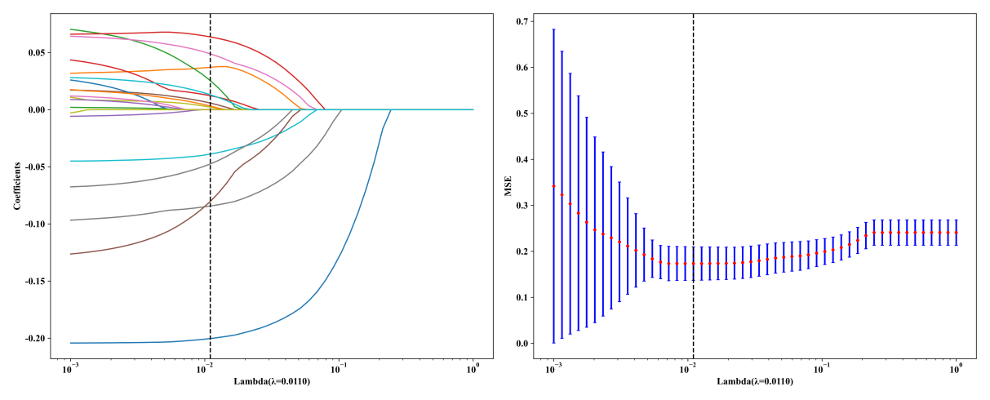
Figure S1. LASSO regression for feature selection;Calibration curves (left) and Mean Square Error (MSE) (right)

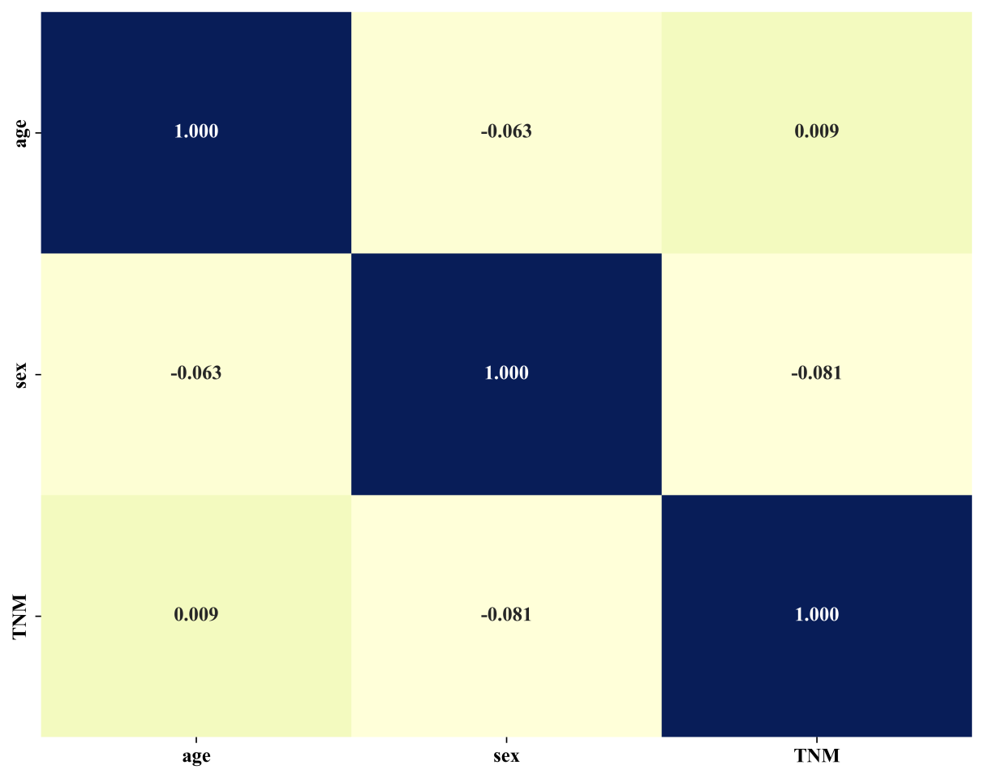
Figure S2. Spearman correlations among selected clinical predictors. The prespecified threshold for high redundancy was absolute rho >= 0.90; observed
pairwise coefficients ranged from -0.081 to 0.009.
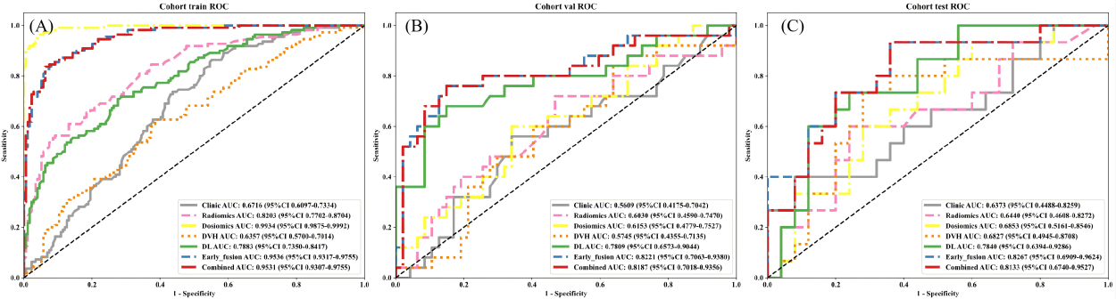
Figure S3 ROC curves of different models in the training cohort (A) , val cohort (B) and test cohort (C). ROC = receiver operating characteristic.
Fig. S4 Calibration of the seven models in the training cohort. Panels show clinical (a), radiomic (b), dosiomic (c), DVH (d), deep-learning (e), early-fusion (f), and Combined (g) models. Solid curves show logistic recalibration, dashed diagonals show perfect calibration, shaded regions show 95% CIs from 2,000 bootstrap resamples, and rug marks show predicted-probability distributions.
Fig. S5 Decision-curve analysis for all seven models in the training cohort. Net benefit is shown for threshold probabilities of 0.10-0.80 together with treat-all and treat-none strategies.

Fig. S6 Decision-curve analysis for all seven models in the internal validation and external test cohorts. Panels a and b show internal validation and external testing, respectively, over threshold probabilities of 0.10-0.80 together with treat-all and treat-none strategies.

