Supplementary Information for
Predicting Post-Surgical Seizure Outcomes in Drug-Resistant Temporal Lobe Epilepsy Using Hippocampal Radiomics from ¹⁸F-FDG hybrid PET/MRI
Jie Hu^{1,3#}, Chenyang Yao^{1#}, Jingjuan Wang¹, Siqi Zhang¹, Bixiao Cui¹, Zhenming Wang¹, Yaqin Hou¹, Jie Lu^{1,2}*
¹Department of Radiology and Nuclear Medicine, Xuanwu Hospital, Capital Medical University, Beijing, China
²Beijing Key Laboratory of Magnetic Resonance Imaging and Brain Informatics, Beijing, China
³Department of Radiology, Union Hospital, Tongji Medical College, Huazhong University of Science and Technology,Wuhan, China
#Jie Hu and Chenyang Yao contributed equally to this work.
*Corresponding author
Jie Lu
E-mail: imaginglu@hotmail.com
Fax number:010-83199418

Supplementary Results
Table S1. Detailed preprocessing and modeling parameters of the PET_T1_T2 radiomics model
Parameter | Description
Preprocessing | Training-set centering and scaling
Candidate selection | mRMR, 30 candidate features
Model | LASSO binomial logistic regression
Alpha | 1
Cross-validation | 10-fold cross-validation; binomial deviance
Primary penalty | lambda.min = 0.02743498
Reference penalty | lambda.1se = 0.13340538
Selected features | 17 non-zero coefficients at lambda.min
Standardized-scale intercept | 0.897465
Original-scale intercept | 56.730597

Table S2. clinicopathological characteristics distribution between the training and test datasets
Dataset | Training dataset (n=95) | Test dataset (n=22) | P value
Age, years (mean ± SD) | 27.98 ± 10.16 | 27.32 ± 7.98 | 0.742
Gender, n (%)
Male | 55 (57.89%) | 16 (72.73%) | 0.297
Female | 40 (42.11%) | 6 (27.27%)
Age of onset, years (mean ± SD) | 14.84 ± 9.88 | 14.64 ± 9.20 | 0.920
Duration, years (mean ± SD) | 13.14 ± 9.12 | 12.68 ± 7.80 | 0.812
Seizure frequency, n (%)
Daily | 14 (14.74%) | 2 (9.09%) | 0.620
Weekly | 20 (21.05%) | 5 (22.73%)
Monthly | 50 (52.63%) | 12 (54.55%)
Yearly | 11 (11.58%) | 3 (13.64%)
MRI, n (%)
Positive (+) | 45 (47.37%) | 6 (27.27%) | 0.140
Negative (-) | 50 (52.63%) | 16 (72.73%)
PET, n (%)
Positive (+) | 60 (63.16%) | 10 (45.45%) | 0.198
Negative (-) | 35 (36.84%) | 12 (54.55%)
Epileptogenic zone lateralization, n (%)
Left | 51 (53.68%) | 10 (45.45%) | 0.645
Right | 44 (46.32%) | 12 (54.55%)
Treatment, n (%)
Anterior temporal lobectomy (ATL) | 79 (83.16%) | 20 (90.90%) | 0.561
Stereotactic radiofrequency thermocoagulation (SEEG-guided RFTC) | 16 (16.84%) | 2 (9.10%)
Engel classification, n (%)
Engel I | 64 (67.37%) | 15 (68.18%) | 0.999
Engel II–IV | 31 (32.63%) | 7 (31.82%)
Continuous variables are presented as mean ± SD or median according to the distribution; categorical variables are presented as n (%); normal variables use t-test, non-normal variables use Mann-Whitney U test, and categorical variables use chi-square or Fisher’s exact test.

Table S3. The selected most predictive subset of feature and the corresponding coefficients in PET_T1_T2 radiomics model.
Features | Coefficient
PET_con_CA4+DG_original_glszm_SmallAreaEmphasis | 0.378441572
T2_con_CA2+CA3_original_glcm_Correlation | 0.372596349
T2_ipsi_CA1_original_glszm_LargeAreaLowGrayLevelEmphasis | 0.346395924
PET_con_subiculum_original_firstorder_Kurtosis | 0.258583262
PET_ipsi_CA1_original_glszm_SmallAreaLowGrayLevelEmphasis | 0.217006948
T1_ipsi_CA2+CA3_original_glcm_ClusterShade | 0.193605967
T1_con_CA1_original_glcm_ClusterShade | 0.058221588
T2_ipsi_CA1_original_glcm_MaximumProbability | 0.050052441
T2_ipsi_subiculum_original_glszm_SmallAreaLowGrayLevelEmphasis | 0.044717201
T1_con_CA2+CA3_original_gldm_LargeDependenceLowGrayLevelEmphasis | -0.005331969
T2_con_CA4+DG_original_glcm_Idmn | -0.06338632
T2_ipsi_subiculum_original_glcm_Autocorrelation | -0.226674051
T2_ipsi_subiculum_original_glcm_Idmn | -0.236348111
T1_con_CA2+CA3_original_shape_SurfaceVolumeRatio | -0.309740448
T1_con_CA1_original_ngtdm_Contrast | -0.311475559
T1_con_subiculum_original_glcm_Idn | -0.314689608
PET_ipsi_subiculum_original_glszm_LargeAreaHighGrayLevelEmphasis | -0.605445262

Table S4. The selected most predictive subset of feature and the corresponding coefficients in PET_T1 radiomics model.
Features | Coefficient
PET_con_CA4+DG_original_glszm_SmallAreaEmphasis | 0.29534309
PET_con_subiculum_original_firstorder_Kurtosis | 0.1581151
PET_con_CA1_original_firstorder_Minimum | 0.08221973
PET_ipsi_CA1_original_glszm_SmallAreaLowGrayLevelEmphasis | 0.06867939
T1_ipsi_CA2+CA3_original_glcm_ClusterShade | 0.02181644
T1_con_CA2+CA3_original_shape_SurfaceVolumeRatio | -0.01371439
T1_ipsi_CA1_original_shape_Flatness | -0.01622191
T1_con_CA1_original_glszm_SizeZoneNonUniformityNormalized | -0.02712371
T1_ipsi_subiculum_original_glcm_Idn | -0.04951299
T1_con_CA4+DG_original_glcm_MaximumProbability | -0.14434145
T1_con_CA2+CA3_original_glrlm_LowGrayLevelRunEmphasis | -0.20014351
T1_con_subiculum_original_glcm_Idn | -0.29435576
PET_ipsi_subiculum_original_glszm_LargeAreaHighGrayLevelEmphasis | -0.38652093

Table S5. The selected most predictive subset of feature and the corresponding coefficients in PET_T2 radiomics model.
Features | Coefficient
PET_con_CA4+DG_original_glszm_SmallAreaEmphasis | 0.202396894
PET_con_subiculum_original_firstorder_Kurtosis | 0.139780843
T2_con_CA2+CA3_original_glcm_Correlation | 0.100760819
T2_ipsi_subiculum_original_glszm_SmallAreaLowGrayLevelEmphasis | 0.078118691
PET_ipsi_CA1_original_glszm_SmallAreaLowGrayLevelEmphasis | 0.066923991
T2_ipsi_CA1_original_glcm_MaximumProbability | 0.061720968
PET_con_CA2+CA3_original_glcm_Correlation | 0.04412088
T2_ipsi_CA1_original_glszm_LargeAreaLowGrayLevelEmphasis | 0.036697099
PET_con_CA1_original_firstorder_Minimum | 0.029064738
T2_ipsi_subiculum_original_gldm_LargeDependenceLowGrayLevelEmphasis | 0.005367606
T2_con_CA2+CA3_original_shape_SurfaceVolumeRatio | -0.03079026
T2_con_subiculum_original_shape_SurfaceVolumeRatio | -0.045022607
T2_ipsi_subiculum_original_glcm_Idmn | -0.19654297
PET_ipsi_subiculum_original_glszm_LargeAreaHighGrayLevelEmphasis | -0.299944955

Table S6. The selected most predictive subset of feature and the corresponding coefficients in T1_T2 radiomics model.
Features | Coefficient
T2_ipsi_subiculum_original_glszm_SmallAreaLowGrayLevelEmphasis | 0.151256708
T2_ipsi_CA1_original_glcm_MaximumProbability | 0.076557115
T2_con_CA2+CA3_original_glcm_Correlation | 0.03553545
T2_ipsi_subiculum_original_gldm_LargeDependenceLowGrayLevelEmphasis | 0.004110723
T1_con_CA2+CA3_original_gldm_LargeDependenceLowGrayLevelEmphasis | -0.001971509
T1_con_CA2+CA3_original_shape_SurfaceVolumeRatio | -0.071342964
T1_con_CA1_original_ngtdm_Contrast | -0.114635369
T2_ipsi_subiculum_original_glcm_Idmn | -0.199807546
T1_con_subiculum_original_glcm_Idn | -0.244587102

Table S7. The selected most predictive subset of feature and the corresponding coefficients in PET radiomics model.
Features | Coefficient
PET_con_CA4+DG_original_glszm_SmallAreaEmphasis | 0.2327735
PET_con_subiculum_original_firstorder_Kurtosis | 0.15892508
PET_ipsi_CA1_original_glszm_SmallAreaLowGrayLevelEmphasis | 0.09395511
PET_con_CA2+CA3_original_glcm_Correlation | 0.06101185
PET_con_CA1_original_firstorder_Minimum | 0.01529804
PET_con_CA2+CA3_original_shape_SurfaceVolumeRatio | -0.04603244
PET_con_subiculum_original_shape_SurfaceVolumeRatio | -0.04871543
PET_ipsi_subiculum_original_glszm_LargeAreaHighGrayLevelEmphasis | -0.34424132

Table S8. The selected most predictive subset of feature and the corresponding coefficients in 3DT1 radiomics model.
Features | Coefficient
T1_ipsi_subiculum_original_glrlm_LongRunLowGrayLevelEmphasis | 0.02686479
T1_ipsi_CA2+CA3_original_shape_Flatness | -0.02139219
T1_ipsi_CA1_original_shape_Flatness | -0.02325451
T1_ipsi_subiculum_original_glcm_Idn | -0.02694629
T1_con_CA1_original_ngtdm_Contrast | -0.08268864
T1_con_CA2+CA3_original_glrlm_LowGrayLevelRunEmphasis | -0.15485064
T1_con_subiculum_original_glcm_Idn | -0.28234014

Table S9. The selected most predictive subset of feature and the corresponding coefficients in T2_FLAIR radiomics model.
Features | Coefficient
T2_ipsi_subiculum_original_glszm_SmallAreaLowGrayLevelEmphasis | 0.080194159
T2_ipsi_subiculum_original_gldm_LargeDependenceLowGrayLevelEmphasis | 0.065311871
T2_ipsi_CA4+DG_original_glcm_SumEntropy | 0.028295593
T2_con_CA2+CA3_original_glcm_Correlation | 0.011508976
T2_con_CA2+CA3_original_shape_SurfaceVolumeRatio | -0.003039386
T2_con_CA4+DG_original_firstorder_Kurtosis | -0.03923532
T2_ipsi_CA1_original_glszm_SizeZoneNonUniformity | -0.095265497
T2_ipsi_subiculum_original_glcm_Idmn | -0.195115051

Table S10. Leave-one-feature-out sensitivity analysis of the final 17-feature radiomics
Feature | Modality | Original test AUC | Test AUC after feature removal | ΔAUC | Interpretation
PET_con_CA4+DG_original_glszm_SmallAreaEmphasis | 18F-FDG PET | 0.752 | 0.724 | +0.029 | Positive contributor
PET_con_subiculum_original_firstorder_Kurtosis | 18F-FDG PET | 0.752 | 0.724 | +0.029 | Positive contributor
PET_ipsi_CA1_original_glszm_SmallAreaLowGrayLevelEmphasis | 18F-FDG PET | 0.752 | 0.733 | +0.019 | Positive contributor
T2_ipsi_CA1_original_glszm_LargeAreaLowGrayLevelEmphasis | T2-FLAIR | 0.752 | 0.743 | +0.010 | Positive contributor
T1_con_CA1_original_ngtdm_Contrast | 3D-T1 | 0.752 | 0.743 | +0.010 | Positive contributor
PET_ipsi_subiculum_original_glszm_LargeAreaHighGrayLevelEmphasis | 18F-FDG PET | 0.752 | 0.743 | +0.010 | Positive contributor
T1_con_CA1_original_glcm_ClusterShade | 3D-T1 | 0.752 | 0.752 | +0.000 | Limited contribution
T2_ipsi_CA1_original_glcm_MaximumProbability | T2-FLAIR | 0.752 | 0.752 | +0.000 | Limited contribution
T2_ipsi_subiculum_original_glszm_SmallAreaLowGrayLevelEmphasis | T2-FLAIR | 0.752 | 0.752 | +0.000 | Limited contribution
T1_con_CA2+CA3_original_gldm_LargeDependenceLowGrayLevelEmphasis | 3D-T1 | 0.752 | 0.752 | +0.000 | Limited contribution
T2_con_CA4+DG_original_glcm_Idmn | T2-FLAIR | 0.752 | 0.752 | +0.000 | Limited contribution
T2_ipsi_subiculum_original_glcm_Autocorrelation | T2-FLAIR | 0.752 | 0.762 | -0.010 | Potential redundancy
T1_ipsi_CA2+CA3_original_glcm_ClusterShade | 3D-T1 | 0.752 | 0.771 | -0.019 | Potential redundancy
T2_con_CA2+CA3_original_glcm_Correlation | T2-FLAIR | 0.752 | 0.781 | -0.029 | Potential redundancy
T2_ipsi_subiculum_original_glcm_Idmn | T2-FLAIR | 0.752 | 0.781 | -0.029 | Potential redundancy
T1_con_CA2+CA3_original_shape_SurfaceVolumeRatio | 3D-T1 | 0.752 | 0.781 | -0.029 | Potential redundancy
T1_con_subiculum_original_glcm_Idn | 3D-T1 | 0.752 | 0.810 | -0.057 | Potential redundancy

Table S11. Multivariate logistic regression for the clinical model
 | Estimate | Std. Error | z value | OR | 95%CI low | 95%CI up | p
(Intercept) | -1.227 | 0.789 | -1.556 | 0.293 | 0.059 | 1.337 | 0.120
MRI | 1.112 | 0.488 | 2.279 | 3.042 | 1.196 | 8.233 | 0.023
PET | 0.900 | 0.480 | 1.875 | 2.458 | 0.965 | 6.408 | 0.061
onset | 0.024 | 0.027 | 0.912 | 1.025 | 0.974 | 1.082 | 0.362
duration | 0.046 | 0.030 | 1.519 | 1.047 | 0.990 | 1.116 | 0.129

Table S12.Multivariate logistic regression for the clinical-radiomics model
 | Estimate | Std. Error | z value | OR | 95%CI low | 95%CI up | p
(Intercept) | -1.403 | 1.066 | -1.316 | 0.246 | 0.027 | 1.884 | 0.188
Onset | 0.010 | 0.037 | 0.266 | 1.010 | 0.940 | 1.087 | 0.791
Duration | -0.008 | 0.042 | -0.204 | 0.992 | 0.915 | 1.079 | 0.838
MRI | 0.208 | 0.679 | 0.307 | 1.231 | 0.318 | 4.766 | 0.759
PET | 1.113 | 0.673 | 1.654 | 3.044 | 0.837 | 12.239 | 0.098
Radiomics score | 2.020 | 0.445 | 4.539 | 7.538 | 3.521 | 20.731 | <0.001

Table S13 Comparison of AUC values of different models
Training Model | AUC | 95%CI | P value
Clinical model | 0.716 | 0.593-0.838 | 0.004*
radiomics model | 0.904 | 0.838-0.970
combined model | 0.915 | 0.853-0.978 | 0.001#
*Comparison between the clinical model and radiomics model
#Comparison between the clinical model and combined model

Table S14 Comparison of AUC values of different models
Test Model | AUC | 95%CI | P value
Clinical model | 0.743 | 0.464-1 | 0.957*
radiomics model | 0.752 | 0.528-0.977
combined model | 0.819 | 0.630-1 | 0.661#
*Comparison between the clinical model and radiomics model
#Comparison between the clinical model and combined model

Table S15 Performance of Radscore in different treatment subgroups
Treatment subgroup | n | Outcome 0 | Outcome 1 | AUC | Cutoff | Accuracy | Sensitivity | Specificity
Resection | 99 | 33 | 66 | 0.880 | 0.560 | 0.859 | 0.818 | 0.879
SEEG-RFTC | 18 | 5 | 13 | 0.862 | 1.048 | 0.833 | 0.769 | 1.000

Table S16 Comparison of combined radiomics-clinical model with and without treatment modality
Model | Dataset | AUC | Accuracy | Sensitivity | Specificity
Combined model without treatment | Training | 0.915 | 0.853 | 0.828 | 0.903
Combined model without treatment | Validation | 0.819 | 0.818 | 0.800 | 0.857
Combined model with treatment | Training | 0.914 | 0.853 | 0.828 | 0.903
Combined model with treatment | Validation | 0.819 | 0.818 | 0.800 | 0.857

Table S17 Logistic regression analysis of treatment modality
Variable | Coefficient | OR | 95% CI | P value
Treatment modality (resection vs SEEG-RFTC) | 0.417 | 1.518 | 0.292-7.885 | 0.619

Table S18. Histopathological types of 99 TLE patients who underwent surgical resection
Histological type | Number
Presence of Hippocampal Sclerosis (n = 58)
Pure hippocampal sclerosis | 26
Hippocampal sclerosis with neocortex focal dysplasia | 32
Absence of Hippocampal Sclerosis (n = 41)
Focal dysplasia | 21
Gliosis | 13
Ganglioglioma | 6
Gray matter heterotopia | 1

Table S19. Effect size estimates for associations between hippocampal sclerosis, Radscore, and postoperative outcome
Association | Statistical measure | Estimate | 95% CI
HS vs non-HS Radscore | Mean difference | 0.689 | 0.094–1.285
HS vs non-HS Radscore | Hedges’ g | 0.491 | 0.092–0.888
HS vs Engel classification | Cramér’s V | 0.276 | 0.086–0.466
HS predicting favorable outcome | Odds ratio | 3.25 | 1.27–8.64

Table S20. Adjusted mediation analysis of the association between hippocampal sclerosis, Radscore, and postoperative outcome
Analysis | Estimate | 95% CI | P value
HS-Radscore (adjusted β) | 0.674 | 0.082–1.266 | 0.026
Radscore-outcome (adjusted OR) | 3.87 | 2.07–7.22 | <0.001
HS-outcome direct effect | 2.89 | 0.85–9.84 | 0.089
ACME | 0.115 | 0.022–0.241 | 0.016
ADE | 0.134 | -0.011–0.331 | 0.070
Total effect | 0.249 | 0.077–0.477 | 0.008

Figure S1. Radscore of Engle I and Engle II-IV patients in the three monomodal radiomics models and four combined radiomics models.

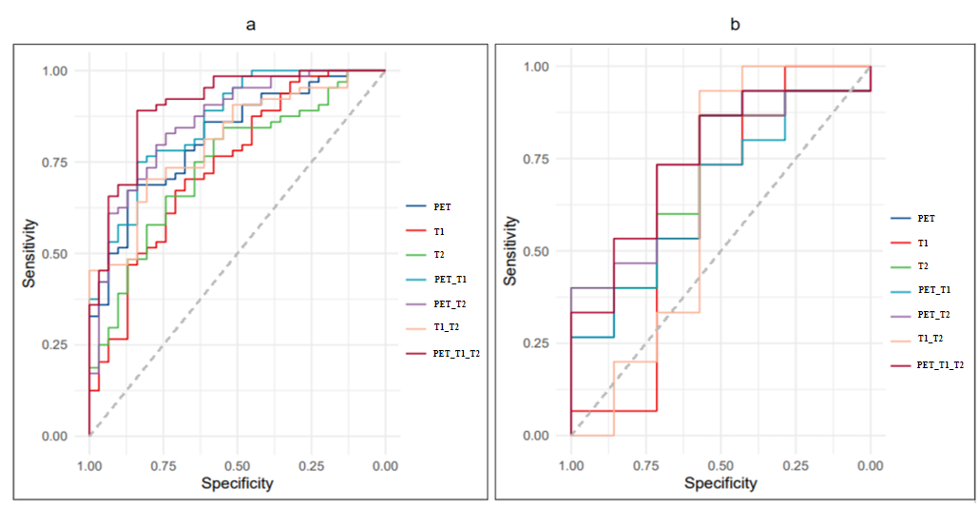
Figure S2. ROC curves for distinguishing Engle I and Engle II-IV of seven radiomics models (PET, 3DT1, T2_FLAIR, PET_T1, PET_T2, T1_T2, and PET_T1_T2 radiomics models). a. Training set b. Test set; ROC, receiver operating characteristic; AUC, area under the curve.

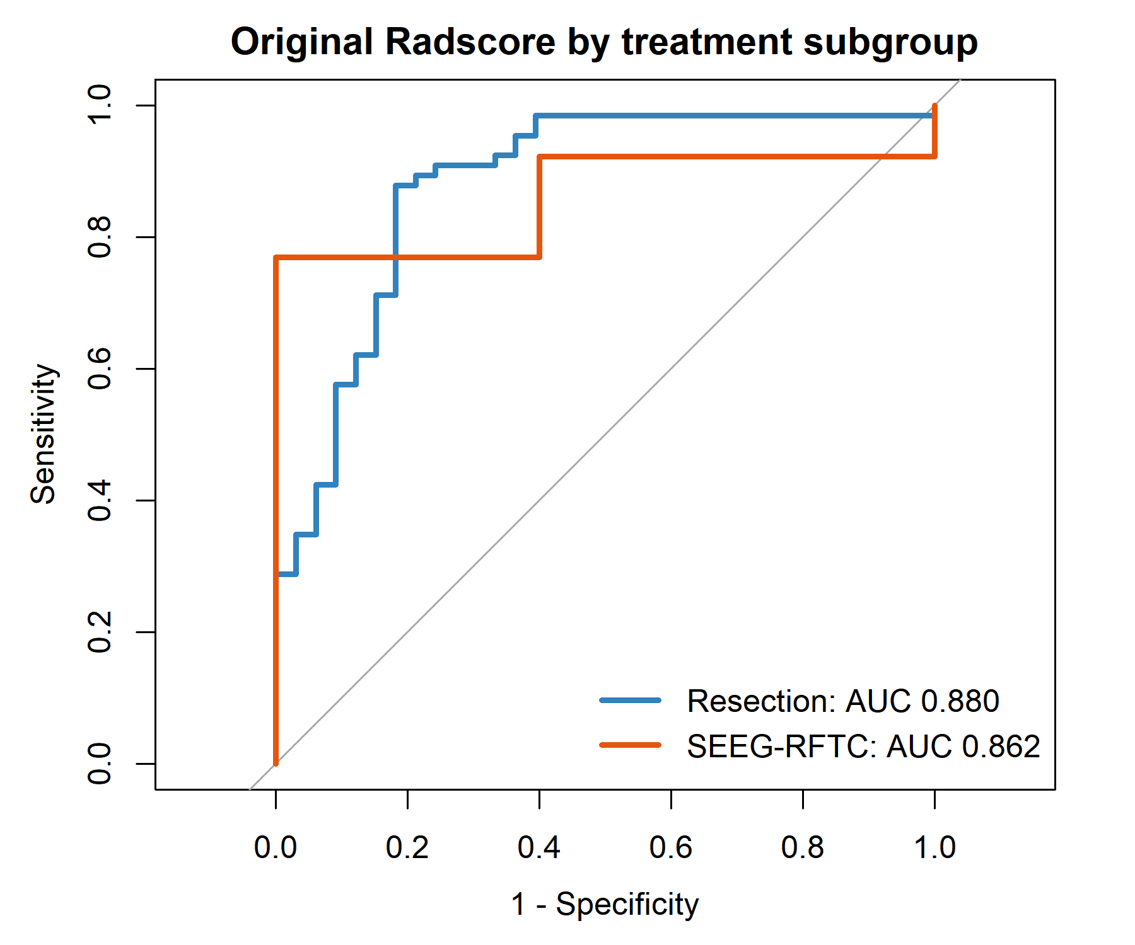
Figure S3 ROC curves of Radscore in different treatment subgroups. Comparison of the predictive performance of combined radiomics-clinical models with and without inclusion of treatment modality. The addition of treatment modality did not improve model performance in either the training dataset or validation dataset.

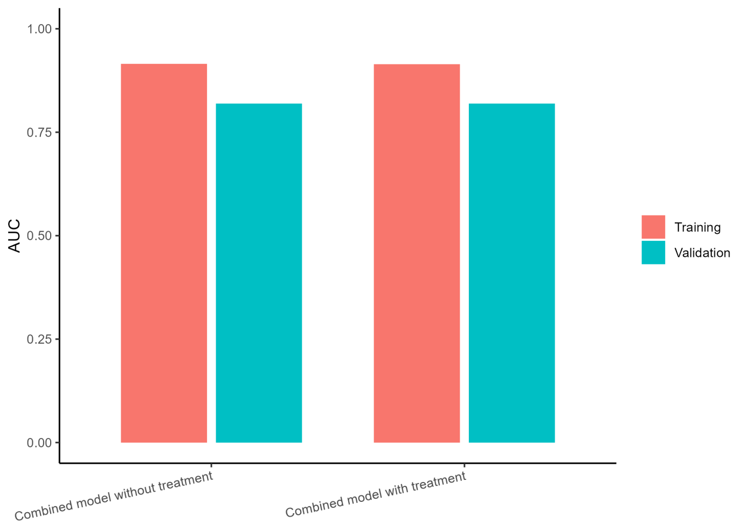
Figure S4 Comparison of AUC values of combined models with and without treatment modality

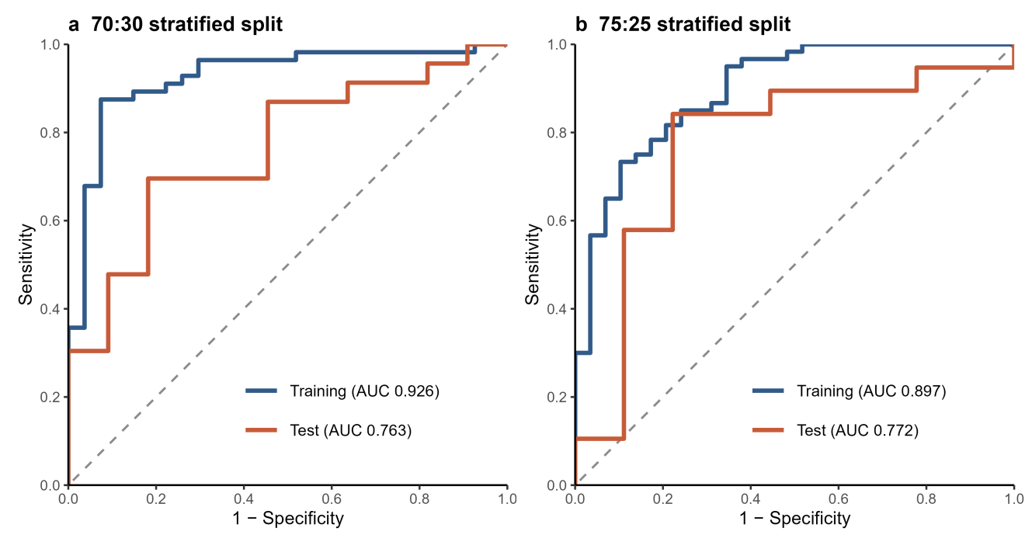
Figure S5. Receiver operating characteristic curves of the pure radiomics model under alternative stratified data partitions. (a) Training- and test-set ROC curves for the 70:30 partition . The training and test AUCs were 0.926 and 0.763, respectively. (b) Training- and test-set ROC curves for the 75:25 partition. The corresponding AUCs were 0.897 and 0.772. For each partition, preprocessing, mRMR screening, LASSO feature selection, and model fitting were performed using the training data, followed by evaluation in the held-out test data.

