Supplementary Materials

Method S1. Processing details of Deep Learning Training Process
Data Normalization: Each cropped tumor or ALN ROI slice was resized to a fixed in-plane matrix of 224 × 224 pixels using bilinear interpolation. The fixed matrix size ensured uniform input dimensions across patients and was consistent with the image dimensions commonly used during ImageNet pretraining^{[1]}.
Data Augmentation: In our study, data augmentation was applied only during model training to increase sample diversity and mitigate overfitting. The augmentation operations included random cropping, horizontal flipping, and vertical flipping. For each five-channel 2.5D input, identical spatial transformations were synchronously applied to all channels to preserve the spatial correspondence between adjacent slices. Images in the validation cohort underwent only the predefined resizing and normalization procedures, without data augmentation.
Training Parameters: All models were trained for 30 epochs with a batch size of 32. Stochastic gradient descent (SGD) was used as the optimizer, and softmax cross-entropy was used as the loss function. The learning rate was initialized at 0.01 and adjusted using a cosine annealing schedule:
$$η_{t}=η_{\text{min}}^{i}+\frac{1}{2}\left(η_{\text{max}}^{i}-η_{\text{min}}^{i}\right)\left(1+cos\left(\frac{T_{\text{cur}}}{T_{i}}π\right)\right)$$
where $η_{t}$ denotes the learning rate at epoch $t$, $η_{max}=0.01$is the initial maximum learning rate, $η_{min}=0$is the minimum learning rate, and $T=30$represents the total number of training epochs. The same optimization settings were used across all models to ensure consistent model omparison.

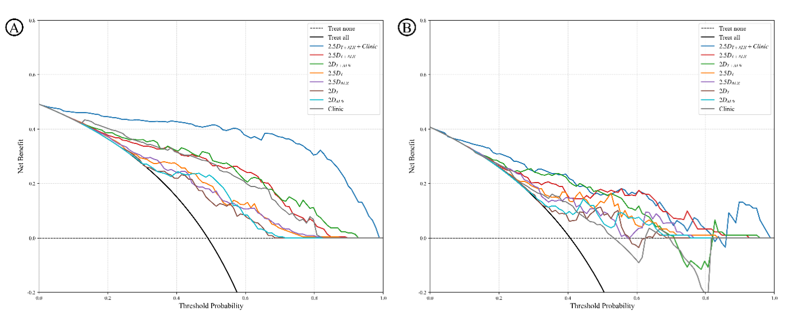
Figure S1: Decision curves of models in training and validation sets. Decision curves of the proposed deep learning models for predicting ALN pCR in the (A) training set and (B) validation set.

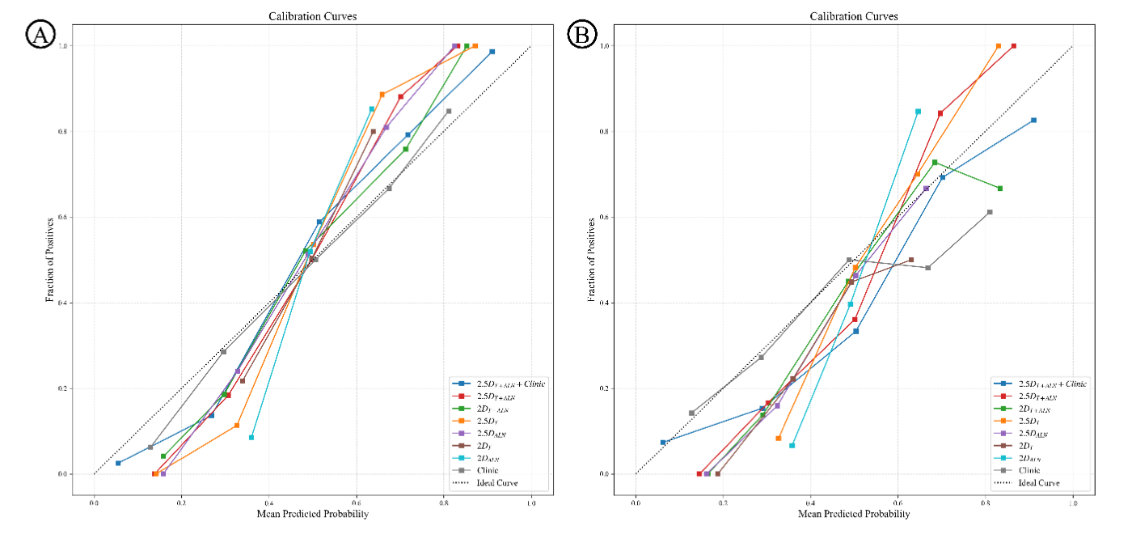
Figure S2: Calibration curves of models in training and validation sets. Calibration curves of the proposed deep learning models for predicting ALN pCR in the (A) training set and (B) validation set.

Table S1 The MRI acquisition parameters.
Scanner | TR/TE  (ms) | FOV  (mm) | Matrix | Slice Thickness  (mm) | Slice Gap  (mm) | Slices | B value  (s/mm2)
GE Discovery MR750 (3.0T) | 5.4/1.7 | 360×360 | 320×320 | 2 | 0 | 80 | 0/800
Siemens Skyra(3.0T) | 4.5/1.6 | 340×340 | 384×384 | 1.5 | 0 | 80 | 0/1000
GE HDxt (1.5T) | 3.4/1.4 | 240×240 | 256×160 | 2.2 | 0 | 120 | 0/1000
Note.—FOV = field of view, TR = repetition time, TE = echo time, ms = millisecond, mm = millimeter.

Reference：
1. Shin HC, Roth HR, Gao M, et al. Deep Convolutional Neural Networks for Computer-Aided Detection: CNN Architectures, Dataset Characteristics and Transfer Learning[J]. IEEE Trans Med Imaging. 2016,35(5):1285-1298.DOI:10.1109/tmi.2016.2528162.

