Method S1. Patient recruitment
This retrospective study included neonates admitted to the Department of Neonatology, Children’s Hospital of Soochow University, between January 2020 and December 2025. Birth asphyxia was identified based on perinatal hypoxic–ischemic history and related clinical findings.The inclusion criteria were: (1) gestational age > 37 weeks; (2) completion of conventional brain MRI during hospitalization, including T1-weighted imaging (T1WI), T2-weighted imaging (T2WI), and diffusion-weighted imaging (DWI); (3) negative visual findings on brain MRI; and (4) availability of clinical and laboratory examination data.The exclusion criteria were: (1) gestational age < 37 weeks; (2) no brain MRI performed during hospitalization;(3) abnormal findings on brain MRI; (4) poor image quality or severe motion artifacts; and (5) infants with metabolic diseases.
A total of 297 neonates were retrospectively enrolled, including 156 in the HIE group and 141 in the non-HIE group. An additional 54 neonates were prospectively recruited, consisting of 20 patients in the HIE group and 34 in the non-HIE group.Patients were assigned to the HIE and non-HIE groups according to the final in-hospital clinical diagnosis made by attending neonatologists on the basis of perinatal hypoxic–ischemic history and neurological assessment, with reference to the Sarnat staging system.

Method S2. Magnetic resonance imaging acquisition and preprocessing
All eligible patients received multiparametric MRI examinations consisting of T1WI, T2WI, and DWI. All images were obtained on two clinical MRI scanners: an Ingenia system (Philips Healthcare, Best, the Netherlands) and a Discovery series system (GE Healthcare, Milwaukee, WI, USA).Uncooperative children received sedation with sponge earplugs placed in the external auditory canals for hearing protection.
The scanning parameters for different devices are shown in the table below.:
 | GE Discovery | Philips Ingenia
T1WI TR/TE | 3316/31.2 ms | 2178/20 ms
T2WI TR/TE | 5350/103 ms | 2762/129 ms
DWI TR/TE | 4781/74.4 ms | 2400/83.5 ms
DWI b-values | 750.0 | 750.0
Slice thickness/gap | 5/5mm | 5/5mm
T1/T2 matrix | 512×512 | 512×512
DWI matrix | 256×256 | 256×256
Number of scans | 266 | 31
HIE | 142 | 14
Non-HIE | 124 | 17

To minimize variability across different scanners and ensure the generation of suitable inputs for quantitative radiomics feature computation, image standardization was implemented. This standardization procedure included N4 bias-field correction, intensity normalization (normalize = true, normalizeScale = 100), resampling to an isotropic voxel spacing of 1×1×1 mm using B-spline interpolation, and discretization using a fixed bin width of 25.

Method S3. Image registration and ROI segmentation
T1WI, T2WI, and DWI images were retrieved from the picture archiving and communication system (PACS) for further analysis. Using ITK-SNAP software(version 3.8.0; http://www.itksnap.org), T2WI and DWI images were automatically aligned to the T1WI image space with intensity-based affine registration to ensure spatial consistency across sequences.For each neonate, the axial slice showing the largest visible area of the basal ganglia (BG) or thalami (TH) was selected for ROI delineation. Accordingly, two ROIs were defined: ROI for the BG and the TH. The segmented images were saved for subsequent radiomics feature extraction.
Two-dimensional ROI segmentation was manually performed on the selected axial slice by Radiologist A, who had 3 years of experience in pediatric neuroradiology, using ITK-SNAP software (version 3.8.0). One month later, 60 cases were randomly selected from the training set for repeated ROI delineation. Radiologist A and another radiologist (Radiologist B, with 10 years of experience in neuroradiology) independently performed the repeat segmentation while blinded to the study data. Intra- and interobserver reproducibility of radiomics features was evaluated, and only features with both intra- and interobserver correlation coefficients greater than 0.85 were retained for subsequent feature selection.

Method S4. Radiomics feature extraction
Radiomics features of the 2D ROIs representing HIE lesions were extracted using Pyradiomics Module (http://pyradiomics.readthedocs.io),A total of 1,197 quantitative features from seven categories were extracted for each patient: (1) 14 shape-based features; (2) 234 first-order features; (3) 286 gray-level co-occurrence matrix (GLCM) features; (4) 182 gray-level dependence matrix (GLDM) features; (5) 208 gray-level run-length matrix (GLRLM) features; (6) 208 gray-level size zone matrix (GLSZM) features; and (7) 65 neighboring gray-tone difference matrix (NGTDM) features.

Method S5. Random Forest Parameters
RF hyperparameters were optimized using five-fold cross-validation within the training set, with AUC as the optimization metric. The candidate values were 10, 20, 50, and 100 for the number of trees (n_estimators) and 2, 3, and 5 for the maximum tree depth (max_depth), while the minimum number of samples per leaf (min_samples_leaf) was fixed at 10. The parameter combination yielding the highest mean cross-validated AUC was selected, and the model was then refitted using the entire training set. A fixed random seed of 0 was used for RF modeling.

Figure 1. Radiomics feature selection by LASSO logistic regression.
Figures 1-6 The least absolute shrinkage and selection operator (LASSO) including the selection of the regular parameter \(\lambda\) and determination of the number of features.

Figure 1 T1-BG
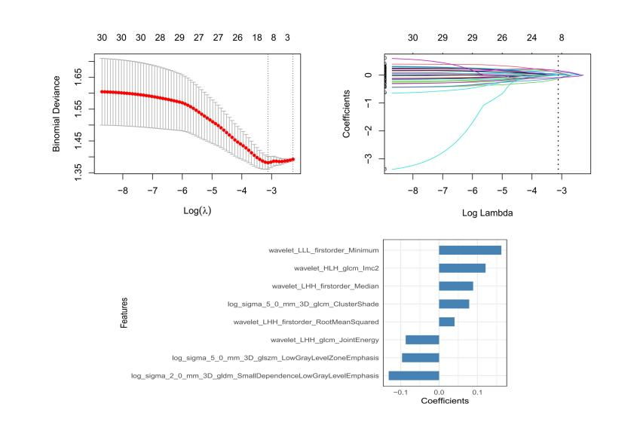
Figure 2 T2-BG
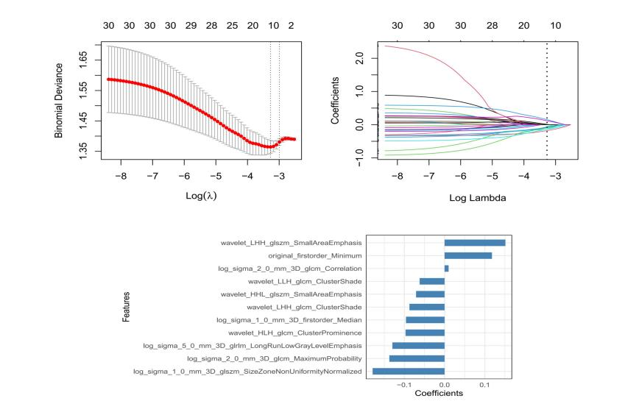
Figure 3 DWI-BG
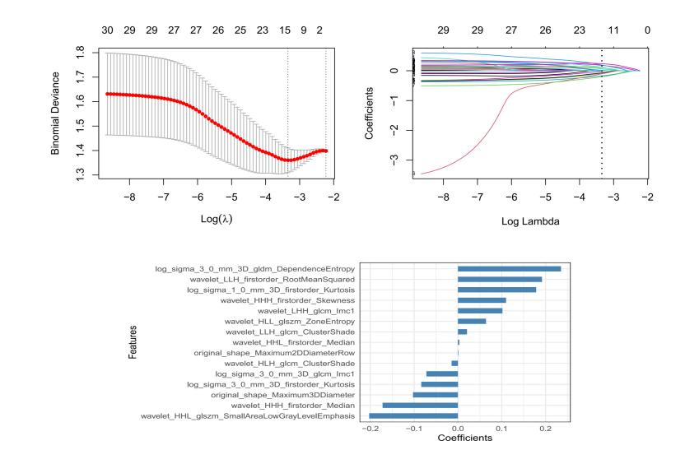
Figure 4 T1-TH
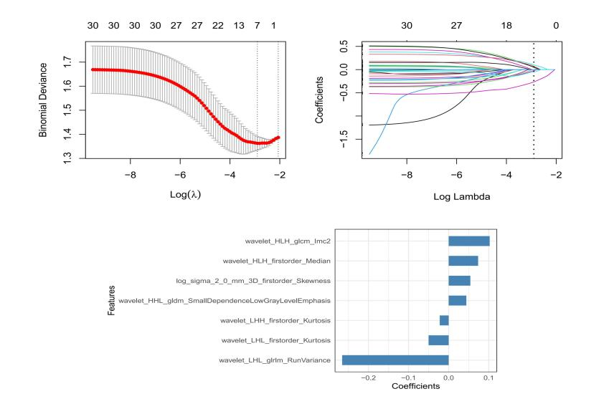
Figure 5 T2-TH
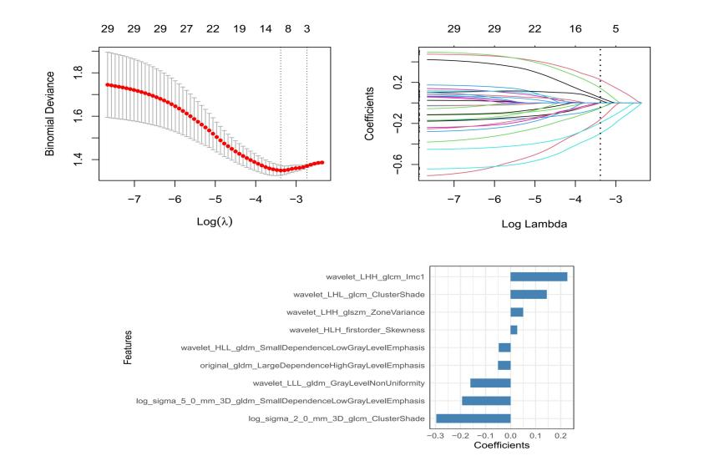
Figure 6 DWI-TH
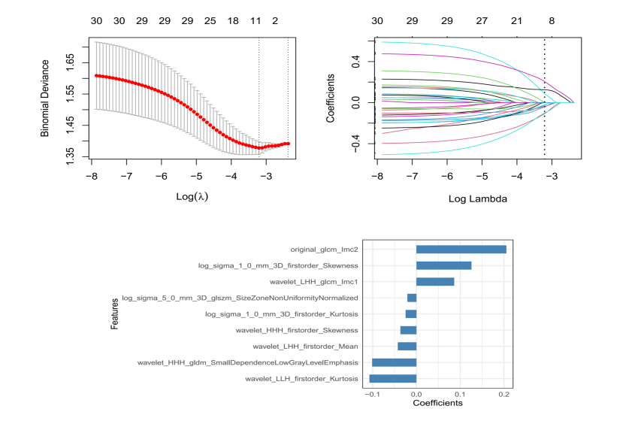

Figure 2. Confusion matrix diagrams of the Combined model in all three cohorts.

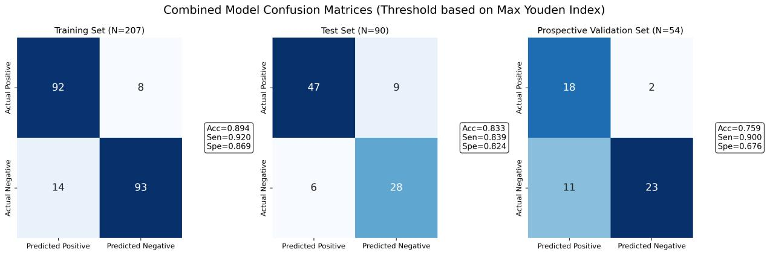

Figure 3. DCA curve of the prospective validation cohort.

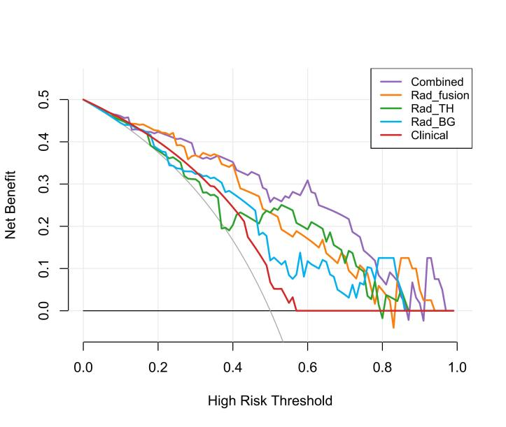

Figure 4. Model performance at the two centers in prospective validation.

