Supplementary Material
Association Between Waist-to-Hip Ratio and Radiation Dose Metrics in Coronary CT Angiography
Supplementary Table S1. Pearson correlations between anthropometric indices and dose/scan variables.
Anthropometric index | Cardiac CTDIvol | Cardiac DLP | Total DLP | Scan length
BMI | +0.06 | -0.09 | -0.04 | -0.21*
Waist circumference | +0.06 | -0.06 | -0.02 | -0.18*
Hip circumference | +0.08 | +0.08 | +0.11 | +0.01
BSA | +0.12 | +0.17* | +0.21* | +0.12
WHR | +0.00 | -0.19* | -0.16 | -0.29***
WHtR | +0.01 | -0.20* | -0.17 | -0.34***
Values are Pearson r. * p < 0.05; ** p < 0.01; *** p < 0.001.
Supplementary Table S2. Mediation sensitivity analysis additionally adjusted for pre-scan heart rate and beta-blocker exposure.
Path / quantity | Estimate | Bootstrap 95% CI
a path: WHR (per 0.1) → scan length | -0.67 cm | —
b path: scan length → cardiac DLP | 45.21 mGy·cm/cm | —
Total effect (c) | -28.27 mGy·cm | —
Direct effect (c′) | 2.09 mGy·cm | —
Indirect effect (a×b) | -30.36 mGy·cm | -45.65 to -16.40
The sensitivity model adjusted for BSA, age, sex, pre-scan heart rate, and any beta-blocker administration. The indirect effect was estimated with 10,000 bootstrap resamples. Because the residual direct effect changed sign, the ratio-based proportion mediated exceeded 100% and was not interpreted.
Supplementary Table S3. WHR-by-sex interaction analyses and sex-stratified WHR estimates.
Outcome | WHR×male interaction B | 95% CI | p
Cardiac CTDIvol | 0.76 | -1.34 to 2.85 | 0.474
Cardiac DLP | 3.18 | -40.36 to 46.73 | 0.885
Total DLP | 7.51 | -40.21 to 55.23 | 0.756
Scan length | -0.18 | -0.80 to 0.44 | 0.560
No interaction term was statistically significant.
Sex | Outcome | n | B per 0.1 WHR | 95% CI | p
Women | Cardiac DLP | 53 | -31.03 | -65.17 to 3.11 | 0.074
Women | Scan length | 53 | -0.60 | -1.10 to -0.10 | 0.019
Men | Cardiac DLP | 81 | -27.22 | -60.22 to 5.79 | 0.105
Men | Scan length | 81 | -0.79 | -1.24 to -0.34 | 0.001
Sex-stratified models adjusted for BSA, age, pre-scan heart rate, and beta-blocker exposure.

Supplementary Table S4. Regression assumption and influence diagnostics.
Model | Shapiro-Wilk p | Breusch-Pagan p | Max Cook D | Cook D >4/n | |studentized residual| >3 | Max leverage
Cardiac CTDIvol | <0.001 | 0.107 | 0.260 | 8 | 3 | 0.123
Cardiac DLP | 0.114 | 0.278 | 0.086 | 8 | 1 | 0.123
Total examination DLP | 0.197 | 0.329 | 0.078 | 8 | 1 | 0.123
CCTA scan length | 0.107 | 0.050 | 0.066 | 8 | 0 | 0.123
Cardiac DLP + scan length | <0.001 | 0.101 | 0.353 | 9 | 2 | 0.132
Variance inflation factors were <1.8 in all reported models. Cook’s distance thresholds are heuristic; no observation had Cook’s D >1.
Supplementary Table S5. HC3 heteroscedasticity-robust sensitivity analysis for the WHR coefficient.
Outcome / model | WHR B per 0.1 | HC3 95% CI | HC3 p
Cardiac CTDIvol | 0.19 | -1.09 to 1.46 | 0.775
Cardiac DLP | -28.27 | -54.70 to -1.84 | 0.036
Total examination DLP | -27.83 | -56.28 to 0.63 | 0.055
CCTA scan length | -0.67 | -0.99 to -0.35 | <0.001
Cardiac DLP + scan length | 2.09 | -19.48 to 23.66 | 0.849
The WHR associations with cardiac DLP and scan length remained statistically significant with HC3 robust inference; the total-examination DLP association became borderline (p = 0.055). WHR remained null after scan-length adjustment.
Supplementary Table S6. Extreme-BMI verification and sensitivity analysis.
Outcome / model after excluding BMI 52.6 case | WHR B per 0.1 | 95% CI | p
Cardiac CTDIvol | 0.23 | -0.86 to 1.32 | 0.678
Cardiac DLP | -27.88 | -50.58 to -5.17 | 0.017
Total DLP | -26.77 | -51.64 to -1.90 | 0.035
Scan length | -0.68 | -1.00 to -0.35 | <0.001
Cardiac DLP scan-adjusted | 2.74 | -15.85 to 21.33 | 0.771
The extreme BMI observation was source-verified as 120 kg and 151 cm (BMI 52.6 kg/m²). Its Cook’s D was <0.006 in each primary model, and exclusion did not materially change the study conclusions.

Supplementary Table S7. Available characteristics of included participants and seven excluded technically inadequate/non-diagnostic examinations.
Group | n | Age (years) | Men / women | BMI (kg/m²) | Pre-scan HR (bpm)
Included cohort | 134 | 52.2 ± 10.6 | 81 / 53 | 28.2 ± 4.4 | 65.2 ± 7.3
Excluded non-diagnostic group | 7 | 50.7 ± 7.7 | 4 / 3 | 30.6 ± 4.4 | 66.6 ± 8.7
Values are mean ± SD or counts. Available characteristics were summarized descriptively; no inferential comparison was performed because only seven examinations were excluded for technical/non-diagnostic reasons and complete WHR/imaging variables were unavailable for these cases.
Supplementary Note S1. Dose-report verification.
All 134 scanner-generated dose reports were source-audited. Cardiac CTDIvol and cardiac DLP were extracted from the Cardiac Helical event; total examination DLP was reconciled against the sum of all cine, axial, and cardiac-helical DLP components. The component sum agreed with the scanner-reported total within rounding tolerance in every examination. The Cardiac Helical event used the Body 32-cm phantom in all 134 examinations.
Supplementary Figure S1. Representative anonymized scanner-generated dose report showing cine, axial, and Cardiac Helical events, event-specific CTDIvol and DLP values, the 32-cm body phantom reference, and total examination DLP.
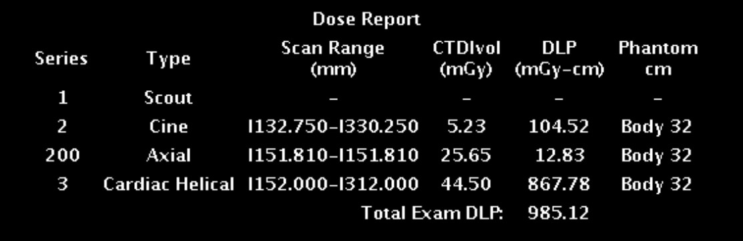
Supplementary Figure S2. Quantile-quantile plots of regression residuals for the primary CTDIvol, cardiac DLP, total examination DLP, CCTA scan-length, and scan-length-adjusted cardiac-DLP models.
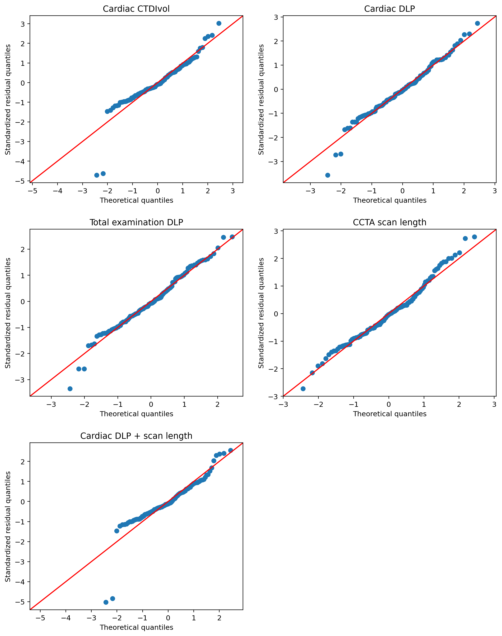
Supplementary Figure S3. Residual-versus-fitted plots for the primary CTDIvol, cardiac DLP, total examination DLP, CCTA scan-length, and scan-length-adjusted cardiac-DLP models.
