SUPPLEMENT
Supplemental Table 1. DCE-MRI scan parameters
Scanner | Center I (3T) | Center II (3T)
Sequence | 3D fast low-angle shot  (FLASH) | 3D fast low-angle shot  (FLASH)
Orientation | Axial | Axial
Fat suppression | Quick Fat Sat | Quick Fat Sat
Repetition time (msec) | 4.51 | 4.51
Echo time (msec) | 1.61 | 1.61
Field of view (mm²) | 340×340 | 340×340
Matrix | 448×448 | 420×420

Supplemental Table 2. DWI scan parameters
Scanner | Center I (3T) | Center II (3T)
Sequence | Single-shot spin-echo EPI with bipolar diffusion pulses | Single-shot spin-echo EPI with bipolar diffusion pulses
Orientation | Axial | Axial
Diffusion directions | Three-direction trace | Three-direction trace
Orientation | Axial | Axial
b value (sec/mm2) | 0, 1000 | 0, 1000
Fat suppression | Spectral Attenuated Inversion Recovery | Spectral Attenuated Inversion Recovery
Repetition time (msec) | 8400 | 10800
Echo time (msec) | 84 | 85
Field of view (mm) | 360×167 | 340×340
Matrix | 220×110 | 220×220

Supplemental Table 3. T2WI scan parameters
Scanner | Center I (3T) | Center II (3T)
Sequence | T2-weighted fat-suppressed spin-echo  (FSE) | T2-weighted fat-suppressed spin-echo  (FSE)
Orientation | Axial | Axial
Repetition time (msec) | 4000 | 8420
Echo time (msec) | 70 | 69
Field of view (mm²) FOV | 360×360 | 340×340
Matrix | 448×448 | 384×307
Slice thickness (mm) | 4.00 | 3.00

Supplementary Table 4. Performance of models for predicting 3-year recurrence in breast cancer
model | C-index(95%CI)
model | Training group | Internal validation group | External validation group
Clinical model | 0.91(0.87-0.95) | 0.90(0.83-0.97) | 0.61(0.52-0.70)
DL model | 0.74(0.67-0.81) | 0.73(0.61-0.85) | 0.65(0.55-0.75)
DLR model | 0.79(0.73-0.85) | 0.77(0.69-0.85) | 0.69(0.61-0.77)
DLC model | 0.91(0.87-0.95) | 0.89(0.82-0.96) | 0.73(0.64-0.82)
DLRC model | 0.91(0.88-0.95) | 0.87(0.80-0.95) | 0.76(0.69-0.84)
CI is the confidence interval; DL is the deep learning model; DLR is the deep learning radiomics model; DLC is the deep learning-clinical model; DLRC is the deep learning-radiomics-clinical model.

Supplementary Table 5. NRI and IDI Analysis of the DLRC Model versus the Clinical Model in Different Datasets
Metric | Training Cohort | Internal Validation Cohort | External Validation Cohort
Continuous NRI | −0.025 (P=0.894) | 0.461 (P=0.179) | 0.667 (P=0.002)
IDI | 0.016 (P=0.640) | 0.058 (P=0.190) | 0.199 (P<0.001)
NRI, Net Reclassification Improvement; IDI, Integrated Discrimination Improvement.

Supplementary Table 6. Quantitative Comparison of Predictive Performance Among Different Models
Model | Training AUC | Internal Validation AUC | External Validation AUC | AUC Decline (Training to External) | External Brier Score
DLRC | 0.946 | 0.842 | 0.788 | −0.158 | 0.108
Clinical | 0.944 | 0.883 | 0.628 | −0.316 | 0.202
DLR | 0.814 | 0.793 | 0.674 | −0.140 | 0.107
DLC | 0.951 | 0.857 | 0.757 | −0.194 | 0.114
All pairwise AUC comparisons between models were performed using bootstrap paired tests based on cumulative/dynamic time-dependent AUC at the 36‑month endpoint with 2000 resamples. AUC, area under the curve.

Supplementary Table 7. Calibration Performance of the DLRC Model at 36-Month Follow-Up
Metric | Training Cohort | Internal Validation Cohort | External Validation Cohort
Brier score | 0.044 | 0.063 | 0.108
Calibration slope | 1.000 | 0.480 | 0.461
Calibration intercept | −0.001 | −1.162 | −1.134
Brier score ranges from 0 to 0, with a lower value indicating better calibration; a calibration slope of 1 and an intercept of 0 represent optimal model calibration. All metrics were calculated based on 36-month survival prediction.

Supplemental Figure 1

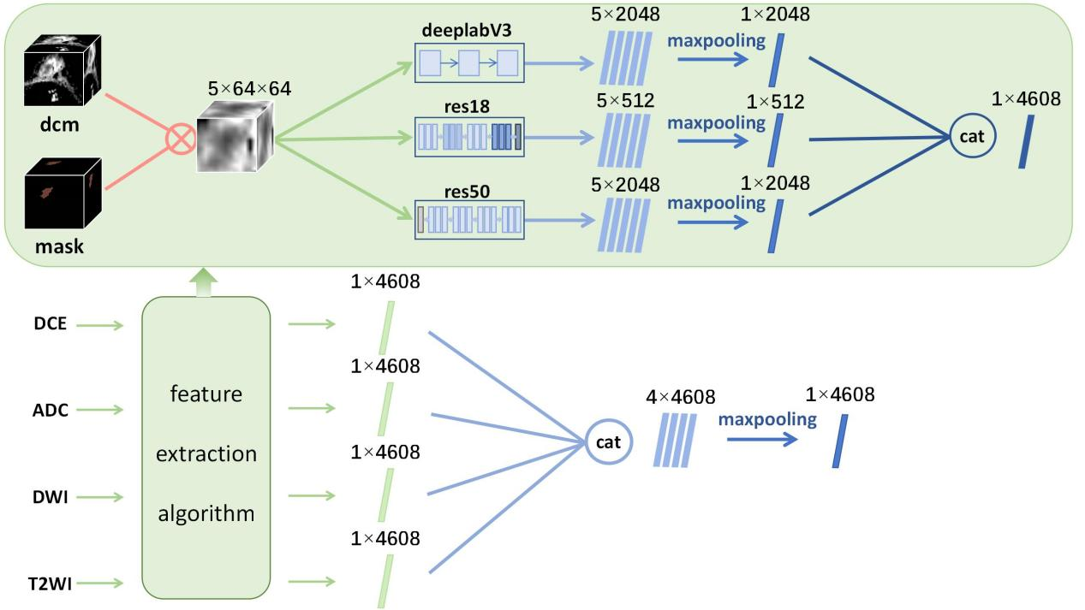

Supplemental Figure 1. Flow feature extraction models based on deep learning. First, the 5-layer images of 64x64 near the maximum cross section of the lesion area and the corresponding ROI were fused with the four sequences of T2WI, DWI,ADC,DCE respectively. Then, after the fusion image is extracted from three pre-trained DeeplabV3, ResNet18 and ResNet50 networks with 5x2048, 5x512 and 5x2048 dimensions, the features are further compressed to 2048, 512 and 2048 dimensions after maximum pooling operation. A total of 4608 dimensional features were extracted from each sequence, and 1x4608 dimensional features were obtained after the obtained 4x4608 dimensional features were maximized.
Supplemental Figure 2

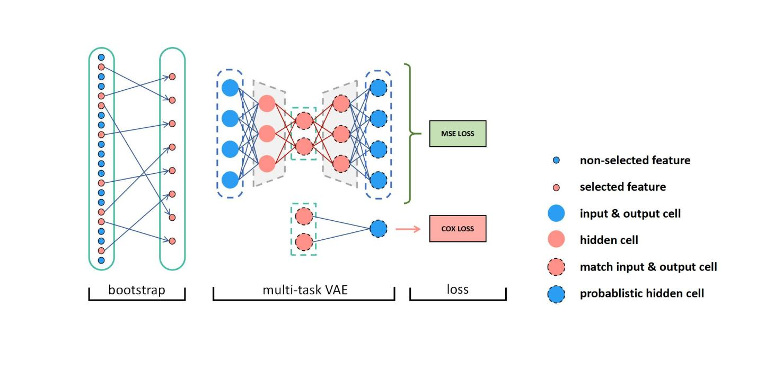
Supplemental Figure 2. Structure of the modified variational autoencoder-based deep survival (VAE-Based DeepSurv) network architecture. The input high-dimensional feature data is randomly sampled for dimensional compression, and the compressed data is used as input to the multi-task VAE network. The multi-task VAE network contains two loss functions, the mean square error loss function and the Cox loss function. The mean square error loss function comes from the feature reconstruction error. CoxLoss is a Cox regression loss, and network training is performed by minimizing mean square error and Cox regression error.

Supplemental Figure 3

Supplemental Figure 3. ROC curves of three models in predicting recurrence in patients with breast cancer after surgery. (a-c) ROC curves of the clinical model in training set, internal validation set and external validation set, respectively. (d-f) ROC curves of the deep learning radiomics model in training set, internal validation set and external validation set, respectively. (g-i) ROC curves of the deep learning-clinical model in training set, internal validation set and external validation set, respectively.

The features used for combined models building are as follows:
- Deep Learning Clinical (DLC) model
RS = Clinical_stage*0.39644154748294413 + Targeted_therapy*1.5546767616948574 + DL riskscore*2.8148518577329917 + HER2*-1.6887168001740962 + Gene*-1.4817856006829453 + Endocrine_therapy*1.5056294485652812 + NAC_neoadjuvant_chemotherapy*1.4360951422779666 + Age*1.9486056761542963 + BI_RADS*0.7348259878417316 + Chemotherapy*0.8911858299486366 + TIC_pattern*-0.3433162615533314 + -5.482922234347178

- Deep Learning Radiomics Clinical (DLRC) model
RS = Clinical_stage*0.4110112058484294 + Targeted_therapy*1.3174764147150126 + Riskscore of DL model*2.982626135591871 +
HER2*-1.6932040870488902 + Gene*-1.554362022533498 + Endocrine_therapy*1.474963234300338 + NAC_neoadjuvant_chemotherapy*1.2403155601296187 + Age*1.8748681527296078 + Riskscore of radiomics model*5.904271245657809 +
BI_RADS*0.9304561283602836 + Tumor_size*-1.4748157722254582 + Chemotherapy*0.8578881211750418 +
-9.384097666347234

