Table S1. Group-wise descriptive statistics for unadjusted ROI-level SUVRs in all 132 ROIs obtained using the grey-matter histogram reference strategy. Values are presented as mean (SD) and median [Q1–Q3] for HC (n = 50), AD (n = 37), and PSP (n = 46). HC, healthy controls; AD, Alzheimer’s disease; PSP, progressive supranuclear palsy; SD, standard deviation; Q1, first quartile; Q3, third quartile.

ROI | HC, mean (SD) | HC, median [Q1–Q3] | AD, mean (SD) | AD, median [Q1–Q3] | PSP, mean (SD) | PSP, median [Q1–Q3]
Lt-Cerebellum-White-Matter | 1.216 (0.125) | 1.225 [1.141–1.257] | 1.103 (0.095) | 1.087 [1.043–1.159] | 1.248 (0.136) | 1.233 [1.146–1.327]
Lt-Cerebellum-Cortex | 1.027 (0.071) | 1.011 [0.991–1.040] | 0.989 (0.078) | 0.978 [0.931–1.052] | 1.044 (0.090) | 1.026 [0.979–1.108]
Lt-Thalamus | 1.372 (0.205) | 1.330 [1.217–1.463] | 1.329 (0.222) | 1.320 [1.200–1.424] | 1.562 (0.289) | 1.506 [1.416–1.713]
Lt-Caudate | 0.776 (0.100) | 0.774 [0.723–0.854] | 0.903 (0.194) | 0.898 [0.783–1.023] | 0.842 (0.157) | 0.857 [0.720–0.957]
Lt-Putamen | 1.048 (0.094) | 1.053 [1.022–1.090] | 1.267 (0.238) | 1.274 [1.113–1.425] | 1.229 (0.155) | 1.210 [1.103–1.294]
Lt-Pallidum | 1.151 (0.124) | 1.177 [1.092–1.229] | 1.194 (0.200) | 1.179 [1.080–1.327] | 1.470 (0.260) | 1.407 [1.319–1.636]
Lt-Hippocampus | 1.424 (0.294) | 1.382 [1.201–1.615] | 1.639 (0.347) | 1.606 [1.427–1.893] | 1.283 (0.234) | 1.308 [1.124–1.425]
Lt-Amygdala | 1.035 (0.100) | 1.024 [0.962–1.108] | 1.541 (0.341) | 1.544 [1.225–1.800] | 1.067 (0.134) | 1.035 [0.960–1.130]
Lt-Accumbens-area | 0.929 (0.078) | 0.922 [0.893–0.978] | 1.299 (0.278) | 1.297 [1.058–1.412] | 0.955 (0.104) | 0.957 [0.916–1.003]
Lt-VentralDC | 1.138 (0.101) | 1.149 [1.090–1.200] | 1.057 (0.168) | 1.059 [0.944–1.185] | 1.313 (0.228) | 1.276 [1.148–1.432]
Rt-Cerebellum-White-Matter | 1.207 (0.125) | 1.218 [1.129–1.251] | 1.096 (0.099) | 1.080 [1.038–1.151] | 1.256 (0.155) | 1.217 [1.135–1.347]
Rt-Cerebellum-Cortex | 1.016 (0.070) | 1.006 [0.977–1.038] | 0.971 (0.087) | 0.956 [0.918–1.013] | 1.036 (0.087) | 1.033 [0.967–1.107]
Rt-Thalamus | 1.378 (0.218) | 1.327 [1.211–1.509] | 1.327 (0.218) | 1.306 [1.234–1.452] | 1.547 (0.258) | 1.520 [1.363–1.699]
Rt-Caudate | 0.808 (0.108) | 0.812 [0.732–0.884] | 0.923 (0.210) | 0.920 [0.768–1.071] | 0.854 (0.133) | 0.873 [0.761–0.932]
Rt-Putamen | 1.043 (0.088) | 1.052 [1.001–1.101] | 1.274 (0.230) | 1.244 [1.150–1.453] | 1.235 (0.158) | 1.217 [1.139–1.293]
Rt-Pallidum | 1.152 (0.122) | 1.161 [1.102–1.222] | 1.197 (0.192) | 1.201 [1.102–1.319] | 1.490 (0.256) | 1.445 [1.338–1.594]
Rt-Hippocampus | 1.466 (0.355) | 1.475 [1.192–1.652] | 1.609 (0.329) | 1.565 [1.441–1.820] | 1.292 (0.260) | 1.305 [1.122–1.444]
Rt-Amygdala | 1.018 (0.082) | 1.023 [0.972–1.074] | 1.528 (0.337) | 1.595 [1.204–1.770] | 1.058 (0.116) | 1.049 [0.985–1.103]
Rt-Accumbens-area | 0.935 (0.068) | 0.939 [0.895–0.989] | 1.293 (0.255) | 1.341 [1.070–1.473] | 0.960 (0.105) | 0.959 [0.916–1.006]
Rt-VentralDC | 1.143 (0.105) | 1.155 [1.092–1.213] | 1.060 (0.160) | 1.119 [0.959–1.182] | 1.313 (0.219) | 1.293 [1.170–1.457]
Midbrain | 1.095 (0.115) | 1.090 [1.034–1.130] | 1.008 (0.157) | 1.025 [0.888–1.117] | 1.340 (0.256) | 1.294 [1.141–1.513]
Pons | 1.186 (0.158) | 1.196 [1.101–1.266] | 1.007 (0.160) | 1.012 [0.923–1.093] | 1.221 (0.195) | 1.210 [1.069–1.322]
Medulla | 1.200 (0.179) | 1.180 [1.101–1.283] | 1.026 (0.153) | 1.035 [0.934–1.161] | 1.194 (0.181) | 1.190 [1.049–1.316]
CC_Posterior | 0.904 (0.174) | 0.882 [0.771–1.045] | 0.930 (0.269) | 0.844 [0.724–1.127] | 0.815 (0.153) | 0.782 [0.691–0.893]
CC_Mid_Posterior | 0.836 (0.208) | 0.840 [0.685–0.969] | 0.850 (0.276) | 0.771 [0.640–1.028] | 0.684 (0.142) | 0.659 [0.568–0.798]
CC_Central | 0.801 (0.161) | 0.808 [0.676–0.887] | 0.826 (0.227) | 0.781 [0.659–0.976] | 0.713 (0.155) | 0.702 [0.591–0.810]
CC_Mid_Anterior | 0.758 (0.151) | 0.745 [0.650–0.877] | 0.720 (0.196) | 0.702 [0.578–0.887] | 0.641 (0.136) | 0.640 [0.548–0.742]
CC_Anterior | 0.813 (0.128) | 0.793 [0.737–0.909] | 0.757 (0.181) | 0.725 [0.605–0.885] | 0.696 (0.125) | 0.702 [0.627–0.760]
Lt-bankssts | 1.003 (0.064) | 1.004 [0.987–1.040] | 1.791 (0.588) | 1.730 [1.314–2.118] | 1.017 (0.076) | 1.020 [0.957–1.063]
Lt-cingulate | 0.940 (0.068) | 0.937 [0.895–0.993] | 1.437 (0.362) | 1.316 [1.169–1.759] | 0.917 (0.091) | 0.919 [0.832–0.983]
Lt-middlefrontal | 0.820 (0.053) | 0.822 [0.783–0.856] | 1.395 (0.415) | 1.246 [1.091–1.614] | 0.864 (0.090) | 0.835 [0.791–0.919]
Lt-cuneus | 0.961 (0.096) | 0.984 [0.915–1.009] | 1.473 (0.444) | 1.473 [1.121–1.661] | 0.974 (0.090) | 0.972 [0.923–1.017]
Lt-entorhinal | 0.937 (0.112) | 0.916 [0.866–0.966] | 1.528 (0.398) | 1.483 [1.254–1.787] | 0.907 (0.100) | 0.908 [0.848–0.967]
Lt-fusiform | 1.035 (0.076) | 1.022 [0.993–1.061] | 1.683 (0.426) | 1.592 [1.401–1.863] | 0.992 (0.060) | 0.995 [0.958–1.028]
Lt-inferiorparietal | 0.887 (0.074) | 0.892 [0.857–0.925] | 1.667 (0.588) | 1.468 [1.239–2.146] | 0.921 (0.065) | 0.922 [0.876–0.965]
Lt-inferiortemporal | 0.975 (0.074) | 0.957 [0.926–1.003] | 1.785 (0.495) | 1.747 [1.336–2.088] | 0.953 (0.061) | 0.948 [0.918–0.989]
Lt-lateraloccipital | 0.910 (0.090) | 0.920 [0.877–0.964] | 1.478 (0.477) | 1.371 [1.176–1.685] | 0.940 (0.087) | 0.922 [0.875–0.986]
Lt-orbitofrontal | 0.920 (0.064) | 0.911 [0.886–0.949] | 1.342 (0.353) | 1.302 [1.015–1.545] | 0.869 (0.059) | 0.859 [0.837–0.910]
Lt-lingual | 1.001 (0.083) | 1.006 [0.946–1.054] | 1.414 (0.378) | 1.373 [1.111–1.613] | 0.972 (0.073) | 0.961 [0.928–0.993]
Lt-middletemporal | 0.916 (0.064) | 0.908 [0.874–0.946] | 1.641 (0.497) | 1.629 [1.239–1.909] | 0.903 (0.057) | 0.906 [0.867–0.935]
Lt-parahippocampal | 0.989 (0.109) | 0.967 [0.918–1.044] | 1.438 (0.310) | 1.434 [1.186–1.689] | 0.904 (0.084) | 0.903 [0.849–0.952]
Lt-paracentral | 0.879 (0.083) | 0.884 [0.817–0.922] | 1.173 (0.237) | 1.168 [1.016–1.272] | 0.975 (0.165) | 0.951 [0.863–1.039]
Lt-inferiorfrontal | 0.866 (0.052) | 0.872 [0.838–0.904] | 1.288 (0.359) | 1.237 [1.049–1.445] | 0.864 (0.080) | 0.855 [0.798–0.920]
Lt-pericalcarine | 1.006 (0.107) | 1.017 [0.947–1.093] | 1.441 (0.358) | 1.467 [1.158–1.651] | 1.027 (0.110) | 1.017 [0.957–1.087]
Lt-postcentral | 0.793 (0.063) | 0.798 [0.750–0.850] | 1.068 (0.245) | 1.044 [0.940–1.120] | 0.833 (0.090) | 0.827 [0.769–0.879]
Lt-precentral | 0.822 (0.060) | 0.822 [0.776–0.872] | 1.128 (0.265) | 1.093 [0.909–1.268] | 0.930 (0.149) | 0.893 [0.848–0.950]
Lt-precuneus | 0.964 (0.072) | 0.963 [0.915–1.004] | 1.675 (0.532) | 1.494 [1.283–2.040] | 0.999 (0.092) | 0.989 [0.945–1.042]
Lt-superiorfrontal | 0.788 (0.046) | 0.791 [0.756–0.814] | 1.245 (0.292) | 1.200 [1.069–1.464] | 0.863 (0.118) | 0.827 [0.782–0.930]
Lt-superiorparietal | 0.829 (0.088) | 0.826 [0.771–0.885] | 1.390 (0.454) | 1.289 [1.112–1.602] | 0.887 (0.096) | 0.869 [0.831–0.928]
Lt-superiortemporal | 0.859 (0.054) | 0.855 [0.832–0.888] | 1.312 (0.346) | 1.287 [1.073–1.506] | 0.829 (0.066) | 0.837 [0.786–0.877]
Lt-supramarginal | 0.870 (0.057) | 0.875 [0.840–0.906] | 1.443 (0.445) | 1.356 [1.064–1.700] | 0.886 (0.068) | 0.890 [0.838–0.933]
Lt-temporalpole | 0.886 (0.087) | 0.860 [0.828–0.932] | 1.330 (0.333) | 1.329 [1.081–1.496] | 0.838 (0.081) | 0.842 [0.780–0.899]
Lt-transversetemporal | 0.923 (0.073) | 0.928 [0.879–0.976] | 1.302 (0.396) | 1.314 [1.031–1.427] | 0.872 (0.088) | 0.883 [0.819–0.926]
Lt-insula | 0.922 (0.055) | 0.918 [0.893–0.951] | 1.289 (0.299) | 1.289 [1.031–1.512] | 0.900 (0.058) | 0.894 [0.851–0.945]
Rt-bankssts | 1.004 (0.074) | 1.009 [0.972–1.051] | 1.761 (0.613) | 1.617 [1.340–2.067] | 1.018 (0.089) | 1.025 [0.973–1.055]
Rt-cingulate | 0.941 (0.061) | 0.944 [0.920–0.975] | 1.438 (0.358) | 1.334 [1.207–1.632] | 0.927 (0.092) | 0.906 [0.854–0.982]
Rt-middlefrontal | 0.821 (0.059) | 0.829 [0.788–0.861] | 1.377 (0.427) | 1.296 [1.062–1.591] | 0.871 (0.101) | 0.857 [0.797–0.920]
Rt-cuneus | 0.940 (0.098) | 0.946 [0.888–0.979] | 1.452 (0.376) | 1.394 [1.195–1.656] | 0.962 (0.092) | 0.954 [0.900–1.031]
Rt-entorhinal | 0.955 (0.108) | 0.935 [0.876–0.976] | 1.481 (0.352) | 1.502 [1.195–1.814] | 0.917 (0.103) | 0.922 [0.857–0.994]
Rt-fusiform | 1.032 (0.082) | 1.014 [0.994–1.063] | 1.636 (0.403) | 1.585 [1.350–1.798] | 1.000 (0.065) | 1.003 [0.946–1.044]
Rt-inferiorparietal | 0.883 (0.081) | 0.881 [0.858–0.910] | 1.634 (0.569) | 1.408 [1.156–1.963] | 0.916 (0.074) | 0.910 [0.875–0.966]
Rt-inferiortemporal | 0.979 (0.095) | 0.972 [0.935–1.010] | 1.741 (0.492) | 1.648 [1.373–2.054] | 0.948 (0.062) | 0.953 [0.898–0.985]
Rt-lateraloccipital | 0.915 (0.101) | 0.917 [0.876–0.957] | 1.444 (0.466) | 1.390 [1.130–1.563] | 0.950 (0.095) | 0.940 [0.887–1.006]
Rt-orbitofrontal | 0.925 (0.055) | 0.925 [0.896–0.959] | 1.339 (0.349) | 1.287 [1.078–1.472] | 0.880 (0.066) | 0.878 [0.828–0.920]
Rt-lingual | 0.978 (0.084) | 0.985 [0.921–1.028] | 1.355 (0.360) | 1.314 [1.093–1.490] | 0.961 (0.073) | 0.949 [0.917–0.999]
Rt-middletemporal | 0.925 (0.076) | 0.917 [0.889–0.950] | 1.623 (0.475) | 1.479 [1.305–1.932] | 0.912 (0.059) | 0.908 [0.875–0.955]
Rt-parahippocampal | 0.998 (0.090) | 0.974 [0.931–1.030] | 1.414 (0.277) | 1.376 [1.234–1.649] | 0.920 (0.087) | 0.915 [0.871–0.963]
Rt-paracentral | 0.863 (0.092) | 0.873 [0.794–0.914] | 1.169 (0.222) | 1.155 [1.061–1.258] | 0.954 (0.129) | 0.937 [0.870–1.034]
Rt-inferiorfrontal | 0.874 (0.048) | 0.867 [0.847–0.905] | 1.280 (0.380) | 1.208 [1.022–1.405] | 0.879 (0.095) | 0.877 [0.803–0.920]
Rt-pericalcarine | 1.000 (0.114) | 1.015 [0.946–1.064] | 1.436 (0.386) | 1.364 [1.135–1.632] | 1.016 (0.101) | 1.019 [0.964–1.093]
Rt-postcentral | 0.795 (0.063) | 0.799 [0.748–0.830] | 1.069 (0.245) | 1.018 [0.926–1.167] | 0.838 (0.103) | 0.841 [0.777–0.874]
Rt-precentral | 0.818 (0.064) | 0.824 [0.786–0.865] | 1.111 (0.259) | 1.037 [0.923–1.232] | 0.913 (0.141) | 0.902 [0.821–0.964]
Rt-precuneus | 0.961 (0.082) | 0.952 [0.902–1.004] | 1.659 (0.505) | 1.496 [1.305–1.947] | 0.983 (0.091) | 0.966 [0.925–1.033]
Rt-superiorfrontal | 0.792 (0.050) | 0.796 [0.755–0.816] | 1.241 (0.310) | 1.199 [1.040–1.454] | 0.868 (0.112) | 0.842 [0.799–0.924]
Rt-superiorparietal | 0.811 (0.089) | 0.815 [0.768–0.860] | 1.344 (0.420) | 1.256 [1.071–1.437] | 0.871 (0.105) | 0.857 [0.801–0.906]
Rt-superiortemporal | 0.860 (0.055) | 0.853 [0.829–0.894] | 1.286 (0.320) | 1.229 [1.064–1.433] | 0.838 (0.076) | 0.854 [0.788–0.889]
Rt-supramarginal | 0.869 (0.059) | 0.867 [0.834–0.905] | 1.413 (0.442) | 1.297 [1.114–1.656] | 0.880 (0.087) | 0.887 [0.811–0.919]
Rt-temporalpole | 0.893 (0.085) | 0.878 [0.848–0.921] | 1.322 (0.304) | 1.337 [1.076–1.519] | 0.851 (0.087) | 0.857 [0.804–0.922]
Rt-transversetemporal | 0.904 (0.083) | 0.907 [0.851–0.957] | 1.215 (0.337) | 1.199 [0.960–1.384] | 0.848 (0.117) | 0.837 [0.786–0.905]
Rt-insula | 0.917 (0.050) | 0.914 [0.884–0.955] | 1.269 (0.291) | 1.265 [0.975–1.462] | 0.891 (0.065) | 0.886 [0.837–0.943]
Lt-wm-bankssts | 1.027 (0.081) | 1.039 [0.981–1.070] | 1.563 (0.522) | 1.462 [1.162–1.863] | 1.019 (0.103) | 1.018 [0.929–1.076]
Lt-wm-cingulate | 0.946 (0.116) | 0.946 [0.867–1.020] | 1.112 (0.287) | 1.049 [0.885–1.340] | 0.879 (0.118) | 0.862 [0.786–0.948]
Lt-wm-middlefrontal | 0.967 (0.080) | 0.960 [0.914–1.017] | 1.383 (0.396) | 1.291 [1.089–1.588] | 1.007 (0.132) | 0.981 [0.908–1.090]
Lt-wm-cuneus | 1.009 (0.094) | 1.011 [0.957–1.074] | 1.503 (0.464) | 1.466 [1.159–1.644] | 1.037 (0.104) | 1.029 [0.975–1.095]
Lt-wm-entorhinal | 1.014 (0.100) | 0.980 [0.949–1.053] | 1.594 (0.335) | 1.598 [1.317–1.841] | 0.988 (0.095) | 0.968 [0.920–1.044]
Lt-wm-fusiform | 1.089 (0.080) | 1.082 [1.045–1.140] | 1.595 (0.373) | 1.524 [1.361–1.802] | 1.043 (0.080) | 1.040 [0.996–1.094]
Lt-wm-inferiorparietal | 0.992 (0.085) | 1.004 [0.942–1.047] | 1.651 (0.534) | 1.506 [1.235–2.027] | 1.007 (0.091) | 0.998 [0.942–1.087]
Lt-wm-inferiortemporal | 1.060 (0.063) | 1.062 [1.020–1.115] | 1.693 (0.410) | 1.711 [1.318–2.027] | 1.032 (0.081) | 1.031 [0.974–1.082]
Lt-wm-lateraloccipital | 1.008 (0.098) | 1.014 [0.972–1.057] | 1.609 (0.513) | 1.516 [1.247–1.756] | 1.039 (0.105) | 1.037 [0.953–1.119]
Lt-wm-orbitofrontal | 0.996 (0.064) | 1.003 [0.961–1.041] | 1.298 (0.305) | 1.268 [1.070–1.461] | 0.978 (0.096) | 0.956 [0.917–1.019]
Lt-wm-lingual | 1.061 (0.093) | 1.058 [0.996–1.118] | 1.477 (0.398) | 1.384 [1.149–1.690] | 1.029 (0.088) | 1.019 [0.964–1.080]
Lt-wm-middletemporal | 1.025 (0.057) | 1.028 [0.984–1.071] | 1.703 (0.515) | 1.644 [1.290–2.006] | 1.004 (0.073) | 1.005 [0.944–1.045]
Lt-wm-parahippocampal | 1.138 (0.142) | 1.107 [1.031–1.242] | 1.581 (0.316) | 1.557 [1.349–1.806] | 1.045 (0.097) | 1.042 [0.995–1.104]
Lt-wm-paracentral | 0.969 (0.105) | 0.976 [0.894–1.049] | 1.135 (0.229) | 1.162 [0.979–1.234] | 1.047 (0.176) | 1.030 [0.919–1.142]
Lt-wm-inferiorfrontal | 0.976 (0.070) | 0.967 [0.939–1.032] | 1.326 (0.349) | 1.228 [1.122–1.487] | 0.997 (0.118) | 0.977 [0.903–1.061]
Lt-wm-pericalcarine | 1.009 (0.109) | 1.029 [0.944–1.095] | 1.371 (0.344) | 1.363 [1.097–1.521] | 1.023 (0.119) | 1.026 [0.927–1.113]
Lt-wm-postcentral | 0.906 (0.075) | 0.918 [0.858–0.963] | 1.159 (0.259) | 1.133 [0.986–1.280] | 0.959 (0.118) | 0.942 [0.878–1.005]
Lt-wm-precentral | 0.959 (0.091) | 0.971 [0.886–1.016] | 1.167 (0.274) | 1.108 [0.964–1.298] | 1.068 (0.192) | 1.012 [0.933–1.114]
Lt-wm-precuneus | 0.997 (0.089) | 0.994 [0.932–1.064] | 1.459 (0.416) | 1.388 [1.123–1.727] | 1.007 (0.109) | 0.991 [0.929–1.078]
Lt-wm-superiorfrontal | 0.958 (0.072) | 0.962 [0.913–1.009] | 1.297 (0.307) | 1.230 [1.083–1.521] | 1.033 (0.147) | 0.999 [0.918–1.133]
Lt-wm-superiorparietal | 0.957 (0.102) | 0.962 [0.889–1.031] | 1.451 (0.452) | 1.403 [1.182–1.664] | 1.008 (0.123) | 0.969 [0.929–1.075]
Lt-wm-superiortemporal | 0.981 (0.054) | 0.983 [0.951–1.016] | 1.379 (0.362) | 1.340 [1.110–1.561] | 0.957 (0.084) | 0.955 [0.896–1.025]
Lt-wm-supramarginal | 0.979 (0.074) | 0.978 [0.937–1.029] | 1.439 (0.409) | 1.414 [1.094–1.667] | 0.999 (0.108) | 0.989 [0.930–1.050]
Lt-wm-temporalpole | 0.972 (0.084) | 0.976 [0.905–1.010] | 1.480 (0.344) | 1.484 [1.196–1.651] | 0.942 (0.083) | 0.945 [0.881–0.981]
Lt-wm-transversetemporal | 0.979 (0.071) | 0.983 [0.939–1.025] | 1.318 (0.398) | 1.293 [1.048–1.411] | 0.954 (0.104) | 0.949 [0.880–1.013]
Lt-wm-insula | 1.019 (0.079) | 1.024 [0.976–1.069] | 1.184 (0.225) | 1.165 [1.004–1.327] | 1.047 (0.119) | 1.041 [0.953–1.136]
Rt-wm-bankssts | 1.022 (0.075) | 1.021 [0.982–1.079] | 1.473 (0.454) | 1.326 [1.206–1.744] | 1.013 (0.107) | 1.014 [0.930–1.114]
Rt-wm-cingulate | 0.957 (0.104) | 0.951 [0.886–1.030] | 1.135 (0.287) | 1.090 [0.914–1.310] | 0.897 (0.117) | 0.877 [0.807–0.987]
Rt-wm-middlefrontal | 0.968 (0.080) | 0.982 [0.907–1.018] | 1.386 (0.419) | 1.282 [1.097–1.597] | 1.016 (0.142) | 1.016 [0.899–1.084]
Rt-wm-cuneus | 1.003 (0.095) | 1.008 [0.968–1.047] | 1.514 (0.460) | 1.412 [1.218–1.637] | 1.036 (0.107) | 1.029 [0.963–1.109]
Rt-wm-entorhinal | 1.030 (0.106) | 1.010 [0.958–1.076] | 1.613 (0.339) | 1.597 [1.360–1.773] | 1.000 (0.103) | 0.978 [0.924–1.052]
Rt-wm-fusiform | 1.077 (0.082) | 1.071 [1.019–1.133] | 1.579 (0.371) | 1.528 [1.285–1.847] | 1.036 (0.080) | 1.026 [0.968–1.094]
Rt-wm-inferiorparietal | 0.982 (0.090) | 0.980 [0.925–1.038] | 1.608 (0.525) | 1.475 [1.182–1.934] | 1.000 (0.096) | 0.988 [0.925–1.065]
Rt-wm-inferiortemporal | 1.055 (0.091) | 1.057 [1.004–1.103] | 1.677 (0.416) | 1.618 [1.376–1.989] | 1.028 (0.076) | 1.036 [0.965–1.075]
Rt-wm-lateraloccipital | 1.013 (0.105) | 1.018 [0.969–1.067] | 1.549 (0.493) | 1.424 [1.213–1.681] | 1.045 (0.109) | 1.050 [0.963–1.118]
Rt-wm-orbitofrontal | 0.999 (0.065) | 1.001 [0.951–1.047] | 1.285 (0.305) | 1.245 [1.053–1.439] | 0.983 (0.102) | 0.966 [0.910–1.039]
Rt-wm-lingual | 1.048 (0.094) | 1.046 [0.988–1.118] | 1.435 (0.392) | 1.396 [1.199–1.568] | 1.027 (0.085) | 1.029 [0.967–1.084]
Rt-wm-middletemporal | 1.025 (0.070) | 1.027 [0.987–1.053] | 1.695 (0.508) | 1.530 [1.360–1.980] | 1.008 (0.068) | 1.017 [0.957–1.044]
Rt-wm-parahippocampal | 1.162 (0.153) | 1.124 [1.043–1.211] | 1.570 (0.287) | 1.518 [1.350–1.767] | 1.061 (0.103) | 1.051 [1.006–1.117]
Rt-wm-paracentral | 0.966 (0.108) | 0.977 [0.889–1.055] | 1.140 (0.234) | 1.114 [0.986–1.250] | 1.036 (0.154) | 1.013 [0.923–1.107]
Rt-wm-inferiorfrontal | 0.980 (0.069) | 0.984 [0.937–1.017] | 1.325 (0.381) | 1.211 [1.037–1.449] | 1.007 (0.124) | 0.989 [0.909–1.070]
Rt-wm-pericalcarine | 1.011 (0.111) | 1.018 [0.948–1.097] | 1.392 (0.375) | 1.330 [1.155–1.523] | 1.029 (0.111) | 1.027 [0.946–1.124]
Rt-wm-postcentral | 0.906 (0.080) | 0.906 [0.863–0.957] | 1.150 (0.253) | 1.098 [1.015–1.228] | 0.962 (0.125) | 0.937 [0.879–1.008]
Rt-wm-precentral | 0.950 (0.096) | 0.951 [0.876–1.017] | 1.152 (0.264) | 1.073 [0.971–1.274] | 1.044 (0.161) | 1.007 [0.939–1.121]
Rt-wm-precuneus | 0.995 (0.093) | 1.000 [0.929–1.056] | 1.473 (0.426) | 1.341 [1.175–1.714] | 1.003 (0.109) | 0.981 [0.934–1.064]
Rt-wm-superiorfrontal | 0.962 (0.076) | 0.974 [0.908–1.011] | 1.293 (0.325) | 1.254 [1.082–1.423] | 1.040 (0.143) | 1.026 [0.922–1.097]
Rt-wm-superiorparietal | 0.943 (0.101) | 0.957 [0.886–1.005] | 1.434 (0.446) | 1.348 [1.161–1.594] | 0.998 (0.130) | 0.976 [0.910–1.055]
Rt-wm-superiortemporal | 0.970 (0.055) | 0.969 [0.941–1.009] | 1.383 (0.352) | 1.320 [1.166–1.489] | 0.956 (0.086) | 0.949 [0.901–1.007]
Rt-wm-supramarginal | 0.968 (0.082) | 0.972 [0.917–1.026] | 1.363 (0.391) | 1.225 [1.100–1.570] | 0.977 (0.113) | 0.952 [0.901–1.062]
Rt-wm-temporalpole | 0.980 (0.085) | 0.968 [0.923–1.020] | 1.464 (0.329) | 1.487 [1.195–1.635] | 0.949 (0.087) | 0.942 [0.886–1.013]
Rt-wm-transversetemporal | 0.965 (0.073) | 0.971 [0.924–1.010] | 1.247 (0.329) | 1.228 [1.022–1.430] | 0.930 (0.112) | 0.927 [0.853–0.970]
Rt-wm-insula | 1.022 (0.076) | 1.038 [0.974–1.070] | 1.185 (0.232) | 1.186 [1.003–1.386] | 1.044 (0.119) | 1.031 [0.940–1.136]

Table S2. Group-wise descriptive statistics for unadjusted ROI-level SUVRs in all 132 ROIs obtained using the cerebellar reference strategy. Values are presented as mean (SD) and median [Q1–Q3] for HC (n = 50), AD (n = 37), and PSP (n = 46). HC, healthy controls; AD, Alzheimer’s disease; PSP, progressive supranuclear palsy; SD, standard deviation; Q1, first quartile; Q3, third quartile.

ROI | HC, mean (SD) | HC, median [Q1–Q3] | AD, mean (SD) | AD, median [Q1–Q3] | PSP, mean (SD) | PSP, median [Q1–Q3]
Lt-Cerebellum-White-Matter | 1.191 (0.086) | 1.174 [1.129–1.253] | 1.130 (0.103) | 1.115 [1.070–1.192] | 1.201 (0.084) | 1.187 [1.151–1.241]
Lt-Cerebellum-Cortex | 1.005 (0.009) | 1.006 [1.001–1.009] | 1.010 (0.020) | 1.011 [0.999–1.018] | 1.004 (0.018) | 1.005 [0.993–1.013]
Lt-Thalamus | 1.348 (0.204) | 1.324 [1.211–1.484] | 1.360 (0.219) | 1.365 [1.254–1.480] | 1.503 (0.256) | 1.505 [1.314–1.616]
Lt-Caudate | 0.763 (0.108) | 0.766 [0.698–0.845] | 0.924 (0.197) | 0.910 [0.836–1.061] | 0.810 (0.136) | 0.826 [0.711–0.922]
Lt-Putamen | 1.032 (0.118) | 1.050 [0.963–1.107] | 1.296 (0.235) | 1.295 [1.189–1.437] | 1.186 (0.137) | 1.198 [1.113–1.274]
Lt-Pallidum | 1.134 (0.147) | 1.148 [1.069–1.232] | 1.223 (0.210) | 1.246 [1.113–1.350] | 1.416 (0.224) | 1.401 [1.292–1.526]
Lt-Hippocampus | 1.395 (0.276) | 1.378 [1.177–1.563] | 1.671 (0.318) | 1.643 [1.463–1.924] | 1.240 (0.239) | 1.227 [1.044–1.428]
Lt-Amygdala | 1.016 (0.101) | 1.000 [0.954–1.102] | 1.574 (0.334) | 1.584 [1.296–1.786] | 1.031 (0.138) | 1.005 [0.951–1.064]
Lt-Accumbens-area | 0.913 (0.100) | 0.905 [0.849–0.961] | 1.328 (0.278) | 1.308 [1.156–1.424] | 0.923 (0.113) | 0.938 [0.855–0.988]
Lt-VentralDC | 1.118 (0.116) | 1.123 [1.069–1.188] | 1.081 (0.168) | 1.089 [0.954–1.212] | 1.265 (0.201) | 1.247 [1.105–1.344]
Rt-Cerebellum-White-Matter | 1.183 (0.091) | 1.176 [1.114–1.247] | 1.122 (0.100) | 1.106 [1.064–1.171] | 1.209 (0.117) | 1.195 [1.136–1.236]
Rt-Cerebellum-Cortex | 0.995 (0.008) | 0.995 [0.991–0.999] | 0.990 (0.020) | 0.989 [0.982–1.001] | 0.996 (0.018) | 0.995 [0.987–1.007]
Rt-Thalamus | 1.353 (0.216) | 1.305 [1.207–1.527] | 1.357 (0.213) | 1.363 [1.266–1.486] | 1.489 (0.222) | 1.470 [1.328–1.612]
Rt-Caudate | 0.795 (0.117) | 0.804 [0.735–0.880] | 0.942 (0.203) | 0.939 [0.785–1.085] | 0.822 (0.118) | 0.835 [0.772–0.888]
Rt-Putamen | 1.027 (0.111) | 1.037 [0.975–1.100] | 1.301 (0.216) | 1.333 [1.180–1.419] | 1.192 (0.143) | 1.186 [1.099–1.270]
Rt-Pallidum | 1.134 (0.143) | 1.151 [1.054–1.229] | 1.226 (0.196) | 1.256 [1.145–1.352] | 1.434 (0.217) | 1.404 [1.309–1.547]
Rt-Hippocampus | 1.436 (0.332) | 1.438 [1.166–1.630] | 1.639 (0.296) | 1.671 [1.463–1.829] | 1.249 (0.266) | 1.247 [1.052–1.370]
Rt-Amygdala | 1.000 (0.094) | 1.007 [0.946–1.076] | 1.560 (0.328) | 1.531 [1.305–1.802] | 1.023 (0.127) | 1.012 [0.938–1.099]
Rt-Accumbens-area | 0.920 (0.092) | 0.922 [0.870–0.989] | 1.321 (0.245) | 1.323 [1.151–1.481] | 0.928 (0.115) | 0.913 [0.857–0.982]
Rt-VentralDC | 1.122 (0.111) | 1.128 [1.087–1.189] | 1.084 (0.157) | 1.086 [0.970–1.207] | 1.264 (0.193) | 1.224 [1.130–1.384]
Midbrain | 1.074 (0.109) | 1.066 [1.010–1.116] | 1.033 (0.173) | 1.023 [0.940–1.119] | 1.287 (0.211) | 1.226 [1.129–1.433]
Pons | 1.161 (0.129) | 1.162 [1.092–1.252] | 1.033 (0.184) | 1.019 [0.939–1.107] | 1.174 (0.151) | 1.170 [1.062–1.243]
Medulla | 1.177 (0.165) | 1.151 [1.076–1.284] | 1.048 (0.147) | 1.054 [0.948–1.152] | 1.149 (0.154) | 1.129 [1.036–1.219]
CC_Posterior | 0.887 (0.172) | 0.898 [0.762–0.993] | 0.944 (0.238) | 0.903 [0.766–1.093] | 0.786 (0.143) | 0.764 [0.682–0.889]
CC_Mid_Posterior | 0.818 (0.198) | 0.814 [0.653–0.937] | 0.861 (0.252) | 0.808 [0.645–1.020] | 0.661 (0.137) | 0.649 [0.551–0.744]
CC_Central | 0.786 (0.157) | 0.789 [0.679–0.873] | 0.839 (0.203) | 0.829 [0.696–0.967] | 0.688 (0.147) | 0.695 [0.561–0.787]
CC_Mid_Anterior | 0.743 (0.147) | 0.748 [0.628–0.845] | 0.733 (0.184) | 0.699 [0.576–0.865] | 0.619 (0.131) | 0.619 [0.528–0.720]
CC_Anterior | 0.798 (0.129) | 0.798 [0.696–0.885] | 0.773 (0.175) | 0.742 [0.647–0.885] | 0.672 (0.122) | 0.655 [0.602–0.731]
Lt-bankssts | 0.988 (0.100) | 0.993 [0.948–1.052] | 1.814 (0.523) | 1.747 [1.336–2.189] | 0.983 (0.089) | 0.987 [0.924–1.026]
Lt-cingulate | 0.923 (0.077) | 0.918 [0.876–0.966] | 1.459 (0.315) | 1.390 [1.278–1.684] | 0.885 (0.086) | 0.876 [0.825–0.950]
Lt-middlefrontal | 0.806 (0.074) | 0.808 [0.771–0.865] | 1.415 (0.364) | 1.351 [1.185–1.614] | 0.834 (0.094) | 0.808 [0.768–0.893]
Lt-cuneus | 0.946 (0.118) | 0.942 [0.883–1.014] | 1.489 (0.360) | 1.469 [1.236–1.590] | 0.941 (0.091) | 0.945 [0.883–0.999]
Lt-entorhinal | 0.921 (0.122) | 0.885 [0.845–0.977] | 1.560 (0.390) | 1.547 [1.327–1.796] | 0.876 (0.099) | 0.893 [0.786–0.943]
Lt-fusiform | 1.018 (0.101) | 1.005 [0.965–1.055] | 1.708 (0.361) | 1.652 [1.460–1.885] | 0.960 (0.085) | 0.961 [0.911–1.005]
Lt-inferiorparietal | 0.874 (0.101) | 0.869 [0.841–0.937] | 1.685 (0.523) | 1.513 [1.239–2.188] | 0.890 (0.074) | 0.886 [0.847–0.943]
Lt-inferiortemporal | 0.960 (0.106) | 0.934 [0.903–0.998] | 1.816 (0.458) | 1.770 [1.434–2.065] | 0.922 (0.087) | 0.916 [0.878–0.966]
Lt-lateraloccipital | 0.896 (0.113) | 0.897 [0.844–0.949] | 1.494 (0.409) | 1.402 [1.221–1.692] | 0.908 (0.091) | 0.905 [0.847–0.954]
Lt-orbitofrontal | 0.903 (0.068) | 0.906 [0.862–0.936] | 1.365 (0.315) | 1.355 [1.155–1.554] | 0.840 (0.076) | 0.844 [0.786–0.878]
Lt-lingual | 0.983 (0.095) | 0.990 [0.927–1.030] | 1.431 (0.305) | 1.405 [1.189–1.544] | 0.939 (0.077) | 0.939 [0.896–0.982]
Lt-middletemporal | 0.902 (0.092) | 0.896 [0.851–0.936] | 1.668 (0.459) | 1.688 [1.329–1.928] | 0.873 (0.077) | 0.874 [0.812–0.919]
Lt-parahippocampal | 0.971 (0.110) | 0.952 [0.906–1.021] | 1.464 (0.272) | 1.434 [1.298–1.705] | 0.874 (0.090) | 0.877 [0.820–0.936]
Lt-paracentral | 0.864 (0.097) | 0.858 [0.794–0.934] | 1.197 (0.220) | 1.155 [1.019–1.322] | 0.939 (0.140) | 0.921 [0.846–1.021]
Lt-inferiorfrontal | 0.852 (0.069) | 0.848 [0.818–0.889] | 1.307 (0.300) | 1.258 [1.138–1.459] | 0.835 (0.090) | 0.819 [0.779–0.876]
Lt-pericalcarine | 0.990 (0.125) | 0.999 [0.936–1.073] | 1.461 (0.291) | 1.458 [1.229–1.608] | 0.991 (0.104) | 0.988 [0.925–1.055]
Lt-postcentral | 0.780 (0.085) | 0.789 [0.730–0.834] | 1.087 (0.217) | 1.068 [0.987–1.146] | 0.805 (0.085) | 0.795 [0.737–0.851]
Lt-precentral | 0.809 (0.083) | 0.803 [0.757–0.871] | 1.147 (0.228) | 1.141 [0.997–1.259] | 0.896 (0.126) | 0.877 [0.797–0.960]
Lt-precuneus | 0.949 (0.100) | 0.939 [0.903–1.006] | 1.696 (0.464) | 1.563 [1.361–2.067] | 0.965 (0.099) | 0.962 [0.903–1.000]
Lt-superiorfrontal | 0.775 (0.065) | 0.769 [0.735–0.820] | 1.267 (0.261) | 1.263 [1.091–1.439] | 0.832 (0.106) | 0.794 [0.757–0.883]
Lt-superiorparietal | 0.817 (0.111) | 0.800 [0.760–0.878] | 1.407 (0.400) | 1.331 [1.176–1.556] | 0.856 (0.089) | 0.842 [0.791–0.938]
Lt-superiortemporal | 0.845 (0.076) | 0.852 [0.806–0.898] | 1.337 (0.330) | 1.310 [1.167–1.472] | 0.801 (0.066) | 0.793 [0.749–0.852]
Lt-supramarginal | 0.856 (0.081) | 0.847 [0.804–0.906] | 1.463 (0.393) | 1.397 [1.109–1.760] | 0.855 (0.070) | 0.862 [0.805–0.898]
Lt-temporalpole | 0.871 (0.103) | 0.845 [0.794–0.937] | 1.362 (0.354) | 1.304 [1.124–1.471] | 0.809 (0.076) | 0.804 [0.747–0.864]
Lt-transversetemporal | 0.907 (0.089) | 0.917 [0.852–0.962] | 1.322 (0.362) | 1.307 [1.074–1.468] | 0.841 (0.084) | 0.848 [0.778–0.891]
Lt-insula | 0.905 (0.068) | 0.897 [0.868–0.946] | 1.313 (0.276) | 1.274 [1.139–1.468] | 0.870 (0.070) | 0.864 [0.824–0.902]
Rt-bankssts | 0.989 (0.111) | 0.989 [0.931–1.056] | 1.781 (0.547) | 1.664 [1.414–1.952] | 0.983 (0.085) | 0.973 [0.926–1.033]
Rt-cingulate | 0.924 (0.072) | 0.925 [0.883–0.970] | 1.460 (0.308) | 1.397 [1.205–1.597] | 0.895 (0.092) | 0.880 [0.832–0.953]
Rt-middlefrontal | 0.808 (0.083) | 0.811 [0.770–0.863] | 1.397 (0.381) | 1.336 [1.147–1.523] | 0.840 (0.091) | 0.815 [0.775–0.893]
Rt-cuneus | 0.925 (0.122) | 0.913 [0.860–0.999] | 1.470 (0.303) | 1.442 [1.278–1.636] | 0.930 (0.103) | 0.916 [0.866–0.980]
Rt-entorhinal | 0.938 (0.115) | 0.921 [0.859–0.974] | 1.510 (0.330) | 1.487 [1.236–1.734] | 0.886 (0.106) | 0.883 [0.820–0.959]
Rt-fusiform | 1.015 (0.113) | 1.009 [0.953–1.056] | 1.662 (0.344) | 1.651 [1.376–1.854] | 0.967 (0.088) | 0.967 [0.916–1.009]
Rt-inferiorparietal | 0.871 (0.110) | 0.869 [0.823–0.916] | 1.651 (0.501) | 1.504 [1.262–1.932] | 0.886 (0.091) | 0.875 [0.818–0.928]
Rt-inferiortemporal | 0.965 (0.132) | 0.958 [0.906–1.013] | 1.770 (0.451) | 1.712 [1.417–2.031] | 0.917 (0.087) | 0.915 [0.856–0.968]
Rt-lateraloccipital | 0.901 (0.127) | 0.885 [0.857–0.959] | 1.459 (0.388) | 1.359 [1.196–1.566] | 0.919 (0.110) | 0.899 [0.855–0.943]
Rt-orbitofrontal | 0.910 (0.074) | 0.915 [0.857–0.947] | 1.361 (0.309) | 1.351 [1.189–1.505] | 0.851 (0.080) | 0.852 [0.799–0.890]
Rt-lingual | 0.962 (0.106) | 0.955 [0.904–1.020] | 1.371 (0.286) | 1.297 [1.196–1.505] | 0.929 (0.083) | 0.928 [0.890–0.967]
Rt-middletemporal | 0.912 (0.110) | 0.910 [0.858–0.951] | 1.647 (0.430) | 1.579 [1.344–1.916] | 0.882 (0.068) | 0.878 [0.837–0.923]
Rt-parahippocampal | 0.980 (0.094) | 0.958 [0.919–1.026] | 1.439 (0.230) | 1.432 [1.309–1.580] | 0.889 (0.093) | 0.875 [0.840–0.943]
Rt-paracentral | 0.849 (0.110) | 0.851 [0.780–0.920] | 1.192 (0.198) | 1.179 [1.057–1.286] | 0.920 (0.119) | 0.891 [0.838–0.998]
Rt-inferiorfrontal | 0.859 (0.069) | 0.859 [0.830–0.900] | 1.297 (0.326) | 1.247 [1.131–1.434] | 0.848 (0.088) | 0.828 [0.785–0.901]
Rt-pericalcarine | 0.985 (0.134) | 0.999 [0.922–1.064] | 1.453 (0.306) | 1.423 [1.226–1.559] | 0.983 (0.115) | 0.969 [0.927–1.050]
Rt-postcentral | 0.783 (0.084) | 0.771 [0.737–0.832] | 1.087 (0.207) | 1.080 [0.931–1.177] | 0.808 (0.085) | 0.788 [0.755–0.856]
Rt-precentral | 0.805 (0.087) | 0.807 [0.751–0.841] | 1.129 (0.217) | 1.084 [0.975–1.222] | 0.881 (0.130) | 0.855 [0.800–0.938]
Rt-precuneus | 0.946 (0.108) | 0.941 [0.895–0.991] | 1.678 (0.429) | 1.546 [1.362–1.896] | 0.949 (0.094) | 0.937 [0.871–0.998]
Rt-superiorfrontal | 0.779 (0.070) | 0.786 [0.723–0.828] | 1.261 (0.271) | 1.229 [1.074–1.431] | 0.837 (0.105) | 0.816 [0.768–0.894]
Rt-superiorparietal | 0.799 (0.111) | 0.790 [0.748–0.850] | 1.360 (0.357) | 1.258 [1.163–1.496] | 0.840 (0.094) | 0.826 [0.761–0.890]
Rt-superiortemporal | 0.846 (0.081) | 0.844 [0.802–0.904] | 1.307 (0.281) | 1.275 [1.107–1.477] | 0.809 (0.068) | 0.797 [0.758–0.861]
Rt-supramarginal | 0.855 (0.086) | 0.853 [0.806–0.905] | 1.429 (0.376) | 1.350 [1.167–1.590] | 0.848 (0.068) | 0.850 [0.803–0.876]
Rt-temporalpole | 0.879 (0.107) | 0.879 [0.806–0.922] | 1.351 (0.302) | 1.315 [1.123–1.478] | 0.822 (0.089) | 0.811 [0.772–0.882]
Rt-transversetemporal | 0.889 (0.095) | 0.898 [0.833–0.958] | 1.232 (0.288) | 1.237 [1.010–1.387] | 0.817 (0.099) | 0.829 [0.736–0.884]
Rt-insula | 0.902 (0.069) | 0.897 [0.869–0.938] | 1.291 (0.256) | 1.299 [1.110–1.445] | 0.860 (0.060) | 0.857 [0.821–0.892]
Lt-wm-bankssts | 1.011 (0.110) | 1.015 [0.956–1.081] | 1.583 (0.466) | 1.453 [1.275–1.770] | 0.984 (0.106) | 0.950 [0.909–1.064]
Lt-wm-cingulate | 0.929 (0.119) | 0.944 [0.856–1.012] | 1.128 (0.245) | 1.107 [0.960–1.343] | 0.848 (0.110) | 0.816 [0.762–0.932]
Lt-wm-middlefrontal | 0.951 (0.099) | 0.950 [0.905–1.012] | 1.402 (0.337) | 1.327 [1.149–1.591] | 0.973 (0.130) | 0.942 [0.879–1.068]
Lt-wm-cuneus | 0.994 (0.120) | 1.002 [0.940–1.077] | 1.520 (0.387) | 1.439 [1.305–1.607] | 1.001 (0.098) | 0.995 [0.940–1.075]
Lt-wm-entorhinal | 0.998 (0.121) | 0.961 [0.912–1.075] | 1.628 (0.328) | 1.635 [1.442–1.857] | 0.955 (0.104) | 0.948 [0.880–1.017]
Lt-wm-fusiform | 1.071 (0.106) | 1.072 [1.022–1.144] | 1.621 (0.316) | 1.599 [1.394–1.759] | 1.008 (0.089) | 1.009 [0.952–1.055]
Lt-wm-inferiorparietal | 0.977 (0.113) | 0.972 [0.936–1.050] | 1.670 (0.466) | 1.528 [1.287–2.096] | 0.973 (0.096) | 0.966 [0.903–1.027]
Lt-wm-inferiortemporal | 1.043 (0.103) | 1.040 [0.992–1.099] | 1.724 (0.378) | 1.716 [1.419–2.006] | 0.998 (0.097) | 0.989 [0.931–1.047]
Lt-wm-lateraloccipital | 0.993 (0.124) | 1.000 [0.949–1.055] | 1.626 (0.435) | 1.536 [1.330–1.777] | 1.004 (0.107) | 1.006 [0.927–1.050]
Lt-wm-orbitofrontal | 0.979 (0.080) | 0.971 [0.941–1.037] | 1.323 (0.282) | 1.326 [1.174–1.450] | 0.945 (0.104) | 0.922 [0.880–1.015]
Lt-wm-lingual | 1.043 (0.110) | 1.036 [0.975–1.102] | 1.495 (0.326) | 1.422 [1.229–1.689] | 0.993 (0.087) | 0.993 [0.942–1.040]
Lt-wm-middletemporal | 1.009 (0.095) | 1.005 [0.961–1.056] | 1.730 (0.470) | 1.676 [1.413–2.030] | 0.971 (0.093) | 0.971 [0.905–1.024]
Lt-wm-parahippocampal | 1.117 (0.141) | 1.083 [1.019–1.192] | 1.612 (0.288) | 1.567 [1.412–1.823] | 1.009 (0.099) | 1.003 [0.921–1.075]
Lt-wm-paracentral | 0.953 (0.120) | 0.969 [0.865–1.042] | 1.158 (0.212) | 1.168 [1.004–1.267] | 1.009 (0.151) | 0.985 [0.907–1.100]
Lt-wm-inferiorfrontal | 0.959 (0.090) | 0.954 [0.915–1.024] | 1.347 (0.294) | 1.291 [1.200–1.519] | 0.963 (0.119) | 0.949 [0.875–1.047]
Lt-wm-pericalcarine | 0.993 (0.126) | 1.000 [0.936–1.080] | 1.389 (0.275) | 1.355 [1.164–1.554] | 0.987 (0.111) | 0.980 [0.912–1.052]
Lt-wm-postcentral | 0.892 (0.098) | 0.899 [0.847–0.951] | 1.182 (0.233) | 1.138 [1.038–1.258] | 0.925 (0.107) | 0.915 [0.846–0.997]
Lt-wm-precentral | 0.943 (0.110) | 0.948 [0.883–1.008] | 1.187 (0.238) | 1.153 [1.036–1.293] | 1.029 (0.165) | 0.988 [0.911–1.104]
Lt-wm-precuneus | 0.981 (0.110) | 0.981 [0.911–1.049] | 1.479 (0.357) | 1.429 [1.200–1.774] | 0.972 (0.102) | 0.982 [0.890–1.037]
Lt-wm-superiorfrontal | 0.942 (0.091) | 0.936 [0.896–1.017] | 1.320 (0.264) | 1.339 [1.101–1.465] | 0.997 (0.136) | 0.976 [0.891–1.079]
Lt-wm-superiorparietal | 0.942 (0.124) | 0.932 [0.879–1.023] | 1.469 (0.386) | 1.419 [1.223–1.623] | 0.972 (0.112) | 0.958 [0.894–1.043]
Lt-wm-superiortemporal | 0.965 (0.085) | 0.972 [0.918–1.015] | 1.404 (0.331) | 1.382 [1.237–1.525] | 0.924 (0.082) | 0.917 [0.866–0.983]
Lt-wm-supramarginal | 0.963 (0.098) | 0.962 [0.922–1.029] | 1.461 (0.361) | 1.399 [1.173–1.683] | 0.964 (0.098) | 0.946 [0.893–1.033]
Lt-wm-temporalpole | 0.957 (0.112) | 0.960 [0.881–1.019] | 1.517 (0.367) | 1.451 [1.318–1.683] | 0.911 (0.090) | 0.894 [0.849–0.956]
Lt-wm-transversetemporal | 0.963 (0.094) | 0.958 [0.917–1.027] | 1.339 (0.364) | 1.286 [1.091–1.457] | 0.920 (0.091) | 0.916 [0.851–0.984]
Lt-wm-insula | 1.002 (0.097) | 1.003 [0.953–1.064] | 1.208 (0.209) | 1.194 [1.116–1.333] | 1.010 (0.110) | 0.984 [0.932–1.094]
Rt-wm-bankssts | 1.006 (0.107) | 1.010 [0.970–1.056] | 1.491 (0.390) | 1.386 [1.249–1.687] | 0.977 (0.099) | 0.967 [0.900–1.057]
Rt-wm-cingulate | 0.940 (0.109) | 0.938 [0.884–1.015] | 1.152 (0.242) | 1.133 [0.982–1.316] | 0.866 (0.112) | 0.829 [0.785–0.942]
Rt-wm-middlefrontal | 0.952 (0.103) | 0.957 [0.904–1.020] | 1.405 (0.364) | 1.312 [1.135–1.532] | 0.980 (0.131) | 0.949 [0.881–1.074]
Rt-wm-cuneus | 0.988 (0.124) | 0.982 [0.943–1.050] | 1.529 (0.374) | 1.470 [1.304–1.579] | 1.001 (0.110) | 0.989 [0.935–1.059]
Rt-wm-entorhinal | 1.013 (0.124) | 0.990 [0.919–1.077] | 1.648 (0.329) | 1.641 [1.387–1.833] | 0.966 (0.102) | 0.948 [0.904–1.061]
Rt-wm-fusiform | 1.060 (0.115) | 1.070 [0.993–1.121] | 1.605 (0.317) | 1.576 [1.349–1.860] | 1.001 (0.095) | 0.989 [0.939–1.041]
Rt-wm-inferiorparietal | 0.967 (0.119) | 0.967 [0.920–1.038] | 1.626 (0.455) | 1.520 [1.291–1.832] | 0.966 (0.100) | 0.956 [0.894–1.031]
Rt-wm-inferiortemporal | 1.040 (0.133) | 1.033 [0.973–1.096] | 1.707 (0.379) | 1.673 [1.400–1.927] | 0.994 (0.098) | 0.984 [0.929–1.039]
Rt-wm-lateraloccipital | 0.998 (0.136) | 0.997 [0.951–1.061] | 1.566 (0.407) | 1.465 [1.284–1.698] | 1.011 (0.123) | 1.005 [0.933–1.043]
Rt-wm-orbitofrontal | 0.983 (0.091) | 0.973 [0.933–1.044] | 1.309 (0.277) | 1.328 [1.154–1.421] | 0.949 (0.105) | 0.921 [0.871–1.019]
Rt-wm-lingual | 1.031 (0.118) | 1.035 [0.968–1.117] | 1.452 (0.315) | 1.387 [1.263–1.547] | 0.992 (0.093) | 0.972 [0.938–1.061]
Rt-wm-middletemporal | 1.010 (0.113) | 1.018 [0.956–1.058] | 1.719 (0.453) | 1.633 [1.436–1.958] | 0.974 (0.081) | 0.971 [0.925–1.026]
Rt-wm-parahippocampal | 1.140 (0.148) | 1.124 [1.034–1.221] | 1.600 (0.242) | 1.623 [1.431–1.765] | 1.025 (0.109) | 1.015 [0.961–1.079]
Rt-wm-paracentral | 0.951 (0.125) | 0.959 [0.872–1.036] | 1.162 (0.206) | 1.145 [1.022–1.294] | 0.998 (0.134) | 0.963 [0.881–1.091]
Rt-wm-inferiorfrontal | 0.964 (0.092) | 0.966 [0.923–1.029] | 1.344 (0.323) | 1.313 [1.157–1.482] | 0.972 (0.114) | 0.957 [0.891–1.028]
Rt-wm-pericalcarine | 0.995 (0.131) | 1.003 [0.932–1.057] | 1.409 (0.298) | 1.361 [1.205–1.520] | 0.995 (0.117) | 0.980 [0.922–1.057]
Rt-wm-postcentral | 0.891 (0.100) | 0.884 [0.843–0.961] | 1.170 (0.216) | 1.144 [1.024–1.248] | 0.926 (0.101) | 0.921 [0.855–0.975]
Rt-wm-precentral | 0.935 (0.115) | 0.944 [0.860–1.014] | 1.171 (0.224) | 1.132 [1.021–1.295] | 1.007 (0.146) | 0.974 [0.906–1.089]
Rt-wm-precuneus | 0.979 (0.113) | 0.980 [0.934–1.049] | 1.491 (0.351) | 1.391 [1.223–1.705] | 0.968 (0.099) | 0.976 [0.876–1.035]
Rt-wm-superiorfrontal | 0.946 (0.096) | 0.947 [0.895–1.023] | 1.314 (0.276) | 1.277 [1.117–1.467] | 1.003 (0.133) | 0.980 [0.910–1.069]
Rt-wm-superiorparietal | 0.929 (0.123) | 0.930 [0.872–1.003] | 1.451 (0.374) | 1.340 [1.238–1.519] | 0.962 (0.116) | 0.941 [0.877–1.045]
Rt-wm-superiortemporal | 0.955 (0.090) | 0.958 [0.909–1.015] | 1.405 (0.300) | 1.358 [1.215–1.581] | 0.923 (0.080) | 0.907 [0.867–0.965]
Rt-wm-supramarginal | 0.952 (0.104) | 0.954 [0.917–1.016] | 1.381 (0.329) | 1.292 [1.154–1.520] | 0.942 (0.091) | 0.932 [0.882–1.010]
Rt-wm-temporalpole | 0.966 (0.119) | 0.964 [0.895–1.032] | 1.497 (0.332) | 1.492 [1.303–1.624] | 0.917 (0.095) | 0.909 [0.860–0.971]
Rt-wm-transversetemporal | 0.949 (0.095) | 0.958 [0.880–1.025] | 1.265 (0.276) | 1.251 [1.070–1.417] | 0.897 (0.100) | 0.908 [0.825–0.945]
Rt-wm-insula | 1.006 (0.098) | 1.011 [0.973–1.060] | 1.208 (0.205) | 1.223 [1.094–1.338] | 1.007 (0.107) | 0.978 [0.921–1.097]

Table S3. List of ROI labels used in Fig. S5.
ROI label | Full region name
Accumbens-area | accumbens
Amygdala | amygdala
bankssts | banks of superior temporal sulcus
Caudate | caudate
CC_Anterior | anterior segment of corpus callosum
CC_Mid_Anterior | mid-anterior segment of corpus callosum
CC_Mid_Posterior | mid-posterior segment of corpus callosum
CC_Posterior | posterior segment of corpus callosum
Cerebellum-Cortex | cerebellar cortex
Cerebellum-White-Matter | cerebellar white matter
cingulate | cingulate cortex
cuneus | cuneus
entorhinal | entorhinal cortex
fusiform | fusiform gyrus
Hippocampus | hippocampus
inferiorparietal | inferior parietal lobule
inferiortemporal | inferior temporal gyrus
insula | insular cortex
lingual | lingual gyrus
Medulla | medulla oblongata
Midbrain | midbrain
middlefrontal | middle frontal gyrus
middletemporal | middle temporal gyrus
orbitofrontal | orbitofrontal cortex
Pallidum | globus pallidus
paracentral | paracentral gyrus
parahippocampal | parahippocampal gyrus
pericalcarine | pericalcarine cortex
Pons | pons
postcentral | postcentral gyrus
precentral | precentral gyrus
precuneus | precuneus
Putamen | putamen
superiorfrontal | superior frontal gyrus
superiorparietal | superior parietal lobule
superiortemporal | superior temporal gyrus
supramarginal | supramarginal gyrus
temporalpole | temporal pole
Thalamus | thalamus
transversetemporal | transverse temporal gyrus
VentralDC | ventral diencephalon

Fig. S1. Quality-assurance report for temporal realignment of dynamic PET frames and PET-to-T1 coregistration. The top row (“Coregistered PET”) shows the PET image obtained by averaging the temporally realigned dynamic frames and subsequently coregistering the averaged image to the T1-weighted image. The brain-surface contour derived from the T1-weighted image is superimposed to facilitate visual assessment of PET-to-T1 alignment. The second row (“Target image for Realignment”) shows the PET frame used as the reference target for temporal realignment of the dynamic PET series. Because the first dynamic frame was used as the realignment target in the present analysis, this row displays frame 1. The subsequent rows show all individual PET frames after temporal realignment. The T1-derived head contour is superimposed on each frame, allowing visual assessment of residual inter-frame displacement and consistency of PET-to-T1 alignment across the dynamic series.
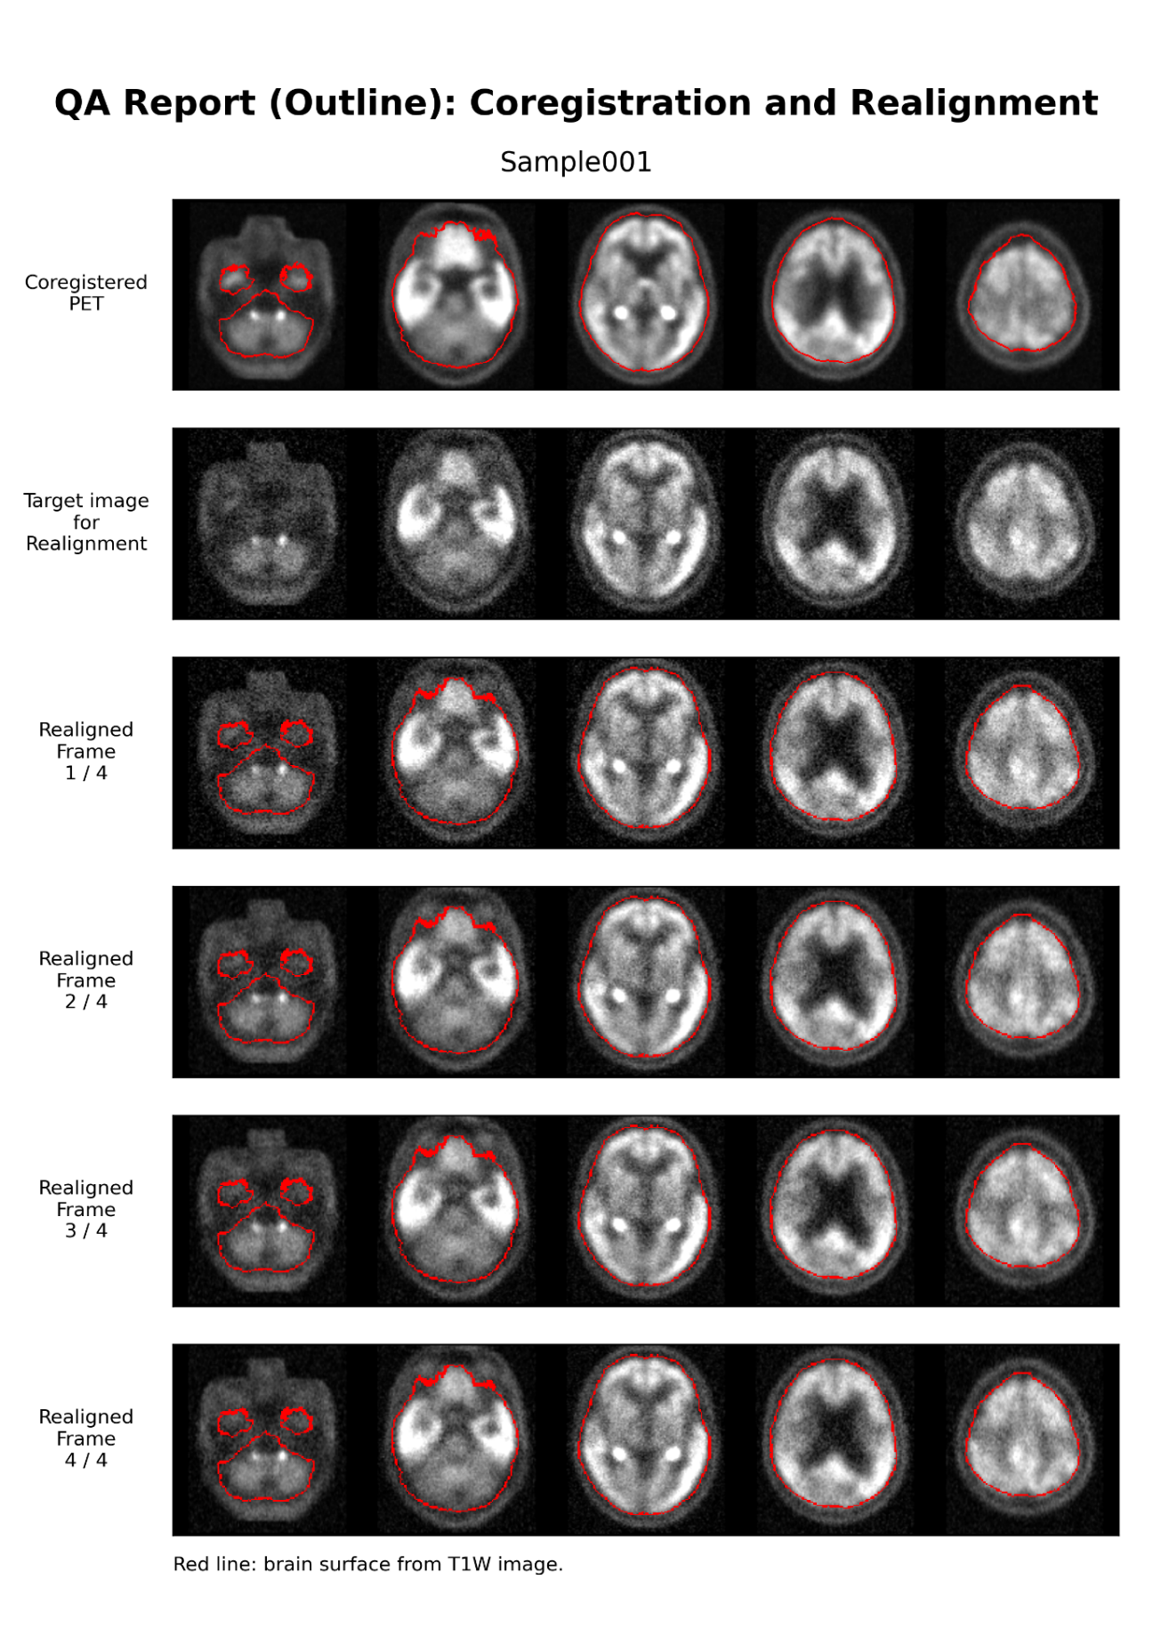

Fig. S2. An example overview image exported in a format that does not require specialized neuroimaging software, enabling easy visual inspection of the processed data. Similar overview images are generated for PET images semi-quantified using grey-matter, white-matter, or cerebellar reference regions.

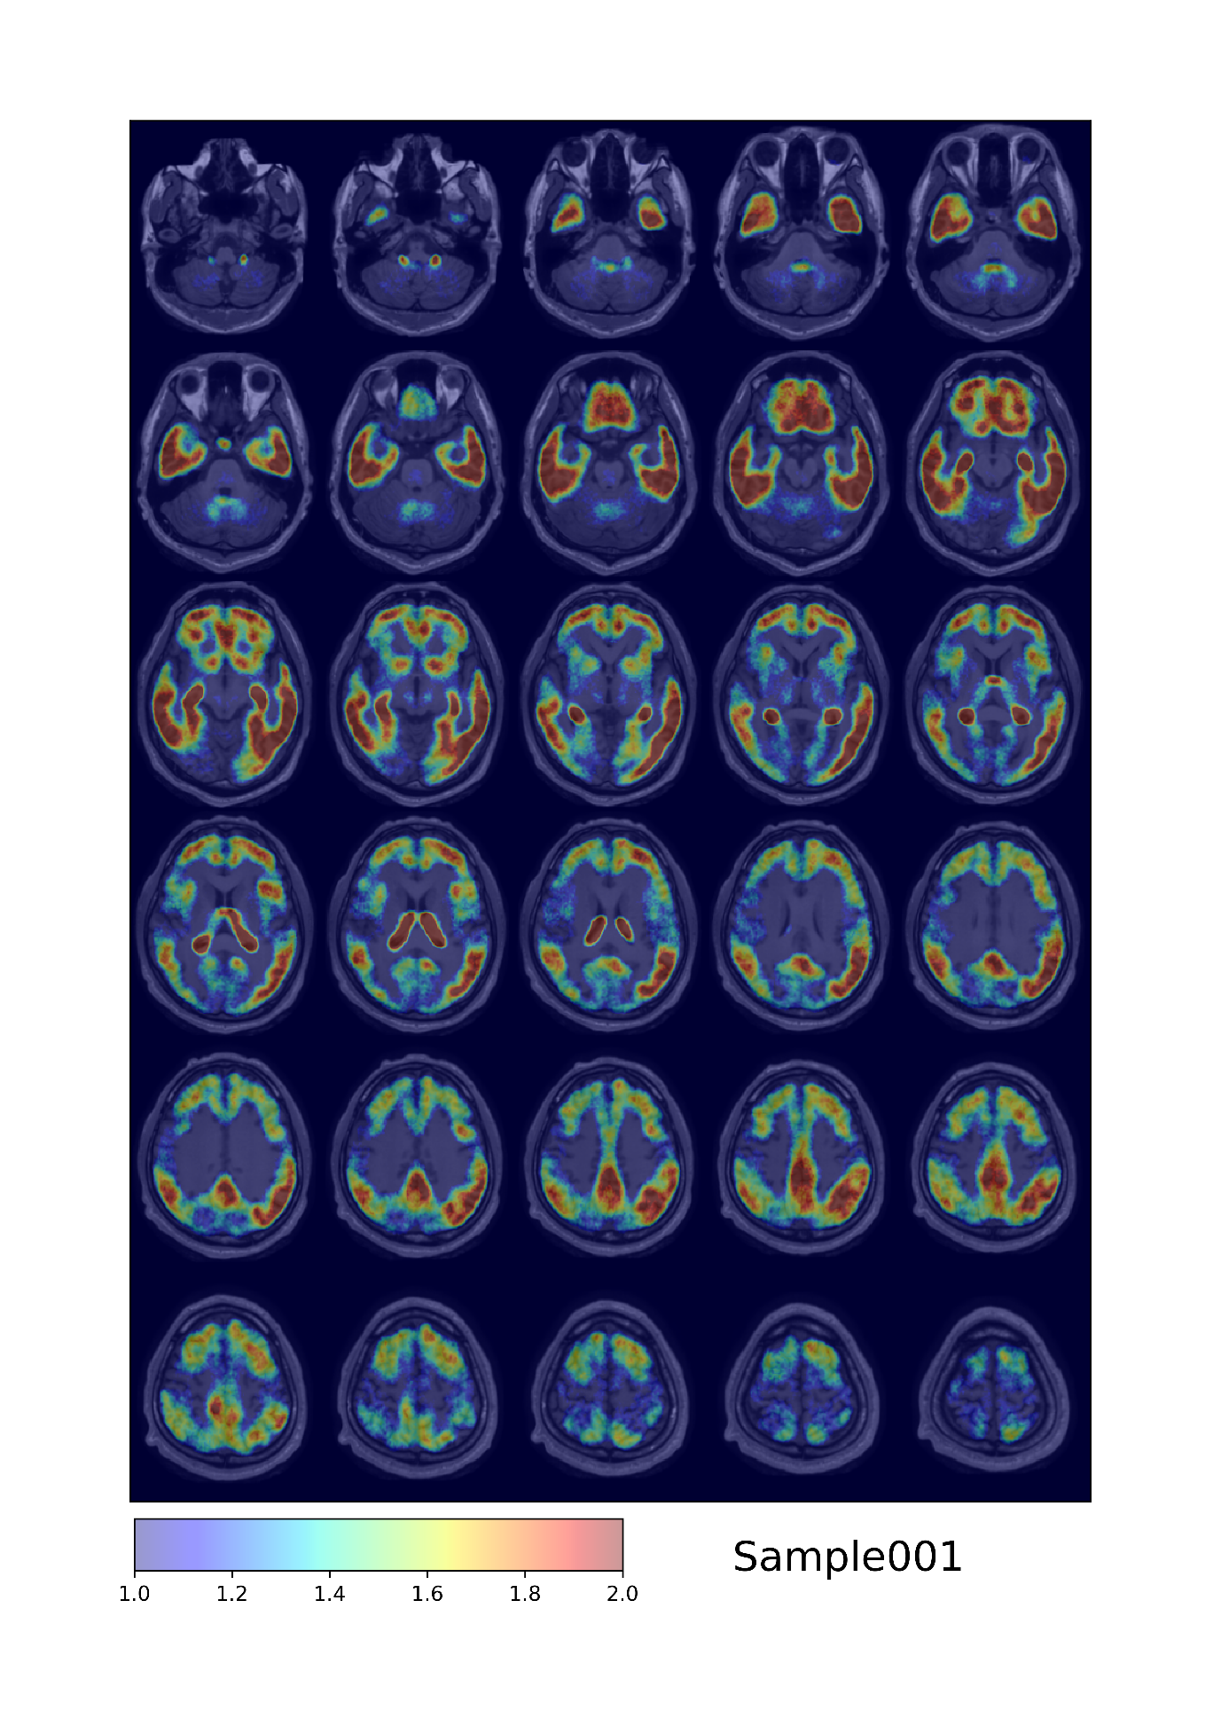
Fig. S3. Representative histogram fitting and model selection for histogram-based grey-matter reference estimation. In each row, the panels show the target intensity histogram, the bimodal Gaussian mixture fit, and the monomodal Gaussian fit from left to right. (a) A visually bimodal distribution for which the bimodal fit captured both peaks and was selected. (b) A case in which the peak height of the lower-mean Gaussian was less than half that of the higher-mean Gaussian. Because the Dice coefficient between the monomodal fit and the target histogram was 0.862, below the threshold of 0.936, the bimodal fit was retained. (c) A case meeting the same peak-height criterion in which the Dice coefficient was 0.947, above the threshold of 0.936; the monomodal fit was therefore selected. (d) A case in which the mean of the lower-mean Gaussian estimated by the bimodal fit fell outside the intensity range of the target histogram, and the monomodal fit was selected.
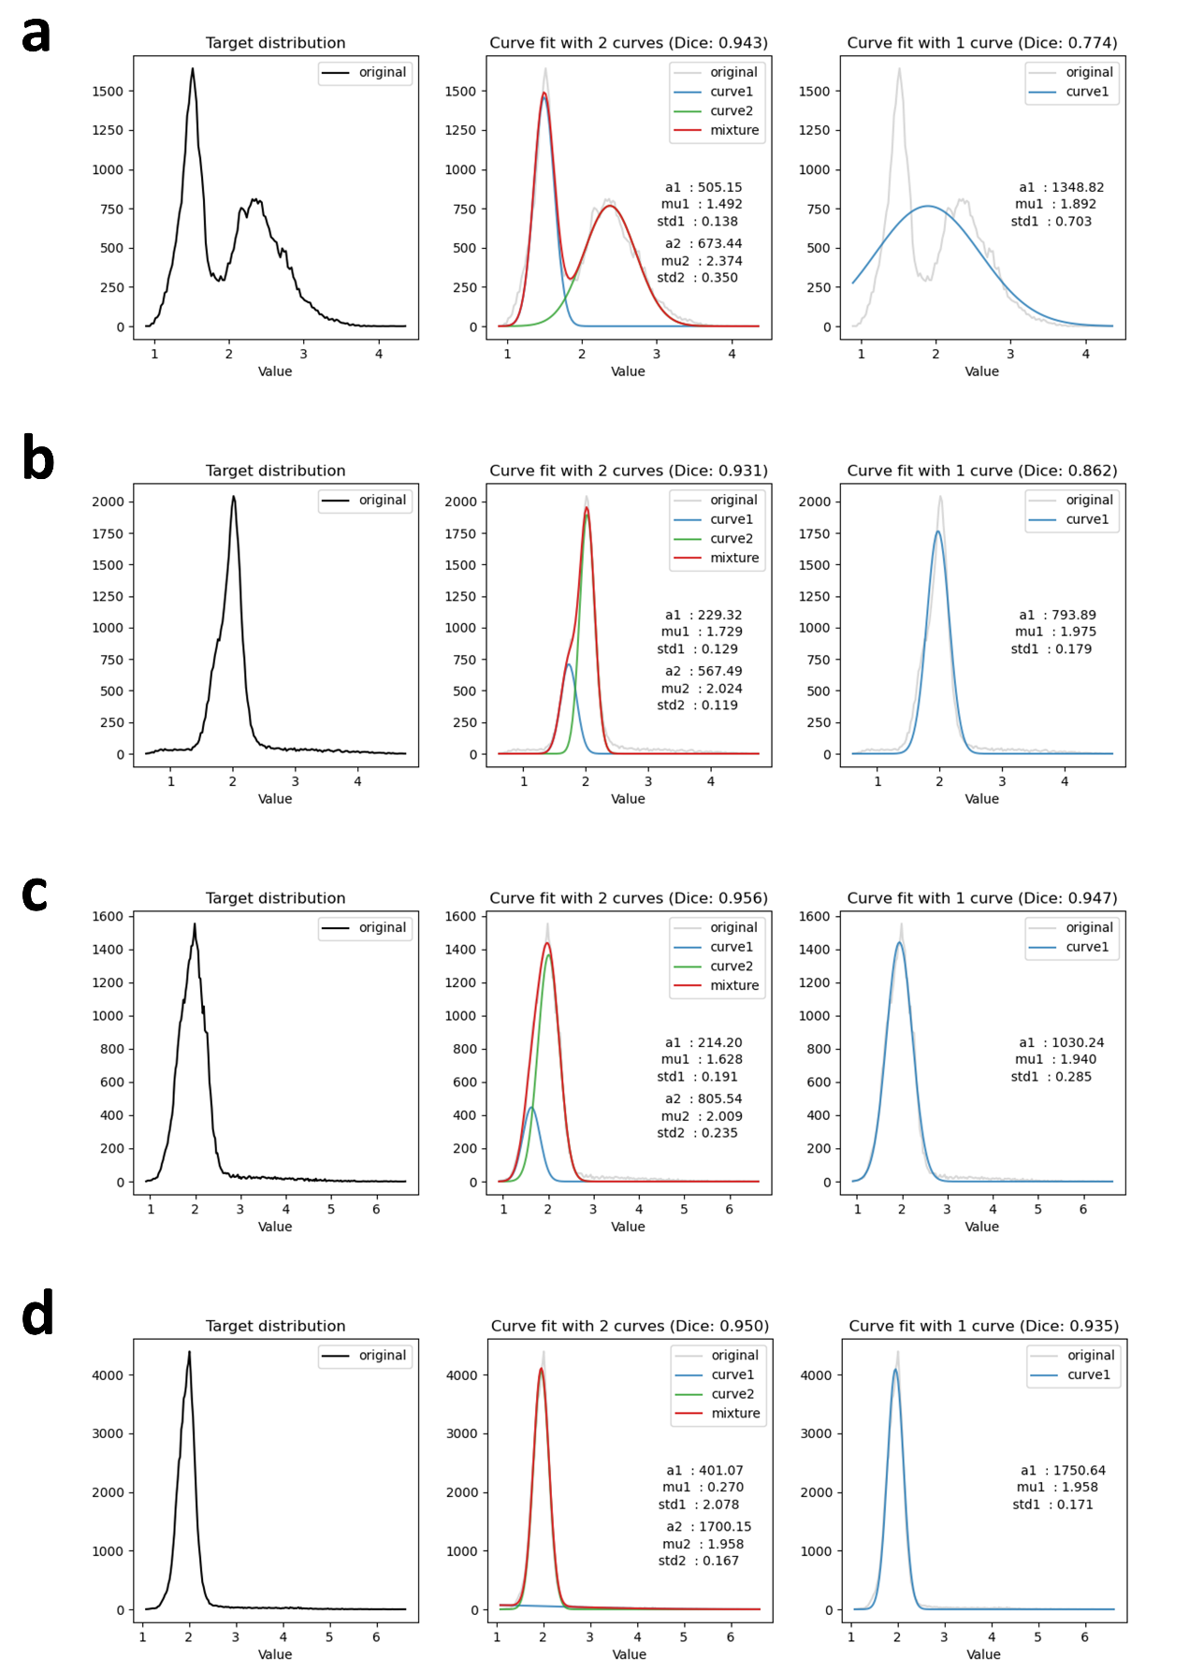
Fig. S4. Group comparison of age- and sex-adjusted ROI-level cerebellar-referenced SUVRs in the inferior temporal gyrus and globus pallidus. AD exhibited significantly higher SUVR in the inferior temporal gyrus compared to both HC and PSP. Conversely, PSP exhibited significantly elevated SUVR in the globus pallidus relative to both HC and AD. Individual points represent SUVRs adjusted to the overall mean age and sex distribution of the analysed sample. Sample sizes are indicated below the corresponding diagnostic-group labels. Pairwise group contrasts were derived from separate linear regression models adjusted for age and sex, using HC3 heteroscedasticity-robust standard errors. The displayed p values were adjusted using the Holm method across the three planned pairwise group comparisons within each ROI. Effect sizes are presented as covariate-adjusted Cohen’s d, with positive values indicating a higher SUVR in the second group of each contrast. HC, healthy controls; AD, Alzheimer’s disease; PSP, progressive supranuclear palsy.

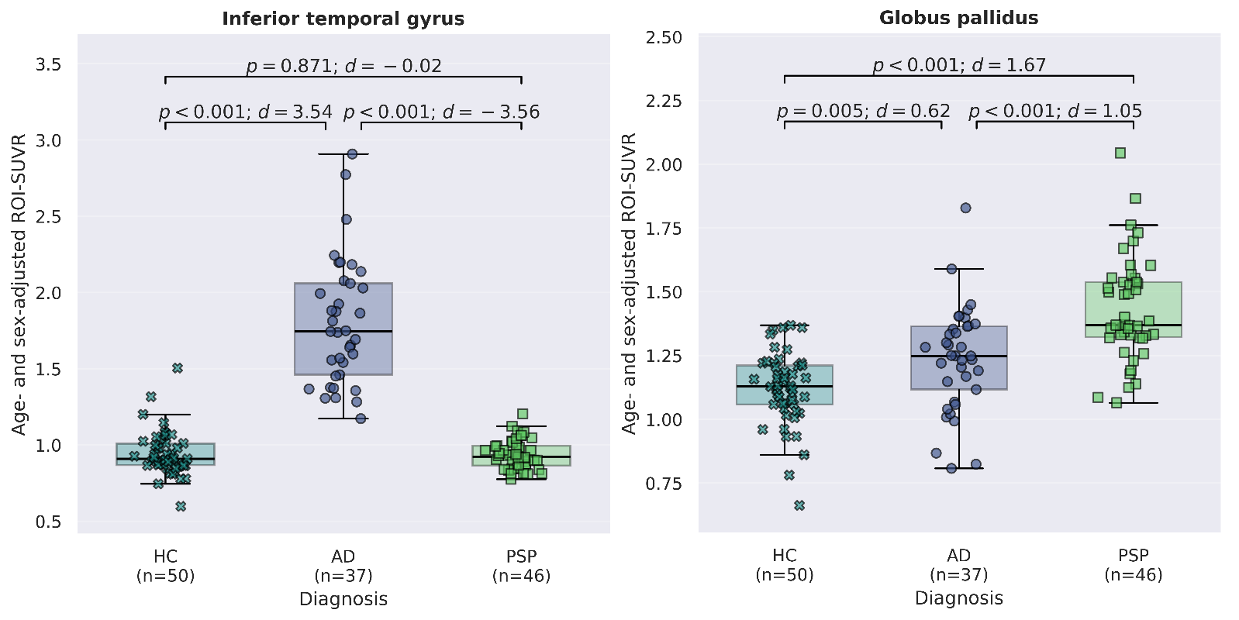

Fig. S5. ROI coefficients contributing to the final AD-tau and PSP-tau score equations. (a) AD-tau coefficient vector. Because the AD-tau vector contained a large number of non-zero coefficients, coefficients with absolute values less than 5% of the largest absolute coefficient (Lt-Amygdala) are omitted from the figure for visual clarity. These omitted coefficients remained included in the calculation of the primary AD-tau score. (b) PSP-tau coefficient vector. All non-zero coefficients are shown. Positive and negative coefficients are shown in red and blue, respectively. ROI labels are primarily based on FreeSurfer labels, and their definitions are provided in Table S3. Lt, left; Rt, right; wm, white matter.

