Table 1S The radiomics features screened from T2WI, ADC and HBP sequences for radiomics model construction.
Sequences | Radiomics features | Weight
T2WI  (6) | T2_wavelet-HHH_glszm_SizeZoneNonUniformityNormalized  T2_wavelet-HHL_firstorder_Skewness  T2_wavelet-HHL_gldm_LargeDependenceEmphasis  T2_wavelet-HHL_gldm_SmallDependenceEmphasis  T2_wavelet-HLH_ngtdm_Busyness  T2_wavelet-LLL_firstorder_Skewness | -0.12142  -0.02677  0.001703  -0.17443  0.000845  -0.05295
ADC  (7) | ADC_original_glcm_MCC  ADC_wavelet-HHH_ngtdm_Busyness  ADC_wavelet-HHL_glcm_InverseVariance  ADC_wavelet-HLH_gldm_LowGrayLevelEmphasis  ADC_wavelet-LHL_firstorder_Mean  ADC_wavelet-LLL_firstorder_Median  ADC_wavelet-LLL_glcm_ClusterShade | 0.076447  -0.00014  0.097652  -0.03823  0.000611  -3.3E-05  4.28E-08
HBP  (12) | HBP_original_glcm_Imc1  HBP_wavelet-HHH_gldm_DependenceEntropy  HBP_wavelet-HHL_glcm_ClusterShade  HBP_wavelet-HHL_ngtdm_Complexity  HBP_wavelet-HLL_firstorder_Skewness  HBP_wavelet-LHL_firstorder_10Percentile  HBP_wavelet-LHL_glcm_Correlation  HBP_wavelet-LHL_gldm_LargeDependenceHighGrayLevelEmphasis  HBP_wavelet-LLH_glcm_ClusterShade  HBP_wavelet-LLH_glcm_MCC  HBP_wavelet-LLL_ngtdm_Coarseness  HBP_wavelet-LLL_ngtdm_Strength | 0.182916  0.045429  -0.0002  9.36E-06  0.049709  -0.00012  0.176123  5.95E-06  3.88E-06  -0.04226  -0.75361  -8.4E-06
Note: The final radiomics score was calculated as: Radiomics score = 0.3770 +Σ(Feature_{i} × Weight_{i})

Table 2S The distribution of TRG heterogeneity and radiomics-predicted TRG heterogeneity in the training and validation groups.
Predicted heterogeneity | Training group |  | Validation group
Predicted heterogeneity | TRG_{H-} | TRG_{H+} | TRG_{H-} | TRG_{H+}
R_{H-} | 36 | 12 | 19 | 3
R_{H+} | 2 | 4 | 1 | 6

Table 3S Comparison of different multivariate Cox models for the prediction of LTDFS.
Model | Characteristic | HR (95%CI) | P-value | AUC
Model (R_{H} and intraoperative RFA) | R_{H} | 2.588 (1.367,4.900) | 0.003 | 0.797
Model (R_{H} and intraoperative RFA) | Intraoperative RFA | 1.816 (1.091, 3.021) | 0.022 | 0.797
Model (R_{min} and intraoperative RFA) | R_{min} | 1.926 (1.185, 3.129) | 0.008 | 0.823
Model (R_{min} and intraoperative RFA) | intraoperative RFA | 2.002 (1.192, 3.362) | 0.009 | 0.823
Model (R_{max} and intraoperative RFA) | R_{max} | 2.120 (1.177, 3.818) | 0.012 | 0.786
Model (R_{max} and intraoperative RFA) | intraoperative RFA | 1.860 (1.117, 3.097) | 0.017 | 0.786
Model (R_{H}, R_{min} and intraoperative RFA) | R_{H} | 2.282 (1.200, 4.339) | 0.012 | 0.851
Model (R_{H}, R_{min} and intraoperative RFA) | R_{min} | 1.836 (1.099, 3.068) | 0.020 | 0.851
Model (R_{H}, R_{min} and intraoperative RFA) | intraoperative RFA | 1.982 (1.178, 3.336) | 0.010 | 0.851
AUC = area under the curve; RFA = radiofrequency ablation

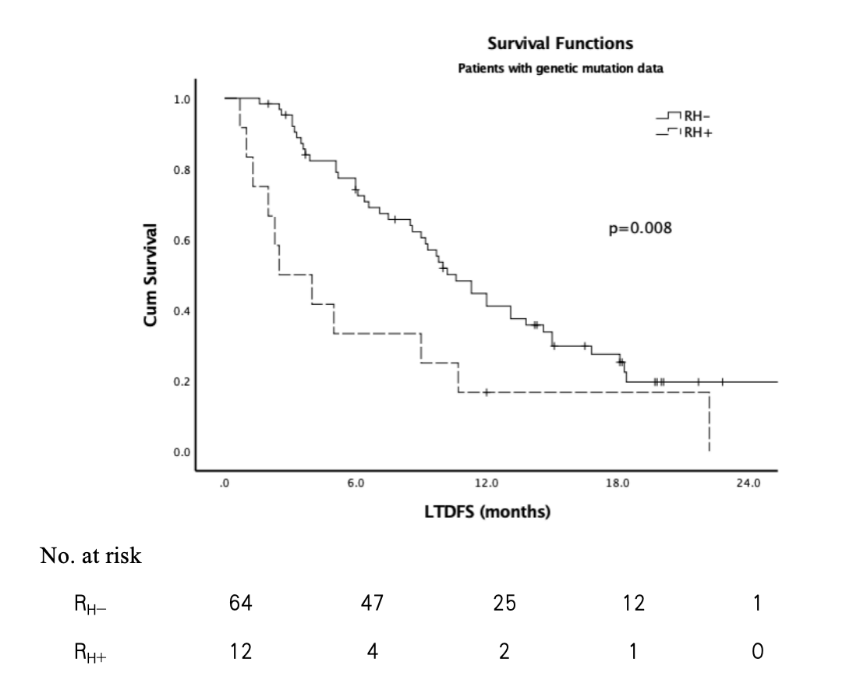
Fig. 1S Kaplan-Meier curve for LTDFS according to R_{H} in patients with genetic mutation data.

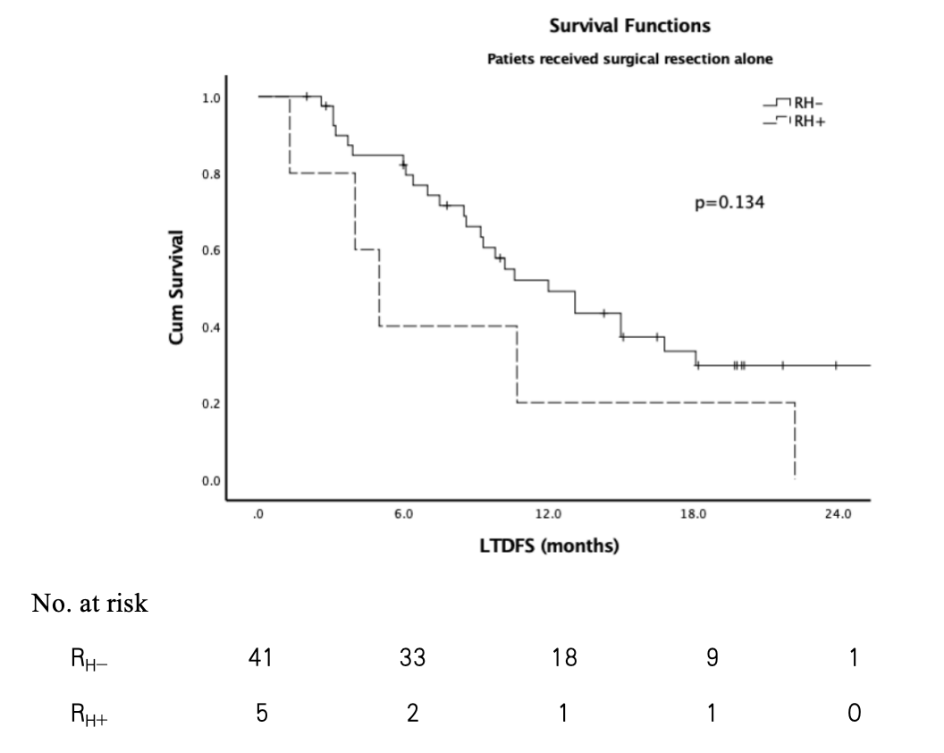 | 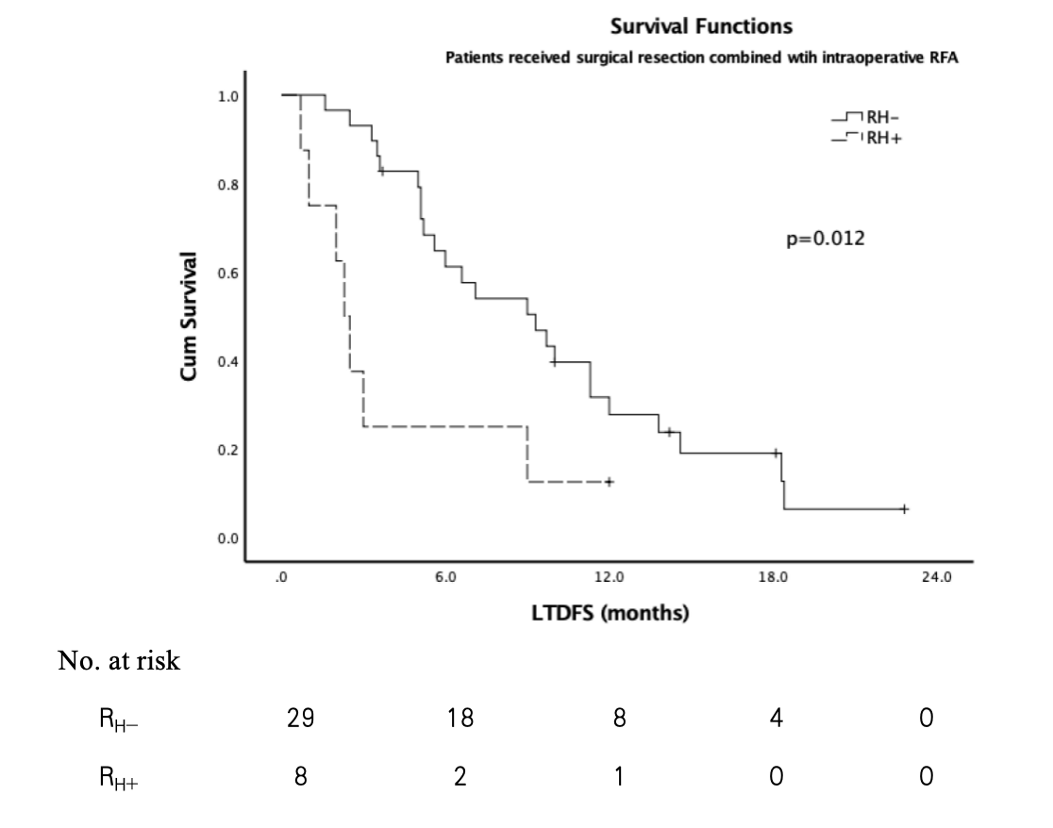
a | b
Fig. 2S Kaplan-Meier curve for LTDFS according to R_{H} in patients received surgical resection alone (a) and patients received surgical resection combined with intraoperative RFA (b).

