Supplemental Material

Feasibility of Automated Quantitative CT Imaging Metrics in Pulmonary Langerhans Cell Histiocytosis: A Pilot Study

Supplementary results
Supplementary tables
Supplementary Table S1: PRM metrics and pulmonary vascular volume in each lung region
 | Upper |  | Middle |  | Lower
 | Left upper | Right upper | Left middle | Right middle | Left lower | Right lower
PRM^{Pers} % | 19.0 [5.0; 24.5] | 19.0 [5.2; 27.0] | 12.0 [2.0; 25.2] | 11.0[3.5; 21.0] | 1.0 [0.0; 2.8] | 1.0 [0.0; 4.0]
PRM^{fSAD} % | 25.0 [9.25; 36.8] | 21.0 [10.5; 35.8] | 24.0 [7.0; 28.8] | 19.5 [8.3; 29.8] | 8.0 [3.3; 19.0] | 15.0 [5.3; 21.8]
PVV cm³ | 6.5 [5.2; 9.8] | 8.0 [6.2; 12.0] | 23.5 [17.2; 28.8] | 26.5 [22.0; 31.8] | 15.5 [14.0; 22.8] | 19.0 [16.0; 21.8]
PRM: Parametric Response Mapping; PRM^{Pers}: Parametric Response Mapping of persistent low-attenuation regions; PRM^{fSAD}: Parametric Response Mapping of functional small airways disease regions; PVV: Pulmonary vascular volume.
Supplementary Table S2: Individual patient PRM results with corresponding spirometry and smoking habits
Patient |  | PRM^{Pers} | PRM^{fSAD} |  | FEV₁* |  | FVC* | FEV₁/FVC |  | Pack-years
1 |  | 2 | 8 |  | 105 |  | 104 | 87 |  | 19
2 |  | 1 | 2 |  | 101 |  | 103 | 81 |  | 17
3 |  | 1 | 5 |  | 89 |  | 86 | 85 |  | 8
4 |  | 15 | 28 |  | 86 |  | 104 | 64 |  | 44
5 |  | 1 | 7 |  | 83 |  | 86 | 84 |  | 10
6 |  | 14 | 34 |  | 82 |  | 101 | 65 |  | 35
7 |  | 5 | 29 |  | 82 |  | 109 | 59 |  | 25
8 |  | 18 | 21 |  | 79 |  | 148 | 45 |  | 45
9 |  | 3 | 6 |  | 77 |  | 88 | 75 |  | 37
10 |  | 5 | 13 |  | 77 |  | 108 | 58 |  | 6
11 |  | 10 | 11 |  | 74 |  | 95 | 65 |  | 27
12 |  | 3 | 7 |  | 58 |  | 73 | 62 |  | 60
13 |  | 23 | 19 |  | 56 |  | 104 | 44 |  | 47
14 |  | 20 | 24 |  | 47 |  | 100 | 34 |  | 18
15 |  | 26 | 30 |  | 43 |  | 67 | 52 |  | 30
16 |  | 28 | 28 |  | 42 |  | 81 | 42 |  | 10
17 |  | 14 | 41 |  | 32 |  | 65 | 41 |  | 50
18 |  | 23 | 33 |  | 27 |  | 49 | 45 |  | 15,5
*Percentage predicted
CT: computed tomography; PRM: Parametric Response Mapping; PFTs: pulmonary function tests; PRM^{fSAD}: Parametric Response Mapping of functional small airway disease regions; PRM^{Pers}: Parametric Response Mapping of persistent low-attenuation regions; FEV₁: forced expiratory volume in 1 second; FVC: forced vital capacity; PA: pack-years.

Supplementary figures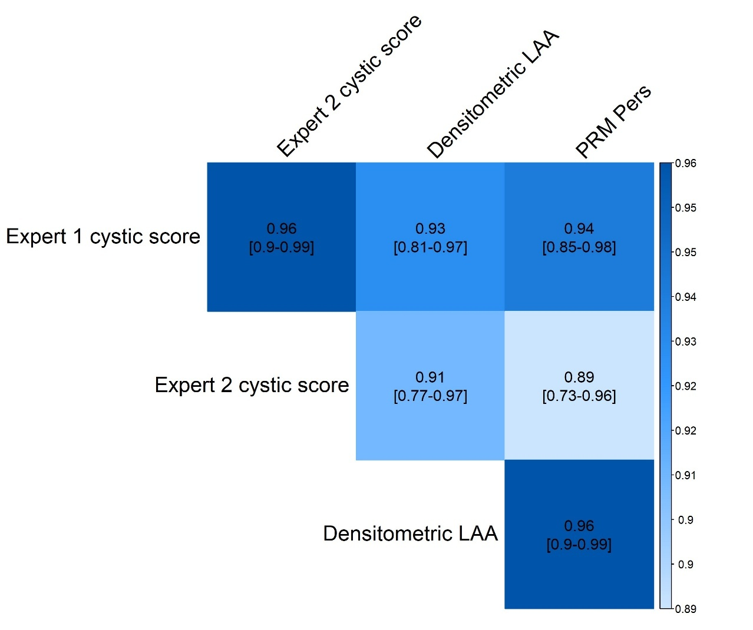
Supplementary Figure S1: Pearson correlation matrix between visual cystic scores (Expert 1 and Expert 2), densitometric LAA, and PRM^{Pers} measurements. Darker blue colours indicate the strongest positive correlations.
LAA: low-attenuation area; PRM^{Pers}: Parametric Response Mapping of persistent low-attenuation regions.

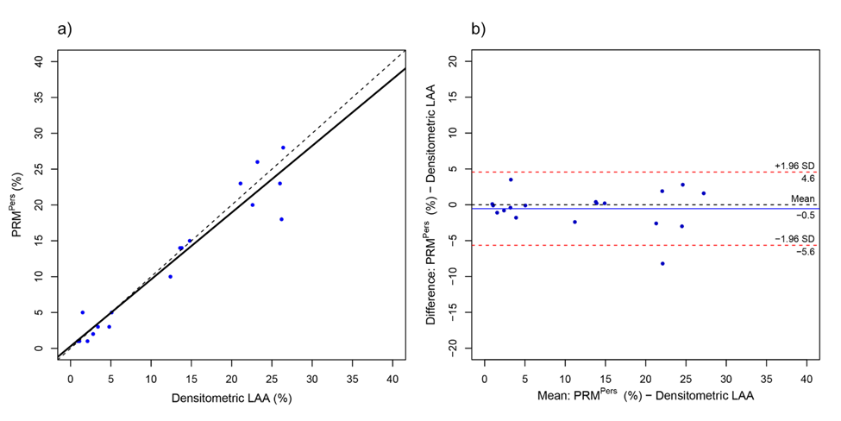
Supplementary Figure S2: Relationships among the quantitative cystic lung metrics across imaging modalities. a) Correlations between densitometric LAA% and PRM^{Pers}. The solid black lines represent linear regression fits for each pairwise comparison, whereas the dashed line indicates the line of identity (x = y). b) Bland‒Altman plots comparing average cystic lung volume quantified by both methods. The x-axis shows the mean value between paired measurements, and the y-axis shows the difference. Dashed lines indicate the limits of agreement (mean ± 1.96 SD). The data are expressed as percentages of total lung volume.
LAA: low attenuation area; PRM^{Pers}: parametric response mapping of persistent low-attenuation regions; SD: standard deviation.

