Supplementary Figures
Figure S1. Representative examples of visually assessed putaminal rim scores on DWI and SWI
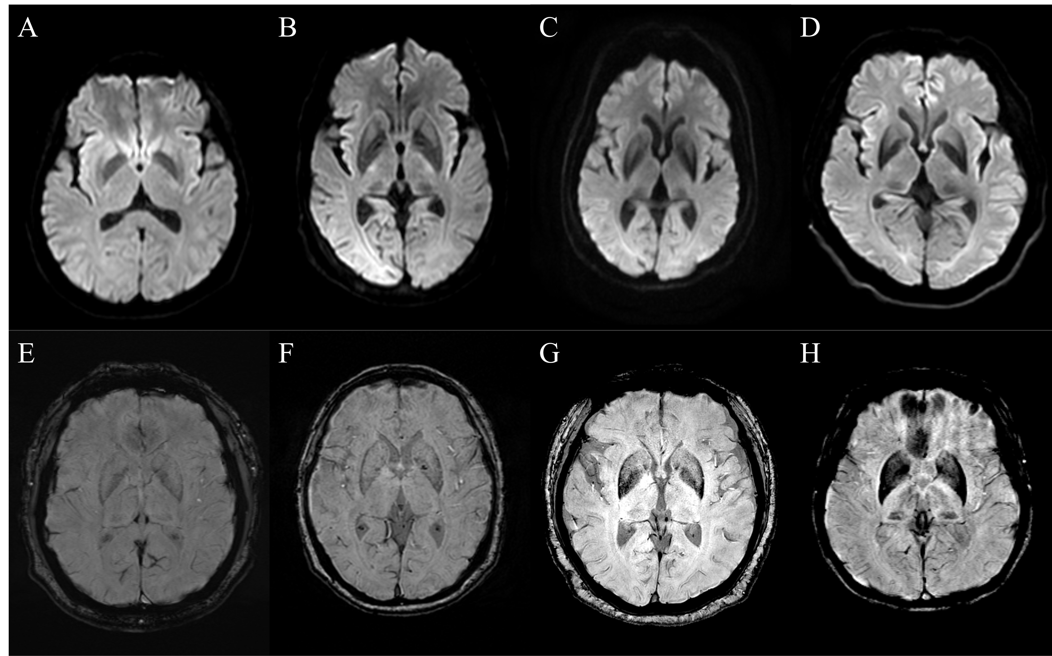
Representative examples of the visually assessed putaminal rim scoring system used in this study. Panels A–D show DWI examples with putaminal rim scores of 0, 1, 2, and 3, respectively. Panels E–H show SWI examples with putaminal rim scores of 0, 1, 2, and 3, respectively. All images were obtained at the axial basal ganglia level. These images illustrate the ordinal visual rating anchors applied to the putaminal rim signs in the study cohort. Abbreviations: DWI, diffusion-weighted imaging; SWI, susceptibility-weighted imaging.

Supplementary Figure S2. Representative examples of binary visual MRI signs used in the study
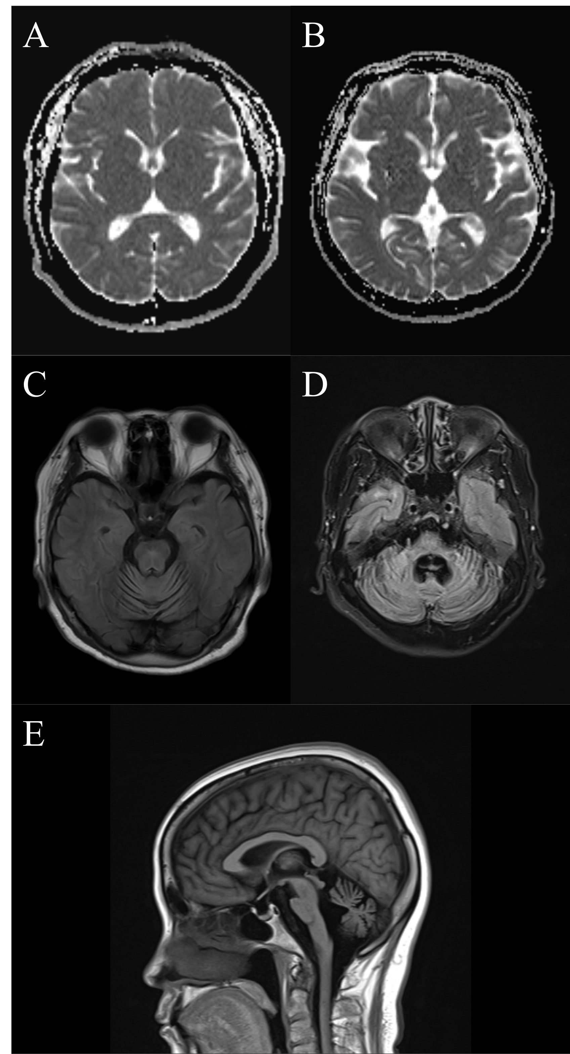
Representative examples of the binary visual MRI signs assessed in this study. (A) Axial ADC map without lateral putaminal ADC hyperintensity (absent). (B) Axial ADC map with lateral putaminal ADC hyperintensity (present). (C) Axial T2-FLAIR showing the “hot cross bun” sign. (D) Axial T2-FLAIR showing MCP abnormality, defined in this study as visible MCP atrophy or T2 hyperintensity. (E) Mid-sagittal T1-weighted image showing pontine and cerebellar atrophy. These images were selected as representative examples of the visually assessed binary MRI markers used in the main analyses. Abbreviations: ADC, apparent diffusion coefficient; FLAIR, Fluid-attenuated inversion recovery; MRI, magnetic resonance imaging; MCP, middle cerebellar peduncle.

Supplementary Tables
Table S1. Inter-rater agreement for visually assessed MRI markers
MRI marker | Variable type | n | Agreement (%) | Statistic
Left DWI putaminal rim score | Ordinal | 94 | 87.2 | Linear-weighted Cohen’s κ = 0.815 (95% CI, 0.709–0.922)
Right DWI putaminal rim score | Ordinal | 94 | 84.0 | Linear-weighted Cohen’s κ = 0.801 (95% CI, 0.700–0.902)
Left SWI putaminal rim score | Ordinal | 69 | 89.9 | Linear-weighted Cohen’s κ = 0.920 (95% CI, 0.864–0.977)
Right SWI putaminal rim score | Ordinal | 69 | 91.3 | Linear-weighted Cohen’s κ = 0.925 (95% CI, 0.867–0.984)
Left putaminal ADC hyperintensity | Binary | 88 | 94.3 | Cohen’s κ = 0.880
Right putaminal ADC hyperintensity | Binary | 88 | 96.6 | Cohen’s κ = 0.929
“Hot cross bun” sign | Binary | 94 | 98.9 | Cohen’s κ = 0.976
Pons atrophy | Binary | 94 | 93.6 | Cohen’s κ = 0.868
Cerebellar atrophy | Binary | 94 | 95.7 | Cohen’s κ = 0.914
MCP abnormality (atrophy or T2 hyperintensity) | Binary | 94 | 96.8 | Cohen’s κ = 0.934
MRI, magnetic resonance imaging; DWI, diffusion-weighted imaging; SWI, susceptibility-weighted imaging; ADC, apparent diffusion coefficient; MCP, middle cerebellar peduncle.

Table S2. MRI features of the participants.
Imaging marker | All MSA | MSA-P | MSA-C | p value (MSA-P vs. MSA-C)
Putaminal DWI rim score, left (0-3) | 1.0 (2.0) | 2.0 (2.0) (n = 50) | 0.0 (1.0) (n = 44) | 0.005**
Putaminal DWI rim score, right (0-3) | 1.0 (2.0) | 1.0 (2.0) (n = 50) | 1.0 (1.0) (n = 44) | 0.031*
Putaminal SWI rim score, left (0-3) | 1.0 (2.0) | 2.0 (3.0) (n = 40) | 1.0 (1.0) (n = 29) | 0.007**
Putaminal SWI rim score, right (0-3) | 1.0 (2.0) | 2.0 (2.0) (n = 40) | 0.0 (1.0) (n = 29) | 0.006**
Putaminal ADC hyperintensity, left | 34/88 (38.6%) | 26/47 (55.3%) | 8/41 (19.5%) | <0.001***
Putaminal ADC hyperintensity, right | 36/88 (40.9%) | 24/47 (51.1%) | 12/41 (29.3%) | 0.038*
“Hot cross bun” sign | 33/94 (35.1%) | 9/50 (18.0%) | 24/44 (54.5%) | <0.001***
Pons atrophy | 38/94 (40.4%) | 10/50 (20.0%) | 28/44 (63.6%) | <0.001***
Cerebellar atrophy | 52/94 (55.3%) | 18/50 (36.0%) | 34/44 (77.3%) | <0.001***
MCP abnormality (atrophy or T2 hyperintensity) | 39/94 (41.5%) | 10/50 (20.0%) | 29/44 (65.9%) | <0.001***
All the numerical variables do not follow a normal distribution. MSA, Multiple system atrophy; MSA-C, Multiple system atrophy with predominant cerebellar ataxia; MSA-P, Multiple system atrophy with predominant parkinsonism; DWI, diffusion-weighted imaging; SWI, susceptibility-weighted imaging; ADC, apparent diffusion coefficient; MCP, middle cerebellar peduncle. Significance: p < 0.05 (*), p < 0.01 (**), p < 0.001 (***).

Table S3. Comparison of participants with and without available clinical outcomes
Clinical measure | Characteristic | Outcome unavailable | Outcome available | p value
Side-specific MDS-UPDRS Part III scores  Outcome unavailable: n = 43  Outcome available: n = 51 | Age, years, mean (SD) | 62.8 (8.1) | 63.6 (7.9) | 0.641
 | Disease duration, years, median (IQR) | 1.7 (1.9) | 1.8 (2.8) | 0.554
 | Male sex, n/N (%) | 14/43 (32.6%) | 26/51 (51.0%) | 0.072
 | MSA-P subtype, n/N (%) | 23/43 (53.5%) | 27/51 (52.9%) | 0.958
 | Clinically established MSA, n/N (%) | 29/43 (67.4%) | 30/51 (58.8%) | 0.389
 | Left DWI rim score, median (IQR) | 1.0 (2.0) | 1.0 (2.0) | 0.131
 | Right DWI rim score, median (IQR) | 1.0 (2.0) | 1.0 (2.0) | 0.113
 | Left SWI rim score, median (IQR) | 1.5 (1.0), n=28 | 1.0 (2.0), n=41 | 0.179
 | Right SWI rim score, median (IQR) | 1.0 (1.3), n=28 | 1.0 (2.0), n=41 | 0.191
 | Left ADC hyperintensity, n/N (%) | 17/38 (44.7%) | 17/50 (34.0%) | 0.306
 | Right ADC hyperintensity, n/N (%) | 15/38 (39.5%) | 21/50 (42.0%) | 0.811
 | “Hot cross bun” sign, n/N (%) | 14/43 (32.6%) | 19/51 (37.3%) | 0.635
 | Pons atrophy, n/N (%) | 17/43 (39.5%) | 21/51 (41.2%) | 0.872
 | Cerebellar atrophy, n/N (%) | 24/43 (55.8%) | 28/51 (54.9%) | 0.929
 | MCP abnormality, n/N (%) | 20/43 (46.5%) | 19/51 (37.3%) | 0.364
Heel-knee-shin score  Outcome unavailable: n = 45  Outcome available: n = 49 | Age, years, mean (SD) | 63.4 (7.7) | 63.1 (8.3) | 0.848
 | Disease duration, years, median (IQR) | 1.7 (1.8) | 2.0 (2.8) | 0.374
 | Male sex, n/N (%) | 16/45 (35.6%) | 24/49 (49.0%) | 0.189
 | MSA-P subtype, n/N (%) | 26/45 (57.8%) | 24/49 (49.0%) | 0.393
 | Clinically established MSA, n/N (%) | 29/45 (64.4%) | 30/49 (61.2%) | 0.747
 | Left DWI rim score, median (IQR) | 1.0 (2.0) | 1.0 (2.0) | 0.188
 | Right DWI rim score, median (IQR) | 1.0 (2.0) | 1.0 (2.0) | 0.168
 | Left SWI rim score, median (IQR) | 1.0 (1.0), n=29 | 1.0 (2.0), n=40 | 0.136
 | Right SWI rim score, median (IQR) | 1.0 (1.0), n=29 | 0.5 (2.0), n=40 | 0.194
 | Left ADC hyperintensity, n/N (%) | 17/40 (42.5%) | 17/48 (35.4%) | 0.497
 | Right ADC hyperintensity, n/N (%) | 16/40 (40.0%) | 20/48 (41.7%) | 0.874
 | “Hot cross bun” sign, n/N (%) | 13/45 (28.9%) | 20/49 (40.8%) | 0.226
 | Pons atrophy, n/N (%) | 16/45 (35.6%) | 22/49 (44.9%) | 0.357
 | Cerebellar atrophy, n/N (%) | 23/45 (51.1%) | 29/49 (59.2%) | 0.432
 | MCP abnormality, n/N (%) | 19/45 (42.2%) | 20/49 (40.8%) | 0.890
Data are presented as mean (SD), median (IQR), or n/N (%). Outcome availability was defined separately for the side-specific MDS-UPDRS Part III motor scores and the UMSARS Part II heel-knee-shin score. Age was compared using the independent-samples t test; disease duration and DWI/SWI scores using the Mann-Whitney U test; and categorical variables using the Pearson chi-square test. Denominators vary for SWI and ADC because these sequences were not available in all participants. MDS-UPDRS, Movement Disorder Society-Unified Parkinson’s Disease Rating Scale; UMSARS, the Unified Multiple System Atrophy Rating Scale; MSA, multiple system atrophy; DWI, diffusion-weighted imaging; SWI, susceptibility-weighted imaging; ADC, apparent diffusion coefficient; MCP, middle cerebellar peduncle. Significance: p < 0.05 (*), p < 0.01 (**), p < 0.001 (***).

Table S4. Concordance among putaminal DWI, SWI, and ADC abnormalities
Imaging Abnormality Comparison | N | Cohen’s κ (95% CI) | McNemar p | Spearman ρ | Spearman p
Left ADC vs. SWI | 65 | 0.595 (0.399-0.791) | 0.581 | NA | NA
Right ADC vs. SWI | 65 | 0.444 (0.232-0.655) | 0.096 | NA | NA
Left ADC vs. DWI | 88 | 0.617 (0.447-0.786) | 1.000 | NA | NA
Right ADC vs. DWI | 88 | 0.400 (0.204-0.595) | 0.424 | NA | NA
Left DWI vs. SWI | 69 | NA | NA | 0.718 | <0.001***
Right DWI vs. SWI | 69 | NA | NA | 0.730 | <0.001***
ADC abnormality: lateral putaminal ADC hyperintensity. DWI/SWI abnormality: putaminal rim hypointensity. N varied due to missing sequences (available-case analysis). NA, not applicable; ADC, apparent diffusion coefficient; DWI, diffusion-weighted imaging; SWI, susceptibility-weighted imaging. Significance: p < 0.05 (*), p < 0.01 (**), p < 0.001 (***).

Table S5. Scores and comparison of parkinsonian motor symptoms on the left and right sides
Clinical Score (MDS-UPDRS Part III) | Left Side | Right Side | p value
Resting tremor score | 0.0 (0.0) ^{b} | 0.0 (0.0) ^{b} | 0.705
Action tremor score | 1.0 (2.0) ^{b} | 0.0 (2.0) ^{b} | 0.040*
Bradykinesia score | 9.0 (7.0) ^{b} | 8.0 (5.0) ^{b} | 0.224
Rigidity score | 2.0 (4.0) ^{b} | 2.0 (4.0) ^{b} | 0.135
Bradykinesia + rigidity composite | 11.45 (5.31) ª | 10.69 (5.22) ª | 0.115
Total tremor score | 1.0 (2.0) ^{b} | 0.0 (2.0) ^{b} | 0.094
Total lateral motor score | 12.65 (6.12) ª | 11.63 (5.73) ª | 0.070
MDS-UPDRS: the Movement Disorder Society-Unified Parkinson’s Disease Rating Scale. ª. All the data involved in the comparison followed a normal distribution. ^{b}. Some of the data involved in the comparison follows a non-normal distribution. Significance: p < 0.05 (*), p < 0.01 (**), p < 0.001 (***).

Table S6. Correlations between putaminal DWI/SWI scores and contralateral motor subscores

Imaging Variable | Contralateral Clinical Score (MDS-UPDRS Part III) | Correlation coefficient (ρ) | p value | n
Left putaminal rim DWI hypointensity score | Resting tremor score | 0.129 | 0.366 | 51
Left putaminal rim DWI hypointensity score | Action tremor score | 0.214 | 0.132 | 51
Left putaminal rim DWI hypointensity score | Bradykinesia score | 0.106 | 0.458 | 51
Left putaminal rim DWI hypointensity score | Rigidity score | 0.185 | 0.194 | 51
Left putaminal rim DWI hypointensity score | Bradykinesia + rigidity composite | 0.151 | 0.289 | 51
Left putaminal rim DWI hypointensity score | Total tremor score | 0.193 | 0.174 | 51
Left putaminal rim DWI hypointensity score | Total lateral motor score | 0.177 | 0.214 | 51
Left putaminal rim SWI hypointensity score | Resting tremor score | 0.214 | 0.180 | 41
Left putaminal rim SWI hypointensity score | Action tremor score | 0.216 | 0.175 | 41
Left putaminal rim SWI hypointensity score | Bradykinesia score | 0.056 | 0.730 | 41
Left putaminal rim SWI hypointensity score | Rigidity score | 0.309 | 0.0496* | 41
Left putaminal rim SWI hypointensity score | Bradykinesia + rigidity composite | 0.170 | 0.288 | 41
Left putaminal rim SWI hypointensity score | Total tremor score | 0.212 | 0.184 | 41
Left putaminal rim SWI hypointensity score | Total lateral motor score | 0.204 | 0.200 | 41
Right putaminal rim DWI hypointensity score | Resting tremor score | 0.167 | 0.242 | 51
Right putaminal rim DWI hypointensity score | Action tremor score | 0.053 | 0.712 | 51
Right putaminal rim DWI hypointensity score | Bradykinesia score | 0.147 | 0.303 | 51
Right putaminal rim DWI hypointensity score | Rigidity score | -0.019 | 0.894 | 51
Right putaminal rim DWI hypointensity score | Bradykinesia + rigidity composite | 0.153 | 0.285 | 51
Right putaminal rim DWI hypointensity score | Total tremor score | 0.062 | 0.667 | 51
Right putaminal rim DWI hypointensity score | Total lateral motor score | 0.154 | 0.279 | 51
Right putaminal rim SWI hypointensity score | Resting tremor score | 0.000 | 1.000 | 41
Right putaminal rim SWI hypointensity score | Action tremor score | 0.152 | 0.344 | 41
Right putaminal rim SWI hypointensity score | Bradykinesia score | -0.025 | 0.875 | 41
Right putaminal rim SWI hypointensity score | Rigidity score | 0.227 | 0.153 | 41
Right putaminal rim SWI hypointensity score | Bradykinesia + rigidity composite | 0.120 | 0.455 | 41
Right putaminal rim SWI hypointensity score | Total tremor score | 0.131 | 0.413 | 41
Right putaminal rim SWI hypointensity score | Total lateral motor score | 0.132 | 0.410 | 41
Associations were assessed using Spearman correlation. Side-specific resting tremor score = resting tremor (upper extremity) + resting tremor (lower extremity) on the same side. Side-specific action tremor score = postural tremor of the hands + kinetic tremor of the hands on the same side. Side-specific bradykinesia score = finger tapping + hand movements + pronation-supination movements of hands + toe tapping + leg agility (same side). Side-specific rigidity score = rigidity (upper extremity) + rigidity (lower extremity) on the same side. Side-specific total tremor score = resting tremor score + action tremor score (same side). Side-specific total lateral motor score = total tremor score + bradykinesia score + rigidity score (same side). Left-sided imaging markers were paired with right-sided clinical scores and vice versa. MDS-UPDRS: the Movement Disorder Society-Unified Parkinson’s Disease Rating Scale; DWI, diffusion-weighted imaging; SWI, susceptibility-weighted imaging. Significance: p < 0.05 (*), p < 0.01 (**), p < 0.001 (***).

Table S7. Contralateral motor subscores by presence of putaminal ADC hyperintensity
Grouping variable | Contralateral clinical Score (MDS-UPDRS Part Ⅲ) | Group of ADC absent [Median (IQR)] | Group of ADC present [Median (IQR)] | p value
Left putaminal ADC abnormality (absent vs. present: n = 33 vs 17) | Resting tremor score | 0.0 (0.0) | 0.0 (0.0) | 0.514
 | Action tremor score | 0.0 (1.0) | 1.0 (3.0) | 0.008**
 | Bradykinesia score | 8.0 (5.0) | 9.00 (4.0) | 0.136
 | Rigidity score | 1.0 (4.0) | 2.0 (4.0) | 0.037*
 | Bradykinesia + rigidity composite | 9.0 (7.0) | 13.0 (8.0) | 0.047*
 | Total tremor score | 0.0 (1.0) | 1.0 (3.0) | 0.023*
 | Total lateral motor score | 10.0 (7.0) | 14.0 (7.5) | 0.022*
Right putaminal ADC abnormality (absent vs. present: n = 29 vs 21) | Resting tremor score | 0.0 (0.0) | 0.0 (0.0) | 0.738
 | Action tremor score | 1.0 (2.0) | 1.0 (3.0) | 0.502
 | Bradykinesia score | 8.0 (6.0) | 10.0 (6.0) | 0.229
 | Rigidity score | 2.0 (4.0) | 3.0 (6.0) | 0.279
 | Bradykinesia + rigidity composite | 10.0 (6.0) | 14.0 (6.0) | 0.070
 | Total tremor score | 1.0 (2.0) | 1.0 (3.0) | 0.536
 | Total lateral motor score | 12.0 (5.5) | 14.0 (8.5) | 0.078
Groups were compared using two-sided Mann–Whitney U tests. MDS-UPDRS: the Movement Disorder Society-Unified Parkinson’s Disease Rating Scale; ADC, apparent diffusion coefficient. Significance: p < 0.05 (*), p < 0.01 (**), p < 0.001 (***).

Table S8. Separate side-specific multivariable associations between putaminal MRI markers and contralateral motor scores
Imaging predictor | Contralateral outcome | n | Adjusted B (95% CI) | p value | Adjusted R²
Left ADC hyperintensity | Right total lateral motor score | 50 | 2.645 (-0.411 to 5.701) | 0.088 | 0.267
Right ADC hyperintensity | Left total lateral motor score | 50 | 2.181 (-0.782 to 5.145) | 0.145 | 0.329
Left DWI rim score | Right total lateral motor score | 51 | 0.776 (-0.748 to 2.300) | 0.311 | 0.240
Right DWI rim score | Left total lateral motor score | 51 | 0.731 (-0.923 to 2.385) | 0.379 | 0.292
Left SWI rim score | Right total lateral motor score | 41 | 0.623 (-0.864 to 2.111) | 0.401 | 0.161
Right SWI rim score | Left total lateral motor score | 41 | 0.061 (-1.484 to 1.606) | 0.937 | 0.221
Each MRI marker was entered into a separate linear regression model adjusted for age and MSA subtype. B denotes the unstandardized regression coefficient. ADC, apparent diffusion coefficient; CI, confidence interval; DWI, diffusion-weighted imaging; MRI, magnetic resonance imaging; MSA, multiple system atrophy; SWI, susceptibility-weighted imaging. Significance: p < 0.05 (*), p < 0.01 (**), p < 0.001 (***).

Table S9. Side-combined generalized estimating equation analyses of putaminal MRI markers and contralateral total lateral motor scores
Analysis panel | Predictor | n | Observations | Adjusted B (95% CI) | p value | Working correlation
Panel A. Main-effect GEE models | ADC hyperintensity | 50 | 100 | 2.885 (0.944 to 4.826) | 0.004** | 0.764
Panel A. Main-effect GEE models | DWI rim score | 51 | 102 | 1.455 (0.265 to 2.645) | 0.017* | 0.759
Panel A. Main-effect GEE models | SWI rim score | 41 | 82 | 1.343 (0.260 to 2.427) | 0.015* | 0.801
Panel B. Marker-by-imaging-side interaction models | ADC × imaging side | 50 | 100 | 0.977 (-1.098 to 3.053) | 0.356 | 0.778
Panel B. Marker-by-imaging-side interaction models | DWI × imaging side | 51 | 102 | 0.376 (-0.764 to 1.517) | 0.518 | 0.771
Panel B. Marker-by-imaging-side interaction models | SWI × imaging side | 41 | 82 | 0.363 (-0.598 to 1.325) | 0.459 | 0.816
Each participant contributed up to two observations, pairing the left-sided imaging marker with the right-sided motor score and the right-sided imaging marker with the left-sided motor score. Gaussian generalized estimating equation (GEE) models used an identity link, an exchangeable working correlation structure, robust covariance estimates, and adjustment for age, MSA subtype, and imaging side. B denotes the population-averaged change in contralateral total lateral motor score. Interaction models additionally included the marker-by-imaging-side term. Participants were the clustering units. The main-effect models estimated a common marker slope across imaging sides; participants, rather than observations, represent the number of independent subjects. These exploratory GEE analyses should be interpreted together with the separate side-specific adjusted models. ADC, apparent diffusion coefficient; CI, confidence interval; DWI, diffusion-weighted imaging; GEE, generalized estimating equation; MRI, magnetic resonance imaging; MSA, multiple system atrophy; SWI, susceptibility-weighted imaging. Significance: p < 0.05 (*), p < 0.01 (**), p < 0.001 (***).

Table S10. Associations between putaminal imaging asymmetry and contralateral motor asymmetry
Imaging asymmetry predictor | n | Adjusted B | HC3 robust SE | 95% CI | p value | Adjusted R²
ADC asymmetry | 50 | 3.420 | 1.180 | 1.044 to 5.795 | 0.006** | 0.197
DWI score asymmetry | 51 | 3.134 | 1.259 | 0.602 to 5.666 | 0.016* | 0.150
SWI score asymmetry | 41 | 3.710 | 1.078 | 1.526 to 5.894 | 0.001** | 0.200
Imaging asymmetry was defined as left minus right imaging score, whereas motor asymmetry was defined as right minus left total lateral motor score; therefore, a positive coefficient indicates anatomically concordant contralateral asymmetry. Models were adjusted for age and MSA subtype and used heteroscedasticity-consistent type 3 (HC3) robust standard errors. The analyses were exploratory. ADC, apparent diffusion coefficient; CI, confidence interval; DWI, diffusion-weighted imaging; MSA, multiple system atrophy; SE, standard error; SWI, susceptibility-weighted imaging. Significance: p < 0.05 (*), p < 0.01 (**), p < 0.001 (***).

Table S11. Differences in UMSARS subitems by olivopontocerebellar imaging signs (Mann-Whitney U test)
Imaging sign | Clinical metric (UMSARS subitem) | Absent Median (IQR) | Present Median (IQR) | p value
“Hot cross bun” sign | Heel-knee-shin test | 0.0 (1.0) | 1.0 (2.0) | 0.043*
“Hot cross bun” sign | Body sway | 2.0 (2.0) | 2.5 (2.0) | 0.558
“Hot cross bun” sign | Ocular motor dysfunction | 0.0 (1.0) | 0.0 (1.0) | 0.443
Pons atrophy | Heel-knee-shin test | 0.0 (1.0) | 1.0 (1.0) | 0.002**
Pons atrophy | Body sway | 2.0 (2.0) | 3.0 (3.0) | 0.566
Pons atrophy | Ocular motor dysfunction | 0.0 (1.0) | 0.0 (1.0) | 0.499
Cerebellar atrophy | Heel-knee-shin test | 0.0 (1.0) | 1.0 (2.0) | 0.004**
Cerebellar atrophy | Body sway | 2.0 (2.0) | 2.0 (3.0) | 0.702
Cerebellar atrophy | Ocular motor dysfunction | 0.0 (1.0) | 0.0 (1.0) | 0.299
MCP abnormality (atrophy or T2 hyperintensity) | Heel-knee-shin test | 0.0 (1.0) | 1.0 (2.0) | 0.021*
MCP abnormality (atrophy or T2 hyperintensity) | Body sway | 2.0 (2.0) | 3.0 (3.0) | 0.565
MCP abnormality (atrophy or T2 hyperintensity) | Ocular motor dysfunction | 0.0 (1.0) | 0.0 (1.0) | 0.443
UMSARS, the Unified Multiple System Atrophy Rating Scale; MCP, Middle cerebellar peduncle. Significance: p < 0.05 (*), p < 0.01 (**), p < 0.001 (***).

Table S12. Adjusted ordinal logistic regression of infratentorial MRI signs and heel-knee-shin scores
MRI sign | n | Adjusted OR (95% CI) | p | Parallel-lines p
“Hot cross bun” sign | 49 | 1.53 (0.46 to 5.03) | 0.489 | 0.607
Pons atrophy | 49 | 1.79 (0.45 to 7.18) | 0.409 | 0.330
Cerebellar atrophy | 49 | 1.82 (0.44 to 7.47) | 0.406 | 0.780
MCP abnormality | 49 | 0.79 (0.19 to 3.34) | 0.749 | 0.789
Each MRI sign was entered into a separate proportional-odds ordinal logistic regression model adjusted for age and MSA subtype. Odds ratio (OR) > 1 indicates higher odds of a worse heel-knee-shin category. The proportional-odds assumption was not violated in any model. CI, confidence interval; MCP, middle cerebellar peduncle; MRI, magnetic resonance imaging; MSA, multiple system atrophy; OR, odds ratio. Significance: p < 0.05 (*), p < 0.01 (**), p < 0.001 (***).

Table S13. Exploratory interactions between infratentorial MRI signs and MSA subtype in relation to heel-knee-shin performance
Interaction term | n | B (95% CI) | Interaction OR (95% CI) | p value
“Hot cross bun” sign × MSA subtype | 49 | 0.989 (-1.476 to 3.453) | 2.69 (0.23 to 31.60) | 0.432
Pons atrophy × MSA subtype | 49 | 1.008 (-1.872 to 3.888) | 2.74 (0.15 to 48.81) | 0.493
Cerebellar atrophy × MSA subtype | 49 | -0.549 (-3.432 to 2.333) | 0.58 (0.03 to 10.31) | 0.709
MCP abnormality × MSA subtype | 49 | 1.006 (-2.293 to 4.306) | 2.73 (0.10 to 74.14) | 0.550
Each row represents a separate proportional-odds ordinal logistic regression model containing age, MSA subtype, the corresponding MRI sign, and the MRI-sign-by-subtype interaction term. None of the interaction terms was statistically significant. The outcome was sparse (heel-knee-shin scores 0/1/2/3: 21/14/12/2), and 70.5%-73.3% of observed outcome-by-predictor cells were empty. The unrestricted models used for the parallel-lines tests showed separation and did not yield finite maximum-likelihood estimates; therefore, parallel-lines p values are not reported for these exploratory interaction models. No additional subtype-specific regression models were performed. CI, confidence interval; MCP, middle cerebellar peduncle; MRI, magnetic resonance imaging; MSA, multiple system atrophy; OR, odds ratio. Significance: p < 0.05 (*), p < 0.01 (**), p < 0.001 (***).

