Additional file 7.Sanger sequencing of candidate SNVs and Indels.
Part1 Sanger sequencing results of samples identified with novel mutations
1.DSD01, SRY,c.230_231insA,Hem
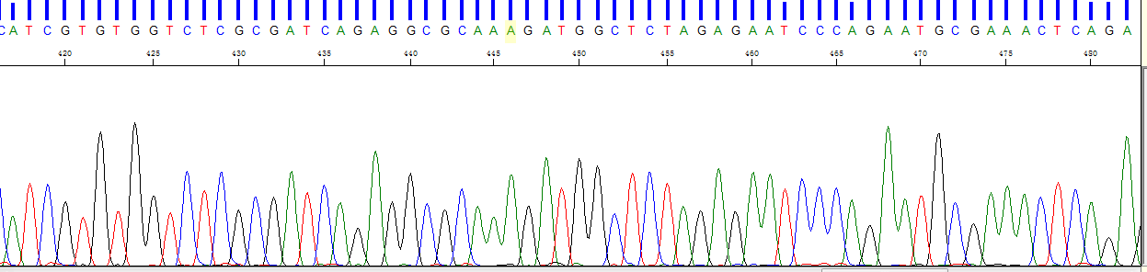

DSD01-father, SRY,c.230_231insA,normal
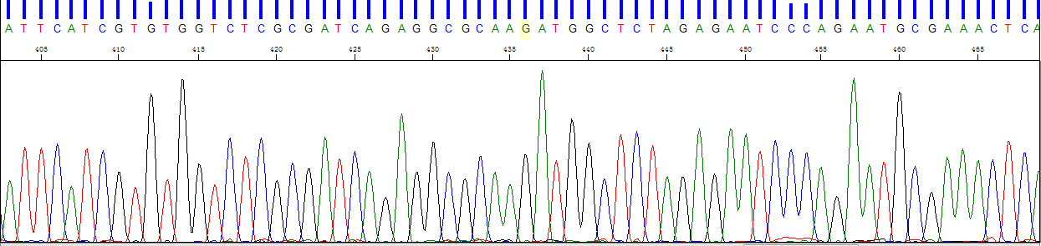

DSD01-brother, SRY,c.230_231insA,normal
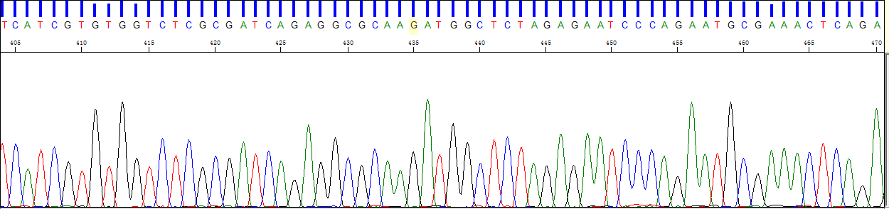

2.DSD09-1,AR,c.2158G>A,Hem
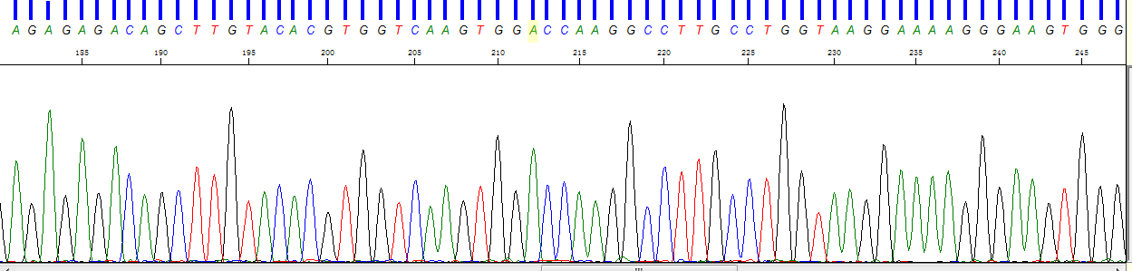

DSD09-2,AR,c.2158G>A,Hem
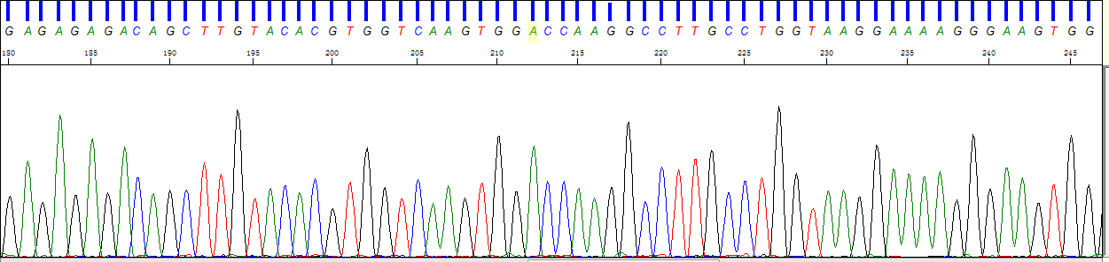

DSD09-Mother,AR,c.2158G>A,Het
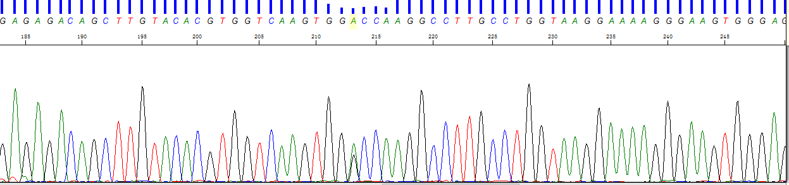

3.DSD18,AR,c.1825A>G,Hem
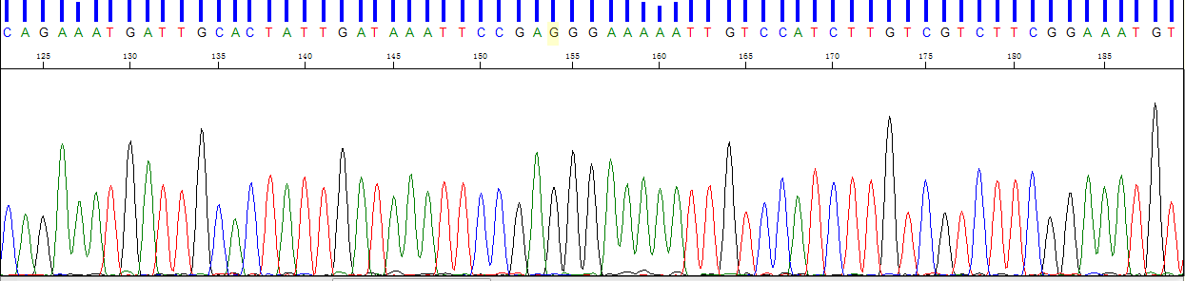

DSD18-Mother,AR,c.1825A>G,Het
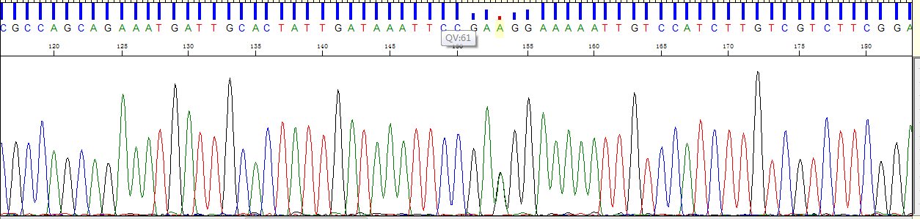
DSD18-Sister, AR,c.1825A>G,Het
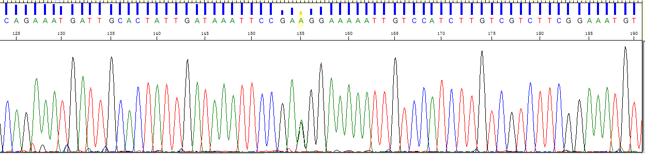
4.DSD20,AR,c.2057_2065dupTGTGTGCTG,Hem
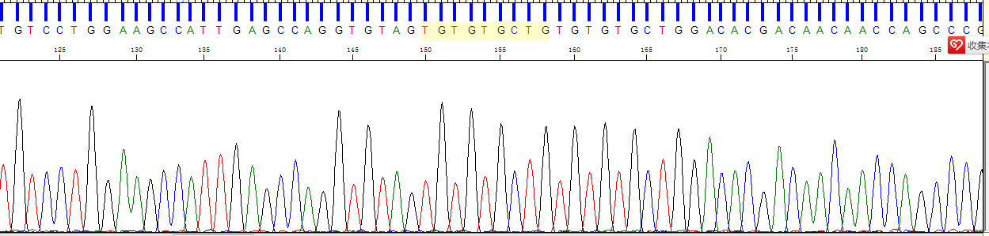

DSD20-Mother,AR,c.2057_2065dupTGTGTGCTG,Het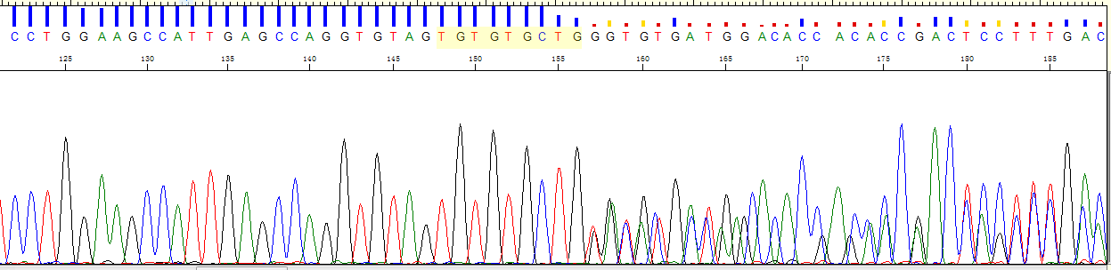

5.DSD04,CHD7 c.7389delA,Het
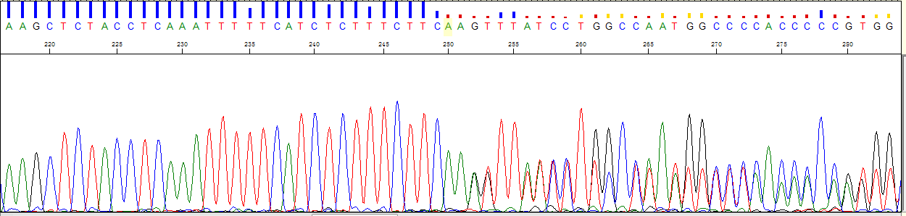
DSD04-father, CHD7 c.7389delA, normal
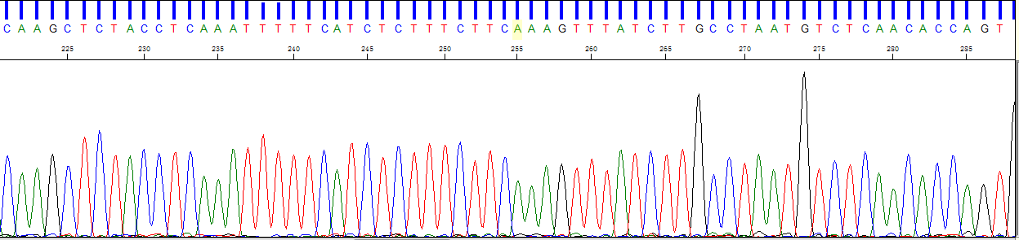

Part2 Sanger sequencing results of samples identified with previous repored mutations
1.DSD07,NR0B1,c.273C>G,Hem
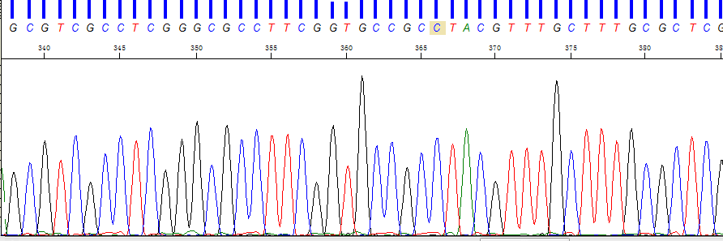

2.DSD13,CYP17A1,c.297+2T>C,Hom
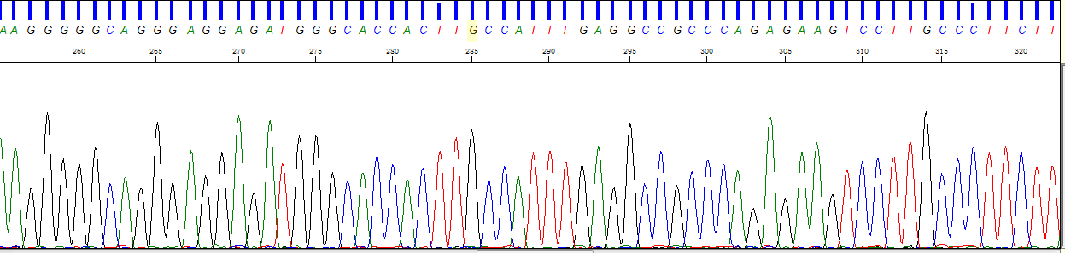

3.DSD14, AR ,c.2359C>T,Hem
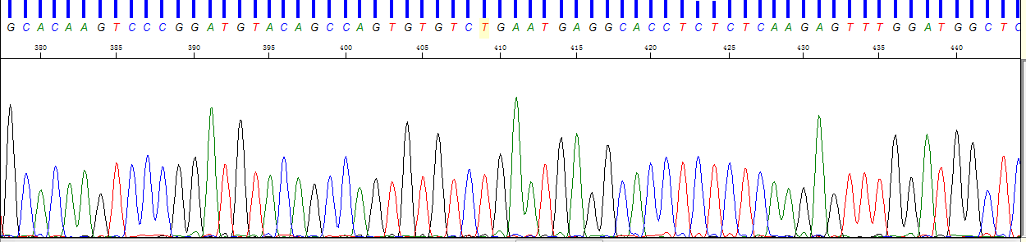

4.DSD17,AR,c.174_175insTAGCAGCAGCAGCAG,Hem
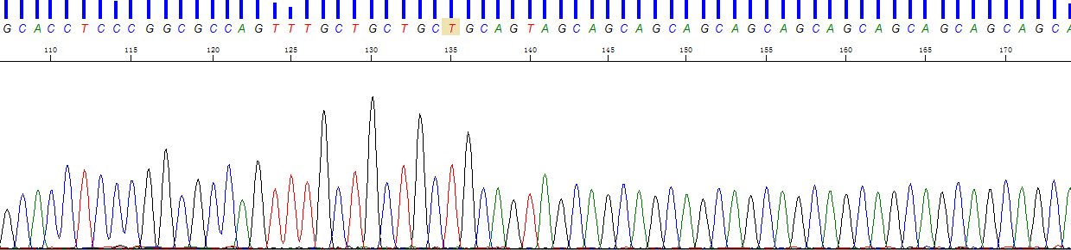

DSD17-Mother,AR,c.174_175insTAGCAGCAGCAGCAG,Het
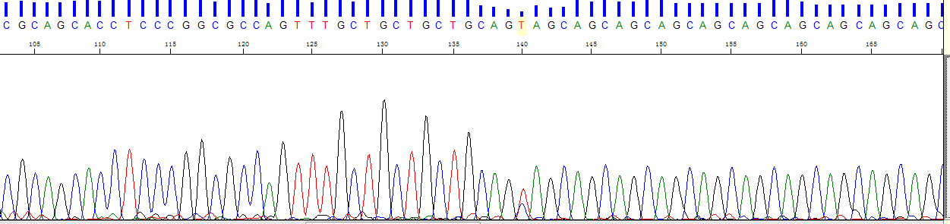

DSD17,NR5A1,c.1379A>T,Het
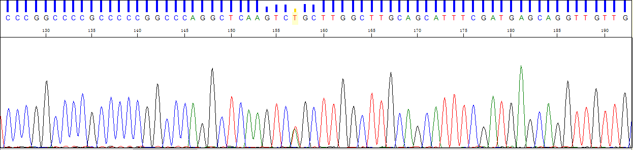

DSD17-Mother,NR5A1,c.1379A>T,Het
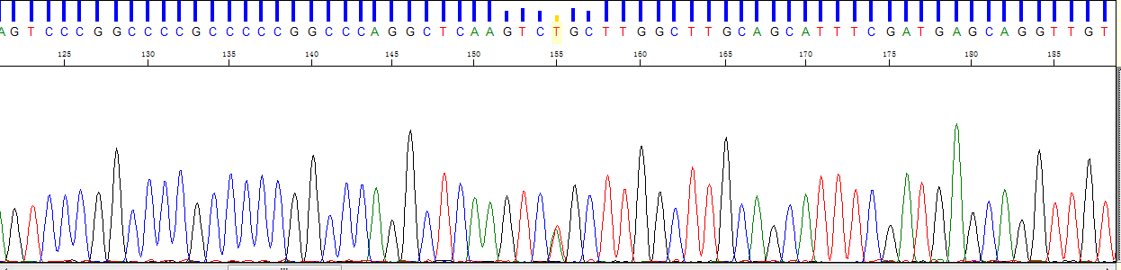

5.DSD21,SRD5A2,c.680G>A,Het
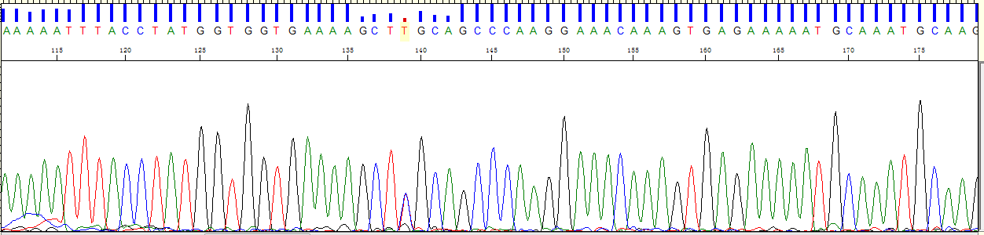

DSD21-Mother,SRD5A2,c.680G>A,Het


