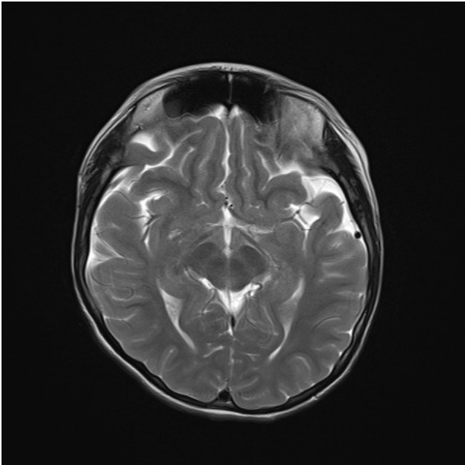
Figure S1. Brain MRI of the older sister. Axial T2 image of the older sister (II-2) showing relatively wide sulci and a mild cerebral atrophy.

