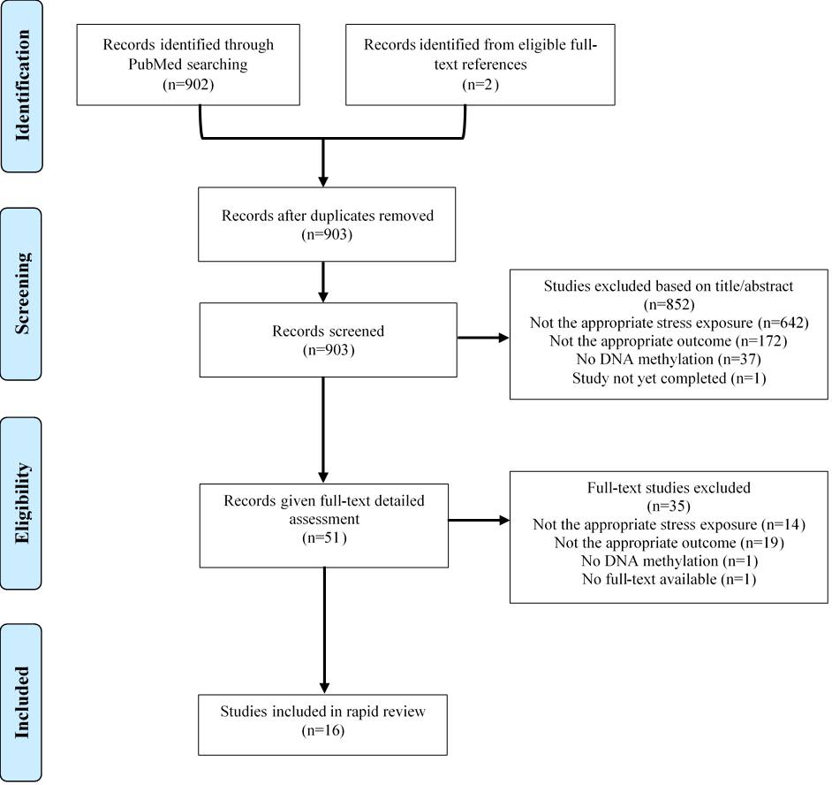

Figure S1. Flow diagram of study selection.

