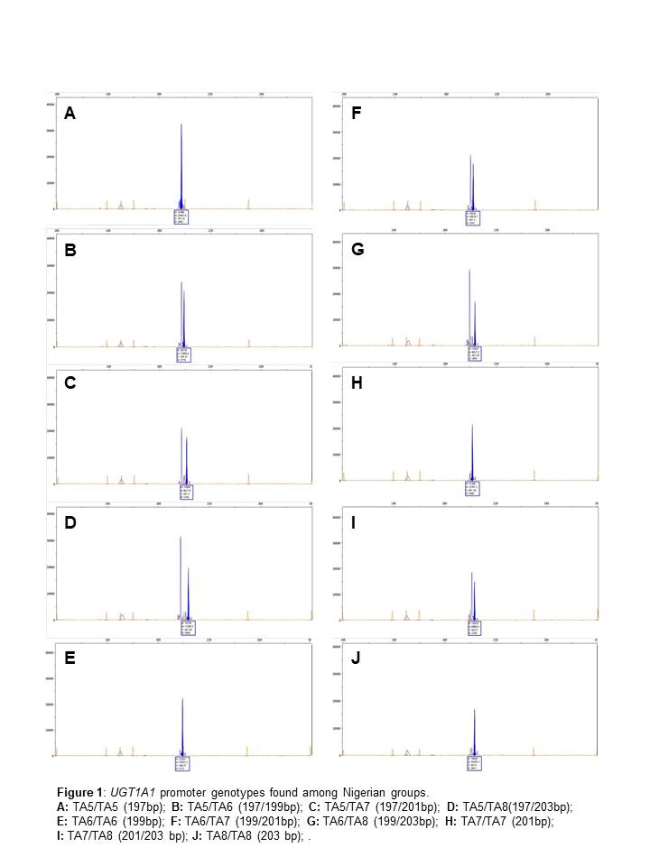
Figure S1. SUPPLEMENT MATERIAL FOR UGT1A1 POLYMORPHISM IN YOUNG NIGERIANS WITH SCA

