Additional file
Supplementary Figures 1: Distribution of Lp(a) (mg/dL) according to the genotypes for LPA rs10455872 and rs3798220
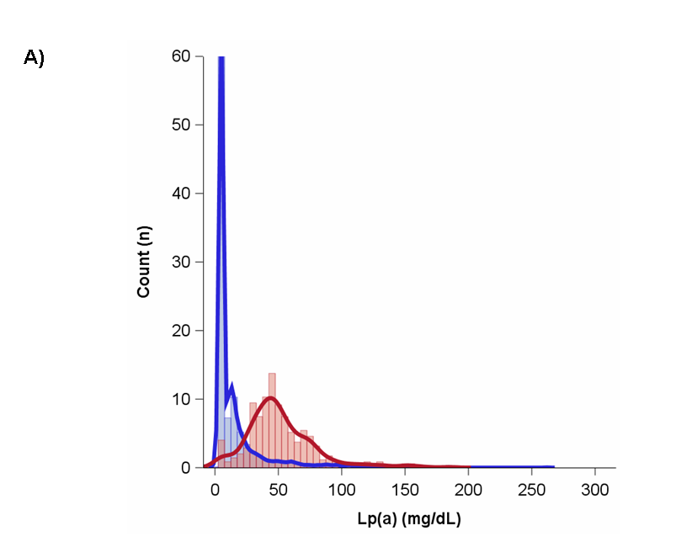
(A)
rs10455872
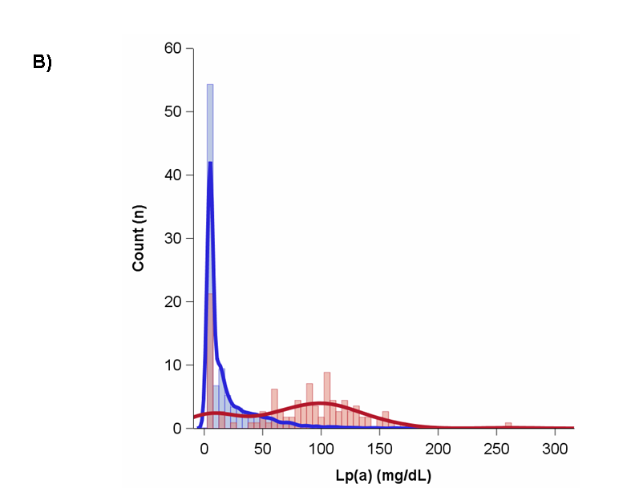
(B)
rs3798220

Supplementary Figures 1 (A) and (B): Distribution of Lp(a) (mg/dL) according to the genotypes for LPA (A) rs10455872 and (B) rs3798220. The blue and red curves are AA and AB or BB genotypes respectively. The genotypes are as follows rs10455872: AA=AA; AB or BB=AG+GG and rs3798220: AA=TT; AB or BB=TC+CC.

Supplementary Figures 2: Distribution of CAC (log(CAC+1)) in strata of Lp(a) according to the genotypes for SNPs rs10455872, rs3798220 and rs13415097

(A) 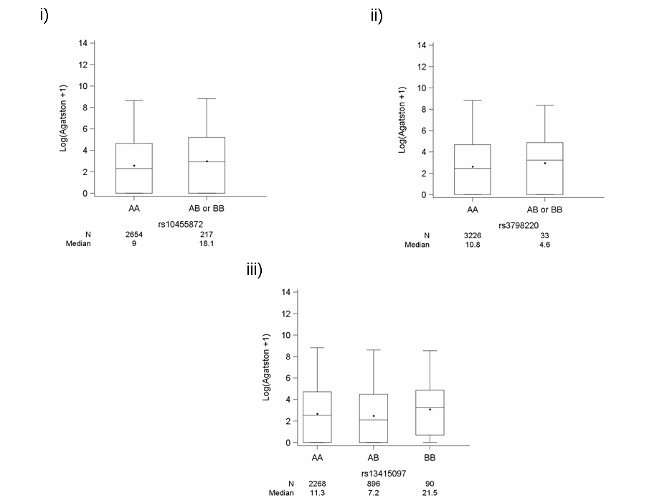

(B) 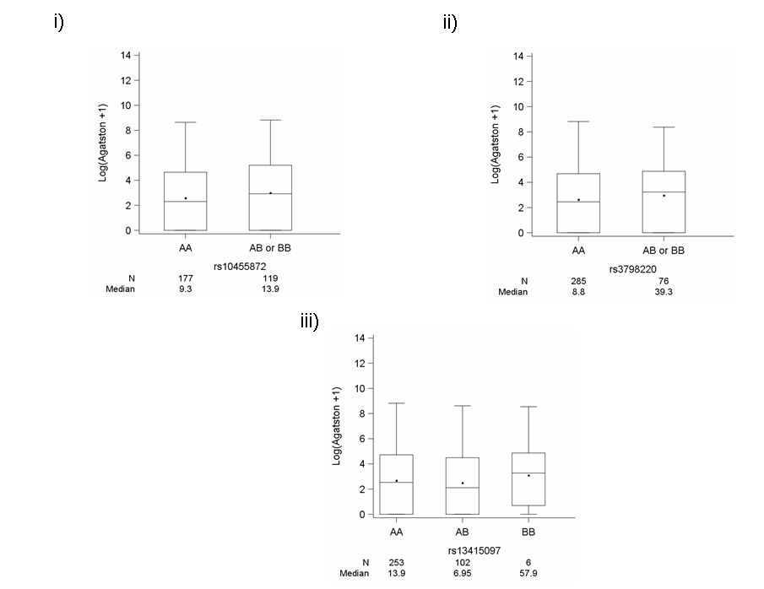

Supplementary Figures 2 (A) and (B): Distribution of CAC (log(CAC+1)) in strata of Lp(a); (A) Lp(a)<54.3 mg/dL and (B) Lp(a) ≥54.3 mg/dL; according to the genotypes (increase in the risk allele) for SNPs i) rs10455872, ii) rs3798220 and iii) rs13415097. The genotypes are as follows rs10455872: AA=AA; AB or BB=AG+GG, rs3798220: AA=TT; AB or BB=TC+CC and rs13415097: AA=TT; AB=TC; BB=CC. N denotes the number of participants and median is the median value of CAC score (Agatston units).

Supplementary Figure 3: Association between log-transformed Lp(a) with log(CAC+1) in an unadjusted model.

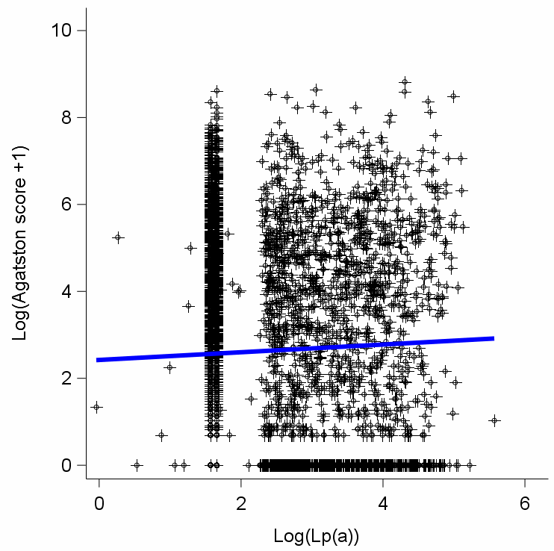
Log(Agatston score+1)= 2.42 +
0.09 * Log(Lp(a))

Supplementary Figure 4: Association between Lp(a) and CAC score (Agatston) in quantiles of CAC in an unadjusted model.

