Confirmation of variant using Sanger sequencing

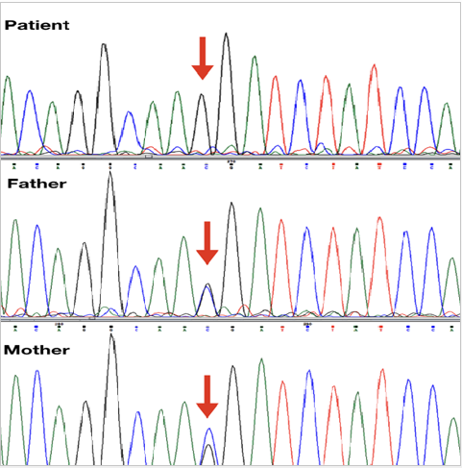
Figure S.2. sequencing chromatograms of the proband and her parents

