Interaction of residue located at position 314 with the surrounding residues

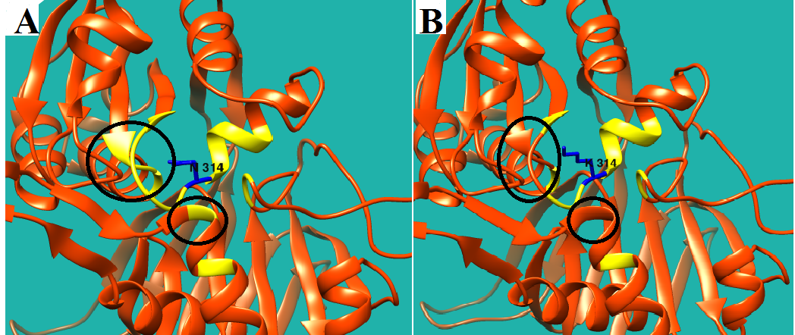
Figure S.3. The interaction of the residue located at position 314 with the surrounding residues is shown in yellow. A. Asparagine (Wild Type residue) and B. Lysine (mutant residue). The difference between the interaction of the wild type and the mutant residues is illustrated using black ellipses.

