H-bonds formed by wild type and mutant residues
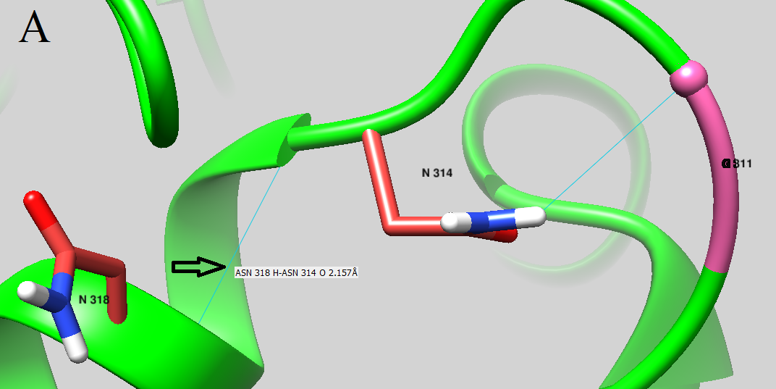
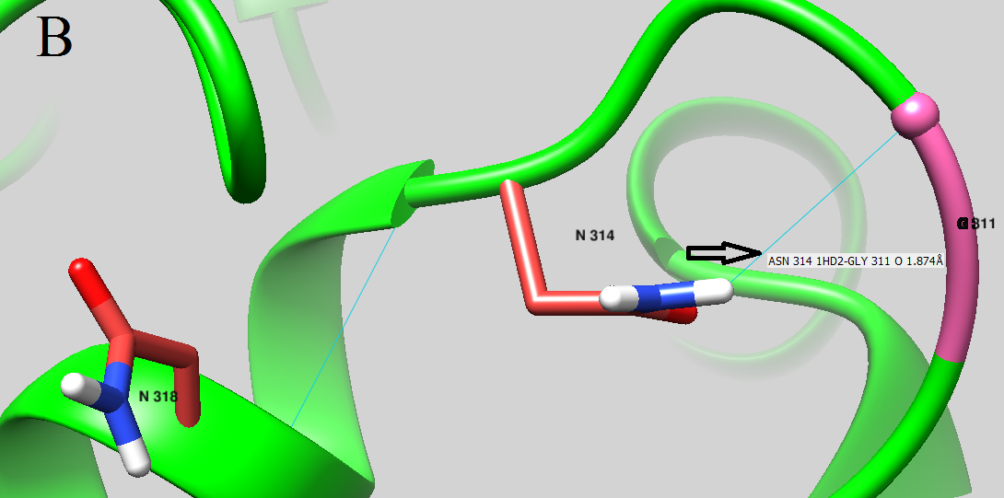
Figure S.4-1. A. H-bonds formed by Asn314 and Asn318 B. H-bonds formed by Asn314 and Gly311. Wild type residue formed H-bonds with two residues located at N-terminal (G311) and C-terminal (N318).

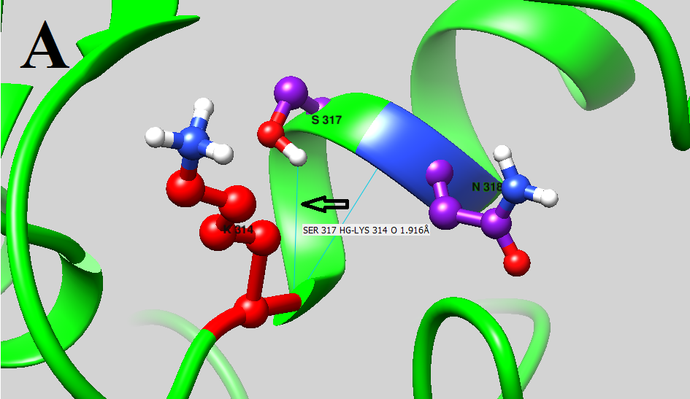
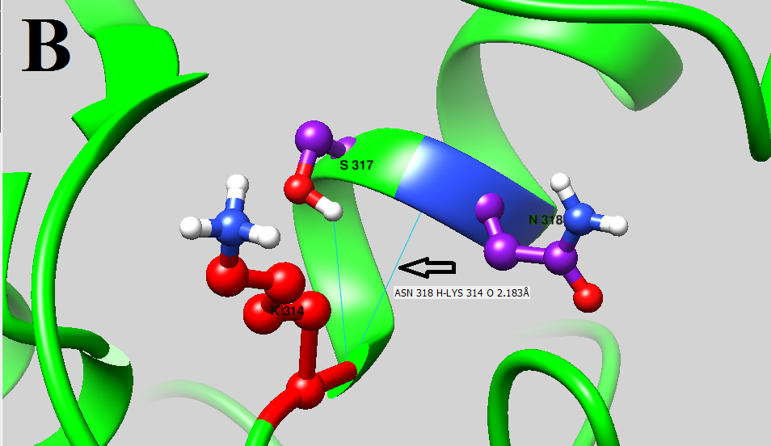
Figure S.4-2 A. H-bonds formed by Lys314 and Ser317 B. H-bond formed by Lys314 and Asn318. Mutant residue formed H-bonds with 2 residues located at C-terminal (S317 and N318).

