The distances between Thr 312 and Asp 315 (pocket amino acids located on the sides of position 314)
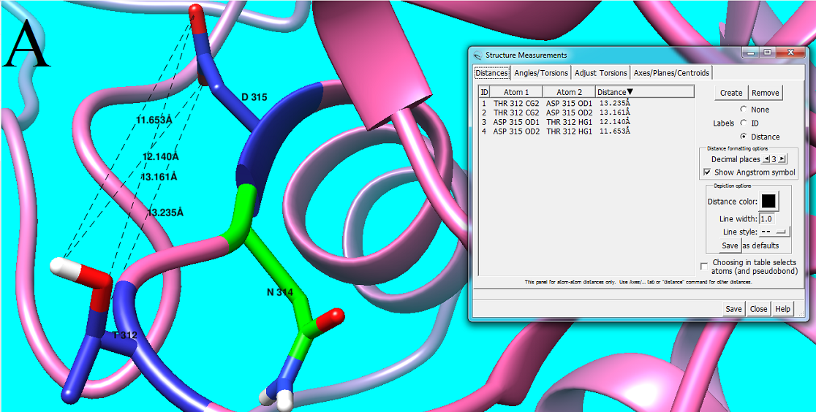

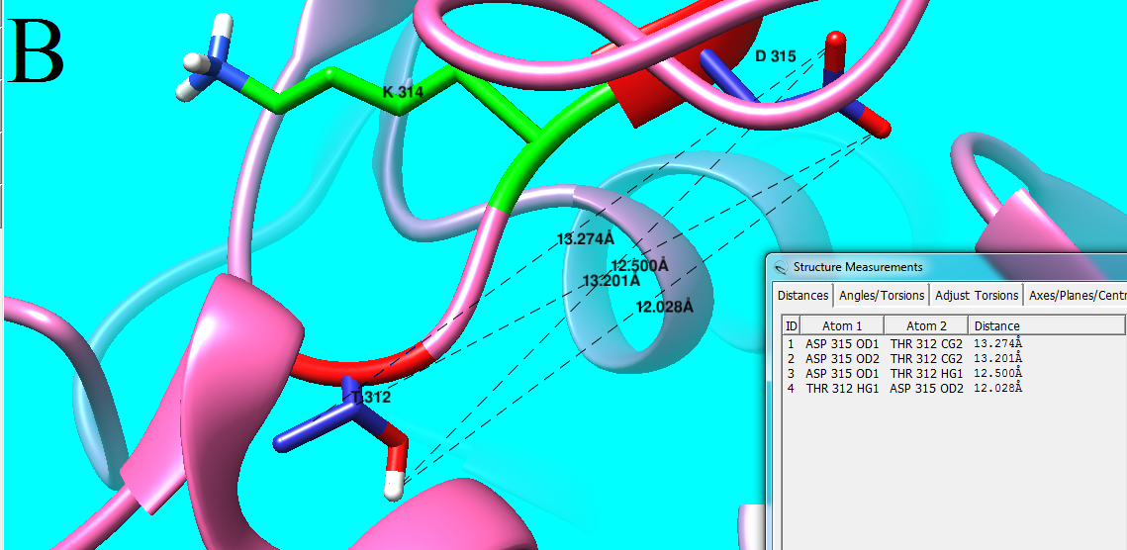
Figure S.5.A. Wild type residue (Asn) is located at position 314. B. Mutant residue (Lys) is located at position 314.
The distances, after replacement of asparagine with lysine, increased. As Thr312, Gly313 and Asp315 are pocket amino acids, increased distances may affect the interaction between enzyme and substrate.

