Additional file 4. Gout

Additional file 4.1. Data used for pooling effects of ABCG2 and SLC2A9 polymorphisms on gout
ABCG2 rs2231142
Author |  | Year | Gout |  |  |  |  |  |  |  |  |  | Control |  |  |  |  |  |  | HWE |  | AA/CC |  |  | CA/CC
 |  | Year | No. of subjects | Genotype |  |  |  |  |  |  |  |  | No. of subjects | Genotype |  |  |  |  |  | p-value |  | OR₁ | 95% CI |  | OR₂ |  | 95% CI
 |  | Year | No. of subjects | CC |  |  | CA |  |  | AA |  |  | No. of subjects | CC | CA |  | AA
Caucasians
Stark K. |  | 2009 | 677 | 500 |  |  | 168 |  |  | 9 |  |  | 1552 | 1241 | 299 |  | 12 |  |  | 0.191 |  | 1.86 | 0.78, 4.45 |  | 1.39 |  | 1.12, 1.73
Woodward OM. |  | 2009 | 455 | 327 |  |  | 118 |  |  | 10 |  |  | 8034 | 6465 | 1483 |  | 86 |  |  | 0.926 |  | 2.30 | 1.18, 4.47 |  | 1.57 |  | 1.27, 1.96
Oetjens MT. |  | 2016 | 363 | 250 |  |  | 102 |  |  | 11 |  |  | 5528 | 4379 | 1082 |  | 67 |  |  | 0.986 |  | 2.88 | 1.50, 5.51 |  | 1.65 |  | 1.30, 2.10
Phipps-Green AJ. |  | 2016 | 638 | 392 |  |  | 209 |  |  | 37 |  |  | 1541 | 1169 | 352 |  | 20 |  |  | 0.258 |  | 5.52 | 3.16, 9.62 |  | 1.77 |  | 1.44, 2.18
Stiburkova B. |  | 2017 | 145 | 84 |  |  | 55 |  |  | 6 |  |  | 115 | 86 | 13 |  | 1 |  |  | 0.433 |  | 6.14 | 0.72, 52.12 |  | 4.33 |  | 2.21, 8.51
Pooled OR |  |  |  |  |  |  |  |  |  |  |  |  |  |  |  |  |  |  |  |  |  | 3.24 | 2.39, 4.41 |  | 1.64 |  | 1.47, 1.82
Asians
Matsuo H.ª |  | 2009 | 159 | 41 |  |  | 87 |  |  | 31 |  |  | 865 | 462 | 316 |  | 87 |  |  | 0.003 |  | 4.02 | 2.39, 6.75 |  | 3.10 |  | 2.08, 4.62
Wang B. |  | 2010 | 200 | 64 |  |  | 91 |  |  | 45 |  |  | 235 | 103 | 112 |  | 20 |  |  | 0.172 |  | 3.62 | 1.96, 6.68 |  | 1.31 |  | 0.86, 1.98
Yamagishi K. |  | 2010 | 45 | 15 |  |  | 18 |  |  | 12 |  |  | 3878 | 1846 | 1655 |  | 377 |  |  | 0.829 |  | 3.92 | 1.82, 8.44 |  | 1.34 |  | 0.67, 2.66
Urano W. |  | 2013 | 153 | 46 |  |  | 76 |  |  | 31 |  |  | 532 | 275 | 215 |  | 42 |  |  | 0.998 |  | 4.41 | 2.52, 7.72 |  | 2.11 |  | 1.41, 3.18
Tu HP._1 |  | 2014 | 254 | 61 |  |  | 104 |  |  | 89 |  |  | 446 | 217 | 180 |  | 49 |  |  | 0.210 |  | 6.46 | 4.12, 10.13 |  | 2.06 |  | 1.42, 2.98
Tu HP._2 |  | 2014 | 533 | 128 |  |  | 230 |  |  | 175 |  |  | 1105 | 364 | 518 |  | 223 |  |  | 0.119 |  | 2.23 | 1.68, 2.96 |  | 1.26 |  | 0.98, 1.63
Wang Q. |  | 2014 | 185 | 64 |  |  | 86 |  |  | 35 |  |  | 311 | 157 | 126 |  | 28 |  |  | 0.707 |  | 3.07 | 1.72, 5.45 |  | 1.67 |  | 1.12, 2.50
Zhou D. |  | 2014 | 352 | 87 |  |  | 181 |  |  | 84 |  |  | 350 | 167 | 150 |  | 33 |  |  | 0.935 |  | 4.89 | 3.03, 7.89 |  | 2.32 |  | 1.65, 3.25
Kim YS. |  | 2015 | 109 | 26 |  |  | 51 |  |  | 32 |  |  | 102 | 53 | 44 |  | 5 |  |  | 0.275 |  | 13.05 | 4.55, 37.39 |  | 2.36 |  | 1.27, 4.39
Wan W. |  | 2015 | 97 | 22 |  |  | 49 |  |  | 26 |  |  | 101 | 54 | 38 |  | 9 |  |  | 0.539 |  | 7.09 | 2.87, 17.54 |  | 3.17 |  | 1.65, 6.08
Jiri M. |  | 2016 | 143 | 71 |  |  | 59 |  |  | 12 |  |  | 310 | 154 | 129 |  | 27 |  |  | 0.998 |  | 0.96 | 0.46, 2.01 |  | 0.99 |  | 0.65, 1.51
Matsuo H. |  | 2016 | 1193 | 581 |  |  | 990 |  |  | 422 |  |  | 1334 | 711 | 526 |  | 97 |  |  | 0.983 |  | 5.32 | 4.16, 6.81 |  | 2.30 |  | 1.98, 2.68
Zheng C. |  | 2016 | 155 | 34 |  |  | 77 |  |  | 44 |  |  | 140 | 59 | 62 |  | 19 |  |  | 0.674 |  | 4.02 | 2.03, 7.96 |  | 2.16 |  | 1.26, 3.69
Higashino T. |  | 2017 | 477 | 152 |  |  | 233 |  |  | 92 |  |  | 480 | 262 | 185 |  | 33 |  |  | 0.965 |  | 4.81 | 3.08, 7.50 |  | 2.17 |  | 1.64, 2.87
Li Z. |  | 2017 | 1255 | 319 |  |  | 627 |  |  | 309 |  |  | 1848 | 882 | 789 |  | 177 |  |  | 0.977 |  | 4.83 | 3.86, 6.04 |  | 2.20 |  | 1.86, 2.59
Yu KH. |  | 2017 | 210 | 36 |  |  | 102 |  |  | 72 |  |  | 123 | 60 | 52 |  | 11 |  |  | 0.956 |  | 10.91 | 5.12, 23.26 |  | 3.27 |  | 1.92, 5.56
Chen CJ. |  | 2018 | 747 | 193 |  |  | 385 |  |  | 169 |  |  | 2070 | 1088 | 812 |  | 170 |  |  | 0.287 |  | 5.60 | 4.31, 7.28 |  | 2.67 |  | 2.20, 3.25
Pooled OR |  |  |  |  |  |  |  |  |  |  |  |  |  |  |  |  |  |  |  |  |  | 4.53 | 4.10, 5.00 |  | 2.10 |  | 1.95, 2.26
Africans
Oetjens MT. |  | 2016 | 64 | 60 |  |  | 4 |  |  | 0 |  |  | 617 | 580 | 36 |  | 1 |  |  | 0.444 |  | 3.20 | 0.13, 79.37 |  | 1.07 |  | 0.37, 3.12
Polynesians
Phipps-Green AJ. |  | 2016 | 876 | 494 |  |  | 288 |  |  | 94 |  |  | 1081 | 824 | 229 |  | 28 |  |  | 0.014 |  | 5.60 | 3.62, 8.66 |  | 2.10 |  | 1.71, 2.58
ABCG2 rs72552713
Author |  | Year | Gout |  |  |  |  |  |  |  |  |  | Control |  |  |  |  |  |  | HWE | TT/CC |  |  |  | CT/CC
 |  | Year | No. of subjects | Genotype |  |  |  |  |  |  |  |  | No. of subjects | Genotype |  |  |  |  |  | p-value | OR₁ |  |  | 95% CI | OR₂ |  | 95% CI
 |  | Year | No. of subjects | CC |  |  | CT |  |  | TT |  |  | No. of subjects | CC | CT |  | TT
Asians
Matsuo H. |  | 2009 | 161 | 139 |  |  | 21 |  |  | 1 |  |  | 871 | 840 | 31 |  | 0 |  |  | 1.000 | 18.08 |  |  | 0.73, 445.93 | 4.11 |  | 2.31, 7.32
Urano W. |  | 2013 | 153 | 138 |  |  | 15 |  |  | 0 |  |  | 532 | 511 | 21 |  | 0 |  |  | 1.000 | 3.69 |  |  | 0.07, 186.96 | 2.66 |  | 1.35, 5.25
Tu HP._1 |  | 2014 | 254 | 250 |  |  | 4 |  |  | 0 |  |  | 446 | 445 | 1 |  | 0 |  |  | 1.000 | 1.78 |  |  | 0.04, 89.90 | 5.34 |  | 0.84, 34.08
Tu HP._2 |  | 2014 | 533 | 533 |  |  | 0 |  |  | 0 |  |  | 1105 | 1105 | 0 |  | 0 |  |  | 1.000 | 2.07 |  |  | 0.04, 104.57 | 2.07 |  | 0.04, 104.57
Zhou D. |  | 2014 | 352 | 319 |  |  | 33 |  |  | 0 |  |  | 350 | 338 | 12 |  | 0 |  |  | 1.000 | 1.06 |  |  | 0.02, 53.55 | 2.84 |  | 1.46, 5.53
Matsuo H. |  | 2016 | 1993 | 1802 |  |  | 186 |  |  | 5 |  |  | 1334 | 1273 | 60 |  | 1 |  |  | 0.516 | 3.53 |  |  | 0.41, 30.27 | 2.19 |  | 1.62, 2.96
Higashino T. |  | 2017 | 478 | 423 |  |  | 53 |  |  | 2 |  |  | 478 | 455 | 23 |  | 0 |  |  | 1.000 | 5.38 |  |  | 0.26, 112.34 | 2.45 |  | 1.48, 4.05
Li Z. |  | 2017 | 1255 | 1233 |  |  | 22 |  |  | 0 |  |  | 1848 | 1830 | 18 |  | 0 |  |  | 1.000 | 1.48 |  |  | 0.03, 74.84 | 1.80 |  | 0.97, 3.35
Pooled OR |  |  |  |  |  |  |  |  |  |  |  |  |  |  |  |  |  |  |  |  | 3.86 |  |  | 2.30, 9.76 | 2.46 |  | 1.93, 3.18
 | ABCG2 rs2231137
Author |  | Year | Gout |  |  |  |  |  |  |  | Control |  |  |  |  |  |  |  |  | HWE |  | AA/GG |  |  |  | GA/GG
 |  | Year | No. of subjects | Genotype |  |  |  |  |  |  | No. of subjects |  |  | Genotype |  |  |  |  |  | p-value |  | OR₁ | 95% CI |  |  | OR₂ | 95% CI
 |  | Year | No. of subjects | GG | GA |  |  | AA |  |  |  |  |  | GG |  | GA |  | AA
Asians
Matsuo H. |  | 2009 | 158 | 112 |  | 43 |  |  | 3 |  |  | 862 |  | 526 |  | 306 |  |  | 30 | 0.072 |  | 0.47 | 0.14, 1.57 |  |  | 0.66 | 0.45, 0.96
Tu HP._1 |  | 2014 | 254 | 131 | 101 |  |  | 22 |  |  | 446 |  |  | 199 |  | 184 |  |  | 63 | 0.057 |  | 0.53 | 0.31, 0.90 |  |  | 0.83 | 0.60, 1.16
Tu HP._2 |  | 2014 | 533 | 299 | 195 |  |  | 39 |  |  | 1105 |  |  | 518 |  | 471 |  |  | 116 | 0.561 |  | 0.58 | 0.39, 0.86 |  |  | 0.72 | 0.58, 0.89
Zhou D. |  | 2014 | 352 | 239 | 97 |  |  | 16 |  |  | 350 |  |  | 182 |  | 133 |  |  | 35 | 0.149 |  | 0.35 | 0.19, 0.65 |  |  | 0.56 | 0.40, 0.77
Higashino T. |  | 2017 | 479 | 361 | 109 |  |  | 9 |  |  | 479 |  |  | 299 |  | 159 |  |  | 21 | 0.981 |  | 0.35 | 0.16, 0.79 |  |  | 0.57 | 0.43, 0.76
Yu KH. |  | 2017 | 210 | 143 | 61 |  |  | 6 |  |  | 123 |  |  | 47 |  | 58 |  |  | 18 | 0.988 |  | 0.11 | 0.04, 0.29 |  |  | 0.35 | 0.16, 0.79
Pooled OR |  |  |  |  |  |  |  |  |  |  |  |  |  |  |  |  |  |  |  |  |  | 0.43 | 0.34, 0.55 |  |  | 0.64 | 0.56, 0.72
Caucasians
Stiburkova B. |  | 2017 | 145 | 138 | 7 |  |  | 0 |  |  | 100 |  |  | 97 |  | 3 |  |  | 0 | 1.000 |  | 0.70 | 0.01, 35.78 |  | 1.51 |  | 0.41, 5.51
 | SLC2A9 rs1014290
Author |  | Year | Gout |  |  |  | Control |  |  |  | HWE | CC/TT |  | TC/TT
 |  | Year | No. of subjects | Genotype |  |  | No. of subjects | Genotype |  |  | p-value | OR₁ | 95% CI | OR₂ | 95% CI
 |  | Year | No. of subjects | TT | TC | CC | No. of subjects | TT | TC | CC
Caucasians
Vitart V. |  | 2008
- Croatia |  |  | 57 | 31 | 22 | 4 | 440 | 210 | 188 | 42 | 0.994 | 0.65 | 0.22, 1.92 | 0.79 | 0.44, 1.42
- Germany |  | 2008 | 148 | 97 | 46 | 5 | 231 | 137 | 82 | 12 | 0.953 | 0.59 | 0.20, 1.73 | 0.79 | 0.51, 1.24
- Scotland  (Go-DARTS) |  | 2008 | 484 | 325 | 143 | 16 | 9659 | 5727 | 3421 | 511 | 0.997 | 0.55 | 0.33, 0.92 | 0.74 | 0.60, 0.90
Pooled OR |  |  |  |  |  |  |  |  |  |  |  | 0.57 | 0.37, 0.87 | 0.75 | 0.63, 0.89
Asians
Urano W. |  | 2010 | 177 | 90 | 72 | 15 | 577 | 204 | 279 | 94 | 0.932 | 0.36 | 0.20, 0.66 | 0.58 | 0.41, 0.84
Liu WC. |  | 2011 | 61 | 28 | 24 | 9 | 942 | 296 | 489 | 157 | 0.060 | 0.61 | 0.28, 1.32 | 0.52 | 0.30, 0.89
Tu HP. |  | 2016 | 157 | 82 | 66 | 9 | 295 | 101 | 138 | 56 | 0.469 | 0.20 | 0.09, 0.42 | 0.59 | 0.39, 0.89
Nakayama A. |  | 2017
- GWAS |  |  | 945 | 434 | 413 | 98 | 1213 | 386 | 596 | 231 | 0.972 | 0.38 | 0.29, 0.50 | 0.62 | 0.51, 0.74
- Replica-tion |  |  | 1396 | 632 | 615 | 149 | 1268 | 421 | 619 | 228 | 0.986 | 0.44 | 0.34, 0.55 | 0.66 | 0.56, 0.78
Tu HP. |  | 2018 | 373 | 181 | 158 | 34 | 305 | 136 | 137 | 32 | 0.773 | 0.80 | 0.47, 1.36 | 0.87 | 0.63, 1.19
Pooled OR |  |  |  |  |  |  |  |  |  |  |  | 0.42 | 0.36, 0.49 | 0.65 | 0.58, 0.72
Solomon Islanders
Tu HP. |  | 2010 | 69 | 31 | 32 | 6 | 168 | 68 | 78 | 22 | 0.960 | 0.60 | 0.22, 1.62 | 0.90 | 0.50, 1.63
SLC2A9 rs3733591
Author | Year | Gout |  |  |  | Control |  |  |  | HWE | CC/TT |  | TC/TT
Author | Year | No. of subjects | Genotype |  |  | No. of subjects | Genotype |  |  | p-value | OR₁ | 95% CI | OR₂ | 95% CI
Author | Year | No. of subjects | TT | TC | CC | No. of subjects | TT | TC | CC
Caucasians
Hollis-Moffatt JE. | 2011
- ARIC |  | 153 | 6 | 30 | 117 | 6968 | 168 | 1898 | 4902 | 0.325 | 0.67 | 0.29, 1.54 | 0.44 | 0.18, 1.08
- FHS |  | 67 | 2 | 21 | 44 | 4712 | 169 | 1385 | 3158 | 0.263 | 1.18 | 0.28, 4.90 | 1.28 | 0.30, 5.51
- NZ |  | 313 | 9 | 87 | 217 | 636 | 23 | 196 | 417 | 0.996 | 1.33 | 0.60, 2.92 | 1.13 | 0.50, 2.55
Pooled OR |  |  |  |  |  |  |  |  |  |  | 1.03 | 0.60, 1.79 | 0.85 | 0.48, 1.50
Asians
Tu HP. | 2010 | 109 | 35 | 50 | 24 | 191 | 85 | 91 | 15 | 0.164 | 3.89 | 1.83, 8.27 | 1.33 | 0.79, 2.25
Urano W. | 2010 | 178 | 58 | 93 | 27 | 576 | 268 | 252 | 56 | 0.771 | 2.23 | 1.30, 3.82 | 1.71 | 1.18, 2.47
Mahfudzah A. | 2015 | 82 | 69 | 12 | 1 | 78 | 74 | 4 | 0 | 1.000 | 3.22 | 0.13, 80.27 | 3.22 | 0.99, 10.45
Wan W. | 2015 | 97 | 36 | 49 | 12 | 100 | 45 | 46 | 9 | 0.569 | 1.67 | 0.63, 4.39 | 1.33 | 0.73, 2.41
Zheng C. | 2016 | 163 | 42 | 95 | 26 | 187 | 61 | 99 | 27 | 0.194 | 1.40 | 0.72, 2.72 | 1.39 | 0.86, 2.26
Tu HP. | 2018 | 373 | 150 | 183 | 40 | 305 | 113 | 152 | 40 | 0.317 | 0.75 | 0.46, 1.24 | 0.91 | 0.66, 1.26
Pooled OR |  |  |  |  |  |  |  |  |  |  | 1.55 | 1.17, 2.06 | 1.29 | 1.07, 1.55
Solomon Islanders
Tu HP. | 2010 | 69 | 23 | 28 | 18 | 168 | 62 | 75 | 31 | 0.327 | 1.57 | 0.74, 3.32 | 1.01 | 0.53, 1.92
Polynesians
Hollis-Moffatt JE. | 2011 | 606 | 84 | 263 | 259 | 800 | 100 | 334 | 366 | 0.083 | 0.84 | 0.61, 1.17 | 0.94 | 0.67, 1.31
SLC2A9 rs6449213
Author |  | Year |  |  |  | Gout |  |  |  |  |  |  |  | Control |  |  |  |  |  |  |  | HWE |  | CC/TT |  | TC/TT
 |  |  |  |  |  | No. of subjects |  | Genotype |  |  |  |  |  | No. of subjects |  | Genotype |  |  |  |  |  | p-value |  | OR₁ | 95% CI | OR₂ | 95% CI
 |  |  |  |  |  |  |  | TT |  | TC |  | CC |  |  |  | TT |  | TC |  | CC
Caucasians
Doring A. |  | 2008
- KORA |  |  |  |  |  | 557 |  | 305 |  | 214 |  | 38 |  | 5249 |  | 2110 |  | 2436 |  | 703 |  | 0.998 |  | 0.37 | 0.26, 0.53 | 0.61 | 0.51, 0.73
Vitart V. |  | 2008
- Croatia |  |  |  |  |  | 57 |  | 35 |  | 19 |  | 3 |  | 440 |  | 248 |  | 165 |  | 27 |  | 0.949 |  | 0.79 | 0.23, 2.73 | 0.82 | 0.45, 1.48
- Germany |  |  |  |  |  | 148 |  | 112 |  | 33 |  | 3 |  | 231 |  | 152 |  | 71 |  | 8 |  | 0.934 |  | 0.51 | 0.13, 1.96 | 0.63 | 0.39, 1.02
- Scotland  (Go-DARTS) |  |  |  |  |  | 484 |  | 358 |  | 117 |  | 9 |  | 9659 |  | 6495 |  | 2851 |  | 313 |  | 0.995 |  | 0.52 | 0.27, 1.02 | 0.74 | 0.60, 0.92
Stark K. |  | 2008 |  |  |  | 656 |  | 469 |  | 181 |  | 6 |  | 660 |  | 421 |  | 207 |  | 32 |  | 0.319 |  | 0.17 | 0.07, 0.41 | 0.78 | 0.62, 1.00
Pooled OR |  |  |  |  |  |  |  |  |  |  |  |  |  |  |  |  |  |  |  |  |  |  |  | 0.38 | 0.29, 0.50 | 0.69 | 0.62, 0.78
Asians
Urano W. |  | 2010 |  |  |  | 179 |  | 176 |  | 3 |  | 0 |  | 576 |  | 566 |  | 9 |  | 1 |  | 0.047 |  | 1.07 | 0.04, 26.38 | 1.18 | 0.34, 4.07
Kim YS. |  | 2015 |  |  |  | 109 |  | 107 |  | 2 |  | 0 |  | 102 |  | 101 |  | 1 |  | 0 |  | 1.000 |  | 0.94 | 0.02, 48.03 | 1.57 | 0.20, 12.13
SLC2A9 rs16890979
Author |  |  |  | Year |  |  | Gout |  |  |  |  |  |  |  | Control |  |  |  |  |  |  |  | HWE | TT/CC |  | CT/CC
 |  |  |  |  |  |  | No. of subjects |  | Genotype |  |  |  |  |  | No. of subjects |  | Genotype |  |  |  |  |  | p-value | OR₁ | 95% CI | OR₂ | 95% CI
 |  |  |  |  |  |  |  |  | CC |  | CT |  | TT |  |  |  | CC |  | CT |  | TT
Caucasians
Hollis-Moffatt JE. |  |  | 2009 |  |  |  | 131 |  | 103 |  | 24 |  | 4 |  | 551 |  | 338 |  | 183 |  | 30 |  | 0.427 | 0.44 | 0.15, 1.27 | 0.43 | 0.27, 0.70
Asians
Urano W. |  |  |  | 2010 |  |  | 180 |  | 178 |  | 2 |  | 0 |  | 591 |  | 580 |  | 11 |  | 0 |  | 1.000 | 3.25 | 0.06, 164.48 | 0.71 | 0.18, 2.80
Kim YS. |  |  |  | 2015 |  |  | 109 |  | 109 |  | 0 |  | 0 |  | 102 |  | 100 |  | 2 |  | 0 |  | 1.000 | 0.92 | 0.02, 46.69 | 0.18 | 0.01, 3.87
Li Z. |  |  |  | 2017 |  |  | 1255 |  | 1228 |  | 27 |  | 0 |  | 1848 |  | 1785 |  | 62 |  | 1 |  | 0.426 | 0.48 | 0.02, 11.90 | 0.64 | 0.41, 1.01
Pooled OR |  |  |  |  |  |  |  |  |  |  |  |  |  |  |  |  |  |  |  |  |  |  |  | NA | NA | 0.60 | 0.39, 0.94
Polynesians
Hollis-Moffatt JE. |  |  |  | 2009 |  |  | 123 |  | 121 |  | 2 |  | 0 |  | 157 |  | 118 |  | 35 |  | 4 |  | 0.494 | 0.11 | 0.01, 2.04 | 0.07 | 0.02, 0.25
SLC2A9 rs6855911
Author | Year |  |  |  | Gout |  |  |  |  |  |  |  |  |  | Control |  |  |  |  |  |  |  | HWE | GG/AA |  | AG/AA
Author |  |  |  |  | No. of subjects |  |  |  | Genotype |  |  |  |  |  | No. of subjects |  | Genotype |  |  |  |  |  | p-value | OR₁ | 95% CI | OR₂ | 95% CI
Author |  |  |  |  |  |  |  |  | AA |  | AG |  | GG |  |  |  | AA |  | AG |  | GG
Caucasians
Doring A. | 2008
- KORA |  |  |  |  |  |  | 557 |  | 244 |  | 249 |  | 64 |  | 5249 |  | 1571 |  | 2601 |  | 1077 |  | 0.994 | 0.38 | 0.29, 0.51 | 0.62 | 0.51, 0.74
Stark K. | 2009 |  |  |  | 677 |  |  |  | 429 |  | 233 |  | 15 |  | 1546 |  | 829 |  | 603 |  | 114 |  | 0.763 | 0.25 | 0.15, 0.44 | 0.75 | 0.62, 0.90
Pooled OR |  |  |  |  |  |  |  |  |  |  |  |  |  |  |  |  |  |  |  |  |  |  |  | 0.36 | 0.28, 0.46 | 0.67 | 0.59, 0.77
Asians
Urano W. | 2010 |  |  |  | 179 |  |  |  | 177 |  | 2 |  | 0 |  | 581 |  | 570 |  | 11 |  | 0 |  | 1.000 | 3.21 | 0.06, 162.57 | 0.70 | 0.18, 2.77
Guan M. | 2011 |  |  |  | 166 |  |  |  | 160 |  | 6 |  | 0 |  | 206 |  | 197 |  | 9 |  | 0 |  | 1.000 | 1.23 | 0.02, 62.36 | 0.84 | 0.30, 2.33
Zheng C. | 2016 |  |  |  | 163 |  |  |  | 125 |  | 33 |  | 5 |  | 187 |  | 135 |  | 43 |  | 9 |  | 0.055 | 0.60 | 0.20, 1.84 | 0.83 | 0.50, 1.39
Pooled OR |  |  |  |  |  |  |  |  |  |  |  |  |  |  |  |  |  |  |  |  |  |  |  | 0.61 | 0.20, 1.87 | 0.82 | 0.53, 1.27

SLC2A9 rs7442295
Author | Year | Gout |  |  |  | Control |  |  |  | HWE | GG/AA |  | AG/AA
Author | Year | No. of subjects | Genotype |  |  | No. of subjects | Genotype |  |  | p-value | OR₁ | 95% CI | OR₂ | 95% CI
Author | Year | No. of subjects | AA | AG | GG | No. of subjects | AA | AG | GG
Caucasians
Stark K. | 2008 | 658 | 449 | 200 | 9 | 659 | 389 | 230 | 40 | 0.443 | 0.19 | 0.09, 0.41 | 0.75 | 0.60, 0.95
Doring A. | 2008
- KORA |  | 557 | 274 | 233 | 50 | 5249 | 1877 | 2524 | 848 | 0.992 | 0.40 | 0.30, 0.55 | 0.63 | 0.53, 0.76
- SHIP |  | 260 | 140 | 102 | 18 | 3806 | 1449 | 1799 | 558 | 0.992 | 0.33 | 0.20, 0.55 | 0.59 | 0.45, 0.76
Pooled OR |  |  |  |  |  |  |  |  |  |  | 0.35 | 0.28, 0.46 | 0.65 | 0.57, 0.74
Asians
Urano W. | 2010 | 177 | 176 | 1 | 0 | 587 | 578 | 9 | 0 | 1.000 | 3.28 | 0.06, 165.78 | 0.52 | 0.09, 2.92
SLC2A9 rs12510549
Author | Year | Gout |  |  |  | Control |  |  |  | HWE | CC/TT |  | TC/TT
Author | Year | No. of subjects | Genotype |  |  | No. of subjects | Genotype |  |  | p-value | OR₁ | 95% CI | OR₂ | 95% CI
Author | Year | No. of subjects | TT | TC | CC | No. of subjects | TT | TC | CC
Caucasians
Doring A. | 2008
- KORA |  | 557 | 264 | 239 | 54 | 5249 | 1896 | 2517 | 836 | 0.989 | 0.46 | 0.34, 0.63 | 0.68 | 0.57, 0.82
Stark K. | 2008 | 660 | 459 | 192 | 9 | 656 | 392 | 238 | 26 | 0.170 | 0.30 | 0.14, 0.64 | 0.69 | 0.55, 0.87
Hollis-Moffatt JE. | 2009 | 130 | 100 | 26 | 4 | 563 | 350 | 192 | 21 | 0.396 | 0.67 | 0.22, 1.99 | 0.47 | 0.30, 0.76
Pooled OR |  |  |  |  |  |  |  |  |  |  | 0.44 | 0.34, 0.58 | 0.66 | 0.58, 0.76
Polynesians
Hollis-Moffatt JE. | 2009 | 119 | 112 | 7 | 0 | 163 | 141 | 22 | 0 | 1.000 | 1.26 | 0.02, 63.89 | 0.42 | 0.18, 0.99
ª Not included in pooling due to non-compliance with HWE.
ABCG2, ATP-binding cassette sub-family G member 2; ARIC, Atherosclerosis Risk in Communities; CI, confidence interval; FHS, Framingham Heart Study; Go-DARTS, Genetics of Diabetes Audit and Research Tayside Study; GWAS, genome-wide association study; KORA, Kooperative Gesundheitsforschung in der Region Augsburg; NZ, New Zealand; OR, odds ratio; SHIP, Study of Health in Pomerania; SLC2A9, solute carrier family 2 member 9.

Additional file 4.2. Pooled prevalence of minor allele of ABCG2 and SLC2A9 polymorphisms
SNP | Minor/Major allele | Ethnicity | Minor allele prevalence | 95% CI
ABCG2
rs2231142 | A/C | Caucasian | 0.11 | 0.10, 0.12
rs2231142 | A/C | Asian | 0.31 | 0.28, 0.33
rs72552713 | T/C | Asian | 0.015 | 0.008, 0.022
rs2231137 | A/G | Asian | 0.29 | 0.24, 0.34
SLC2A9
rs1014290 | C/T | Caucasian | 0.26 | 0.21, 0.31
 |  | Asian | 0.41 | 0.39, 0.43
rs3733591ª | T/C | Caucasian | 0.18 | 0.16, 0.20
 | C/T | Asian | 0.29 | 0.15, 0.43
rs6449213 | C/T | Caucasian | 0.24 | 0.14, 0.34
rs6855911 | G/A | Caucasian | 0.40 | 0.39, 0.41
 |  | Asian | 0.06 | 0.01, 0.11
rs16890979 | T/C | Asian | 0.013 | 0.007, 0.019
rs7442295 | G/A | Caucasian | 0.34 | 0.27, 0.41
rs12510549 | C/T | Caucasian | 0.28 | 0.13, 0.42
ª For rs3733591, major allele in Caucasians is C whereas major allele in Asians is T.
ABCG2, ATP-binding cassette sub-family G member 2; CI, confidence interval; SLC2A9, solute carrier family 2 member 9; SNP, single nucleotide polymorphism.

Additional file 4.3. Exploring source of heterogeneity for ABCG2 and SLC2A9 polymorphisms on gout
 | No. of  sub-studies | OR₁ |  |  | OR₂
 | No. of  sub-studies | OR | 95% CI | I² (%) | OR | 95% CI | I² (%)
ABCG2
rs2231142 (Caucasians)
Overall | 5 | 3.24 | 2.39, 4.41 | 39.2 | 1.64 | 1.47, 1.82 | 62.9
Source of heterogeneity
Age | 4 | 3.36 | 2.37, 4.78 | 47.9 | 1.63 | 1.45, 1.84 | 81.4
BMI | 4 | 3.36 | 2.37, 4.78 | 0.0 | 1.64 | 1.45, 1.84 | 44.1
Percent male | 4 | 3.36 | 2.36, 4.78 | 23.1 | 1.64 | 1.45, 1.84 | 70.0
Percent maleª | 4 | 3.36 | 2.37, 4.78 | 67.1 | 1.64 | 1.45, 1.84 | 18.9
Subgroup analysis
%male < 90 | 3 | 3.29 | 2.30, 4.71 | 67.1 | 1.58 | 1.39, 1.78 | 18.9
%male ≥ 90 | 1 | 6.14 | 0.72, 52.13 | NA | 4.33 | 2.21, 8.51 | NA
rs2231142 (Asians)
Overall | 16 | 4.53 | 4.10, 5.00 | 75.2 | 2.10 | 1.95, 2.26 | 68.7
Source of heterogeneity
Age | 16 | 4.53 | 4.10, 5.00 | 76.9 | 2.10 | 1.95, 2.26 | 70.6
BMI | 9 | 4.51 | 3.99, 5.10 | 77.7 | 2.11 | 1.93, 2.30 | 72.6
Percent maleª | 16 | 4.53 | 4.10, 5.00 | 33.6 | 2.10 | 1.95, 2.26 | 27.3
Subgroup analysis
%male < 90 | 5 | 2.40 | 1.94, 2.97 | 62.3 | 1.35 | 1.14, 1.61 | 37.3
%male ≥ 90 | 11 | 5.32 | 4.75, 5.97 | 4.6 | 2.29 | 2.11, 2.48 | 22.4
rs2231137 (Asians)
Overall | 6 | 0.43 | 0.34, 0.55 | 54.6 | 0.64 | 0.56, 0.72 | 54.9
Source of heterogeneity
Age | 5 | 0.42 | 0.33, 0.55 | 72.0 | 0.63 | 0.55, 0.72 | 72.8
Percent maleª | 6 | 0.43 | 0.33, 0.55 | 49.1 | 0.64 | 0.56, 0.72 | 57.4
SLC2A9
rs1014290 (Asians)
Overall | 6 | 0.42 | 0.36, 0.49 | 55.0 | 0.65 | 0.58, 0.72 | 0.0
Source of heterogeneity
Age | 5 | 0.43 | 0.36, 0.50 | 69.9 | NA |  | NA
BMI | 5 | 0.43 | 0.36, 0.50 | 57.6 | NA |  | NA
Percent maleª | 6 | 0.42 | 0.36, 0.49 | 6.8 | NA |  | NA
Subgroup analysis
%male < 100 | 2 | 0.75 | 0.48, 1.16 | 0.0 | NA |  | NA
%male = 100 | 4 | 0.39 | 0.33, 0.46 | 24.3 | NA |  | NA
rs3733591 (Asians)
Overall | 6 | 1.55 | 1.17, 2.06 | 68.1 | 1.29 | 1.07, 1.55 | 45.2
Source of heterogeneity
Age | 4 |  |  | 84.2 | NA^{b} |  | NA^{b}
Percent maleª | 6 | 1.54 | 1.16, 2.05 | 6.8 | 1.28 | 1.06, 1.54 | 8.4
Subgroup analysis
%male < 90 | 2 | 0.92 | 0.62, 1.37 | 52.7 | 1.02 | 0.78, 1.34 | 52.1
%male ≥ 90 | 4 | 2.52 | 1.71, 3.73 | 0.0 | 1.56 | 1.20, 2.03 | 0.0
rs7442295 (Caucasians)
Overall | 3 | 0.35 | 0.28, 0.46 | 38.7 | 0.65 | 0.57, 0.74 | 8.6
Source of heterogeneity
Age | 3 | 0.35 | 0.28, 0.45 | 46.0 | NA |  | NA
Percent maleª | 3 | 0.36 | 0.28, 0.46 | 0.0 | NA |  | NA
Subgroup analysis
%male < 70 | 2 | 0.38 | 0.09, 0.50 | 0.0 | NA |  | NA
%male ≥ 70 | 1 | 0.19 | 0.09, 0.41 | NA | NA |  | NA
ª Categorized variables, ^{b} No heterogeneity among studies with data of age available.
ABCG2, ATP-binding cassette sub-family G member 2; BMI, body mass index; CI, confidence interval; NA, not applicable; OR, odds ratio; SLC2A9, solute carrier family 2 member 9.

Additional file 4.4. Egger’s tests for ABCG2 and SLC2A9 polymorphisms on gout
 | No. of sub-studies | OR₁ |  |  | OR₂
 |  | Coef. of Egger’s test | SE | P value | Coef. of Egger’s test | SE | P value
ABCG2
rs2231142
- Caucasians | 5 | -0.45 | 1.95 | 0.834 | 4.14 | 1.47 | 0.066
- Asians | 16 | 0.02 | 1.16 | 0.986 | -1.00 | 0.99 | 0.329
rs72552713
- Asians | 8 | -0.76 | 0.80 | 0.380 | 0.65 | 0.64 | 0.350
rs2231137
- Asians | 6 | -2.66 | 1.36 | 0.122 | -3.49 | 2.25 | 0.196
SLC2A9
rs1014290
- Caucasians | 3 | 0.38 | 0.18 | 0.285 | 0.46 | 0.12 | 0.157
- Asians | 6 | 0.13 | 1.54 | 0.936 | -0.35 | 1.09 | 0.766
rs3733591
- Caucasians | 3 | 0.34 | 2.97 | 0.927 | 1.05 | 4.13 | 0.841
- Asians | 6 | 1.45 | 1.97 | 0.503 | 2.29 | 1.48 | 0.195
rs6449213
- Caucasians | 5 | 0.37 | 1.25 | 0.787 | 0.65 | 1.29 | 0.648
rs16890979
- Asians | 3 | 3.42 | 2.63 | 0.417 | -0.53 | 0.58 | 0.530
rs6855911
- Asians | 3 | 0.84 | 0.36 | 0.260 | -0.24 | 0.25 | 0.519
rs7442295
- Caucasians | 3 | -3.07 | 0.73 | 0.149 | 0.01 | 5.68 | 0.999
rs12510549
- Caucasians | 3 | -0.17 | 1.51 | 0.926 | -2.48 | 0.87 | 0.215
ABCG2, ATP-binding cassette sub-family G member 2; Coef., coefficient; OR, odds ratio; SE, standard error; SLC2A9, solute carrier family 2 member 9.

Additional file 4.5. Funnel plots for ABCG2 and SLC2A9 polymorphisms on gout

Additional file 4.5.1. Funnel plots of rs2231142 on gout in Asians and Caucasians. A) OR₁ in Asians B) OR₂ in Asians C) OR₁ in Caucasians D) OR₂ in Caucasians
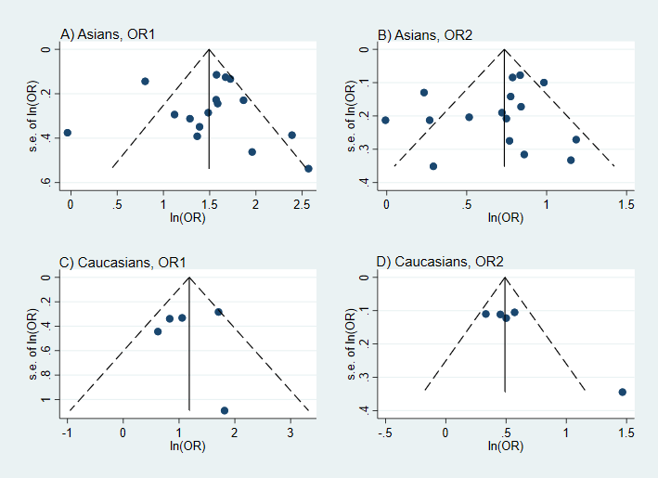

Additional file 4.5.2. Funnel plots of rs72552713 on gout in Asians. A) OR₁ in Asians B) OR₂ in Asians
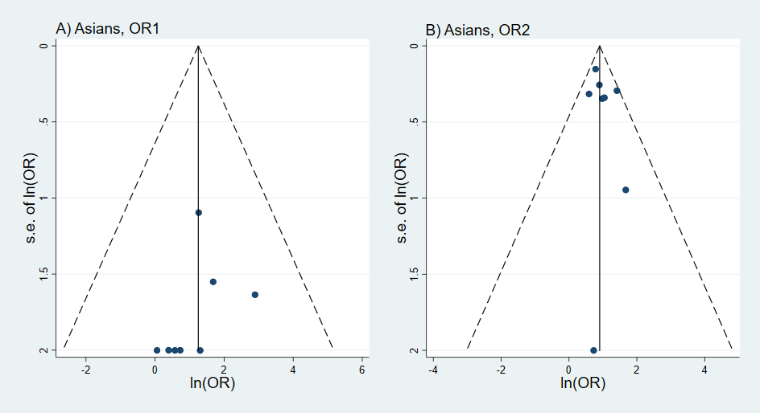

Additional file 4.5.3. Funnel plots of rs2231137 on gout in Asians. A) OR₁ in Asians B) OR₂ in Asians
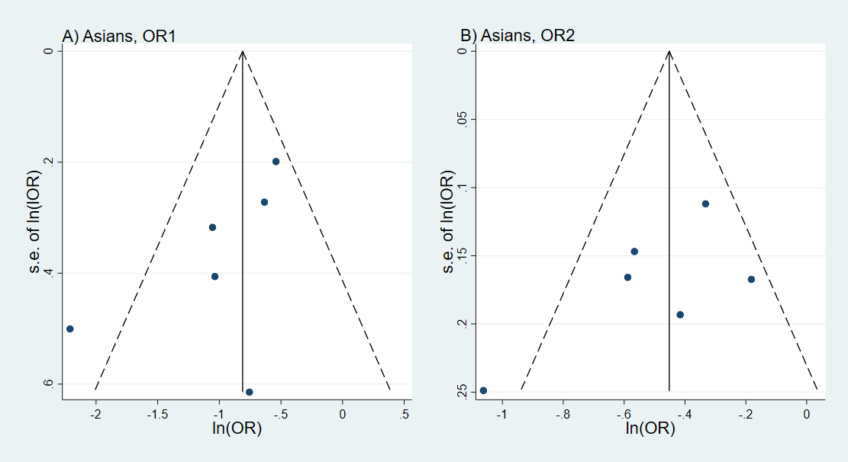

Additional file 4.5.4. Funnel plots of rs1014290 on gout in Asians and Caucasians. A) OR₁ in Asians B) OR₂ in Asians C) OR₁ in Caucasians D) OR₂ in Caucasians
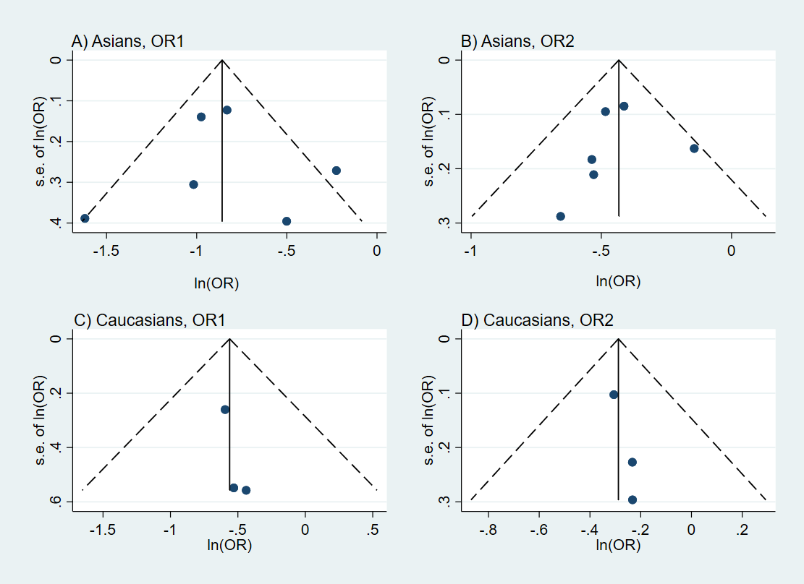

Additional file 4.5.5. Funnel plots of rs3733591 on gout in Asians and Caucasians. A) OR₁ in Asians B) OR₂ in Asians C) OR₁ in Caucasians D) OR₂ in Caucasians
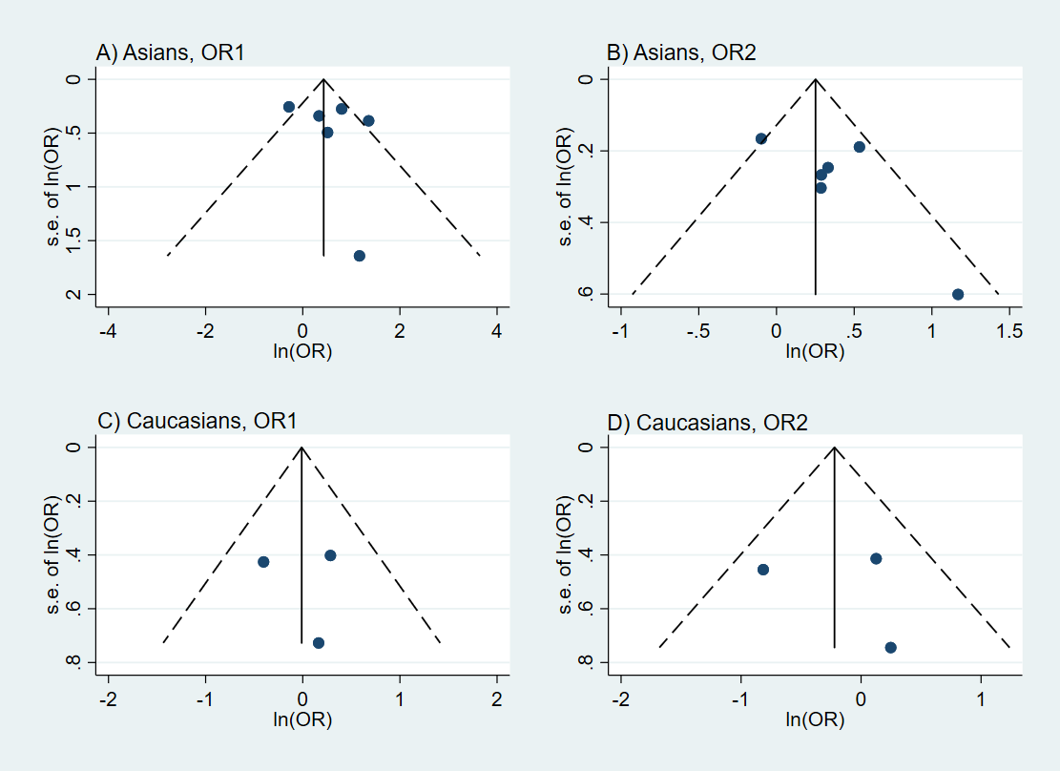

Additional file 4.5.6. Funnel plots of rs6855911 on gout in Asians and Caucasians. A) OR₁ in Asians B) OR₂ in Asians C) OR₁ in Caucasians D) OR₂ in Caucasians
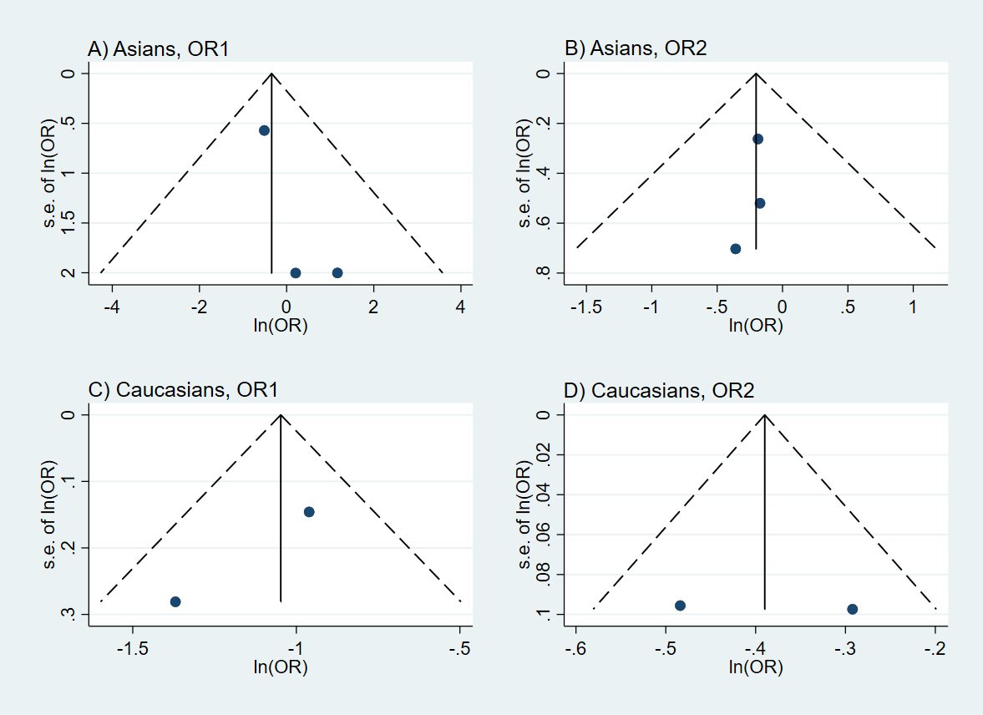

Additional file 4.5.7. Funnel plots of rs16890979 on gout in Asians. A) OR₁ in Asians B) OR₂ in Asians
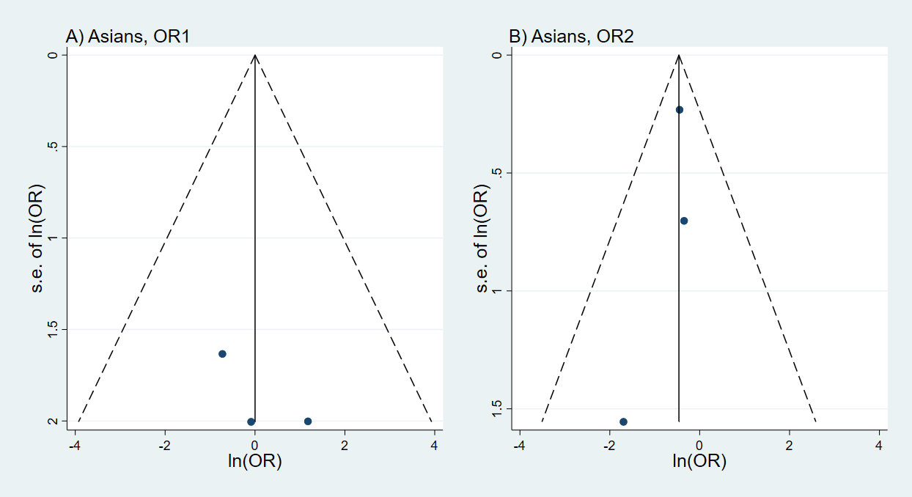

Additional file 4.5.8. Funnel plots of rs6449213 on gout in Caucasians. A) OR₁ in Caucasians B) OR₂ in Caucasians
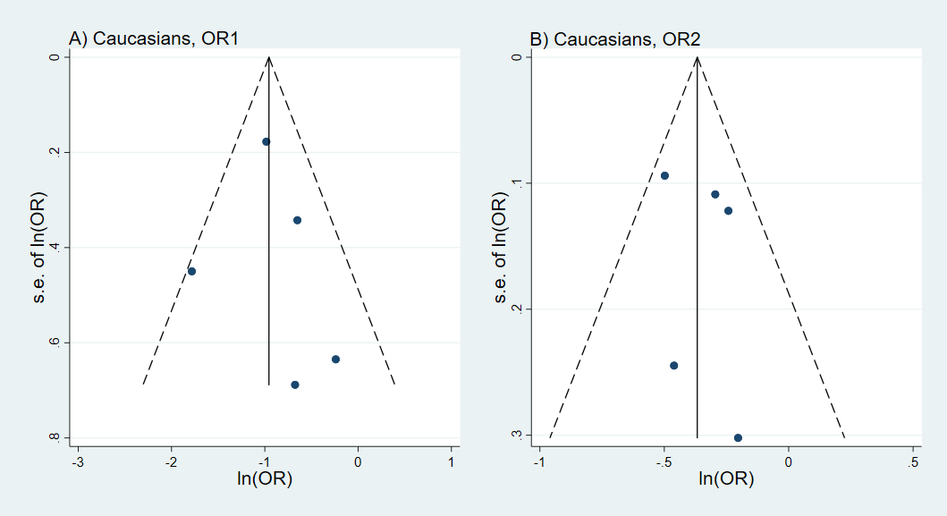

Additional file 4.5.9. Funnel plots of rs7442295 on gout in Caucasians. A) OR₁ in Caucasians B) OR₂ in Caucasians
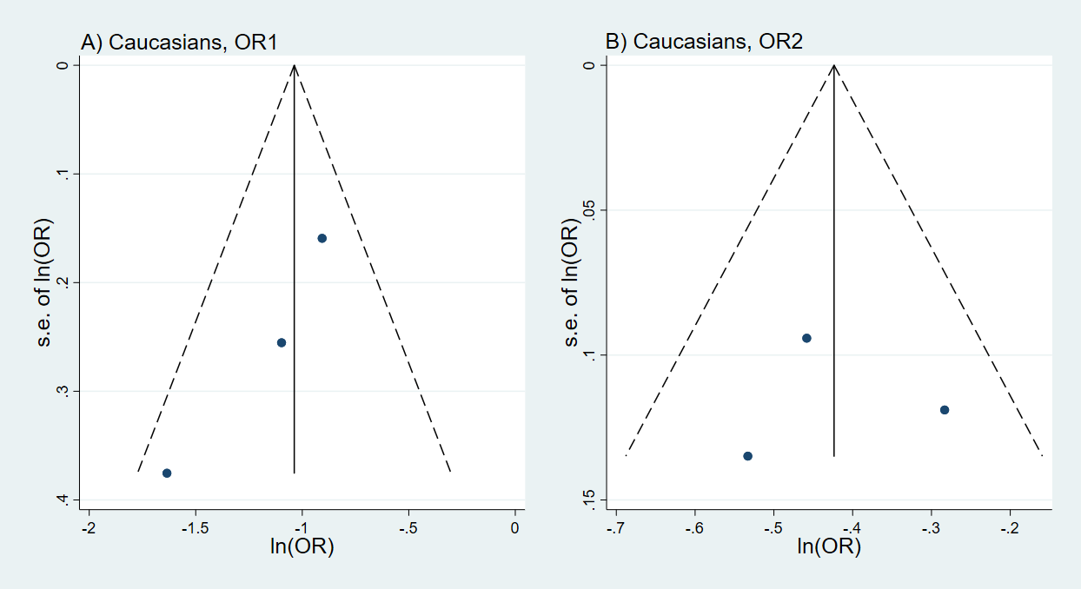

Additional file 4.5.10. Funnel plots of rs12510549 on gout in Caucasians. A) OR₁ in Caucasians B) OR₂ in Caucasians
