Additional file 6. Serum urate

Additional file 6.1. Data used for pooling mean difference of ABCG2 and SLC2A9 polymorphisms on serum urate
ABCG2 rs2231142
Author | Year | Genotype |  |  |  |  |  |  |  |  | HWE | AA/CC |  | CA/CC
Author | Year | CC |  |  | CA |  |  | AA |  |  | p-value | MD₁ (µmol/l) | 95% CI | MD₂ (µmol/l) | 95% CI
Author | Year | No. of subjects | Mean urate (µmol/l) | SD | No. of subjects | Mean urate (µmol/l) | SD | No. of subjects | Mean urate (µmol/l) | SD
Caucasians
Brandstatter A. | 2010
- Bruneck |  | 612 | 270.63 | 73.57 | 178 | 294.43 | 71.42 | 10 | 305.13 | 67.71 | 0.463 | 34.50 | 21.22, 47.77 | 23.79 | 11.79, 35.79
- SAPHIR |  | 1339 | 328.33 | 65.30 | 358 | 347.36 | 67.52 | 35 | 371.75 | 70.38 | 0.058 | 43.42 | 39.48, 47.36 | 19.03 | 11.21, 26.85
Stiburkova B. | 2014 | 475 | 271.52 | 43.62 | 108 | 291.56 | 47.90 | 6 | 373 | 49.56 | 0.960 | 101.48 | 61.63, 141.33 | 20.04 | 10.19, 29.89
Bartakova V. | 2016 | 344 | 365.33 | 88.59 | 74 | 372.00 | 79.39 | 4 | 357.00 | 75.35 | 0.993 | -8.33 | -82.77, 66.10 | 6.67 | -13.70, 27.03
Pooled OR |  |  |  |  |  |  |  |  |  |  |  | 50.43 | 32.66, 68.20 | 19.46 | 14.19, 24.73
Asians
Matsuo H. | 2009 | 374 | 287.88 | 72.57 | 297 | 299.78 | 77.32 | 68 | 333.68 | 85.06 | 0.417 | 45.80 | 24.29, 67.31 | 11.90 | 0.43, 23.36
Tabara Y. | 2010
- Ehime |  | 1590 | 300.60 | 73.74 | 951 | 311.98 | 73.63 | 153 | 322.94 | 73.84 | 0.492 | 22.34 | 10.09, 34.59 | 11.38 | 5.46, 17.30
- Suita |  | 1254 | 303.92 | 68.43 | 1018 | 308.55 | 71.05 | 199 | 314.20 | 81.76 | 0.704 | 10.28 | -1.69, 22.25 | 4.63 | -1.15, 10.41
Yamagishi K. | 2010 | 1861 | 276.85 | 66.05 | 1673 | 286.64 | 66.77 | 389 | 288.07 | 70.97 | 0.647 | 11.22 | 3.56, 18.89 | 9.79 | 5.41, 14.18
Hu M.ª | 2012 | 172 | 359.56 | 87.90 | 129 | 350.27 | 83.70 | 48 | 339.67 | 93.00 | 0.004 | -19.90 | -49.30, 9.51 | -9.29 | -28.82, 10.23
Cheng ST. | 2017 | 208 | 358.07 | 92.79 | 202 | 391.38 | 96.36 | 41 | 378.89 | 98.14 | 0.418 | 20.82 | -11.76, 53.40 | 33.31 | 14.99, 51.63
Pooled OR |  |  |  |  |  |  |  |  |  |  |  | 18.41 | 8.68, 28.14 | 11.49 | 4.10, 18.89
SLC2A9 rs1014290
Author | Year | Genotype |  |  |  |  |  |  |  |  | HWE | CC/TT |  | TC/TT
Author | Year | TT |  |  | TC |  |  | CC |  |  | p-value | MD₁ (µmol/l) | 95% CI | MD₂ (µmol/l) | 95% CI
Author | Year | No. of subjects | Mean urate (µmol/l) | SD | No. of subjects | Mean urate (µmol/l) | SD | No. of subjects | Mean urate (µmol/l) | SD
Caucasians
Vitart V. | 2008
- Croatia |  | 375 | 304.47 | 30.14 | 332 | 290.39 | 27.35 | 87 | 260.50 | 15.5 | 0.297 | -43.97 | -48.43, -39.51 | -14.08 | -18.32, -9.84
- Scotland  (Orkney) |  | 391 | 310.45 | 25.39 | 220 | 293.00 | 18.93 | 38 | 273.82 | 7.52 | 0.343 | -36.64 | -40.11, -33.16 | -17.45 | -21.00, -13.90
Bartakova V. | 2016 | 230 | 363.33 | 83.55 | 163 | 370.17 | 87.51 | 29 | 389.67 | 115.40 | 0.987 | 26.33 | -17.03, 69.70 | 6.83 | -10.40, 24.07
Pooled OR |  |  |  |  |  |  |  |  |  |  |  | -32.33 | -52.61, -12.05 | -9.87 | -25.27, 5.54
Asians
Tabara Y. | 2010
- Ehime |  | 761 | 315.99 | 73.76 | 1330 | 305.70 | 73.76 | 603 | 291.48 | 70.78 | 0.633 | -24.51 | -32.22, -16.81 | -10.30 | -16.87, -3.73
- Suita |  | 819 | 314.02 | 70.78 | 1214 | 306.42 | 68.40 | 438 | 291.57 | 89.22 | 0.746 | -22.44 | -32.10, -12.78 | -7.60 | -13.79, -1.41
Urano W. | 2010 | 204 | 333.68 | 63.05 | 279 | 342.60 | 69.00 | 94 | 334.87 | 77.92 | 0.932 | 1.19 | -16.78, 19.16 | 8.92 | -2.93, 20.77
Liu WC. | 2011 | 324 | 361.67 | 76.70 | 513 | 354.45 | 96.19 | 166 | 345.50 | 91.73 | 0.121 | -16.17 | -32.44, 0.09 | -7.22 | -19.01, 4.57
Hu M. | 2012 | 144 | 376.93 | 81.5 | 151 | 344.97 | 83.5 | 51 | 313.39 | 92.8 | 0.271 | -63.54 | -92.28, -34.80 | -31.96 | -50.79, -13.13
Zhang XY. | 2015 | 139 | 409.07 | 141.52 | 143 | 398.84 | 155.20 | 30 | 401.52 | 145.36 | 0.436 | -7.55 | -64.64, 49.54 | -10.23 | -44.88, 24.42
Pooled OR |  |  |  |  |  |  |  |  |  |  |  | -21.47 | -30.97, -11.96 | -8.16 | -16.63, 0.31
SLC2A9 rs6449213
Author | Year | Genotype |  |  |  |  |  |  |  |  | HWE | CC/TT |  | TC/TT
Author | Year | TT |  |  | TC |  |  | CC |  |  | p-value | MD₁ (µmol/l) | 95% CI | MD₂ (µmol/l) | 95% CI
Author | Year | No. of subjects | Mean urate (µmol/l) | SD | No. of subjects | Mean urate (µmol/l) | SD | No. of subjects | Mean urate (µmol/l) | SD
Caucasians
Brandstatter A. | 2008
- Utah |  | 539 | 330.11 | 91.14 | 259 | 297.40 | 92.85 | 20 | 271.82 | 112.25 | 0.087 | -58.29 | -108.08, -8.50 | -32.71 | -46.39, -19.04
Vitart V. | 2008
- Croatia |  | 456 | 303.18 | 46.12 | 277 | 286.57 | 36.95 | 56 | 250.09 | 15.49 | 0.123 | -53.09 | -58.96, -47.23 | -16.61 | -22.68, -10.54
- Scotland (Orkney) |  | 429 | 308.43 | 37.90 | 190 | 292.75 | 24.54 | 22 | 278.31 | 8.91 | 0.865 | -30.12 | -35.29, -24.95 | -15.68 | -20.69, -10.68
Brandstatter A. | 2010
- Bruneck |  | 525 | 286.10 | 68.13 | 245 | 262.31 | 65.14 | 31 | 228.40 | 66.45 | 0718 | -57.70 | -81.80, -33.59 | -23.79 | -33.82, -13.77
- SAPHIR |  | 1114 | 341.42 | 79.40 | 542 | 322.98 | 69.24 | 76 | 293.24 | 67.50 | 0.331 | -48.18 | -64.05, -32.30 | -18.44 | -25.90, -10.97
Voruganti VS. | 2013 | 384 | 327.14 | 83.27 | 217 | 309.30 | 83.27 | 31 | 249.82 | 71.38 | 0.962 | -77.32 | -103.79, -50.85 | -17.84 | -31.70, -3.98
Pooled OR |  |  |  |  |  |  |  |  |  |  |  | -49.29 | -59.85, -38.74 | -20.43 | -28.91, -11.94
Asians
Urano W. | 2010 | 566 | 338.44 | 68.40 | 9 | 344.39 | 49.37 | 1 | 368.78 | 0 | 0.047 | NA | NA | 5.95 | -26.79, 38.69
American Indians
Laston SL. | 2015 | 459 | 365.21 | 95.17 | 432 | 344.98 | 95.17 | 102 | 309.89 | 89.22 | 0.981 | -55.32 | -74.70, -35.94 | -20.22 | -32.73, -7.72
Mixed
Cummings N. | 2010 | 260 | 277.34 | 78.79 | 110 | 259.91 | 86.32 | 12 | 193.25 | 82.18 | 0.930 | -84.09 | -131.56, -36.62 | -17.43 | -36.19, 1.33
SLC2A9 rs6855911
Author | Year | Genotype |  |  |  |  |  |  |  |  | HWE | GG/AA |  | AG/AA
Author | Year | AA |  |  | AG |  |  | GG |  |  | p-value | MD₁ (µmol/l) | 95% CI | MD₂ (µmol/l) | 95% CI
Author | Year | No. of subjects | Mean urate (µmol/l) | SD | No. of subjects | Mean urate (µmol/l) | SD | No. of subjects | Mean urate (µmol/l) | SD
Caucasians
Li S. | 2007
- InCHIANTI |  | 706 | 313.46 | 85.65 | 485 | 293.83 | 77.92 | 85 | 257.55 | 81.49 | 0.890 | -55.91 | -74.35, -37.47 | -19.63 | -29.01, -10.25
- SardiNIA |  | 715 | 277.18 | 89.81 | 508 | 266.47 | 94.57 | 87 | 239.11 | 96.95 | 0.800 | -38.07 | -59.48, -16.66 | -10.71 | -21.24, -0.17
Brandstatter A. | 2008
- Utah |  | 471 | 330.71 | 92.94 | 304 | 303.94 | 92.30 | 43 | 288.48 | 98.68 | 0.502 | -42.23 | -72.90 -11.57 | -26.77 | -40.11, -13.42
Brandstatter A. | 2010
- Bruneck |  | 467 | 287.88 | 64.23 | 290 | 265.88 | 70.95 | 43 | 232.57 | 66.46 | 0.817 | -55.32 | -76.02 -34.62 | -22.01 | -32.04, -11.98
- SAPHIR |  | 935 | 344.98 | 72.76 | 672 | 324.76 | 77.10 | 125 | 289.07 | 66.42 | 0.778 | -55.91 | -68.45 -43.37 | -20.22 | -27.69, -12.76
Lyngdoh T. | 2012 | 2684 | 325.5 | 82.3 | 2142 | 303.5 | 83.6 | 398 | 275.4 | 83.4 | 0.302 | -50.10 | -58.87 -41.33 | -22.00 | -26.71, -17.29
Pooled OR |  |  |  |  |  |  |  |  |  |  |  | -51.23 | -57.22, -45.25 | -20.65 | -23.83, -17.47
Asians
Urano W. | 2010 | 570 | 339.04 | 68.402 | 11 | 337.85 | 90.41 | 0 | NA | NA | 1.000 | NA | NA | -1.19 | -54.91, 52.53
Guan M. | 2011 | 357 | 380.7 | 130.8 | 15 | 284.5 | 97.6 | 0 | NA | NA | 1.000 | NA | NA | -96.20 | -147.42, -44.98
Mixed
Cummings N. | 2010 | 196 | 277.68 | 78.23 | 160 | 265.71 | 84.02 | 32 | 230.67 | 67.34 | 0.935 | -47.01 | -72.78, -21.24 | -11.97 | -28.98, 5.04
SLC2A9 rs7442295
Author | Year | Genotype |  |  |  |  |  |  |  |  | HWE | GG/AA |  | AG/AA
Author | Year | AA |  |  | AG |  |  | GG |  |  | p-value | MD₁ (µmol/l) | 95% CI | MD₂ (µmol/l) | 95% CI
Author | Year | No. of subjects | Mean urate (µmol/l) | SD | No. of subjects | Mean urate (µmol/l) | SD | No. of subjects | Mean urate (µmol/l) | SD
Caucasians
Li S. | 2007
- InCHIANTI |  | 764 | 312.27 | 85.06 | 443 | 293.83 | 79.70 | 68 | 245.65 | 71.38 | 0.718 | -66.62 | -84.62, -48.61 | -18.44 | -28.00, -8.88
- SardiNIA |  | 882 | 279.56 | 90.41 | 455 | 264.09 | 95.76 | 55 | 228.40 | 79.70 | 0.699 | -51.15 | -73.05, -29.26 | -15.46 | -26.10, -4.83
Brandstatter A. | 2008
- Utah |  | 501 | 330.71 | 91.86 | 287 | 299.78 | 92.70 | 28 | 286.69 | 108.90 | 0.090 | -44.02 | -85.15, -2.88 | -30.93 | -44.34, -17.52
Brandstatter A. | 2010
- Bruneck |  | 500 | 286.69 | 66.50 | 265 | 264.09 | 67.75 | 34 | 231.97 | 66.28 | 0.881 | -54.72 | -77.75, -31.69 | -22.60 | -32.63, -12.58
- SAPHIR |  | 1037 | 343.20 | 76.63 | 601 | 322.38 | 72.91 | 94 | 290.86 | 69.03 | 0.571 | -52.34 | -67.06, -37.63 | -20.82 | -28.28, -13.35
Kobylecki CJ. | 2017 | 53769 | 303.33 | 81.55 | 28739 | 286.67 | 88.96 | 3702 | 250 | 88.99 | 0.077 | -53.33 | -56.28, -50.38 | -16.67 | -17.90, -15.43
Pooled OR |  |  |  |  |  |  |  |  |  |  |  | -54.30 | -58.78, -49.82 | -18.34 | -22.68, -13.99
Asians
Urano W. | 2010 | 578 | 339.04 | 67.81 | 9 | 339.63 | 93.98 | 0 | NA | NA | 1.000 | NA | NA | 0.59 | -61.05, 62.24
Mixed
Cummings N. | 2010 | 186 | 226.38 | 66.09 | 160 | 270.53 | 83.55 | 34 | 276.94 | 78.14 | 0.961 | 50.56 | 22.63, 78.49 | 44.15 | 28.09, 60.21
SLC2A9 rs734553
Author | Year | Genotype |  |  |  |  |  |  |  |  | HWE | GG/TT |  | TG/TT
Author | Year | TT |  |  | TG |  |  | GG |  |  | p-value | MD₁ (µmol/l) | 95% CI | MD₂ (µmol/l) | 95% CI
Author | Year | No. of subjects | Mean urate (µmol/l) | SD | No. of subjects | Mean urate (µmol/l) | SD | No. of subjects | Mean urate (µmol/l) | SD
Caucasians
Testa A. | 2014 | 97 | 292.64 | 83.27 | 97 | 265.2808 | 79.70 | 17 | 243.87 | 88.63 | 0.284 | -48.77 | -94.04, -3.50 | -27.36 | -50.30, -4.42
Mallamaci F. | 2015 | 217 | 309.30 | 83.27 | 198 | 279.556 | 77.32 | 34 | 249.82 | 95.17 | 0.222 | -59.48 | -93.33, -25.63 | -29.74 | -45.19, -14.29
Bartakova V. | 2016 | 244 | 367.67 | 85.02 | 154 | 361.67 | 90.55 | 24 | 402 | 117.42 | 0.963 | 34.33 | -13.84, 82.51 | -6.00 | -23.84, 11.84
Pooled OR |  |  |  |  |  |  |  |  |  |  |  | -29.29 | -63.90, 5.33 | -20.68 | -47.08, 5.71
American Indians
Laston SL. | 2015 | 258 | 330.71 | 95.17 | 496 | 349.74 | 95.17 | 239 | 371.16 | 95.17 | 0.984 | 40.45 | 23.70, 57.19 | 19.03 | 4.72, 33.35
ª Not included in pooling due to non-compliance with HWE.
ABCG2, ATP-binding cassette sub-family G member 2; CI, confidence interval; InCHIANTI, Invecchiare in Chianti, aging in the Chianti area; MD, mean difference; SAPHIR, Salzburg Atherosclerosis Prevention Program in Subjects at High Individual Risk; SD, standard deviation; SLC2A9, solute carrier family 2 member 9.

Additional file 6.2. Exploring source of heterogeneity for ABCG2 and SLC2A9 polymorphisms on serum urate
 | No. of  sub-studies | MD₁ |  |  | MD₂
 | No. of  sub-studies | MD | 95% CI | I² (%) | MD | 95% CI | I² (%)
ABCG2
rs2231142 (Caucasians)
Overall | 4 | 50.43 | 32.66, 68.20 | 68.7 | 19.46 | 14.19, 24.73 | 0.0
Source of heterogeneity
Age | 3 |  |  | 79.1 |  |  | NA
BMI | 3 |  |  | 83.7 |  |  | NA
Percent maleª | 4 |  |  | 70.5 |  |  | NA
Type of populationª | 4 |  |  | 71.6 |  |  | NA
rs2231142 (Asians)
Overall | 5 | 18.41 | 8.68, 28.14 | 63.1 | 11.49 | 4.10, 18.89 | 59.1
Source of heterogeneity
Ageª | 5 |  |  | 72.1 |  |  | 5.9
BMI | 4 |  |  | 47.6 |  |  | 66.2
Percent maleª | 5 |  |  | 72.1 |  |  | 5.9
Subgroup analysis | 5
Mean age < 60 & %male ≥ 50 | 1 | 20.82 | -6.65, 48.29 | NA | 33.31 | 14.99, 51.63 | NA
Mean age ≥ 60 & %male < 50 | 4 | 16.22 | 9.09, 23.36 | 72.1 | 9.12 | 4.85, 13.39 | 5.9
SLC2A9
rs1014290 (Caucasians)
Overall | 3 | -32.33 | -52.61,-12.05 | 86.9 | -9.87 | -25.27,5.54 | 75.1
Source of heterogeneity
Percent maleª | 3 |  |  | 84.5 |  |  | 30.0
Type of populationª | 3 |  |  | 84.5 |  |  | 30.0
Subgroup analysis
General population & %male < 50 | 2 | -40.16 | -47.74, -32.57 | 84.5 | -15.80 | -23.36, -8.24 | 30.0
Specific population (T2D) & %male ≥ 50 | 1 | 26.33 | -17.03, 69.70 | NA | 6.83 | -10.40, 24.07 | NA
rs1014290 (Asians)
Overall | 6 | -21.47 | -30.97, -11.96 | 67.9 | -8.16 | -16.63, 0.31 | 65.7
Source of heterogeneity
Age | 4 |  |  | NA^{b} |  |  | NA^{b}
BMI | 3 |  |  | NA^{c} |  |  | NA^{c}
Percent maleª | 6 |  |  | 53.5 |  |  | 33.4
Type of populationª | 6 |  |  | 60.0 |  |  | 55.0
Subgroup analysis
%male < 100 | 5 | -24.14 | -29.59, -18.70 | 53.5 | -9.78 | -13.85, -5.70 | 33.4
%male = 100 | 1 | 1.19 | -17.64, 20.02 | NA | 8.92 | -4.06, 21.90 | NA
rs6449213 (Caucasians)
Overall | 6 | -49.29 | -59.85, -38.74 | 88.5 | -20.43 | -28.91, -11.94 | 26.0
Source of heterogeneity
Age | 6 |  |  | NA^{b} |  |  | NA^{b}
BMI | 3 |  |  | NA^{c} |  |  | 68.4
%maleª | 5 |  |  | 91.6 |  |  | 55.6
rs7442295 (Caucasians)
Overall | 6 | -54.30 | -58.78, -49.82 | 0.0 | -18.34 | -22.68, -13.99 |  | 26.4
Source of heterogeneity
Ageª | 4 |  |  | NA |  |  |  | 33.2
BMI | 4 |  |  | NA |  |  |  | 35.4
Percent maleª | 6 |  |  | NA |  |  |  | 0.0
Subgroup analysis
%male ≥ 48 | 3 |  |  | NA | -23.03 | -28.50, -17.56 |  | 0.0
%male < 48 | 3 |  |  | NA | -16.67 | -17.89, -15.45 |  | 0.0
rs734553 (Caucasians)
Overall | 3 | -29.29 | -63.90, 5.33 | 80.6 | -20.68 | -47.08, 5.71 |  | 52.8
Source of heterogeneity
Percent maleª | 3 |  |  | 0.0 |  |  |  | 0.0
Type of populationª | 3 |  |  | 0.0 |  |  |  | 0.0
Subgroup analysis
General population & %male < 50 | 2 | -55.67 | -82.77, -28.57 | 0.0 | -29.00 | -41.82, -16.19 |  | 0.0
Specific population (T2D) & %male ≥ 50 | 1 | 34.33 | -13.84, 82.51 | NA | -6.00 | -23.84, 11.84 |  | NA
ª Categorized variables, ^{b} No heterogeneity among studies with data of age available, ^{c} No heterogeneity among studies with data of BMI available.
ABCG2, ATP-binding cassette sub-family G member 2; BMI, body mass index; CI, confidence interval; NA, not applicable; MD, mean difference; SLC2A9, solute carrier family 2 member 9, T2D, type 2 diabetes.

Additional file 6.3. Egger’s tests for ABCG2 and SLC2A9 polymorphisms on serum urate
 | No. of sub-studies | MD₁ |  |  | MD₂
 |  | Coef. of Egger’s test | SE | P value | Coef. of Egger’s test | SE | P value
ABCG2
rs2231142
- Caucasians | 4 | -0.66 | 2.92 | 0.843 | -1.32 | 1.39 | 0.443
- Asians | 5 | 2.35 | 1.50 | 0.215 | 2.35 | 1.47 | 0.207
SLC2A9
rs1014290
- Caucasians | 3 | 2.62 | 3.30 | 0.572 | 3.51 | 0.99 | 0.174
- Asians | 6 | 0.098 | 1.62 | 0.955 | -0.38 | 1.69 | 0.833
rs6449213
- Caucasians | 6 | -2.08 | 1.93 | 0.344 | -2.36 | 0.91 | 0.060
rs6855911
- Caucasians | 6 | 0.45 | 0.83 | 0.620 | 0.62 | 1.23 | 0.643
rs7442295
- Caucasians | 6 | -0.16 | 0.41 | 0.718 | -1.03 | 0.46 | 0.088
rs734553
- Caucasians | 3 | 8.87 | 7.67 | 0.454 | 0.69 | 7.57 | 0.942
ABCG2, ATP-binding cassette sub-family G member 2; Coef., coefficient; MD, mean difference; SE, standard error; SLC2A9, solute carrier family 2 member 9.

Additional file 6.4. Funnel plots for ABCG2 and SLC2A9 polymorphisms on serum urate

Additional file 6.4.1. Funnel plots of rs2231142 on serum urate in Asians and Caucasians. A) MD₁ in Asians B) MD₂ in Asians C) MD₁ in Caucasians D) MD₂ in Caucasians
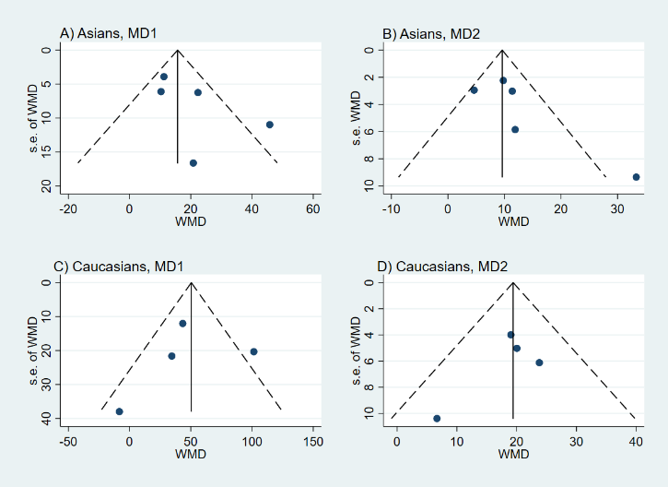

Additional file 6.4.2. Funnel plots of rs1014290 on serum urate in Asians and Caucasians. A) MD₁ in Asians B) MD₂ in Asians C) MD₁ in Caucasians D) MD₂ in Caucasians
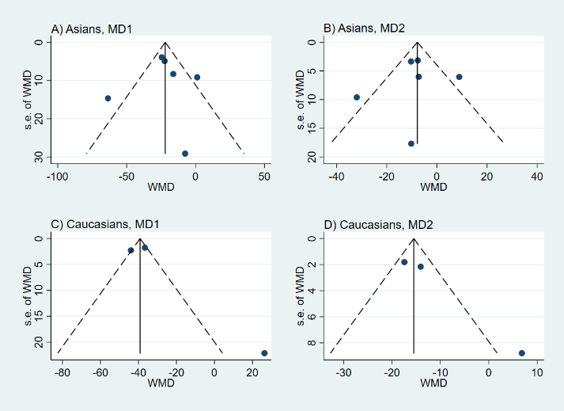

Additional file 6.4.3. Funnel plots of rs6449213 on serum urate in Caucasians. A) MD₁ in Caucasians B) MD₂ in Caucasians
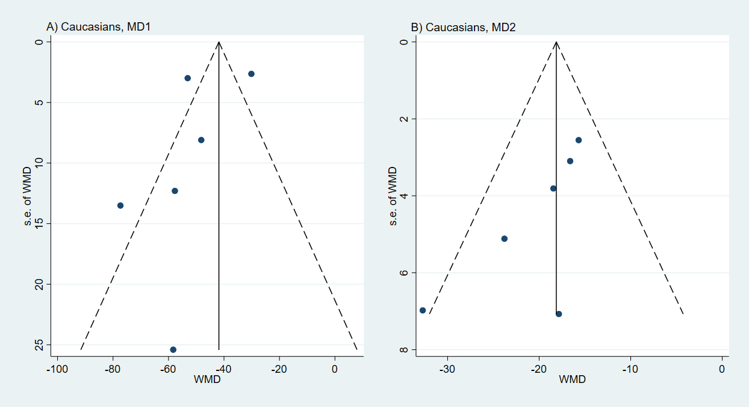

Additional file 6.4.4. Funnel plots of rs7442295 on serum urate in Caucasians. A) MD₁ in Caucasians B) MD₂ in Caucasians
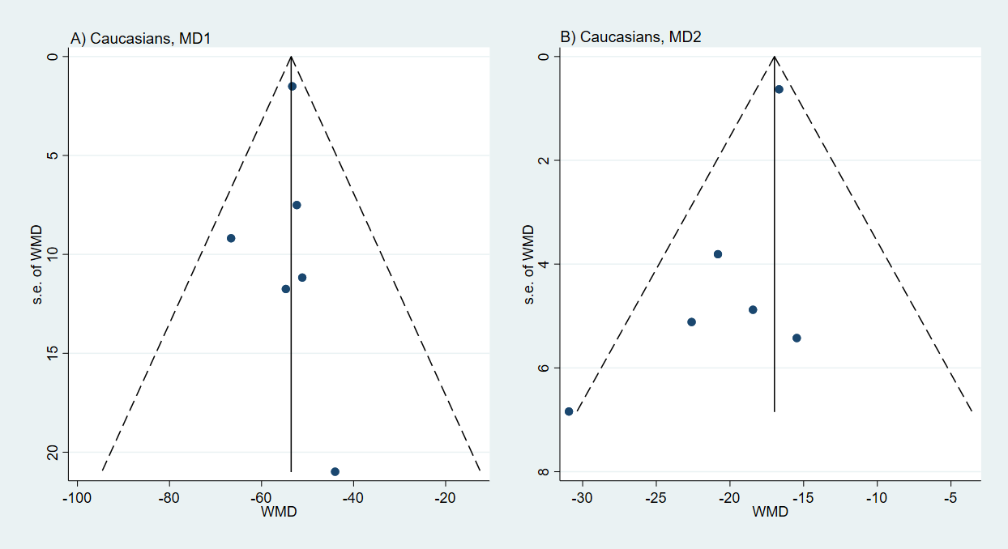

Additional file 6.4.5. Funnel plots of rs6855911 on serum urate in Caucasians. A) MD₁ in Caucasians B) MD₂ in Caucasians
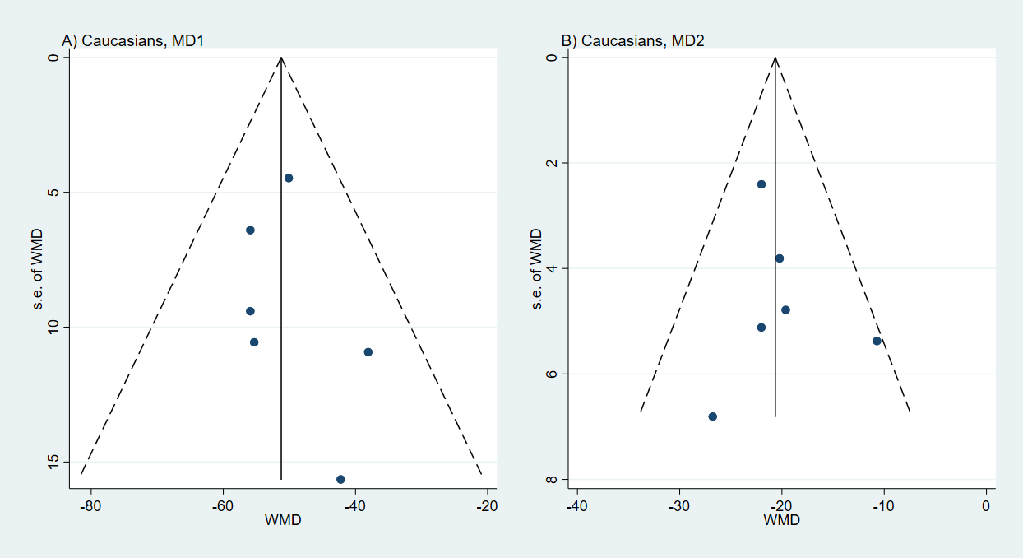

Additional file 6.4.6. Funnel plots of rs734553 on serum urate in Caucasians. A) MD₁ in Caucasians B) MD₂ in Caucasians
