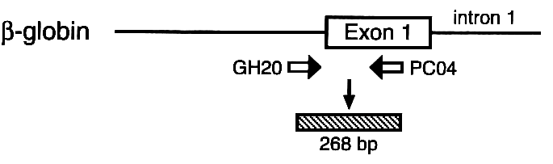

22q11.23
11p15.4
1p13.3

480 bp
268 bp
219 bp

M= Molecular weight marker (100bp); GSTM1-active/GSTT1-active= 6, 9, 11, 16; GSTM1-active/GSTT1-null= 1, 2, 3, 4, 12, 13, 18, 19; GSTM1-null/GSTT1-active= 14, 15, 17; GSTM1-null/GSTT1 null= 5, 7, 8, 10.
Figure S1: Locations of GSTM1, GSTT1, β-globin genes and corresponding bands in electrophoresis gel. Adapted from Chen and al. [35].

