Additional file 2

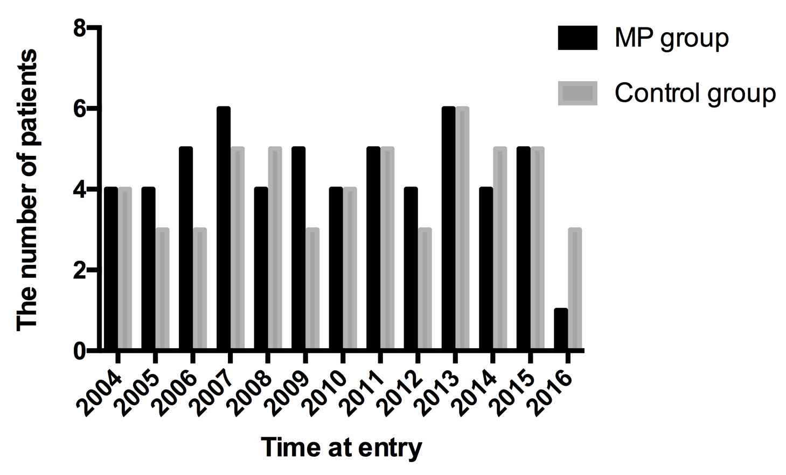
Figure S1. The yearly distribution of patients in MP group and control group from 2004 to 2016.

Table S1. The baseline pathological characteristics in MP group and control group.
 | MP group  (n=28) | Control group  (n=6) | P value
Glomerular global sclerosis (median (IQR), %) | 33.0(14.3-64.4) | 47.9(29.2-84.4) | 0.653
Cellular crescent (median (IQR), %) | 24.0(5.6-50.6) | 12.5(4.9-21.6) | 0.653
Fibrinoid necrosis (case, %) | 8, 28.6 | 1, 16.7 | 0.644
Mesangial proliferation 1/2/3 (case) | 3/8/17 | 0/3/3 | 0.843
Interstitial infiltrates 0/1/2/3 (case) | 2/13/9/4 | 1/3/1/1 | 0.612

Table S2. Adverse events in MP group for treatment responses of intravenous methylprednisolone pulses.
Adverse events | Positive response group  (n=21) | Negative response group  (n=32) | P value
Infection | 13 | 15 | 0.400
bacteria | 9 | 10 | 0.559
fungus | 3 | 1 | 0.289
virus | 1 | 4 | 0.637
Thrombocytopenia | 5 | 8 | 1.000
Leukopenia | 4 | 4 | 0.698
Diabetes | 3 | 1 | 0.289
Gastrointestinal | 1 | 3 | 1.000
Cardiovascular | 1 | 1 | 1.000
Hemorrhage | 0 | 3 | 0.269
Epilepsy | 1 | 0 | 0.396
Totals | 28 | 35

