Additional file 1

Statin use and the risk of acute kidney injury in older adults

Marcello A Tonelli, MD SM MSc, (1)

Anita M Lloyd, MSc, (2)

Aminu K Bello, MBBS PhD, (2)

Matthew T James, MD PhD, (1)

Scott W Klarenbach, MD MSc, (2)

Finlay A McAlister, MD MSc, (2)

Braden J Manns, MD MSc, (1)

Ross T Tsuyuki, PharmD MSc, (1)

Brenda R Hemmelgarn, MD PhD, (1)

for the Alberta Kidney Disease Network

Additional file 1: Figure S1. Flow diagram

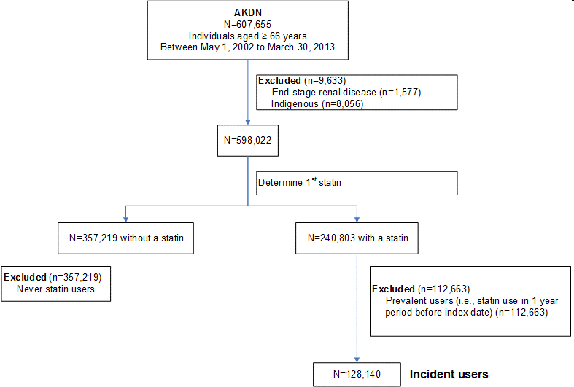

AKDN Alberta Kidney Disease Network

Additional file 1: Figure S2. Assessment of exposure to statins
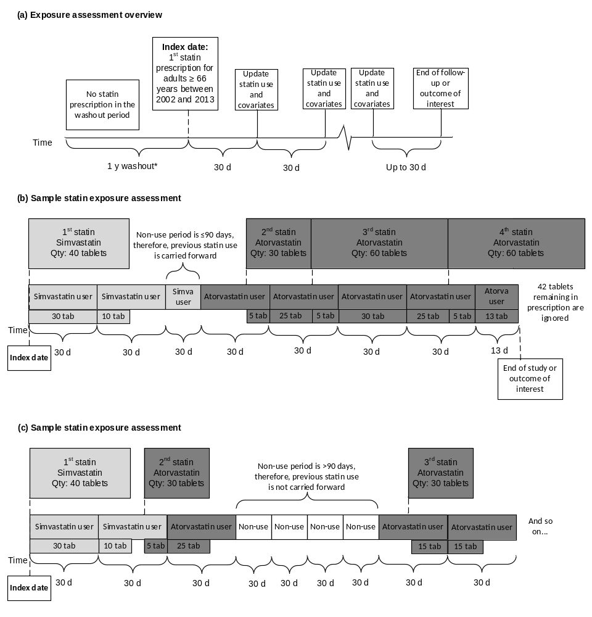
*Individuals who had a statin prescription during the washout period were excluded – these individuals were not considered to be “incident” statin users. The washout period was defined as the 1-year period prior to the index statin prescription. Statin use and covariates were assessed at the index date and were updated every 30 days until the end of follow-up or the outcome of interest.

Qty quantity; tab tablets; simva simvastatin; atorva atorvastatin; d days

Additional file 1: Table S1. Classification of statin intensity

Dose (mg) | Rosuvastatin | Atorvastatin | Simvastatin | Lovastatin | Pravastatin | Fluvastatin
5 |  | n/a |  | n/a | n/a | n/a
10 |  |  |  | n/a |  | n/a
20
40
80 | n/a |  |  | n/a | n/a

Legend:
n/a | Regimens not observed in AKDN participants
 | Low-intensity statin
 | Medium-intensity statin
 | High-intensity statin

Classification system was adapted from National Institute of Clinical Excellence guidance¹.
Additional file 1: Table S2. Algorithm for identifying acute kidney injury from administrative data

Condition | ICD-9 | ICD-10
Acute Kidney Injury | Hospitalization for one of the following:  ICD-9-CM diagnosis codes: 584.5, 584.6, 584.7, 584.8, 584.9 | Hospitalization for one of the following:  ICD-10-CA diagnosis codes: N17.0, N17.1, N17.2, N17.8, N17.9
Acute Kidney Injury requiring dialysis | Hospitalization for one of the following:  ICD-9-CM diagnosis codes: 584.5, 584.6, 584.7, 584.8, 584.9  PLUS  Hospitalization for one of the following:  ICD-9-CM diagnosis code: 39.95  ICD-9-CM procedure codes: V45.1, V56.0, V56.1 | Hospitalization for one of the following:  ICD-10-CA diagnosis codes: N17.0, N17.1, N17.2, N17.8, N17.9  PLUS  Hospitalization for one of the following:  ICD-10-CA diagnosis codes: Z99.2, Z49.0, Z49.1  CCI codes: 1.PZ.21.HQ-BR, 1.PZ.21.HQ-BS, 1.JQ.53, 1.JT.53
Codes may occur in any field

Additional file 1: Table S3. Baseline characteristics of statin users and non-users
 | Statin user | Non-user | Standardized difference
 | N=125,832 | N=125,832 | %
Age, years* | 73.1 (69, 78.4) | 73.1 (69, 78.6) | 1.3
Female | 51 | 51 | 0
Hypertension | 72 | 50 | 46.1
Diabetes | 28 | 11 | 44.2
Comorbidities
Alcohol misuse | 2 | 3 | 3.0
Asthma | 3 | 3 | 3.2
Atrial fibrillation | 11 | 7 | 13.7
Cancer, lymphoma | 1 | 1 | 0.8
Cancer, metastatic | 1 | 2 | 5.3
Cancer, non-metastatic | 7 | 7 | 1.4
Chronic heart failure | 13 | 8 | 17.4
Chronic kidney disease | 40 | 24 | 35.1
Chronic pain | 17 | 14 | 10.2
Chronic pulmonary disease | 20 | 17 | 7.0
Chronic viral hepatitis B | 0.03 | 0.07 | 1.6
Cirrhosis | 0.2 | 0.3 | 2.9
Dementia | 4 | 6 | 9.6
Depression | 9 | 7 | 5.7
Epilepsy | 1 | 1 | 1.3
Hypothyroidism | 14 | 12 | 6.7
Inflammatory bowel disease | 1 | 1 | 0.4
Irritable bowel syndrome | 2 | 2 | 2.0
Multiple sclerosis | 0.4 | 0.6 | 3.0
Myocardial infarction | 12 | 2 | 41.7
Parkinson’s disease | 1 | 2 | 6.2
Peptic ulcer disease | 0.5 | 0.3 | 3.0
Peripheral vascular disease | 3 | 1 | 11.3
Psoriasis | 1 | 1 | 1.9
Rheumatoid Arthritis | 4 | 4 | 0
Schizophrenia | 1 | 1 | 3.8
Severe constipation | 2 | 2 | 0.6
Stroke or TIA | 18 | 9 | 25.4
Proteinuria |  |  | 56.5
Not measured | 42 | 69
Normal | 46 | 26
Moderately increased | 10 | 4
Severely increased | 2 | 1
Medications
ACEI/ARB | 61 | 27 | 72.8
Loop diuretics | 12 | 6 | 21.2
eGFR ml/min/1.73m² |  |  | 68.0
Not measured | 27 | 58
<15 | 0.2 | 0.1
15-29 | 2 | 1
30-44 | 6 | 2
45-59 | 15 | 7
60-89 | 44 | 27
≥90 | 6 | 5

Data expressed as %, except * median (interquartile range). Totals do not always add to 100% because of rounding. Standardized differences in characteristics between statin users and non-users are shown where differences >10% suggest meaningful imbalance.
For male statin users between 66 to 70 years old, there were fewer non-users available to match on. Thus, N=2,308 statin users were not matched and excluded.
Proteinuria categories: Normal (ACR<3 mg/mmol, PCR <15 mg/mmol or urine dipstick negative), moderately increased (ACR 3-30 mg/mmol, PCR 15-50 mg/mmol or urine dipstick trace or 1+), severely increased (ACR >30 mg/mmol, PCR>50 mg/mmol or urine dipstick ≥2+)
ACEI angiotensin converting enzyme inhibitors; ACR albumin creatinine ratio; ARB angiotensin receptor blockers; eGFR estimated glomerular filtration rate; PCR protein:creatinine ratio; TIA transient ischemic attack

References

1. National Institute for Health and Clinical Excellence. Lipid modification: Cardiovascular risk assessment and the modification of blood lipids for the primary and secondary prevention of cardiovascular disease. 2014

