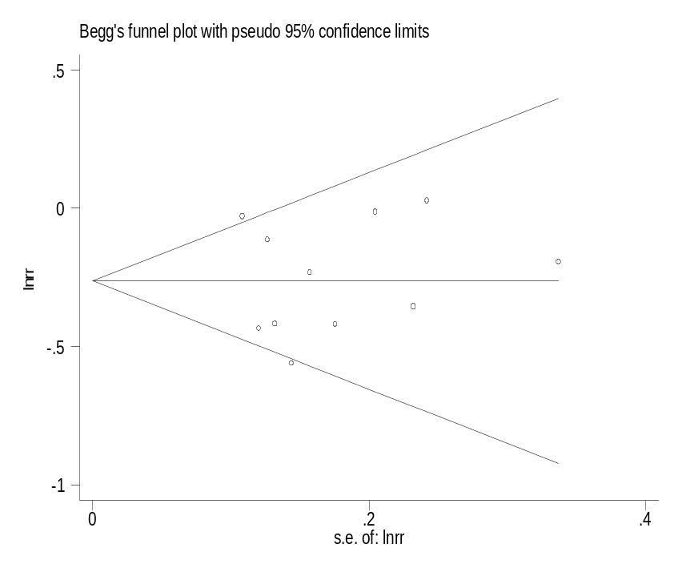
0.65
0.77
0.68
0.87
0.90
Wei,S.Y (2016)
Bech, A.P. (2014)
Beck,LH.Jr. (2011)
Hofstra,J.M (2012)
kIM,Y.G (2015)
Oh,Y.J (2013)
pourcine,F (2017)
Qin,W (2011)
Ruggenenti,P (2015)
song,EJ. (2018)
Timmermans,S.A (2015)
Lower CI Limit
Estimate
Upper CI Limit
Meta-analysis estimates, given named study is omitted

