SUPPLEMENTAL MATERIAL PDF

Table S1. Baseline characteristics excluding patients with stable kidney function
Variable | n=113
Age (years) | 68 (60-75)
Sex (female) | 54 (48)
BMI (kg/m²) | 30 (26-34)
eGFR (mL/min/1.73 m²)
First eGFR | 17 (15-21)
eGFR at AVF | 12 (11-14)
Race
White | 97 (86)
African American | 6 (5)
Other | 10 (8)
Co-morbidities
Hypertension | 109 (97)
Diabetes | 67 (60)
Cardiac and vascular diseases | 49 (43)
Chronic obstructive pulmonary disease | 20 (18)
Heart failure | 6 (5)
Active smoking | 19 (17)
Primary kidney disease
Benign nephrosclerosis | 41 (37)
Diabetic nephropathy | 40 (36)
Glomerulonephritis | 21 (19)
Others | 10 (9)
Furosemide use | 82 (73)
Patients with ≥ 1 hospitalisation pre-AVF | 46 (41)
*BMI: Body mass index, n=80, eGFR: estimated glomerular filtration rate
Results are presented as number (proportion) or median (interquartile range)

Table S2. Estimated glomerular filtration rate at end of follow-up excluding patients with stable kidney function
End of follow-up causes | n (%) | Median | IQR
Hemodialysis initiation | 78 (69) | 8.2 | 6.9-9.9
Death | 4 (4) | 9.0 | 6.5-17.2
Transplantation | 6 (5) | 10.7 | 9.3-13.5
End of study period | 25 (22) | 12.4 | 8.8-15.0

Table S3. Determinants of the eGFR excluding patients with stable kidney disease- Adjusted mixed effect linear regression
Covariates | β Estimate (95% CI) | P-value
Follow-up time (months) | -0.65 (-0.86, -0.44) | <0.0001
Period after AVF (ref. before) | 0.86 (0.49, 1.22) | <0.0001
Follow-up time * period after AVF | 0.17 (0.13, 0.22) | <0.0001
Female | -0.27 (-1.08, 0.54) | 0.51
Age (per 5-year increase ) | 0.06 (-0.08, 0.21) | 0.39
Follow-up time * Age | 0.02 (0.01, 0.04) | 0.005
Black race (ref. White/other) | 3.22 (1.47, 4.98) | 0.0004
Follow-up time * Black race | -0.24 (-0.42, -0.06) | 0.008
RAAS blockade use | 1.22 (0.31, 2.13) | 0.009
Diabetes | 1.03 (0.17, 1.89) | 0.02
AVF: arteriovenous fistula, RAAS: renin angiotensin aldosterone system

Supplementary table S4. Determinants of the eGFR excluding patients with a change in RAAS blockade use - Adjusted mixed effect linear regression

Covariates | β Estimate (95% CI) | P-value
Follow-up time (months) | -0.61 (-0.79, -0.43) | <0.001
Period after AVF (ref. before) | 0.78 (0.44, 1.13) | <0.001
Follow-up time * period after AVF | 0.16 (0.13, 0.20) | <0.001
Female | -1.02 (-1.87, -0.16) | 0.02
Age (per 5-year increase ) | 0.01 (-0.02, 0.05) | 0.47
Follow-up time * Age | 0.004 (0.001, 0.007) | 0.002
Black race (ref. White/other) | 2.09 (-0.54, 4.73) | 0.13
Follow-up time * Black race | -0.07(-0.28, 0.14) | 0.52
RAAS blockade use | 1.76 (0.8, 2.72) | <0.001
Diabetes | 1.3 (0.36, 2.24) | 0.007

Figure S1. Annual eGFR decline pre- and post-AVF creation over different observational periods

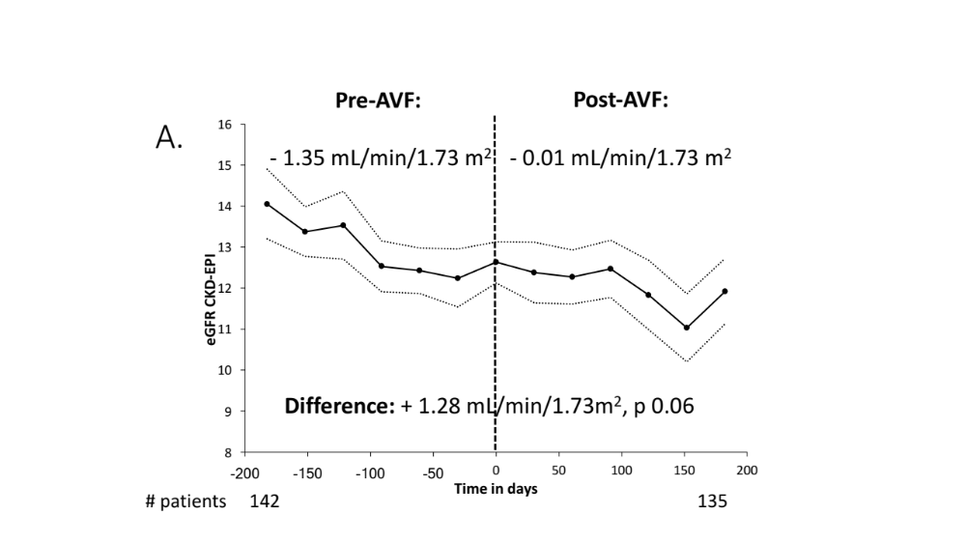
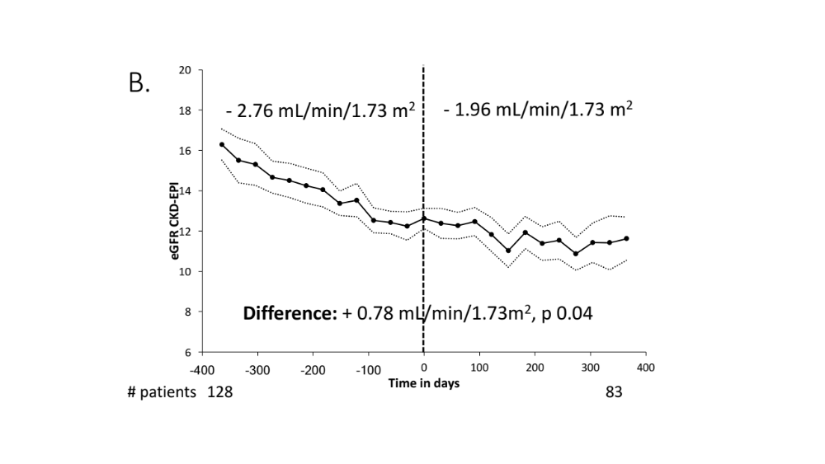
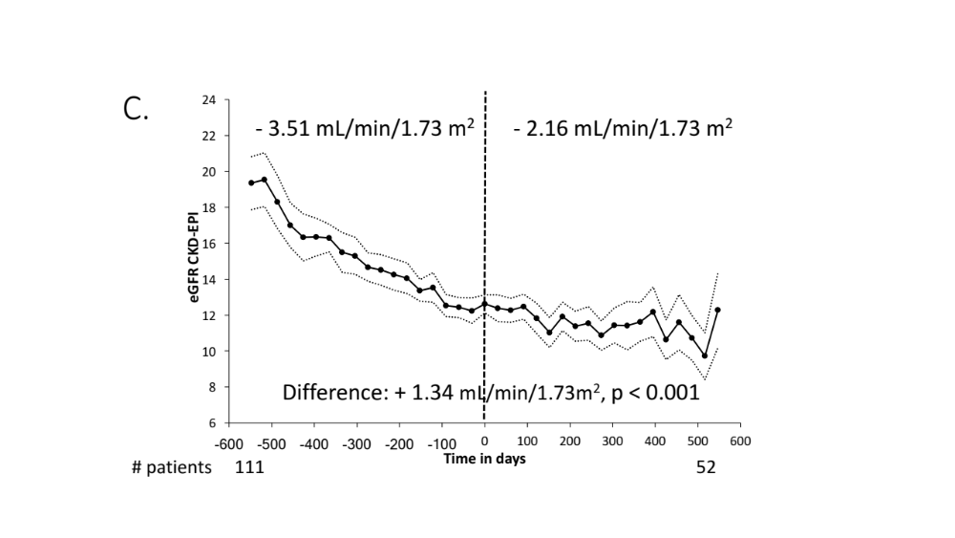

Figure S1 displays the eGFR in mL/min/1.73 m², calculated using the CKD-EPI formula, against the time in days before and after AVF creation, the latter represented by time 0. The estimates are represented by the bold solid line with the 95% confidence interval in dotted lines. The eGFR decline after AVF creation was slowed by 1.28 mL /min/1.73 m² in the 6 months (A), by 0.78 mL/min/1.73 m² in the 12 months (B) and by 1.34 mL/min/1.73 m² in the 18 months (C), pre- and post AVF creation.

