Additional file 4: Figure s4. Iliac artery ROIs in a three-dimensional PET image
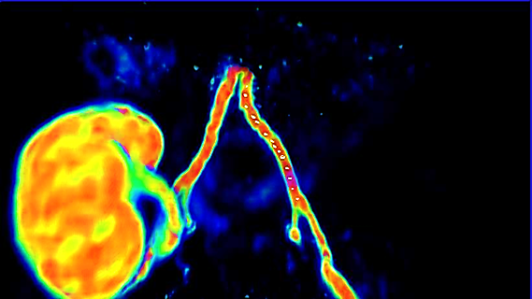
Blue arrow points to ROI:s in left external iliac artery.

