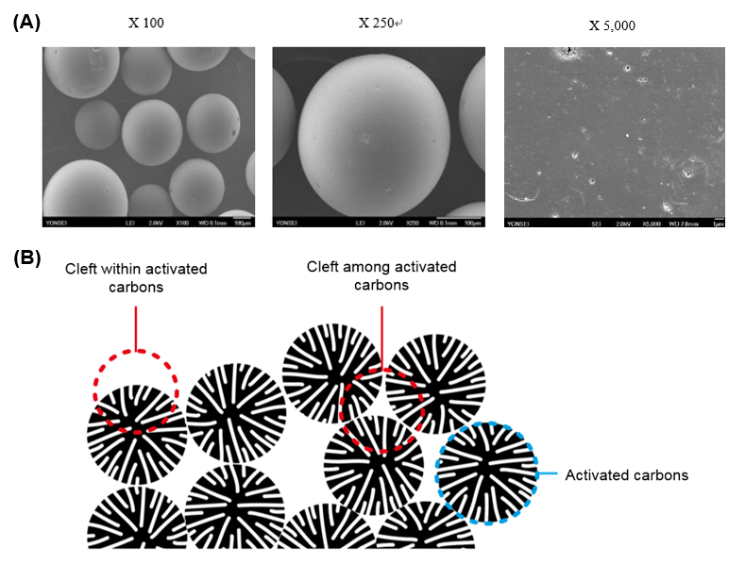
Additional file 1. Figure S1 Structural features of Renamezin. Scanning electron microscopy of demonstrate that Renamezin presents as black, spherical carbon particles of 0.2-0.4 mm in diameter with hard structural surface (x100, x250, x5,000, A). Clefts within activated carbons exhibit increased adsorption to low molecular weight uremic toxins and less adsorption to high molecular weight substances such as digestive enzymes (B). (Patent registration number 10-1145131-0000 Puresphere, Spherical activated carbons).
Note: (A) The images were obtained by scanning electronic microscopy by EM-30 (COXEM, Daejeon, South Korea). (B) Image was developed by Photoshop software (Adobe Systems, Inc. San Jose, CA, USA).

