Additional File 2: Supplemental Figure 1:
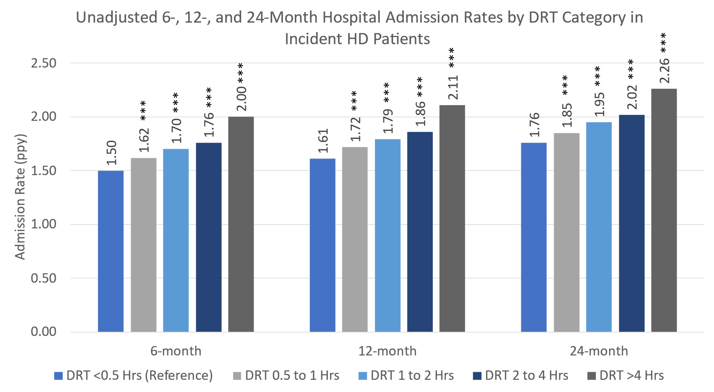
Supplemental Figure 1: Exploratory analysis of unadjusted 6-, 12-, and 24-month hospital admission rates by DRT category in incident HD patients. ***, p<0.001.

