Supplementary File 1.
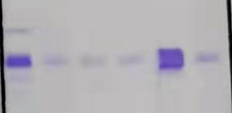
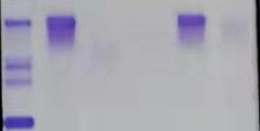
SP IgG IgA IgM κ λ
SP IgG IgA IgM κ λ

Figure S1. Immunofixation electrophoresis. Monoclonal IgGκ in serum (Left) andκlight chain in urine (Right).

SP IgG IgA IgM κ λ
SP IgG IgA IgM κ λ
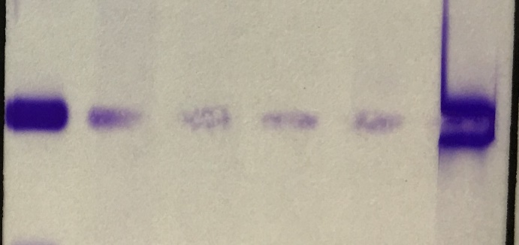
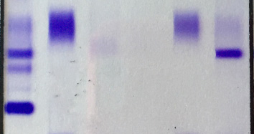

Figure S2. Immunofixation electrophoresis. Monoclonal λ light chain in serum (Left) and urine (Right).

Supplementary File 2.

1、Search strategy for MEDLINE (PubMed) database

Light chain amyloid cast nephropathy

Step | Search Term
1 | Amyloid casts
2 | Intratubular amyloid
3 | Amyloid cast tubulopathy
4 | Unusual casts in multiple myeloma
5 | 1 OR 2 OR 3 OR4

Search results: 67

Light chain crystal casts nephropathy

Step | Search Term
1 | Light chain crystal casts
2 | Crystalline cast nephropathy
3 | Crystal cast in multiple myeloma
4 | Crystalline light chain proximal tubulopathy
5 | 1 OR 2 OR 3 OR4

Search results: 70

2、Search strategy for EMBASE database

Light chain amyloid cast nephropathy

Step | Search Term
1 | Cast nephropathy
2 | Myeloma kidney
3 | Light chain nephropathy
4 | Paraprotein-related kidney disease
5 | Tubular injury
6 | Tubular obstruction
7 | 1 OR 2 OR 3 OR 4 OR5 OR 6
8 | Exp amyloidosis
9 | Exp amyloid
10 | 8 OR 9
11 | 7 AND 10

Search results: 305

Light chain crystal casts nephropathy

Step | Search Term
1 | Cast nephropathy
2 | Myeloma kidney
3 | Light chain nephropathy
4 | Paraprotein-related kidney disease
5 | Tubular injury
6 | Tubular obstruction
7 | 1 OR 2 OR 3 OR 4 OR5 OR 6
8 | Crystalline
9 | Crystal
10 | 8 OR 9
11 | 7 AND 10

Search results: 130

