epidemiology and outcome of elderly patients after renal replacement therapy in the intensive care unit: an observational study: Supplementary material

Figure S1: VAS (visual analog scale) French version, as provided by EuroQol for the use over the phone. This version has been sent to the survivors prior to the phone call.

Excluded:
- < 55 yo (135)
- Chronic dialysis (84)
- Declined data reutilization (37)
Died in ICU (148)
Died on the ward (23)
Could not be reached (23)
Unable to participate (2)
Declined participation (11)
Died during follow-up period (62)

Figure S2: Study flow chart.

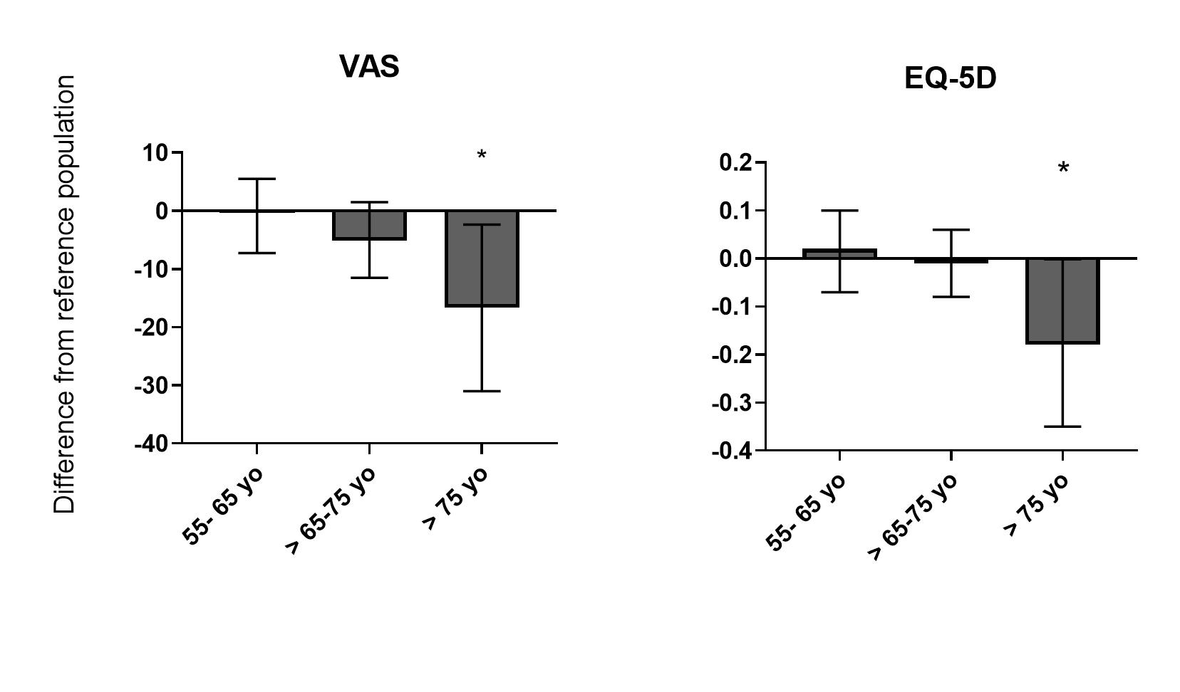

Figure S3: Differences between observed and predicted (French speaking Swiss reference population).
Values are mean (SD). Comparisons with one sample t-test on Observed – predicted difference.
Predicted values calculated according to Ref 15 (Perneger et al).

 | TOTAL | 55-65 yo | >65 – 75 yo | >75 yo | p value
N (%) | 83 (100%) | 24 (28.9%) | 44 (53.0%) | 15 (18.1%)
Median age - years (IQR) | 68.1 (8.6) | 59.9 (5.9) | 68.9 (3.6) | 78.6 (5.0) | <0.001
Gender Male - n (%) | 60 (72.3%) | 21 (87.5%) | 28 (63.6%) | 11 (73.3%) | 0.11
Median weight – kg (IQR) | 85 (28) | 87 (26) | 85.5 (29.0) | 85 (23) | 0.72
Admission year |  |  |  |  | 0.18
2015 | 21 (25.3%) | 7 (29.2%) | 12 (27.3%) | 2 (13.3%)
2016 | 26 (31.3%) | 6 (25.0%) | 13 (29.5%) | 7 (46.7%)
2017 | 26 (31.3%) | 10 (41.7%) | 14 (31.8%) | 2 (13.3%)
2018 | 10 (12.0%) | 1 (4.2%) | 5 (11.4%) | 4 (26.7%)
Admission type
Medical | 36 (43.4%) | 9 (37.5%) | 24 (54.5%) | 3 (20.0%) | 0.08
Surgical | 43 (51.8%) | 15 (62.5%) | 17 (38.6%) | 11 (73.3%)
Other | 4 (4.8%) | 0 (0%) | 3 (6.8%) | 1 (6.7%)
Median SAPS Score (IQR) |  | 53 (22) | 56 (13) | 59 (13) | 0.27
Median ICU LOS – days (IQR) | 10.2 (17.6) | 9.8 (14.0) | 10.6 (22.3) | 6.9 (17.1) | 0.99
Median hospital LOS – days (IQR) | 38.9 (50.7) | 34.3 (51.2) | 34.0 (50.1) | 40.9 (42.2) | 0.57
Co-existing conditions – n (%) | 38 (45.8%) | 12 (50.0%) | 19 (43.2%) |  | 0.86
CKD | 21 (25.9%) | 5 (21.7%) | 15 (34.9%) | 1 (6.7%) | 0.09
CHD | 14 (16.9%) | 5 (21.7%) | 7 (15.9%) | 2 (13.3%) | 0.81
Chron.resp.D | 14 (16.9%) | 1 (4.2%) | 8 (18.2%) | 5 (33.3%) | 0.06
Chron.liver.D | 7 (8.4%) | 4 (16.7%) | 3 (6.8%) | 0 | 0.16
Immunosupp. | 8 (9.6%) | 4 (16.7%) | 4 (9.1%) | 0 | 0.23
Haematological | 3 (3.6%) | 2 (8.3%) | 1 (2.3%) | 0 | 0.31
Metastatic cancer | 0 (0%) | 0 (0%) | 0 (0%) | 0 (0%) | 1
On RRT initiation
MV on initiation | 56 (67.5%) | 18 (75.0%) | 27 (61.4%) | 11 (73.3%) | 0.45
NA on initiation | 68 (81.9%) | 20 (83.3%) | 33 (75.0%) | 15 (100%) | 0.23
Mean max creatinine - mmol/l (SD) | 366 (254) | 309 (207) | 419 (300) | 298 (106) | 0.16
Mean max lactate - mmol/l (SD) | 6.2 (2.9) | 6.2 (2.0) | 5.8 (2.7) | 6.8 (4.3) | 0.72

Table S1: Demographics of survey responders
IQR: Interquartile range, LOS: ICU length of stay, RRT: renal replacement therapy, MV: mechanical ventilation, NA: noradrenaline, max: maximum.

