Dipstick = 1134
n= 21 subjects did not give a urine sample,
162 excluded because of the detection of blood, leucocytes and/or nitrites.
Included n=1317
n= 730 rural site
n= 587 urban site

Serum creatinine n=1235
eGFRcr n=1235

Ratio A/C n=1070
Missing = 247 (rural 97, urban 150)
n= 100 samples lost during transport
n= 126 volume of samples too low

Cystatin C
Missing 128
n= 82 haemolyzed samples
n= 46 volume of samples too low

Creatinine
Missing n= 82
-n= 36 haemolyzed samples
-n= 46 volume of samples too low

Cystatin C n=1189
eGFRcr/eGFRcr-cys

Excluded n=33
n= 24 pregnant
n= 9 without consent

n=1350
Population screened

Supplementary Figure 1: Flow chart of the study population and data availability.

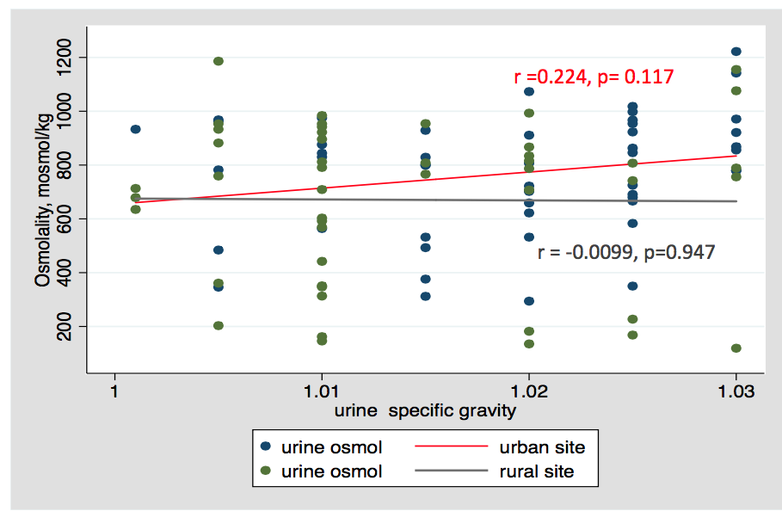

Supplementary Figure 2: correlation between urine specific gravity and osmolality in sub-group of urban (red line) and rural (gray line) subjects.
Supplementary Table 1. Positivity of dipstick proteinuria in cases with ACR < 30 mg/g (A1), ≥ 30 mg/g (A2) and ≥ 300 mg/g (A3)
a) Whole group
 | ACR (mg/g) |  |  | Total
Urine dipstick | < 30 | 30-300 | > 300
0 | 800 | 33 | 9 | 842
≥ 1+ | 88 | 6 | 4 | 98
Total | 888 | 39 | 13 | 940

b) Urban site

 | ACR (mg/g) |  |  | Total
Urine dipstick | < 30 | 30-300 | > 300
0 | 325 | 10 | 8 | 343
≥ 1+ | 15 | 4 | 1 | 20
Total | 340 | 14 | 9 | 363

c) Rural site

 | ACR (mg/g) |  |  | Total
Urine dipstick | < 30 | 30-300 | > 300
0 | 475 | 23 | 1 | 499
≥ 1+ | 73 | 2 | 3 | 78
Total | 548 | 25 | 4 | 577

Supplementary Table 2. Diagnostic performance of dipstick proteinuria for the detection of ACR ≥ 30 mg/g (A2) and ACR ≥ 300 mg/g (A3)
- Whole group
Standard reference | Cutoff | Sensitivity | Specificity | PPV | NPV
ACR ≥ 30 mg/g | ≥ 1+ | 19.2 % | 90.1 % | 10.2 % | 95.0%
ACR ≥ 300 mg/g | ≥ 1+ | 30.8 % | 89.9 % | 4.1% | 98.9 %

b) Urban

Standard reference | Cutoff | Sensitivity | Specificity | PPV | NPV
ACR ≥ 30 mg/g | ≥ 1+ | 17.2 % | 86.7 % | 25 % | 94.8%
ACR ≥ 300 mg/g | ≥ 1+ | 11.1 % | 94.6% | 5 % | 97.7%

c) Rural

Standard reference | Cutoff | Sensitivity | Specificity | PPV | NPV
ACR ≥ 30 mg/g | ≥ 1+ | 21.7 % | 95.6% | 6.4 % | 95.2%
ACR ≥ 300 mg/g | ≥ 1+ | 75% | 86.9 % | 3.8 % | 99.8 %
ACR, spot urine albumin/creatinine ratio (mg/g); NPV, negative predictive value; PPV, positive predictive value.

