Figure S1: Occurence of moderate-severe AKI and KRT (AKI episodes)
Figure S1a: Occurrence of moderate-severe AKI
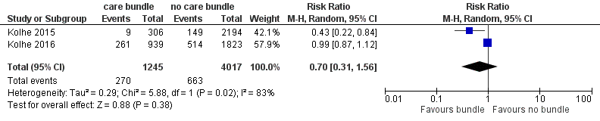
Figure S1b: Occurrence of KRT in patients with AKI
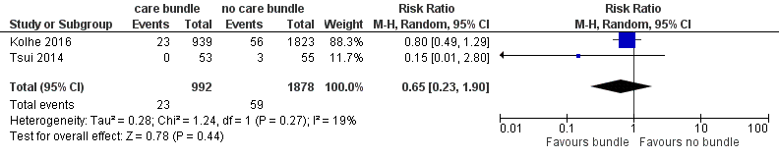

Figure S2: Outcomes in ICU patients only
Figure S2a: AKI occurrence
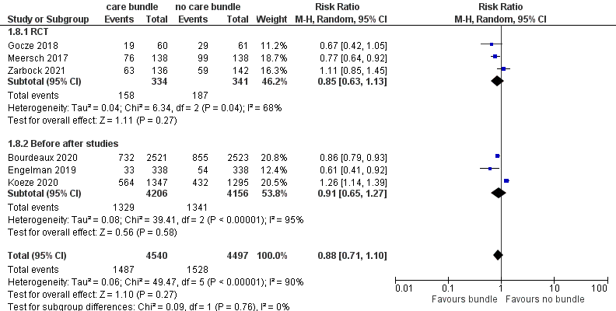

Figure S2b: Occurrence of moderate-severe AKI
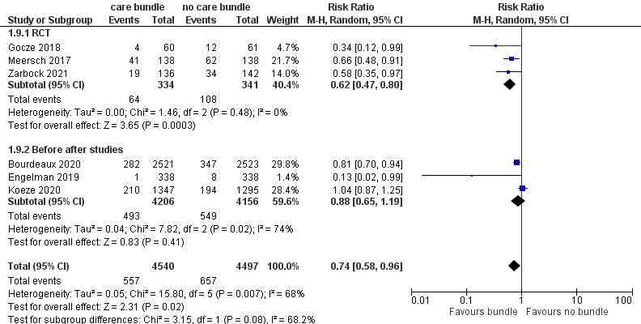
Figure S2c: Use of KRT
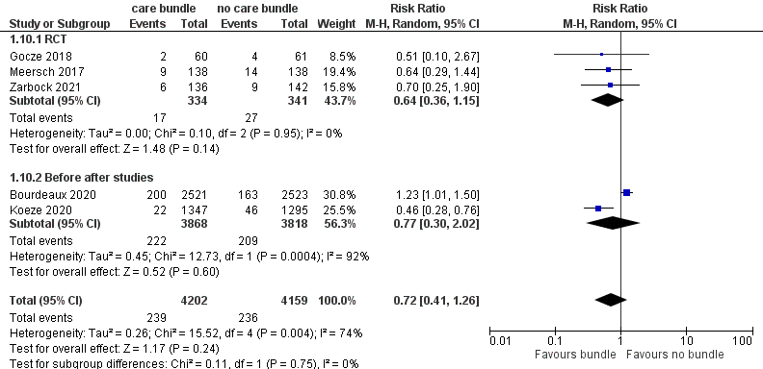

Figure S3: mortality outcomes
Figure S3a: ICU mortality with and without AKI care bundle (AKI episodes)
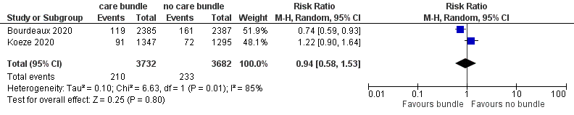
Figure S3b: 30 day mortality with and without AKI care bundle (AKI episodes)
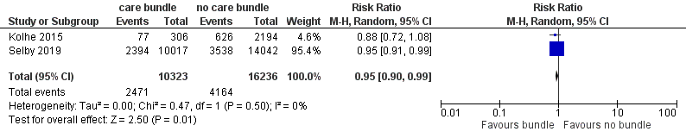
Figure S3c: 30 day mortality with and without AKI care bundle (all patients)
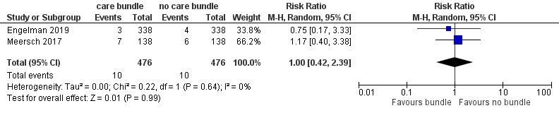
Figure S4: Hospital length-of-stay with and without AKI care bundle (AKI episodes)
