Figure S5: Funnel plots of main outcomes
Figure a: AKI occurrence
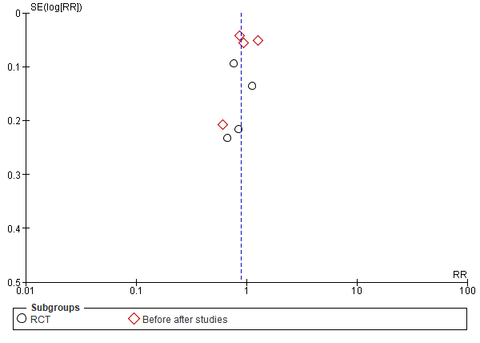
Figure b: Occurrence of moderate severe AKI
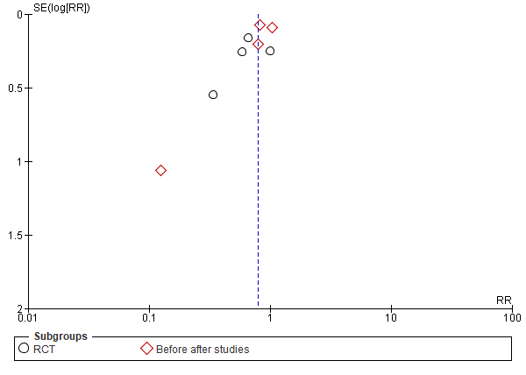

Figure c: Use of KRT
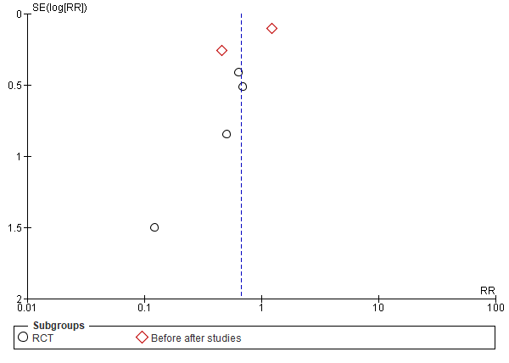
Figure d: In-hospital mortality (all pts)
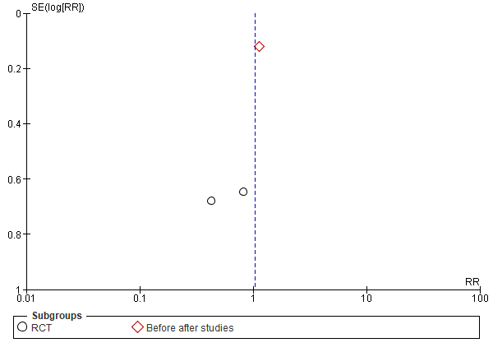

Figure e: In-hospital mortality (AKI pts)
