Additional File 4 Risk of the cardiorenal composite outcome by change in RAASi dose following an HK episode in (a) the US and (b) Japan in patients with CKD stage 3 or 4 (with or without HF)
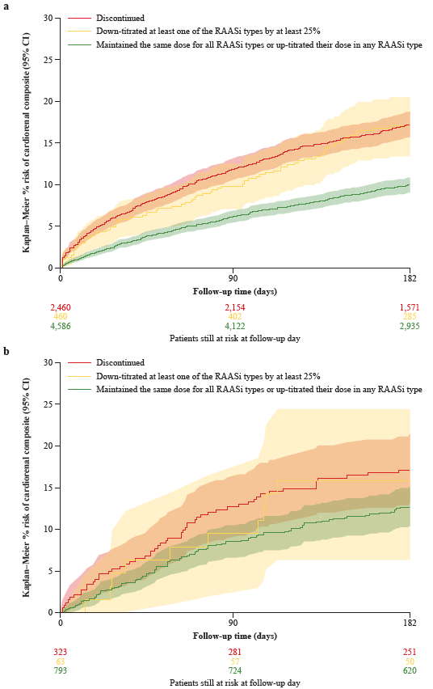

CI confidence interval, CKD chronic kidney disease, HK hyperkalemia, RAASi renin-angiotensin-aldosterone system inhibitor.

