SUPPLEMENTAL MATERIAL

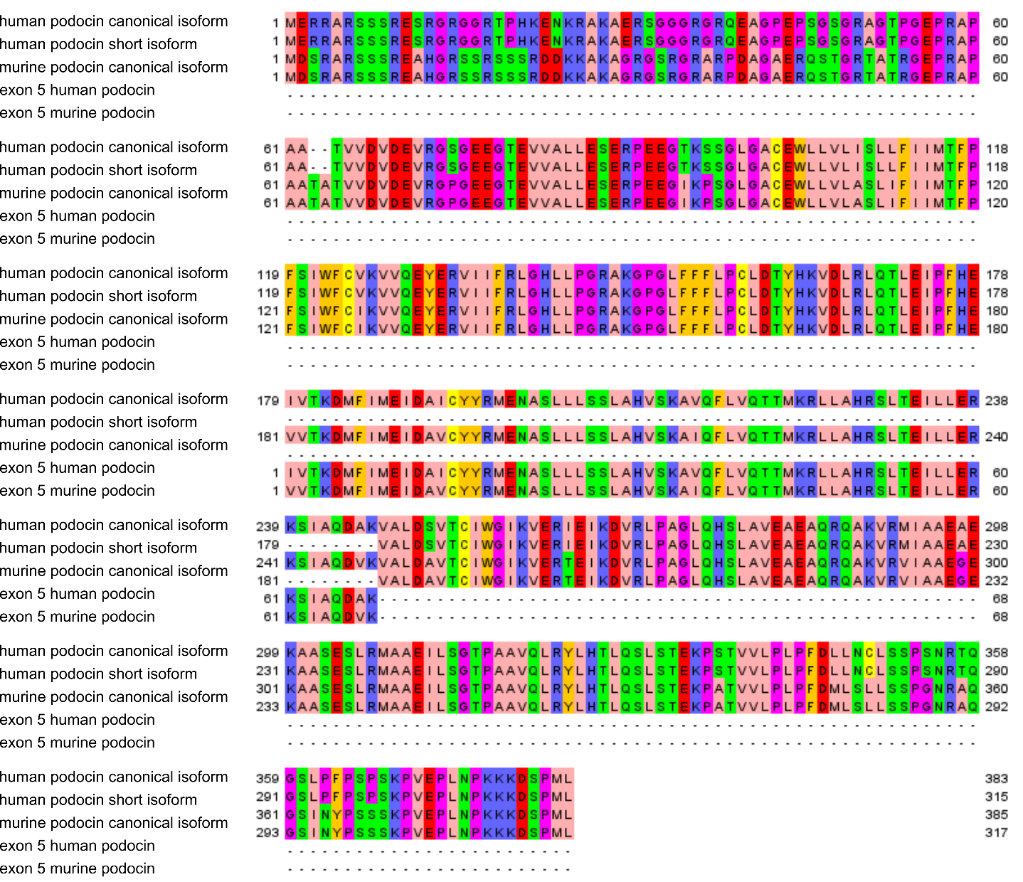
Supplemental Fig. 1: Amino acid alignment of human podocin canonical form, human podocin short isoform, murine podocin canonical form, exon 5 of human podocin and exon 5 of murine podocin. Amino acids are color coded for better visualization of alignment. The alignment was done using the T-Coffee webserver ²³ and formatted using Jalview ²⁴.
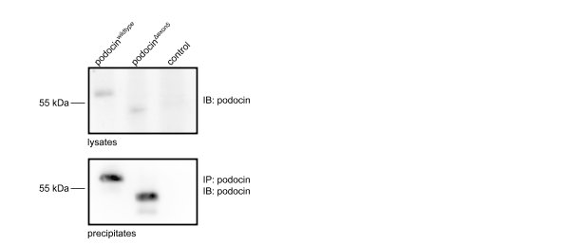
Supplemental Fig. 2: The podocin antibody used in this study is able to bind to the denatured and the native podocin^{Δexon5} protein. Lysates of HEK293T cell transiently expressing podocin^{wildtype} or podocin^{Δexon5} were subjected to immunoprecipitation with an anti-podocin antibody and subsequent immunoblotting. The full-length blot is presented in suppl. fig. 5.
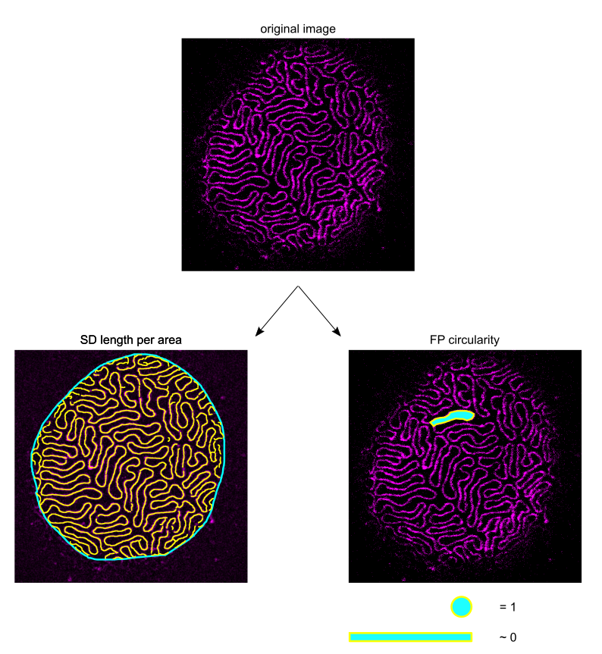 Supplemental Fig. 3: Schematic display of the two morphological parameters used. An original image, labelled with an anti-nephrin antibody, is used to quantify the (1) SD length (yellow lines), represented by the length of the nephrin signal, within a region of interest (cyan line) and (2) the FP circularity, which is a dimensionless-less value expressing how circular a geometric body is (circularity = 4 * π (area/perimeter²)). A perfect circle has a value of 1, an elongated polygon approximates 0.

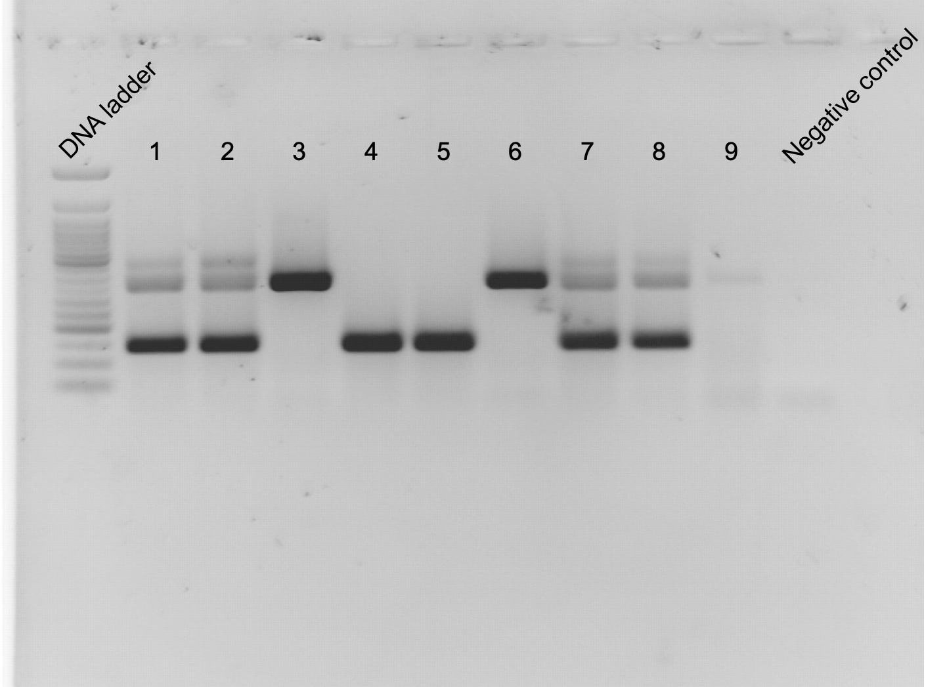
Supplemental Fig. 4: Full-length gel of panel D of figure 1. Numbers refer to individual mice. Samples 3 and 4 are depicted in fig. 1.

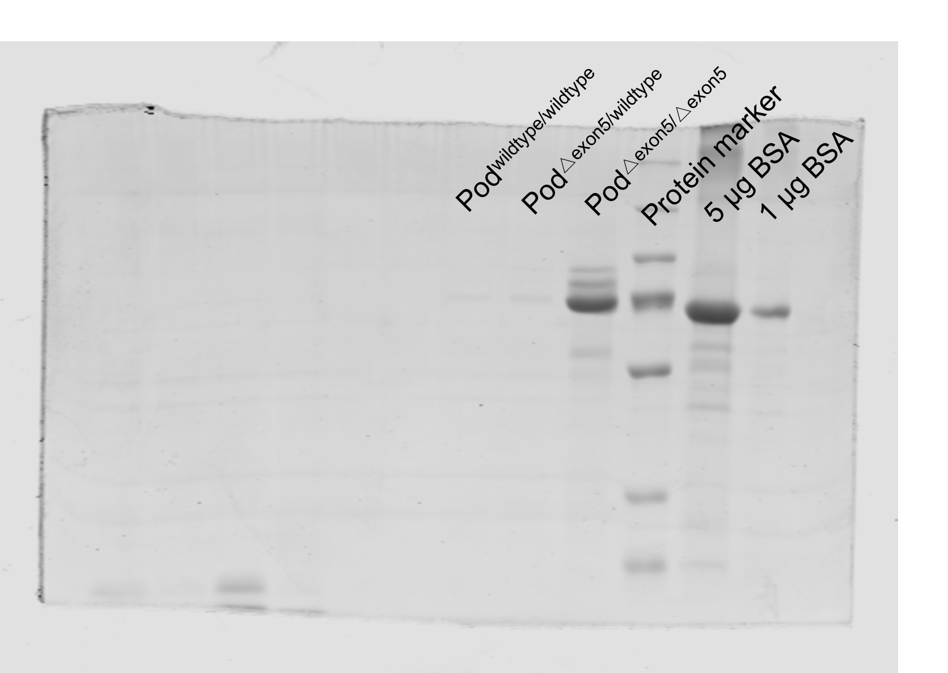
Supplemental Fig. 5: Full-length gel of panel C of figure 2.

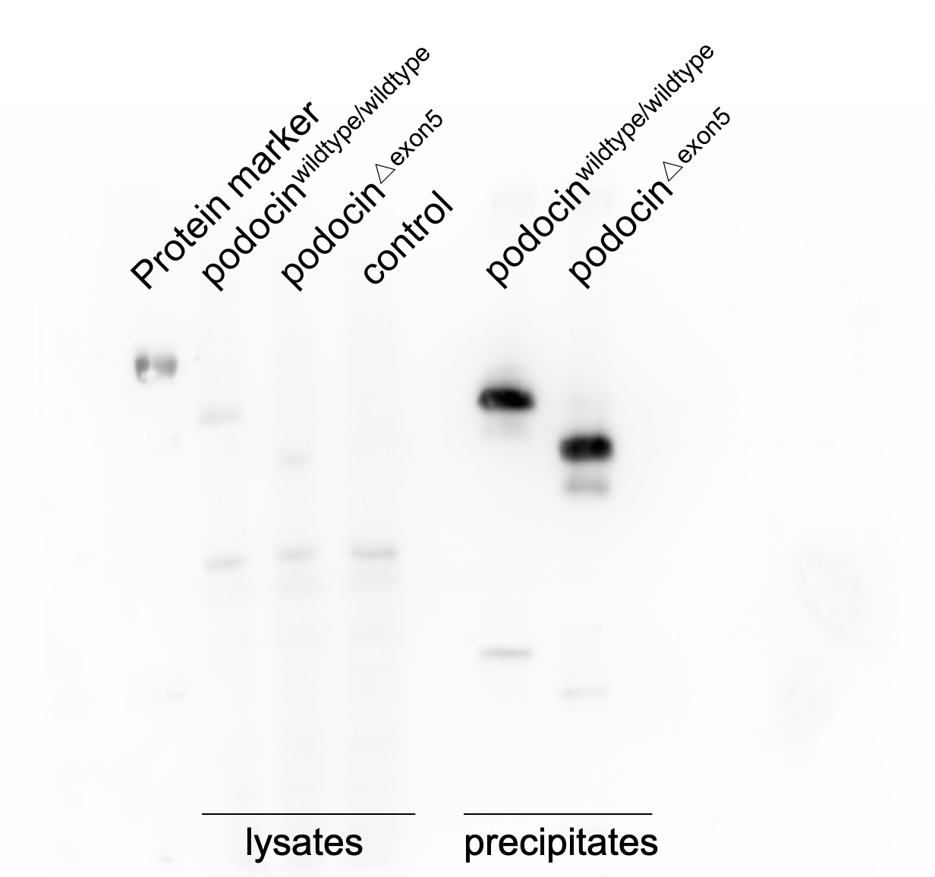
Supplemental Fig. 5: Full-length blot of suppl. fig. 2

