Supplementary Material
Table of Contents

Supplemental Table S1. Cox regression simplified model eGFR hazard ratios for all-cause and CVD mortality among patients with type 2 diabetes stratified by age using 65 years as cut-off and gender, with eGFR between 90-119 mL/min per 1.73 m² as reference 8
Supplemental Figure S1. Kaplan-Meier curves for the survival probability of female and male among groups stratified by eGFR with all-cause mortality as outcome 10
Supplemental Figure S2. Cox regression parsimonious model all-cause mortality hazard curves adjusted for covariates characterizing 2-way interaction of eGFR and gender 11
Supplemental Figure S3. Cox regression sensitivity model with different eGFR knots for the outcome of all-cause mortality hazard curves adjusted for covariates characterizing 3-way interaction of eGFR, gender and age category 12
Supplemental Figure S4. Cox regression model all-cause mortality hazard curves adjusted for covariates characterizing 3-way interaction of eGFR, gender and age category in dataset including the average of at least two measurments of eGFR for every patient during 2013 to 2019 13
Supplemental Figure S5. Cox regression parsimonious model all-cause mortality hazard curves adjusted for covariates, replacing albuminuria by albumin-creatinine-ratio, characterizing 3-way interaction of eGFR, gender and age category 14
Supplemental Figure S6. Cox regression parsimonious model CVD mortality hazard curves adjusted for covariates characterizing 2-way interaction of eGFR and gender 15
Supplemental Figure S7. Cox regression model CVD mortality hazard curves adjusted for covariates characterizing 3-way interaction of eGFR, gender and age category 16
Supplemental Figure S8. Cox regression simplified model all-cause mortality hazard curves adjusted for covariates characterizing 3-way interactions of eGFR, gender and age category 17
Supplemental Figure S9. Cox regression simplified model (excluding living in rental block) all-cause mortality hazard curves adjusted for covariates characterizing 3-way interactions of eGFR, gender and age category 18
Supplemental Figure S10. Cox regression simplified model CVD mortality hazard curves adjusted for covariates characterizing 3-way interactions of eGFR, gender and age category 19
Supplemental Figure S11. Cox regression simplified model (excluding living in rental block) CVD mortality hazard curves adjusted for covariates characterizing 3-way interactions of eGFR, gender and age category 20

Supplemental Table S1. Cox regression simplified model eGFR hazard ratios for all-cause and CVD mortality among patients with type 2 diabetes stratified by age using 65 years as cut-off and gender, with eGFR between 90-119 mL/min per 1.73 m² as reference (N=36556; years 2013-2019)

eGFR categories  (mL/min per 1.73 m²) | <65 years |  |  | ≥65 years
eGFR categories  (mL/min per 1.73 m²) | Male | Female |  | Male | Female
All-cause mortality
<30 | 4.82 (1.19, 19.45) | 18.10 (7.44, 44.02) |  | 3.30 (2.25, 4.85) | 5.67 (4.01, 8.02)
30 - <60 | 1.30 (0.79, 2.14) | 2.73 (1.66, 4.47) |  | 1.88 (1.55, 2.28) | 2.62 (2.13, 3.21)
60 - <90 | 1.12 (0.88, 1.43) | 1.63 (1.18, 2.25) |  | 1.18 (0.98, 1.41) | 1.92 (1.59, 2.31)
90 - <120 | 1.00 (Reference) | 1.00 (Reference) |  | 1.00 (Reference) | 1.00 (Reference)
CVD mortality
<30 | 5.95 (0.82, 43.03) | 40.27 (12.97, 125.03) |  | 2.86 (1.38, 5.96) | 9.86 (5.36, 18.17)
30 - <60 | 1.51 (0.72, 3.18) | 3.98 (1.74, 9.12) |  | 1.86 (1.27, 2.73) | 3.86 (2.50, 5.96)
60 - <90 | 1.10 (0.73, 1.66) | 1.49 (0.76, 2.93) |  | 1.20 (0.83, 1.72) | 2.22 (1.46, 3.37)
90 - <120 | 1.00 (Reference) |  | 1.00 (Reference) | 1.00 (Reference) | 1.00 (Reference)
Model: Elapsed time to all-cause/CVD mortality = eGFR + age + gender + eGFR*age + eGFR*gender + age*gender + eGFR*age*gender + covariates. Covariates: ethnicity, living in rental block, smoking, body mass index, lipid medications, established CVD, and albuminuria. Abbreviations: eGFR, estimated glomerular filtration rate. CVD, cardiovascular disease.

Supplemental Figure 1. Kaplan-Meier curves for the survival probability of female and male among groups stratified by eGFR with all-cause mortality as outcome (N=36556; years 2013-2019)
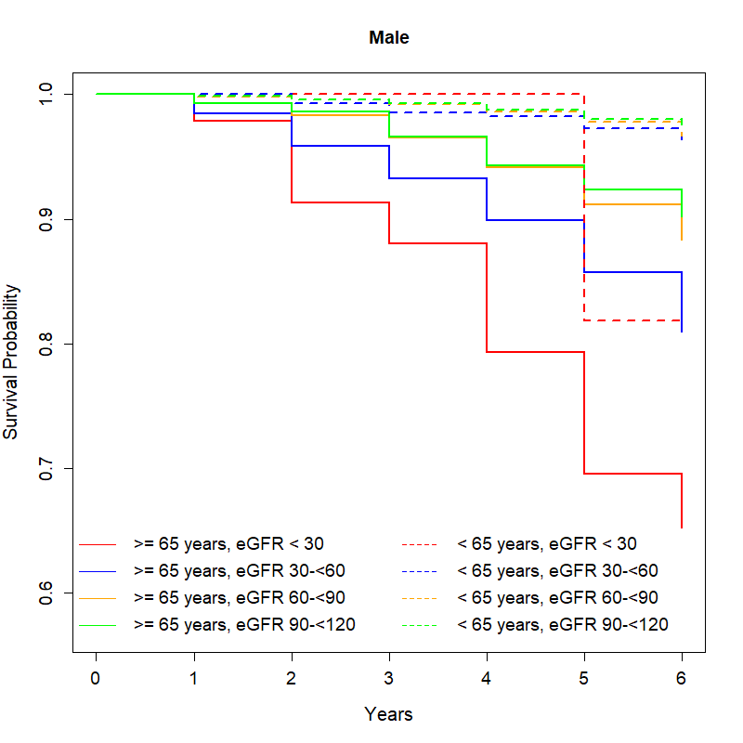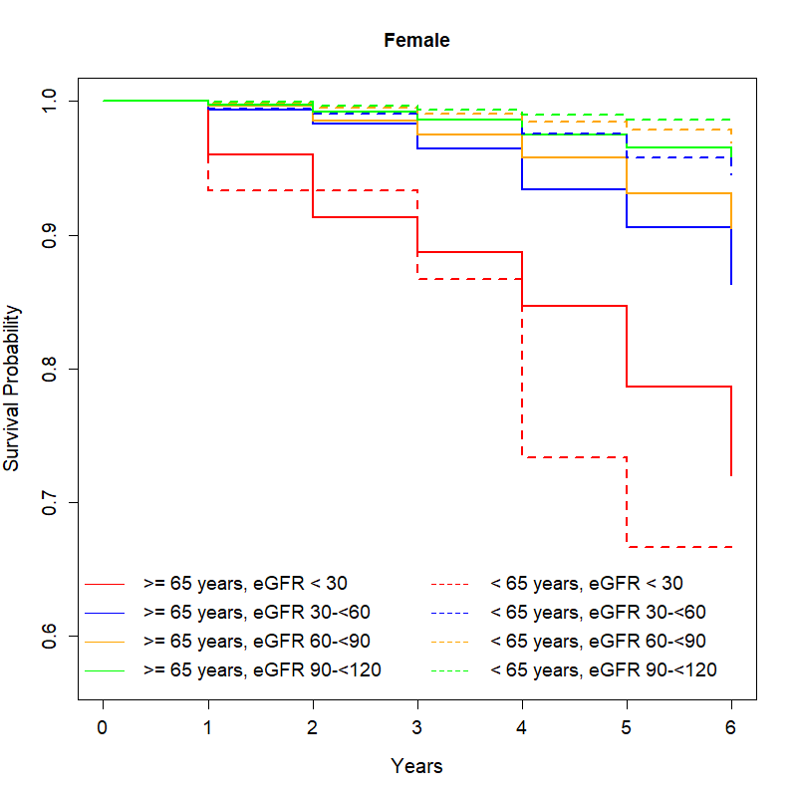
Note: The unit of GFR is in mL/min per 1.73 m².

Supplemental Figure S2. Cox regression parsimonious model all-cause mortality hazard curves adjusted for covariates characterizing 2-way interaction of eGFR and gender (N=36556; years 2013-2019)
eGFR × Gender interaction, p < 0.001

A Reference is eGFR 90 mL/min/1.73m² in men. B Reference for men and women is eGFR 90 mL/min/1.73m². Model: Elapsed time to all-cause mortality = eGFR + gender + eGFR*gender + covariates. Covariates: age, albuminuria. Restrictive cubic spline was applied to eGFR with knots at 5th, 25th, 75th and 95th percentile. Abbreviations: eGFR, estimated glomerular filtration rate.

Supplemental Figure S3. Cox regression sensitivity model with different eGFR knots for the outcome of all-cause mortality hazard curves adjusted for covariates characterizing 3-way interaction of eGFR, gender and age category (N=36556; years 2013-2019)
eGFR × Age × Gender interaction, p = 0.032

A Reference is eGFR 90 mL/min/1.73m² in men aged <65 years. B Reference for men and women is eGFR 90 mL/min/1.73m² aged <65 years. Model: Elapsed time to all-cause mortality = eGFR + age + gender + eGFR*age + eGFR*gender + age*gender + eGFR*age*gender + covariates. Covariates: ethnicity, living in rental block, smoking, body mass index, lipid medications, hypertension, established CVD, albuminuria, systolic blood pressure, diastolic blood pressure, high-density lipoprotein, low-density lipoprotein, and triglycerides. Restrictive cubic spline was applied to eGFR with knots at 30, 45, 90 and 105 mL/min per 1.73 m². Abbreviations: eGFR, estimated glomerular filtration rate. CVD, cardiovascular disease.
Supplemental Figure S4. Cox regression model all-cause mortality hazard curves adjusted for covariates characterizing 3-way interaction of eGFR, gender and age category in dataset including the average of at least two measurments of eGFR for every patient during 2013 to 2019 (N=32873; years 2013-2019)
eGFR × Age × Gender interaction, p <0.001
A Reference is eGFR 90 mL/min/1.73m² in men aged <65 years. B Reference for men and women is eGFR 90 mL/min/1.73m² aged <65 years. Model: Elapsed time to all-cause mortality = eGFR + age + gender + eGFR*age + eGFR*gender + age*gender + eGFR*age*gender + covariates. Covariates: ethnicity, living in rental block, smoking, body mass index, lipid medications, hypertension, established CVD, albuminuria, systolic blood pressure, diastolic blood pressure, high-density lipoprotein, low-density lipoprotein, and triglycerides. Restrictive cubic spline was applied to eGFR with knots at 5th, 25th, 75th and 95th percentile. Abbreviations: eGFR, estimated glomerular filtration rate. CVD, cardiovascular disease.
Supplemental Figure S5. Cox regression parsimonious model all-cause mortality hazard curves adjusted for covariates, replacing albuminuria by albumin-creatinine-ratio, characterizing 3-way interaction of eGFR, gender and age category (N=32087; years 2013-2019)
eGFR × Age × Gender interaction, p < 0.001

A Reference is eGFR 90 mL/min/1.73m² in men aged <65 years. B Reference for men and women is eGFR 90 mL/min/1.73m² aged <65 years. Model: Elapsed time to all-cause mortality = eGFR + gender + eGFR*gender + covariates. Covariates: age, albumin-to-creatinine ratio. Restrictive cubic spline was applied to eGFR with knots at 5th, 25th, 75th and 95th percentile. Abbreviations: eGFR, estimated glomerular filtration rate.
Supplemental Figure S6. Cox regression parsimonious model CVD mortality hazard curves adjusted for covariates characterizing 2-way interaction of eGFR and gender (N=36556; years 2013-2019)

eGFR × Gender interaction, p <0.001

A Reference is eGFR 90 mL/min/1.73m² in men. B Reference for men and women is eGFR 90 mL/min/1.73m². Model: Elapsed time to CVD mortality = eGFR + gender + eGFR*gender + covariates. Covariates: age, albuminuria. Restrictive cubic spline was applied to eGFR with knots at 5th, 25th, 75th and 95th percentile. Abbreviations: eGFR, estimated glomerular filtration rate. CVD, cardiovascular disease.
Supplemental Figure S7. Cox regression model CVD mortality hazard curves adjusted for covariates characterizing 3-way interaction of eGFR, gender and age category (N=36556; years 2013-2019)
eGFR × Age × Gender interaction, p = 0.380
A Reference is eGFR 90 mL/min/1.73m² in men aged <65 years. B Reference for men and women is eGFR 90 mL/min/1.73m² aged <65 years. Model: Elapsed time to CVD mortality = eGFR + age + gender + eGFR*age + eGFR*gender + age*gender + eGFR*age*gender + covariates. Covariates: ethnicity, living in rental block, smoking, body mass index, lipid medications, hypertension, established CVD, albuminuria, systolic blood pressure, diastolic blood pressure, high-density lipoprotein, low-density lipoprotein, and triglycerides. Restrictive cubic spline was applied to eGFR with knots at 5th, 25th, 75th and 95th percentile. Abbreviations: eGFR, estimated glomerular filtration rate. CVD, cardiovascular disease.
Supplemental Figure S8. Cox regression simplified model all-cause mortality hazard curves adjusted for covariates characterizing 3-way interactions of eGFR, gender and age category (N=36556; years 2013-2019)
eGFR × Age × Gender interaction, p=0.022
A Reference is eGFR 90 mL/min/1.73m² in men aged <65 years. B Reference for men and women is eGFR 90 mL/min/1.73m² aged <65 years. Model: Elapsed time to all-cause mortality = eGFR + age + gender + eGFR*age + eGFR*gender + age*gender + eGFR*age*gender + covariates. Covariates: ethnicity, living in rental block, smoking, body mass index, lipid medications, established CVD and albuminuria. Restrictive cubic spline was applied to eGFR with knots at 5th, 25th, 75th and 95th percentile. Abbreviations: eGFR, estimated glomerular filtration rate. CVD, cardiovascular disease.
Supplemental Figure S9. Cox regression simplified model (excluding living in rental block) all-cause mortality hazard curves adjusted for covariates characterizing 3-way interactions of eGFR, gender and age category (N=36556; years 2013-2019)
eGFR × Age × Gender interaction, p=0.022
A Reference is eGFR 90 mL/min/1.73m² in men aged <65 years. B Reference for men and women is eGFR 90 mL/min/1.73m² aged <65 years. Model: Elapsed time to all-cause mortality = eGFR + age + gender + eGFR*age + eGFR*gender + age*gender + eGFR*age*gender + covariates. Covariates: ethnicity, smoking, body mass index, lipid medications, established CVD, and albuminuria. Restrictive cubic spline was applied to eGFR with knots at 5th, 25th, 75th and 95th percentile. Abbreviations: eGFR, estimated glomerular filtration rate. CVD, cardiovascular disease.
Supplemental Figure S10. Cox regression simplified model CVD mortality hazard curves adjusted for covariates characterizing 3-way interactions of eGFR, gender and age category (N=36556; years 2013-2019)
eGFR × Age × Gender interaction, p=0.379
A Reference is eGFR 90 mL/min/1.73m² in men aged <65 years. B Reference for men and women is eGFR 90 mL/min/1.73m² aged <65 years. Model: Elapsed time to all-cause mortality = eGFR + age + gender + eGFR*age + eGFR*gender + age*gender + eGFR*age*gender + covariates. Covariates: ethnicity, living in rental block, smoking, body mass index, lipid medications, established CVD and albuminuria. Restrictive cubic spline was applied to eGFR with knots at 5th, 25th, 75th and 95th percentile. Abbreviations: eGFR, estimated glomerular filtration rate. CVD, cardiovascular disease.
Supplemental Figure S11. Cox regression simplified model (excluding living in rental block) CVD mortality hazard curves adjusted for covariates characterizing 3-way interactions of eGFR, gender and age category (N=36556; years 2013-2019)
eGFR × Age × Gender interaction, p=0.376
A Reference is eGFR 90 mL/min/1.73m² in men aged <65 years. B Reference for men and women is eGFR 90 mL/min/1.73m² aged <65 years. Model: Elapsed time to all-cause mortality = eGFR + age + gender + eGFR*age + eGFR*gender + age*gender + eGFR*age*gender + covariates. Covariates: ethnicity, smoking, body mass index, lipid medications, established CVD, and albuminuria. Restrictive cubic spline was applied to eGFR with knots at 5th, 25th, 75th and 95th percentile. Abbreviations: eGFR, estimated glomerular filtration rate. CVD, cardiovascular disease.

