Supplementary material
Supplementary Table S1. Number of data points and missing data points for each survey item
Items | Number of data points  (Number of missing data points) | Items | Number of data points  (Number of missing data points)
Age | 10916 (0) | K | 9505 (1411)
Sex | 10916 (0) | Cl | 9338 (1578)
Height | 10916 (0) | Ca | 6810 (4106)
Weight | 10916 (0) | P | 6310 (4606)
CKD etiology | 10916 (0) | Glu | 57 (10859)
RBC | 9233 (1683) | HbA1c | 4785 (6131)
Hb | 9233 (1683) | TG | 6680 (4236)
Ht | 9233 (1683) | HDL-C | 5485 (5485)
MCV | 9233 (1683) | LDL-C | 4095 (6821)
MCHC | 9233 (1683) | ferritin | 1414 (9502)
TLC | 6551 (4265) | Fe | 2155 (8761)
Alb | 8463 (2453) | UIBC | 1946 (8970)
ChE | 3628 (7288) | i-PTH | 514 (10402)
UA | 8291 (2625) | HCO3- | 122 (10794)
BUN | 9605 (1311) | UOb | 4584 (6332)
Cr | 9651 (1265) | UP/UCr | 5185 (5731)
eGFR | 9651 (1265) | UNaCl | 2498 (8418)
Na | 9505 (1411)

Supplementary Table S2. Pearson's correlation coefficients between survey items and time to RRT with absolute values greater than 0.3 (items are standardized)
Items | Correlation coefficients
eGFR | 0.73
Cr | −0.66
BUN | −0.58
Ca | 0.46
P | 0.40
UP/UCr | −0.34
Alb | 0.30

Supplementary Table S3. Pearson's correlation coefficients between survey items with absolute values greater than 0.6 (items are standardized)
Items |  | Correlation coefficients
Hb | Ht | 0.96
RBC | Ht | 0.92
RBC | Hb | 0.90
BUN | Cr | 0.76
Cr | eGFR | −0.76
HEIGHT | WEIGHT | 0.69
SEX | HEIGHT | −0.69
BUN | eGFR | −0.68
Cr | P | 0.61

Supplementary Table S4. VIF of survey items (5 or more)
Items | VIF
RBC | 141
Hb | 788
Ht | 864
MCHC | 62
MCV | 22
Cr | 5.4

Supplementary Table S5. Hyperparameters of each algorithm's prediction model
Algorithm | Hyperparameters
Linear regression | None
Ridge regression | Alpha 420
LASSO regression | Alpha 36
Elastic net | Alpha 15，l1_ratio 0.99
Random forest | max_depth 5, max_features sqrt, max_leaf_nodes 20, min_samples_leaf 5, min_samples_split 10, n_estimators 100
GBDT | 'learning_rate 0.1, max_depth 3, max_features log2, min_samples_leaf 1, n_estimators 80

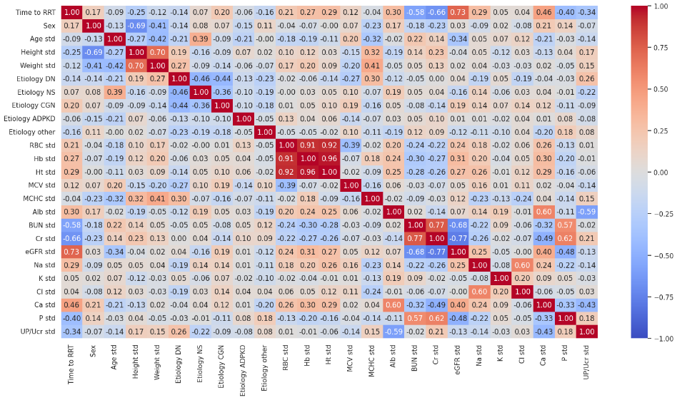
Supplementary Figure S1. Pearson's correlation coefficient heat map of survey items.

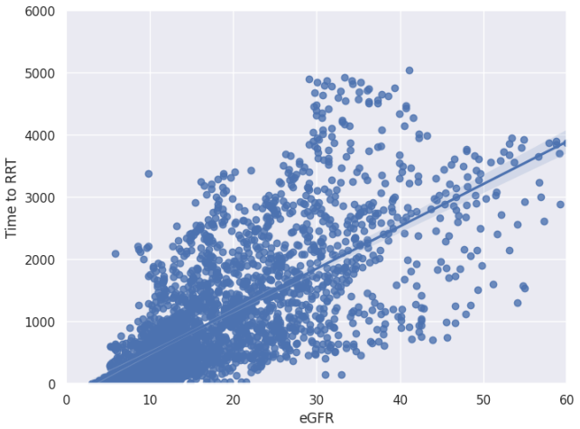
Supplementary Figure S2. Relationship between eGFR and time to RRT. (We used eGFR before standardization.)

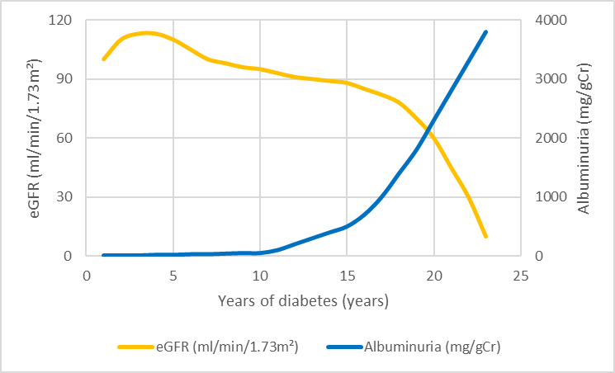
Supplementary Figure S3. Natural history of diabetic nephropathy in type 1 DM, as described by Mogensen et al [45].

