Supplementary file
Table of contents
- PRISMA checklist
- Data sources and Search strategy for each database
- Risk of bias graph
- Risk of bias summary
- eGFR total slope forest plot
- eGFR chronic slope forest plot
- Systolic blood pressure forest plot at week 4
- Diastolic blood pressure forest plot at week 4
- Composite kidney endpoint forest plot
- Treatment emergent adverse events forest plot
- Serious adverse events forest plot
- Adverse events causing withdrawal from the study forest plot
- Adverse events leading to death forest plot
- Headache forest plot
- Dizziness forest plot
- Nausea forest plot
- Edema forest plot
- Diarrhea forest plot
- Hyperkalemia forest plot
- Hypotension forest plot
- Change from baseline in eGFR at week 4
- Table S3. Summary of safety outcome measures
- Table S4. A sensitivity analysis for the efficacy outcome measures
- Table. S5 A sensitivity analysis for the safety outcome measures
- Table. S6 A met regression for eGFR outcome.
************************
Table S1: The PRISMA checklist.
Section and Topic | Item # | Checklist item | Location where item is reported
TITLE
Title | 1 | Identify the report as a systematic review. | 1
ABSTRACT
Abstract | 2 | See the PRISMA 2020 for Abstracts checklist. | 1,2
INTRODUCTION
Rationale | 3 | Describe the rationale for the review in the context of existing knowledge. | 2-4
Objectives | 4 | Provide an explicit statement of the objective(s) or question(s) the review addresses. | 4
METHODS
Eligibility criteria | 5 | Specify the inclusion and exclusion criteria for the review and how studies were grouped for the syntheses. | 5
Information sources | 6 | Specify all databases, registers, websites, organisations, reference lists and other sources searched or consulted to identify studies. Specify the date when each source was last searched or consulted. | 4
Search strategy | 7 | Present the full search strategies for all databases, registers and websites, including any filters and limits used. | 4, Table S2
Selection process | 8 | Specify the methods used to decide whether a study met the inclusion criteria of the review, including how many reviewers screened each record and each report retrieved, whether they worked independently, and if applicable, details of automation tools used in the process. | 4,5
Data collection process | 9 | Specify the methods used to collect data from reports, including how many reviewers collected data from each report, whether they worked independently, any processes for obtaining or confirming data from study investigators, and if applicable, details of automation tools used in the process. | 4,5
Data items | 10a | List and define all outcomes for which data were sought. Specify whether all results that were compatible with each outcome domain in each study were sought (e.g. for all measures, time points, analyses), and if not, the methods used to decide which results to collect. | 4-6
Data items | 10b | List and define all other variables for which data were sought (e.g. participant and intervention characteristics, funding sources). Describe any assumptions made about any missing or unclear information. | 4-6
Study risk of bias assessment | 11 | Specify the methods used to assess risk of bias in the included studies, including details of the tool(s) used, how many reviewers assessed each study and whether they worked independently, and if applicable, details of automation tools used in the process. | 5
Effect measures | 12 | Specify for each outcome the effect measure(s) (e.g. risk ratio, mean difference) used in the synthesis or presentation of results. | 5,6
Synthesis methods | 13a | Describe the processes used to decide which studies were eligible for each synthesis (e.g. tabulating the study intervention characteristics and comparing against the planned groups for each synthesis (item #5)). | 5,6
Synthesis methods | 13b | Describe any methods required to prepare the data for presentation or synthesis, such as handling of missing summary statistics, or data conversions. | 5,6
Synthesis methods | 13c | Describe any methods used to tabulate or visually display results of individual studies and syntheses. | 5,6
Synthesis methods | 13d | Describe any methods used to synthesize results and provide a rationale for the choice(s). If meta-analysis was performed, describe the model(s), method(s) to identify the presence and extent of statistical heterogeneity, and software package(s) used. | 5,6
Synthesis methods | 13e | Describe any methods used to explore possible causes of heterogeneity among study results (e.g. subgroup analysis, meta-regression). | 5,6
Synthesis methods | 13f | Describe any sensitivity analyses conducted to assess robustness of the synthesized results. | 5,6
Reporting bias assessment | 14 | Describe any methods used to assess risk of bias due to missing results in a synthesis (arising from reporting biases). | 5, Fig. 2
Certainty assessment | 15 | Describe any methods used to assess certainty (or confidence) in the body of evidence for an outcome. | 5
RESULTS
Study selection | 16a | Describe the results of the search and selection process, from the number of records identified in the search to the number of studies included in the review, ideally using a flow diagram. | 6, Fig. 1
Study selection | 16b | Cite studies that might appear to meet the inclusion criteria, but which were excluded, and explain why they were excluded. | Fig. 1
Study characteristics | 17 | Cite each included study and present its characteristics. | 6, Table 1
Risk of bias in studies | 18 | Present assessments of risk of bias for each included study. | 7, Figs. 2, 3
Results of individual studies | 19 | For all outcomes, present, for each study: (a) summary statistics for each group (where appropriate) and (b) an effect estimate and its precision (e.g. confidence/credible interval), ideally using structured tables or plots. | 7-9
Results of syntheses | 20a | For each synthesis, briefly summarise the characteristics and risk of bias among contributing studies. | 7-9
Results of syntheses | 20b | Present results of all statistical syntheses conducted. If meta-analysis was done, present for each the summary estimate and its precision (e.g. confidence/credible interval) and measures of statistical heterogeneity. If comparing groups, describe the direction of the effect. | 7-9
Results of syntheses | 20c | Present results of all investigations of possible causes of heterogeneity among study results. | 7-9
Results of syntheses | 20d | Present results of all sensitivity analyses conducted to assess the robustness of the synthesized results. | 7-9
Reporting biases | 21 | Present assessments of risk of bias due to missing results (arising from reporting biases) for each synthesis assessed. | 7-9
Certainty of evidence | 22 | Present assessments of certainty (or confidence) in the body of evidence for each outcome assessed. | 7-9
DISCUSSION
Discussion | 23a | Provide a general interpretation of the results in the context of other evidence. | 9-12
Discussion | 23b | Discuss any limitations of the evidence included in the review. | 11
Discussion | 23c | Discuss any limitations of the review processes used. | 11
Discussion | 23d | Discuss implications of the results for practice, policy, and future research. | 12
OTHER INFORMATION
Registration and protocol | 24a | Provide registration information for the review, including register name and registration number, or state that the review was not registered. | 4
Registration and protocol | 24b | Indicate where the review protocol can be accessed, or state that a protocol was not prepared. | 4
Registration and protocol | 24c | Describe and explain any amendments to information provided at registration or in the protocol. | 4
Support | 25 | Describe sources of financial or non-financial support for the review, and the role of the funders or sponsors in the review. | 12
Competing interests | 26 | Declare any competing interests of review authors. | 12
Availability of data, code and other materials | 27 | Report which of the following are publicly available and where they can be found: template data collection forms; data extracted from included studies; data used for all analyses; analytic code; any other materials used in the review. | 13

Table S2: Search strategy of each database.
Database | Search strategy | Limitations | Number of records
PubMed | (Sparsentan OR (angiotensin II receptor antagonist)) AND ((Focal Segmental Glomerulosclerosis) OR (IgA nephropathy) OR FSGS) | No limitations were applied | 373
Scopus | (sparsentan OR (angiotensin AND receptor AND antagonist)) AND ((focal AND segmental AND glomerulosclerosis) OR (iga AND nephropathy) OR fsgs) | Language: limited to English  Document type: limited to Article  No time restrictions | 534
Cochrane | (Sparsentan OR (angiotensin II receptor antagonist)) AND ((Focal Segmental Glomerulosclerosis) OR (IgA nephropathy) OR FSGS) | Document type: limited to Trials  No time restrictions | 59
Web of Science | (Sparsentan OR (angiotensin II receptor antagonist)) AND ((Focal Segmental Glomerulosclerosis) OR (IgA nephropathy) OR FSGS) | Language: limited to English  No time restrictions | 114

A literature search was performed and four databases (PubMed, Cochrane Central Register of Controlled Trials (CENTRAL), Web of Science, and Scopus) were searched for published articles up to march, 2024 using relevant keywords; (Sparsentan OR (angiotensin II receptor antagonist)) AND ((Focal Segmental Glomerulosclerosis) OR (IgA nephropathy) OR FSGS). Our Search considered research articles published in the English language only without time restrictions.

Risk of bias graph (Figure S1): 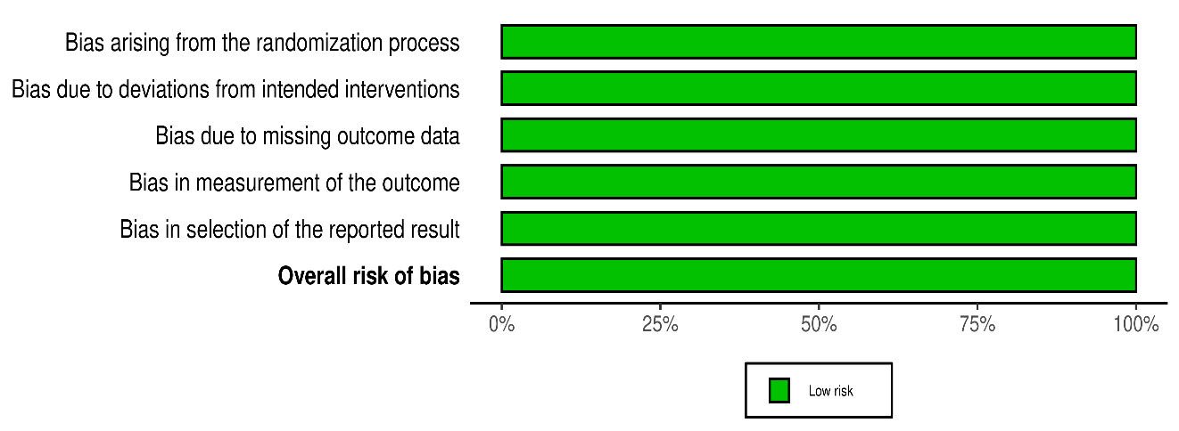

Risk of bias summary (Figure S2): 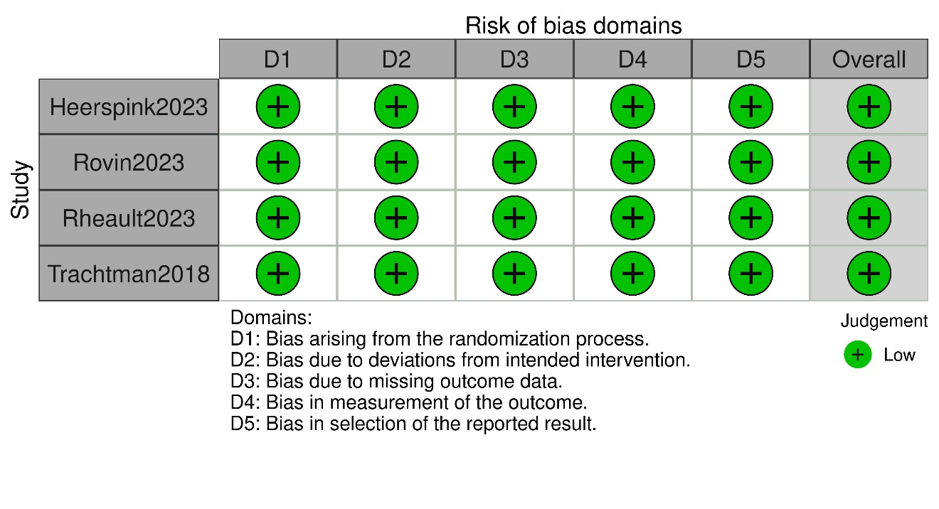

Secondary outcomes:
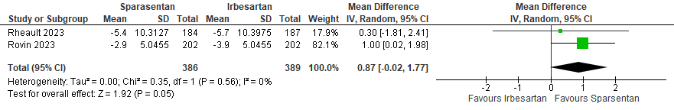 Figure S3: Forest plot showing eGFR total slope

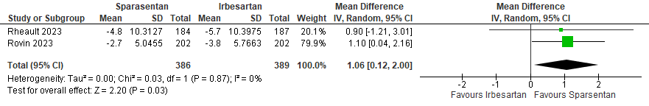 Figure S4: Forest plot showing eGFR chronic slope
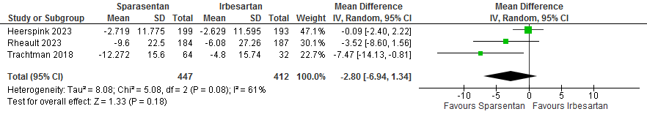
Figure S5: Change in systolic blood pressure from baseline at week 4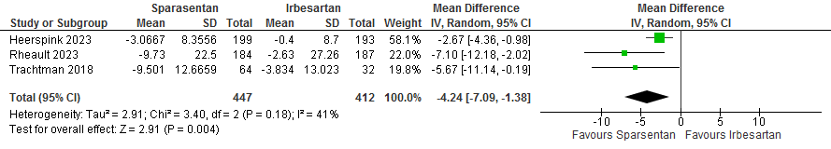
Figure S6: Change in diastolic blood pressure from baseline at week 4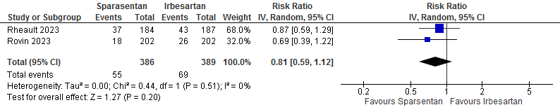
Figure S7: Change in composite kidney outcome

Safety outcomes: (Figure S10 – Figure S20)

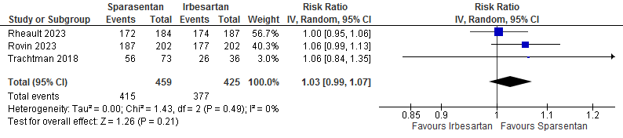 Figure S8: Frequency of any treatment emergent adverse events (TEAE)
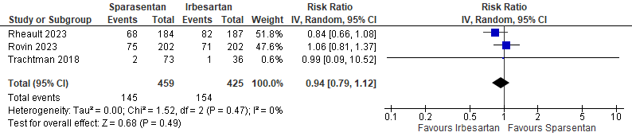 Figure S9: Frequency of serious TEAEs
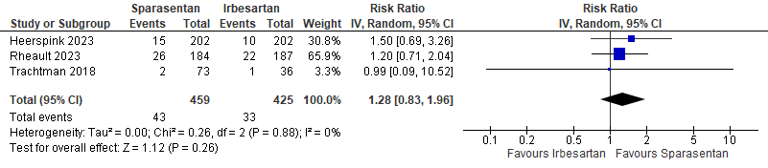
Figure S10: Frequency of TEAEs causing permanent discontinuation of study drug
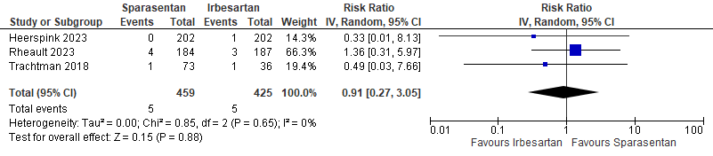 Figure S11: Forest plot shows frequency of reported deaths at the end of the studies
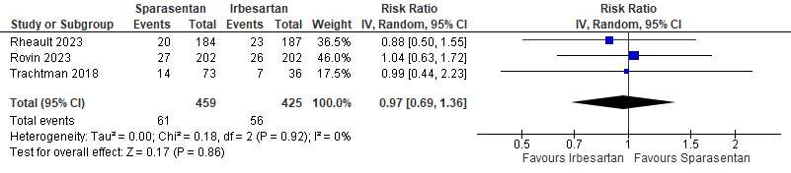
Figure S12: Forest plot showing the frequency of headache
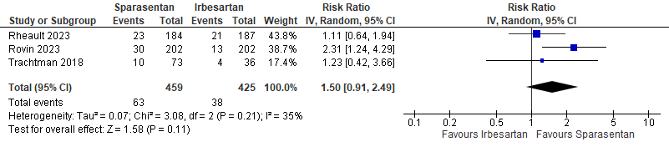
Figure S13: Forest plot showing the frequency of dizziness
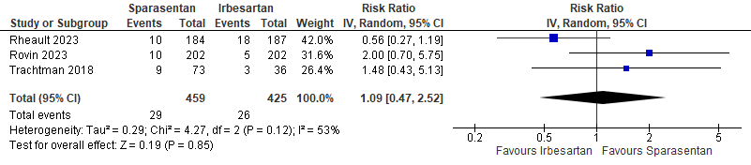
Figure S14: Forest plot shows the frequency of nausea
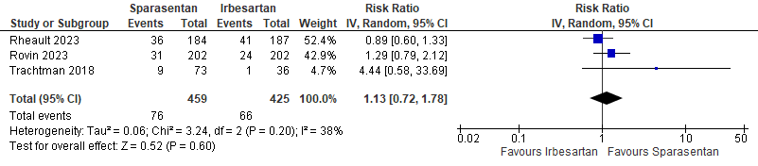
Figure S15: Forest plot shows frequency of edema/peripheral edema

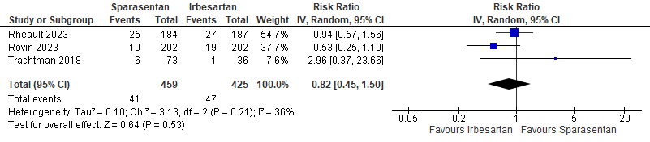
Figure S16: Forest plot shows the frequency of diarrhea 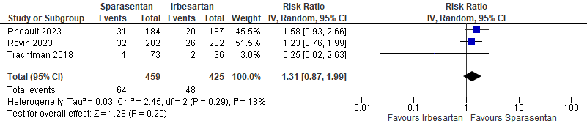
Figure S17: Forest plot shows the frequency of patients developed hyperkalemia
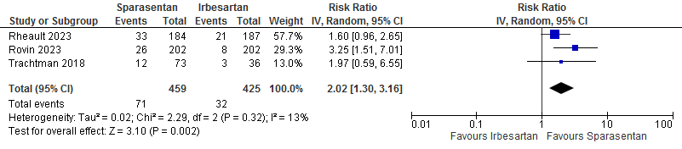
Figure S18: Forest plot shows the frequency of patients experiencing hypotension/orthostatic hypotension

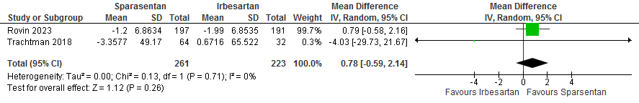
Figure S 19: Forest plot showing the change from baseline in eGFR in week 4.

Outcome measure  Table. S3 A summary for the safety outcome measures | Treatment Effect Estimate  RR(95% Confidence Interval) | P-value | Heterogeneity
Any TEAEs | 1.03 [0.99, 1.07] | P = 0.21 | Chi² = 1.53, (P = 0.47); I² = 0%
Serious TEAEs | 0.94 [0.79, 1.12] | P = 0.49 | Chi² = 1.52, (P = 0.47); I² = 0%
TEAEs leading to study withdrawal | 1.28 [0.83, 1.96] | P = 0.26 | Chi² = 0.26, (P = 0.88); I² = 0%
TEAEs leading to death | 0.91 [0.27, 3.05] | P = 0.88 | Chi² = 0.85, (P = 0.65); I² = 0%
Hypotension/Orthostatic hypotension | 2.02 [1.30, 3.16] | P = 0.002 | Chi² = 2.29, (P = 0.32); I² = 13%
Headache | 0.97 [0.69, 1.36] | P = 0.86 | Chi² = 0.18, (P = 0.92); I² = 0%
Nausea | 1.09 [0.47, 2.52] | P = 0.85 | Chi² = 4.27, (P = 0.12); I² = 53%
Dizziness | 1.50 [0.91, 2.49] | P = 0.11 | Chi² = 3.08, (P = 0.21); I² = 35%
Diarrhea | 0.82 [0.45, 1.50] | P = 0.53 | Chi² = 3.13, (P = 0.21); I² = 36%
Edema/ Peripheral edema | 1.13 [0.72, 1.78] | P = 0.6 | Chi² = 3.24, (P = 0.2); I² = 38%
Hyperkalemia | 1.31 [0.87, 1.99] | P = 0.2 | Chi² = 2.45, (P = 0.29); I² = 18%

Table. S4 A sensitivity analysis for the efficacy outcome measures

Study removed | No. of Participants | No. of trials | Quantitative data synthesis |  |  | Heterogeneity analysis
Study removed | No. of Participants | No. of trials | EE | 95% CI | P-value | P-value | I²(%)
Urine protein to creatinine ratio
Trachtman 2018 | 775 | 2 | MD= 0.66 | [0.52, 0.80] | P< 0.001 | P=0.17 | 47%
Rheault 2023 | 500 | 2 | MD= 0.63 | [0.53, 0.73] | P< 0.001 | P=0.4 | 0%
Rovin 2023 | 467 | 2 | MD= 0.72 | [0.6, 0.83] | P< 0.001 | P=0.67 | 0%
Complete remission of proteinuria
Trachtman 2018 | 763 | 2 | RR= 2.55 | [1.71, 3.8] | P< 0.001 | P=0.88 | 0%
Rheault 2023 | 488 | 2 | RR= 2.65 | [1.56, 4.52] | P=0.0003 | P=0.84 | 0%
Heerspink 2023 | 467 | 2 | RR= 2.5 | [1.41, 4.46] | P=0.002 | P=0.81 | 0%
Partial remission of proteinuria
Trachtman 2018 | 763 | 2 | RR= 1.61 | [1.38, 1.89] | P< 0.001 | P=0.81 | 0%
Rheault 2023 | 488 | 2 | RR= 1.68 | [1.2, 2.36] | P=0.003 | P=0.29 | 12%
Heerspink 2023 | 467 | 2 | RR= 1.74 | [1.28, 2.38] | P=0.0005 | P=0.34 | 0%
Change in eGFR from baseline
Trachtman 2018 | 775 | 2 | MD= 3.09 | [1.28, 4.9] | P=0.0008 | P=0.34 | 0%
Rheault 2023 | 500 | 2 | MD= 0.67 | [-6.83, 8.16] | P=0.86 | P=0.05 | 73%
Rovin 2023 | 467 | 2 | MD= -0.12 | [-5.57, 5.33] | P=0.97 | P=0.16 | 49%
Change in systolic blood pressure from baseline at week 4
Trachtman 2018 | 763 | 2 | MD= -1.03 | [-4.02, 1.97] | P=0.5 | P=0.23 | 31%
Rheault 2023 | 488 | 2 | MD= -3.09 | [-10.2, 4.01] | P=0.39 | P=0.04 | 76%
Heerspink 2023 | 467 | 2 | MD= -4.97 | [-9.02, -0.93] | P=0.02 | P=0.36 | 0%
Change in diastolic blood pressure from baseline at week 4
Trachtman 2018 | 763 | 2 | MD= -4.21 | [-8.35, -0.07] | P=0.05 | P=0.1 | 62%
Rheault 2023 | 488 | 2 | MD= -2.99 | [-4.81, -1.17] | P=0.001 | P=0.3 | 5%
Heerspink 2023 | 467 | 2 | MD= -6.44 | [-10.16, -2.71] | P=0.0007 | P=0.71 | 0%

Table. S5 A sensitivity analysis for the safety outcome measures
Study removed | No. of Participants | No. of trials | Quantitative data synthesis |  |  | Heterogeneity analysis
Study removed | No. of Participants | No. of trials | RR | 95% CI | P-value | P-value | I²(%)
Any TEAEs
Trachtman 2018 | 775 | 2 | 1.03 | [0.98, 1.08] | P= 0.29 | P=0.24 | 26%
Rheault 2023 | 513 | 2 | 1.06 | [0.99, 1.13] | P=0.08 | P=0.97 | 0%
Rovin 2023 | 480 | 2 | 1.01 | [0.96, 1.06] | P= 0.79 | P=0.66 | 0%
Serious TEAEs
Trachtman 2018 | 775 | 2 | 0.94 | [0.75, 1.17] | P= 0.59 | P=0.22 | 34%
Rheault 2023 | 513 | 2 | 1.06 | [0.82, 1.37] | P=0.68 | P=0.95 | 0%
Rovin 2023 | 480 | 2 | 0.84 | [0.66, 1.08] | P= 0.18 | P=0.9 | 0%
AE leading to study withdrawal
Trachtman 2018 | 775 | 2 | 1.29 | [0.83, 2.0] | P= 0.26 | P=0.64 | 26%
Rheault 2023 | 513 | 2 | 1.44 | [0.69, 3.01] | P=0.33 | P=0.74 | 0%
Heerspink 2023 | 480 | 2 | 1.19 | [0.71, 2.0] | P= 0.51 | P=0.87 | 0%
AE leading to death
Trachtman 2018 | 775 | 2 | 1.06 | [0.28, 4.06] | P= 0.94 | P=0.44 | 0%
Rheault 2023 | 513 | 2 | 0.42 | [0.05, 3.35] | P=0.41 | P=0.86 | 0%
Heerspink 2023 | 480 | 2 | 1.08 | [0.29, 3.97] | P= 0.91 | P=0.53 | 0%
Headache
Trachtman 2018 | 775 | 2 | 0.97 | [0.66, 1.41] | P= 0.86 | P=0.68 | 0%
Rheault 2023 | 513 | 2 | 1.02 | [0.67, 1.57] | P=0.91 | P=0.92 | 0%
Rovin 2023 | 480 | 2 | 0.92 | [0.58, 1.46] | P= 0.71 | P=0.83 | 0%
Dizziness
Trachtman 2018 | 775 | 2 | 1.58 | [0.77, 3.23] | P= 0.21 | P=0.09 | 66%
Rheault 2023 | 513 | 2 | 1.98 | [1.15, 3.39] | P=0.01 | P=0.33 | 0%
Rovin 2023 | 480 | 2 | 1.14 | [0.69, 1.86] | P= 0.61 | P=0.87 | 0%
Edema
Trachtman 2018 | 775 | 2 | 1.04 | [0.73, 1.49] | P= 0.82 | P=0.25 | 23%
Rheault 2023 | 513 | 2 | 1.59 | [0.64, 3.95] | P=0.32 | P=0.25 | 26%
Rovin 2023 | 480 | 2 | 1.44 | [0.34, 6.1] | P= 0.62 | P=0.13 | 57%
Nausea
Trachtman 2018 | 775 | 2 | 1 | [0.29, 3.45] | P= 1 | P=0.06 | 73%
Rheault 2023 | 513 | 2 | 1.76 | [0.79, 3.94] | P=0.17 | P=0.72 | 0%
Rovin 2023 | 480 | 2 | 0.8 | [0.32, 1.98] | P= 0.63 | P=0.19 | 41%
Hyperkalemia
Trachtman 2018 | 775 | 2 | 1.38 | [0.97, 1.96] | P= 0.08 | P=0.5 | 0%
Rheault 2023 | 513 | 2 | 0.85 | [0.23, 3.2] | P=0.81 | P=0.19 | 41%
Rovin 2023 | 480 | 2 | 0.91 | [0.17, 4.78] | P= 0.91 | P=0.13 | 56%
Diarrhea
Trachtman 2018 | 775 | 2 | 0.75 | [0.43, 1.31] | P= 0.31 | P=0.2 | 38%
Rheault 2023 | 513 | 2 | 0.94 | [0.19, 4.64] | P=0.94 | P=0.13 | 57%
Rovin 2023 | 480 | 2 | 1.05 | [0.54, 2.04] | P= 0.88 | P=0.29 | 9%
Hypotension/Orthostatic hypotension
Trachtman 2018 | 775 | 2 | 1.06 | [0.28, 4.06] | P= 0.94 | P=0.44 | 0%
Rheault 2023 | 513 | 2 | 0.42 | [0.05, 3.35] | P=0.41 | P=0.86 | 0%
Heerspink 2023 | 480 | 2 | 1.08 | [0.29, 3.97] | P= 0.91 | P=0.53 | 0%

Table. S6 A met regression for eGFR outcome.
Estimate | Coefficient | Std. err. | Z | P>|z| | -95% CI | +95% CI
eGFR, mL/min | -0.39 | 0.2 | -2.00 | 0.046 | -0.77 | -0.01

