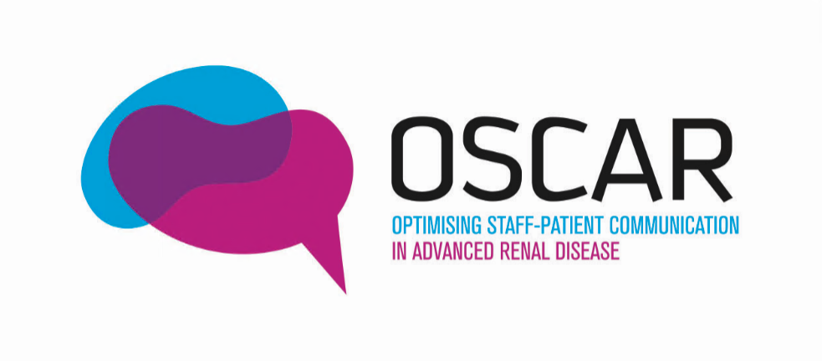


v

SDM-Q-9 for patients
When completing these questions, please think about your recent recorded consultation (whether with a doctor or nurse) and your decision which treatment to have for your kidney disease, if it gets worse.

Nine statements related to the decision-making in your consultation are listed below. For each statement please indicate how much you agree or disagree.

 | My clinician made clear that a decision needs to be made.
 | Completely disagree  ☐ | Strongly disagree  ☐ | Somewhat disagree  ☐ | Somewhat agree  ☐ | Strongly agree  ☐ | Completely agree  ☐
 | My clinician wanted to know exactly how I want to be involved in making the decision.
 | Completely disagree  ☐ | Strongly disagree  ☐ | Somewhat disagree  ☐ | Somewhat agree  ☐ | Strongly agree  ☐ | Completely agree  ☐
 | My clinician told me that there are different options for treating my medical condition.
 | Completely disagree  ☐ | Strongly disagree  ☐ | Somewhat disagree  ☐ | Somewhat agree  ☐ | Strongly agree  ☐ | Completely agree  ☐
 | My clinician precisely explained the advantages and disadvantages of the treatment options.
 | Completely disagree  ☐ | Strongly disagree  ☐ | Somewhat disagree  ☐ | Somewhat agree  ☐ | Strongly agree  ☐ | Completely agree  ☐
 | My clinician helped me understand all the information.
 | Completely disagree  ☐ | Strongly disagree  ☐ | Somewhat disagree  ☐ | Somewhat agree  ☐ | Strongly agree  ☐ | Completely agree  ☐
 | My clinician asked me which tratement option I prefer.
 | Completely disagree  ☐ | Strongly disagree  ☐ | Somewhat disagree  ☐ | Somewhat agree  ☐ | Strongly agree  ☐ | Completely agree  ☐
 | My clinician and I thoroughly weighed the different treatment options.
 | Completely disagree  ☐ | Strongly disagree  ☐ | Somewhat disagree  ☐ | Somewhat agree  ☐ | Strongly agree  ☐ | Completely agree  ☐
 | My clinician and I selected a treatment option together
 | Completely disagree  ☐ | Strongly disagree  ☐ | Somewhat disagree  ☐ | Somewhat agree  ☐ | Strongly agree  ☐ | Completely agree  ☐
 | My clinician and I reached an agreement on how to proceed.
 | Completely disagree  ☐ | Strongly disagree  ☐ | Somewhat disagree  ☐ | Somewhat agree  ☐ | Strongly agree  ☐ | Completely agree  ☐

Adapted from: Scholl I, Kriston L, Dirmaier J, Buchholz A, Härter M. Development and psychometric properties of the Shared Decision Making Questionnaire - physician version (SDM-Q-Doc). Patient Education and Counseling. 2012;88(2):284-90.

