Legends of supplementary material
Supplementary results. Worsening of CKD stage from baseline
Supplementary Table 1. Patient inclusion and exclusion criteria
Supplementary Table 2. Demographic and clinical data, baseline comorbidities, and baseline medication use for the main cohort
Supplementary Figure 1. Patient flow chart
Supplementary Figure 2. Worsening of CKD stage from baseline in patients with non-diabetic CKD stage 3 or 4 A) Risk prediction model; B) Kaplan–Meier plots for non-diabetic CKD population stratified across five risk categories

Supplementary results

Worsening of CKD stage from baseline
The top progressive and protective factors linked to worsening of CKD stage are shown in Figure S2A. According to the developed risk prediction model, stage 4 CKD (HR=2.90, 95% CI=2.83–2.97), severely increased albuminuria-A3 (HR=2.30, 95% CI=2.09–2.53), stage 3 CKD (HR=1.74, 95% CI=1.71–1.77), polycystic kidney disease (HR=1.68, 95% CI=1.60–1.76), and proteinuria (HR=1.55, 95% CI=1.50–1.60) were the top five greatest risk factors that could lead to worsening of CKD stage from baseline. The influential protective factors against worsening of CKD stage included normal to mildly increased albuminuria-A1 (HR=0.64, 95% CI=0.60–0.68), annual medical examination (HR=0.79, 95% CI=0.78–0.81), and female gender (HR=0.84, 95% CI=0.82–0.85). The Kaplan–Meier curves demonstrate clear separation between the predicted risk groups, suggesting good performance of the model (Figure S2B). The α value for worsening of CKD stage from baseline is 0.029, indicating annual risk.

Supplementary Table 1. Patient inclusion and exclusion criteria
Inclusion criteria | Exclusion criteria
- Age ≥18 years at index  - CKD stage 3 or 4, identified using ICD codes for CKD and/or by laboratory values (eGFR 15–59 ml/min/1.73 m²), confirmed by a second ICD code or eGFR value >90 days but <365 days apart (index date); lab test results were available for 30% of the patients in the database  - At least 365 days of continuous insurance coverage prior to the index event (baseline period) | - Any of the following, identified by ICD codes (ICD-9-CM or ICD-10-CM) or procedural codes (ICD-9-CM, ICD-10-CM or CPT-4) prior to the index CKD diagnosis:  - Diabetes  - CKD stage 5  - ESKD  - Patients were also excluded if they had a kidney transplant, kidney failure (acute or unspecified), or dialysis in the 365-day baseline period (rather than prior to index diagnosis)
CKD, chronic kidney disease; CPT-4, Current Procedural Terminology 4; eGFR, estimated glomerular filtration rate; ESKD, end-stage kidney disease; ICD, International Classification of Diseases
Supplementary Table 2. Demographic and clinical data, baseline comorbidities, and baseline medication use for the main cohort
Moderate-to-severe
non-diabetic CKD (main cohort)
N=504,924
Age, years, median (IQR) | 75.0 (68.0–81.0)
Sex, n (%)
Female | 305,297 (60.5)
Missing | 73 (<0.1)
Race, n (%)
Asian | 9435 (1.9)
Hispanic | 35,163 (7.0)
Black | 47,947 (9.5)
Missing | 54,329 (10.8)
Unknown | 42,339 (8.4)
White | 315,711 (62.5)
Index CKD stage, n (%)
CKD 3 | 478,415 (94.7)
CKD 4 | 26,509 (5.3)
Baseline eGFR, ml/min/1.73 m², median (IQR) | 53.0 (47.1–57.0)  (n=313,367)
Baseline UACR, mg/g, median (IQR) | 9.7 (3.0–33.0)  (n=30,793)
Baseline UACR, mg/g, n (%)
<30 | 22,621 (4.5)
30–<300 | 6376 (1.3)
≥300 | 1796 (0.4)
Missing | 474,131 (93.9)
Serum potassium, mmol/l, median (IQR) | 4.0 (3.8–4.0)  (n=317,505)
Most common comorbidities at baseline, n (%)
Charlson-Deyo Comorbidity Index, median (IQR) | 3.0 (2.0–4.0)
Hypertension | 428,867 (84.9)
Hyperlipidaemia | 344,610 (68.3)
Hypothyroidism | 129,616 (25.7)
Anaemia | 127,423 (25.2)
Pulmonary disease | 122,012 (24.2)
CAD | 121,368 (24.0)
Heart failure | 79,935 (15.8)
Depression and other mood affective disorders | 78,353 (15.5)
Specific kidney disease diagnoses, n (%)
Tubulo-interstitial kidney disease | 64,135 (12.7)
Glomerulonephritis (chronic or unspecified) | 24,728 (4.9)
Polycystic kidney disease | 8299 (1.6)
Acute glomerulonephritis | 539 (0.1)
IgA nephropathy (Berger’s disease) | 423 (0.1)
Most frequently used medications at baseline, n (%)
Centrally acting hypertensives | 361,000 (71.5)
Statins | 239,015 (47.3)
Beta-blockers | 222,183 (44.0)
NSAIDs | 179,762 (35.6)
ACE inhibitors | 174,059 (34.5)
Antidepressants | 169,682 (33.6)
Thiazide diuretics | 117,301 (23.2)
Calcium channel blockers | 108,535 (21.5)
ARBs | 103,871 (20.6)

ACE, angiotensin-converting enzyme; ARB, angiotensin receptor blocker; CAD, coronary artery disease; CKD, chronic kidney disease; eGFR, estimated glomerular filtration rate; IgA, immunoglobulin A; IQR, interquartile range; NSAID, nonsteroidal anti-inflammatory drug; UACR, urine albumin-to-creatinine ratio

Supplementary Figure 1. Patient flow chart

CKD, chronic kidney disease

Supplementary Figure 2. Worsening of CKD stage from baseline in non-diabetic CKD stage 3 or 4 A) Risk prediction model; B) Kaplan–Meier plots for non-diabetic CKD population stratified across five risk categories
A)
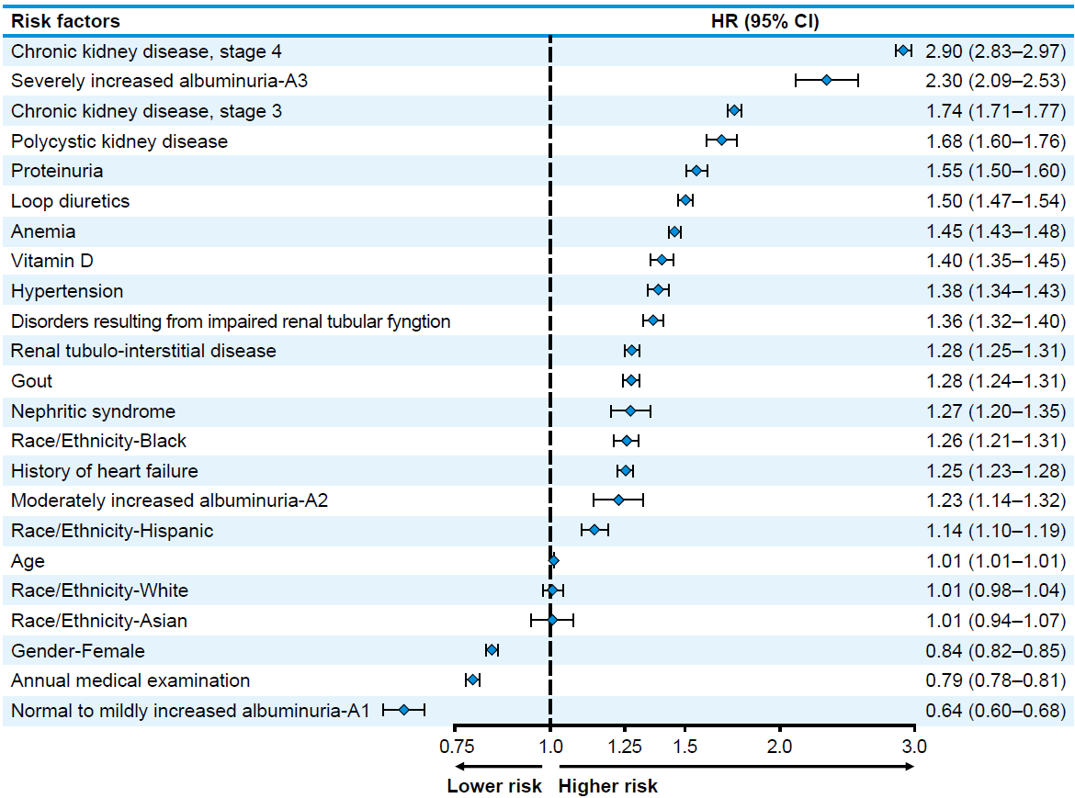

B)
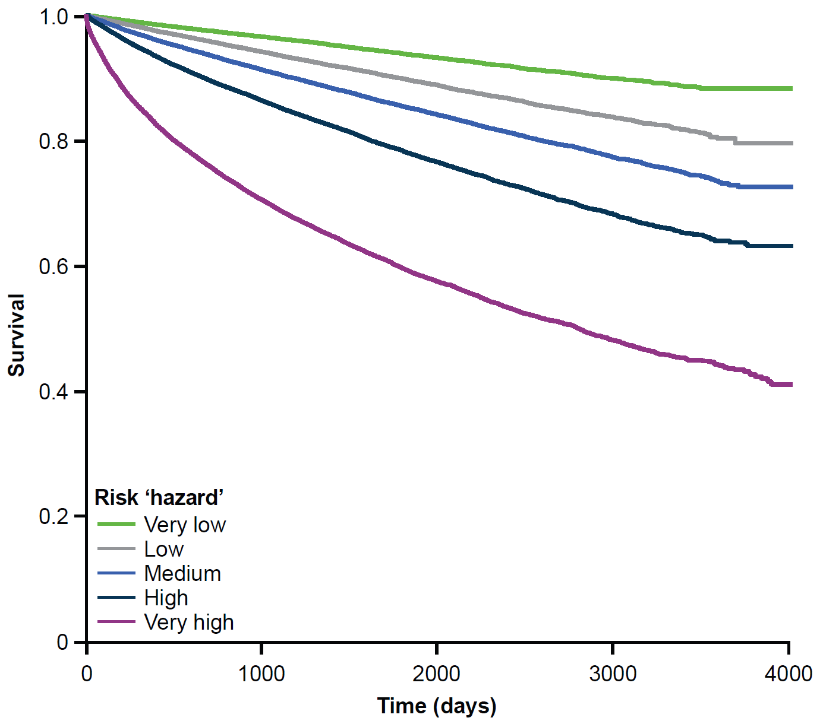
CI, confidence interval; CKD, chronic kidney disease; HR, hazard ratio

