Additional File 1.
Figure S1. Analysis 1 CONSORT patient flow diagram showing patient inclusion and exclusions
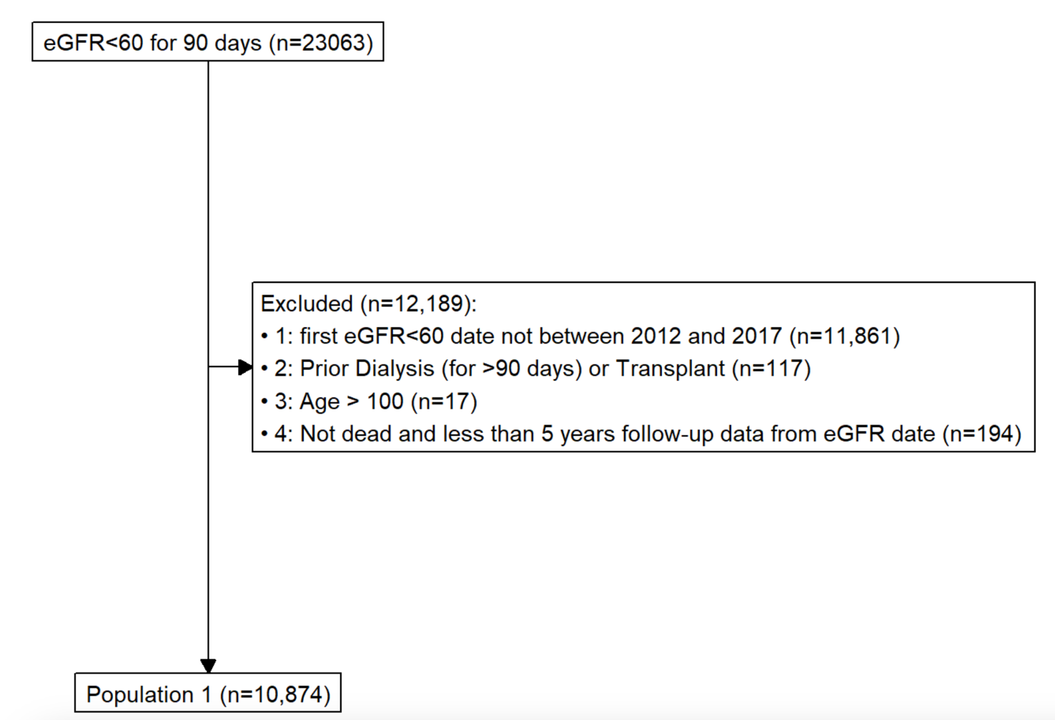

Figure S2. Analysis 2 CONSORT patient flow diagram showing patient inclusion and exclusion
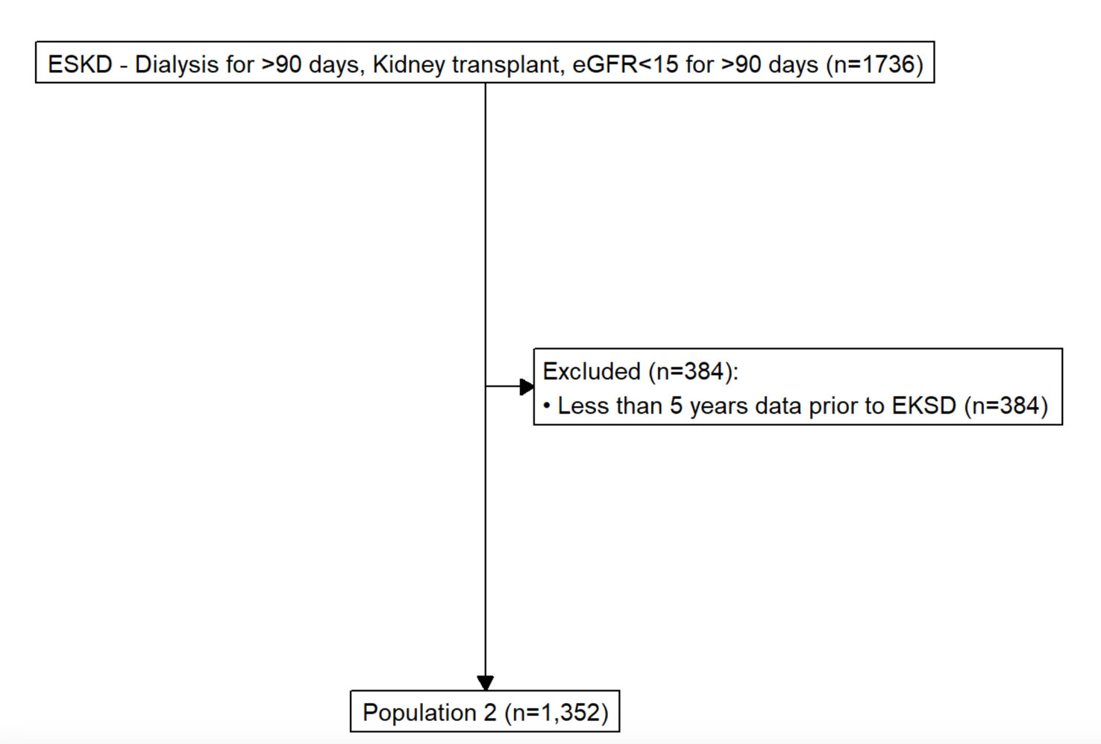

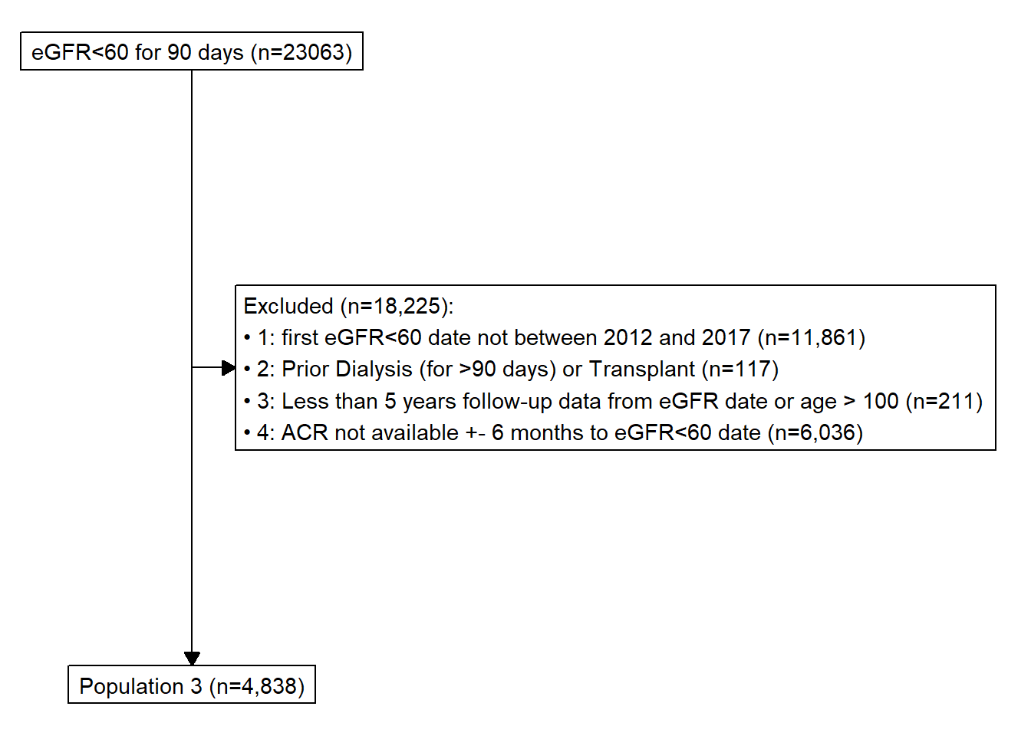
Figure S3. Analysis 3 CONSORT patient flow diagram showing patient inclusion and exclusions

