Kidney transcriptomics signature of prospective rapid diabetic kidney disease progression
Acoba et al (2025), BMC Nephrology

ADDITIONAL MATERIAL

Additional Figure 1 | Glomerular and tubulointerstitial marker check for cross-contamination in data
Additional Table 1 | Patient rapid progression status and characteristics

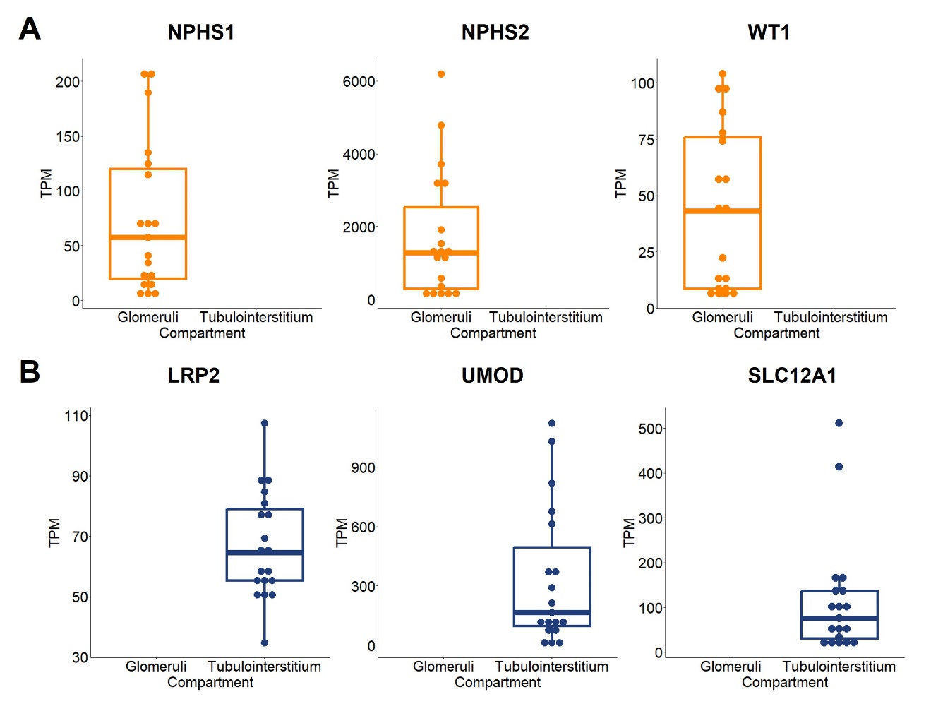
Additional Figure 1. Glomerular and tubulointerstitial marker check for cross-contamination in data. Boxplots show TPM values of glomerular markers (A) and tubulointerstitial markers (B) in the filtered and quality-checked datasets used for subsequent analyses. TPM, transcripts-per-million.

Additional Table 1. Patient rapid progression status and characteristics.

Rapid disease progression definition | Progression status | Sex  (N Male/Female) | Diabetes type  (N T1D/T2D)
steep eGFR decline | rapid | 10/0 | 2/8
steep eGFR decline | non-rapid | 3/4 | 3/4
CKD stage advancement | rapid | 10/1 | 2/9
CKD stage advancement | non-rapid | 3/3 | 3/3
UACR increase | rapid | 5/1 | 3/3
UACR increase | non-rapid | 3/3 | 1/5
NRA status | rapid | 8/1 | 3/6
NRA status | non-rapid | 4/3 | 2/5
Composite outcome | rapid | 12/1 | 3/10
Composite outcome | non-rapid | 2/3 | 2/3
CKD, chronic kidney disease; eGFR, estimated glomerular filtration rate; N, number; NRA, nephrotic-range albuminuria; T1D, Type 1 Diabetes; T2D, Type 2 Diabetes; UACR, urine albumin-to-creatinine ratio

