A multi-ethnic polygenic risk score for chronic kidney disease is associated with increased risk of hypertension in African American individuals

Supplementary Information

Contents
Study population 2
Previously Published PRS for CKD, SBP, and DBP 2
Supplementary Figures 3
Figure S1. Participant selection 3
Figure S2: Distribution of 3 PRS scores 4
Figure S3: AUC plots for CKD status with combined PRS 5
Figure S4: AUC plots for HT status with combined PRS 6
Figure S5: Pairwise scatterplot between SBP-, DBP-, and CKD-PRS 7
Supplementary Tables 8
Table S1. Baseline characteristics stratified by HT 8
Table S2. Deciles of CKD-PRS with CKD 10
Table S3. Deciles of CKD-PRS with HT 11
Table S4. Deciles of CKD-PRS with SBP 12
Table S5. Deciles of CKD-PRS with DBP 13
Table S6. Deciles of SBP-PRS with CKD 14
Table S7. Deciles of SBP-PRS with HT 15
Table S8. Deciles of SBP-PRS with SBP 16
Table S9. Deciles of SBP-PRS with DBP 17
Table S10. Deciles of DBP-PRS with CKD 18
Table S11. Deciles of DBP-PRS with HT 19
Table S12. Deciles of DBP-PRS with SBP 20
Table S13. Deciles of DBP-PRS with DBP 21
Table S14. Associations of PRS with CKD outcome in JHS with AUC 22
Table S15. Associations of PRS with HT outcome in JHS with AUC 23
Table S16. Associations of PRS with SBP outcome in JHS with R-squared 24
Table S17. Associations of PRS with DBP outcome in JHS with R-squared 25

Study population
All JHS participants gave verbal and written informed consent. The JHS design, methods,¹ the study design for genetic analysis,² physical activity assessment methods³ as well as sociocultural methods⁴ have been published previously. The JHS study protocol was approved by the JHS institutional review boards of Jackson State University, Tougaloo College, and the University of Mississippi Medical Center.

Previously Published PRS for CKD, SBP, and DBP
The SNPs for CKD-PRS were selected from a published GWAS study, conducted by Khan et al, in the Chronic Kidney Disease Genetics (CKDGen) Consortium. This meta-analysis study included 765,348 multi-ethnic individuals where 2% of the population was AA.⁵ A PRS was then developed and trained in 177,208 participants (6,573 cases and 170,635 controls) from the UK Biobank Study and subsequently evaluated in an independent multi-ancestry population. The final PRS was obtained using the pruning and thresholding (P+T) approach using R² and p-value inclusion thresholds of 0.2 and 0.03, respectively and consisted of 471,316 variants, 41,426 of which had nonzero weights.⁶ The CKD-PRS is included in the PGS catalog (PGS002237).
The SNPs for SBP-PRS and DBP-PRS were selected from a recent GWAS study for these traits that was conducted in 95,457 AA selected from the Million Veterans Program (MVP; N=66,079) and the Continental Origins and Genetic Epidemiology Network (COGENT; N=29,378) consortium.⁷ MVP is a large electronic health records study which was established in 2011 to determine how genetic variation influences the health of US military veterans. The COGENT consortium consists of 19 studies with GWAS level data, including JHS. While JHS was included in this GWAS, it represented only 2% (N=2,017) of the total sample size. The SBP-PRS and DBP-PRS were constructed in a subset of AA participants of the BioVU biobank (based at Vanderbilt University) using the PRS-CS method with a p-value inclusion threshold of 0.1.⁸ The PRS were validated in African ancestry participants from the UK Biobank (N = 7,641). The final score included 104,823 and 103,234 variants for SBP and DBP respectively.

Supplementary Figures

Figure S1. Participant selection

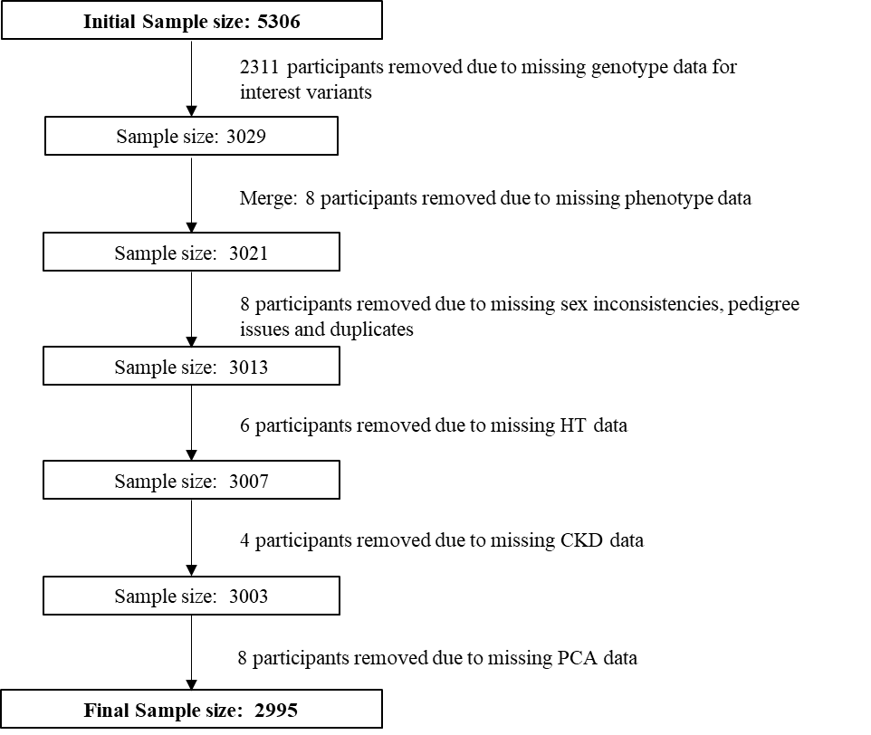

Figure S1. Participant selection for the study

Figure S2: Distribution of 3 PRS scores

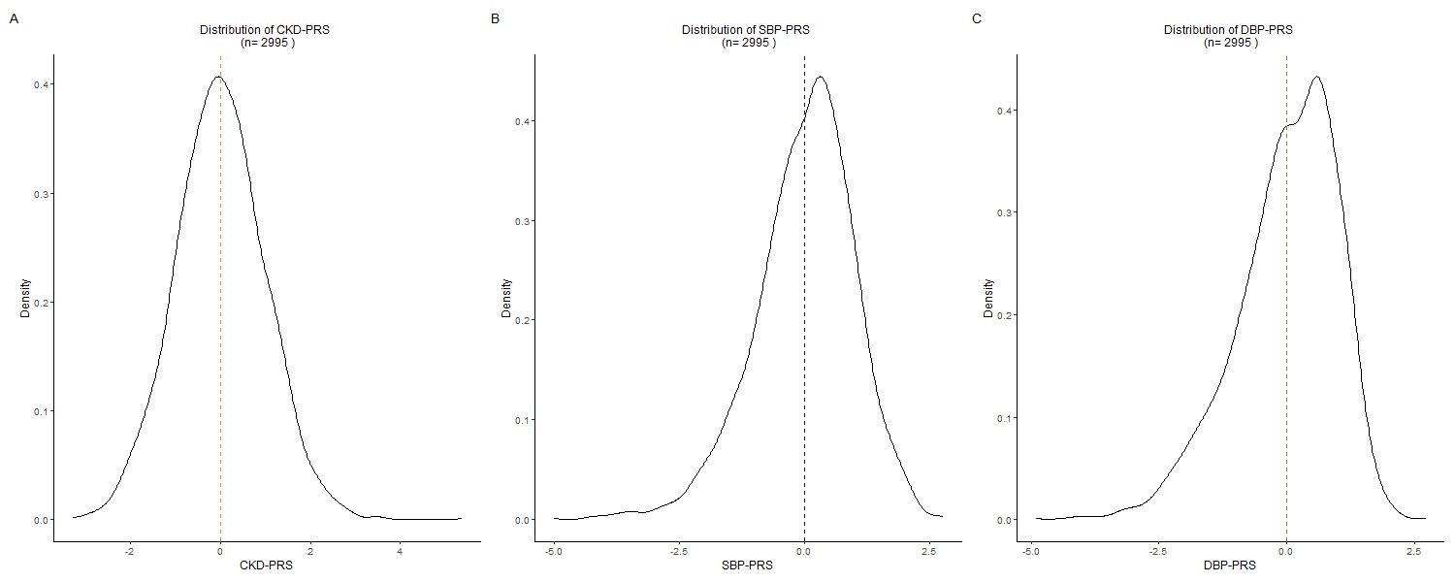
Figure S2. Standardized weighted polygenic risk score distribution in JHS (N=2,995). The vertical line represents the mean of each distribution. (A: Chronic kidney disease PRS, B: Systolic blood pressure PRS, C: Diastolic blood pressure PRS).

Figure S3: AUC plots for CKD status with combined PRS

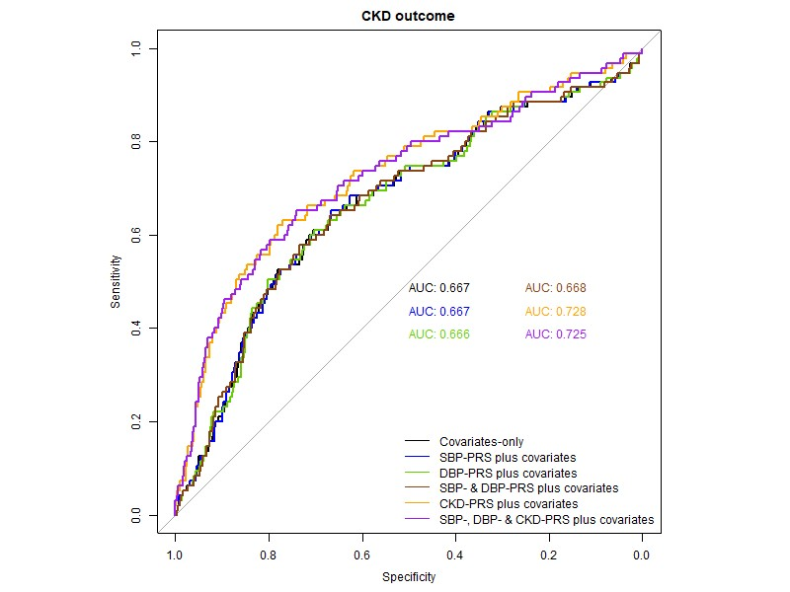
Figure S3. Area under the receiver operator curve for logistic model for CKD status in JHS participants as a function of (i) primary covariates (age, sex and 10PCs), (ii) weighted SBP-PRS plus covariates, (iii) weighted DBP-PRS plus covariates, (iv) weighted SBP- & DBP-PRS plus covariates, (v) weighted CKD-PRS plus covariates and, (vi) weighted SBP-, DBP- & CKD-PRS plus covariates.

Figure S4: AUC plots for HT status with combined PRS
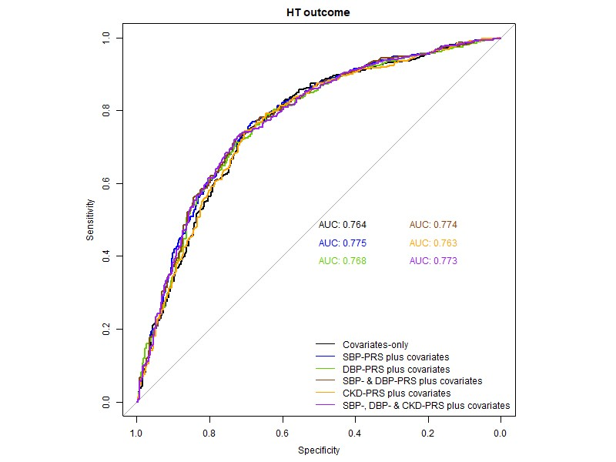
Figure S4. Area under the receiver operator curve for logistic model for HT status in JHS participants as a function of (i) primary covariates (age, sex and 10PCs), (ii) weighted SBP-PRS plus covariates, (iii) weighted DBP-PRS plus covariates, (iv) weighted SBP- & DBP-PRS plus covariates, (v) weighted CKD-PRS plus covariates and, (vi) weighted SBP-, DBP- & CKD-PRS plus covariates.

Figure S5: Pairwise scatterplot between SBP-, DBP-, and CKD-PRS
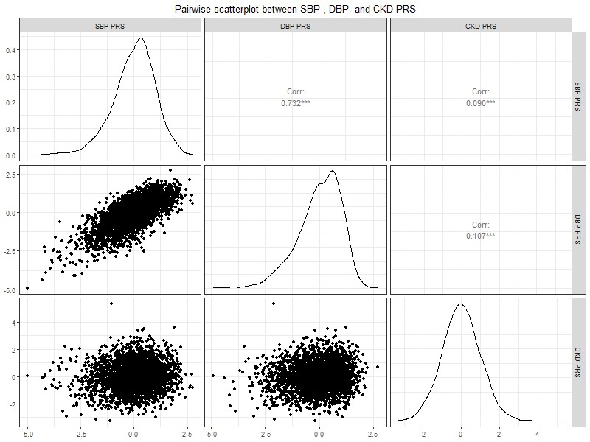

Figure S5. Pairwise scatterplot between SBP-, DBP-, and CKD-PRS.

Supplementary Tables

Table S1. Baseline characteristics stratified by HT

Table S1. Baseline characteristics of the JHS study participants stratified by HT.
 | Without HT (N = 1,206) | With HT (N = 1,789) | p-value
Age (years), Mean (SD) | 47.57 (11.99) | 59.30 (11.17) | <0.001
Male, n (%) | 507 (42.0) | 638 (35.7) | <0.001
Income, Mean (SD) | 2.93 (1.02) | 2.69 (1.02) | <0.001
Current smoker |  |  | 0.016
No, n (%) | 1005 (83.3) | 1558 (87.1)
Yes, n (%) | 190 (15.8) | 217 (12.1)
Missing, n (%) | 11 (0.9) | 14 (0.8)
Alcohol consumption |  |  | <0.001
No, n (%) | 497 (41.2) | 1064 (59.5)
Yes, n (%) | 701 (58.1) | 717 (40.1)
Missing, n (%) | 8 (0.7) | 8 (0.4)
Active Index, Mean (SD) | 2.13 (0.78) | 2.02 (0.80) | <0.001
BMI (kg/m2), Mean (SD) | 30.87 (7.43) | 32.78 (7.36) | <0.001
BMI Categories |  |  | <0.001
Normal Weight, n (%) | 216 (17.9) | 177 (9.9)
Obese, n (%) | 553 (45.9) | 1071 (59.9)
Overweight, n (%) | 433 (35.9) | 530 (29.6)
Underweight, n (%) | 4 (0.3) | 7 (0.4)
Missing, n (%) | 0 (0.0) | 4 (0.2)
Diabetes |  |  | <0.001
No, n (%) | 1076 (89.2) | 1203 (67.2)
Yes, n (%) | 130 (10.8) | 584 (32.6)
Missing, n (%) | 0 (0.0) | 2 (0.1)
ACR, Mean (SD) | 14.28 (70.68) | 84.73 (372.73) | <0.001
Albuminuria |  |  | <0.001
No, n (%) | 640 (53.1) | 625 (34.9)
Yes, n (%) | 36 (3.0) | 167 (9.3)
Missing, n (%) | 530 (43.9) | 997 (55.7)
eGFR, Mean (SD) | 103.39 (18.38) | 88.52 (22.93) | <0.001
Dialysis Ever |  |  | 0.061
No, n (%) | 1188 (98.5) | 1762 (98.5)
Yes, n (%) | 2 (0.2) | 12 (0.7)
Missing, n (%) | 16 (1.3) | 15 (0.8)
BP meds |  |  | <0.001
No, n (%) | 1185 (98.3) | 209 (11.7)
Yes, n (%) | 0 (0.0) | 1577 (88.1)
Missing, n (%) | 21 (1.7) | 3 (0.2)
BP meds, self-reported |  |  | <0.001
No, n (%) | 1178 (97.7) | 278 (15.5)
Yes, n (%) | 0 (0.0) | 1482 (82.8)
Missing, n (%) | 28 (2.3) | 29 (1.6)
SBP, Mean (SD) | 118.63 (10.40) | 133.26 (17.46) | <0.001
DBP, Mean (SD) | 74.33 (7.34) | 76.97 (9.53) | <0.001
CKD (yes), n (%) | 47 (3.9) | 311 (17.4) | <0.001

Table S2. Deciles of CKD-PRS with CKD

Table S2. Association of top-relative-to-bottom decile of CKD-PRS with CKD in the Jackson Heart Study.
PRS Decile | ORª | 95% CI | P value
1 | 1.00 | ref | ref
2 | 0.61 | 0.31, 1.18 | 0.159
3 | 0.58 | 0.30, 1.11 | 0.110
4 | 0.96 | 0.52, 1.74 | 0.886
5 | 1.08 | 0.60, 1.95 | 0.805
6 | 1.25 | 0.71, 2.23 | 0.455
7 | 1.72 | 1.00, 3.01 | 0.059
8 | 2.15 | 1.27, 3.70 | 0.006
9 | 2.36 | 1.41, 4.04 | 0.002
10 | 4.44 | 2.73, 7.45 | <0.001
ªModel adjusted for age, sex and first ten principal components.

Table S3. Deciles of CKD-PRS with HT

Table S3. Association of top-relative-to-bottom decile of CKD-PRS with HT in the Jackson Heart Study.
PRS Decile | ORª | 95% CI | P value
1 | 1.00 | ref | ref
2 | 1.38 | 0.96, 2.00 | 0.085
3 | 1.07 | 0.74, 1.55 | 0.713
4 | 0.98 | 0.68, 1.41 | 0.928
5 | 1.18 | 0.82, 1.71 | 0.380
6 | 1.00 | 0.69, 1.43 | 0.984
7 | 1.08 | 0.75, 1.55 | 0.687
8 | 1.36 | 0.94, 1.96 | 0.112
9 | 1.33 | 0.92, 1.93 | 0.138
10 | 1.66 | 1.14, 2.42 | 0.009
ªModel adjusted for age, sex and first ten principal components.

Table S4. Deciles of CKD-PRS with SBP

Table S4. Association of top-relative-to-bottom decile of CKD-PRS with SBP in the Jackson Heart Study.
PRS Decile | βª | 95% CI | P value
1 | 1.00 | ref | ref
2 | 1.53 | -1.29, 4.35 | 0.287
3 | -1.00 | -3.82, 1.82 | 0.486
4 | 1.85 | -0.97, 4.68 | 0.198
5 | 2.09 | -0.74, 4.91 | 0.148
6 | 0.84 | -1.99, 3.66 | 0.562
7 | 0.92 | -1.91, 3.76 | 0.523
8 | 2.45 | -0.38, 5.28 | 0.090
9 | 1.84 | -0.99, 4.68 | 0.202
10 | 2.02 | -0.82, 4.85 | 0.163
ªModel adjusted for age, sex and first ten principal components.

Table S5. Deciles of CKD-PRS with DBP

Table S5. Association of top-relative-to-bottom decile of CKD-PRS with DBP in the Jackson Heart Study
PRS Decile | βª | 95% CI | P value
1 | 1.00 | ref | ref
2 | 0.50 | -1.09, 2.10 | 0.537
3 | -0.37 | -1.97, 1.23 | 0.650
4 | 0.37 | -1.23, 1.97 | 0.653
5 | 0.65 | -0.95, 2.26 | 0.423
6 | 0.36 | -1.24, 1.96 | 0.663
7 | 0.27 | -1.34, 1.88 | 0.741
8 | 2.13 | 0.53, 3.73 | 0.009
9 | 0.15 | -1.46, 1.75 | 0.859
10 | 1.36 | -0.24, 2.97 | 0.097
ªModel adjusted for age, sex and first ten principal components.

Table S6. Deciles of SBP-PRS with CKD

Table S6. Association of top-relative-to-bottom decile of SBP-PRS with CKD in the Jackson Heart Study.
PRS Decile | ORª | 95% CI | P value
1 | 1.00 | ref | ref
2 | 0.85 | 0.51, 1.42 | 0.543
3 | 0.79 | 0.46, 1.35 | 0.389
4 | 0.76 | 0.44, 1.31 | 0.337
5 | 0.71 | 0.41, 1.25 | 0.240
6 | 0.99 | 0.58, 1.70 | 0.966
7 | 0.91 | 0.53, 1.56 | 0.735
8 | 0.91 | 0.52, 1.59 | 0.749
9 | 0.75 | 0.42, 1.32 | 0.326
10 | 1.12 | 0.65, 1.92 | 0.697
ªModel adjusted for age, sex and first ten principal components.

Table S7. Deciles of SBP-PRS with HT

Table S7. Association of top-relative-to-bottom decile of SBP-PRS with HT in the Jackson Heart Study.
PRS Decile | ORª | 95% CI | P value
1 | 1.00 | ref | ref
2 | 1.61 | 1.10, 2.36 | 0.018
3 | 1.77 | 1.20, 2.61 | 0.005
4 | 2.50 | 1.68, 3.73 | <0.001
5 | 1.99 | 1.33, 2.98 | 0.001
6 | 2.59 | 1.72, 3.91 | <0.001
7 | 3.23 | 2.14, 4.90 | <0.001
8 | 3.81 | 2.50, 5.82 | <0.001
9 | 4.12 | 2.69, 6.34 | <0.001
10 | 5.12 | 3.32, 7.93 | <0.001
ªModel adjusted for age, sex and first ten principal components.

Table S8. Deciles of SBP-PRS with SBP

Table S8. Association of top-relative-bottom decile of SBP-PRS with SBP in the Jackson Heart Study.
PRS Decile | βª | 95% CI | P value
1 | 1.00 | ref | ref
2 | 4.20 | 1.37, 7.02 | 0.004
3 | 5.39 | 2.49, 8.30 | <0.001
4 | 7.02 | 4.07, 9.97 | <0.001
5 | 7.80 | 4.80, 10.81 | <0.001
6 | 9.52 | 6.49, 12.55 | <0.001
7 | 9.89 | 6.87, 12.91 | <0.001
8 | 10.86 | 7.79, 13.94 | <0.001
9 | 12.24 | 9.15, 15.33 | <0.001
10 | 16.51 | 13.43, 19.60 | <0.001
ªModel adjusted for age, sex and first ten principal components.

Table S9. Deciles of SBP-PRS with DBP

Table S9. Association of top-relative-to-bottom decile of SBP-PRS with DBP in the Jackson Heart Study.
PRS Decile | βª | 95% CI | P value
1 | 1.00 | ref | ref
2 | 1.90 | 0.28, 3.52 | 0.029
3 | 2.81 | 1.15, 4.47 | 0.001
4 | 3.36 | 1.67, 5.04 | <0.001
5 | 3.65 | 1.93, 5.37 | <0.001
6 | 3.96 | 2.22, 5.70 | <0.001
7 | 4.75 | 3.02, 6.48 | <0.001
8 | 5.42 | 3.66, 7.18 | <0.001
9 | 5.94 | 4.17, 7.72 | <0.001
10 | 6.66 | 4.89, 8.43 | <0.001
ªModel adjusted for age, sex and first ten principal components.

Table S10. Deciles of DBP-PRS with CKD

Table S10. Association of top-relative-to-bottom decile of DBP-PRS with CKD in the Jackson Heart Study.
PRS Decile | ORª | 95% CI | P value
1 | 1.00 | ref | ref
2 | 0.57 | 0.33, 0.96 | 0.037
3 | 0.68 | 0.41, 1.14 | 0.158
4 | 0.52 | 0.30, 0.89 | 0.017
5 | 0.85 | 0.51, 1.41 | 0.525
6 | 0.77 | 0.46, 1.30 | 0.335
7 | 0.57 | 0.32, 0.99 | 0.046
8 | 0.50 | 0.28, 0.88 | 0.018
9 | 0.57 | 0.32, 0.99 | 0.047
10 | 0.83 | 0.49, 1.42 | 0.493
ªModel adjusted for age, sex and first ten principal components.

Table S11. Deciles of DBP-PRS with HT

Table S11. Association of top-relative-to-bottom decile of DBP-PRS with HT in the Jackson Heart Study.
PRS Decile | ORª | 95% CI | P value
1 | 1.00 | ref | ref
2 | 1.38 | 0.95, 2.01 | 0.109
3 | 1.45 | 0.99, 2.12 | 0.066
4 | 1.30 | 0.88, 1.91 | 0.189
5 | 1.10 | 0.75, 1.63 | 0.637
6 | 1.43 | 0.96, 2.14 | 0.090
7 | 1.89 | 1.26, 2.84 | 0.004
8 | 1.90 | 1.26, 2.88 | 0.003
9 | 2.91 | 1.91, 4.46 | <0.001
10 | 3.09 | 2.02, 4.76 | <0.001
ªModel adjusted for age, sex and first ten principal components.

Table S12. Deciles of DBP-PRS with SBP

Table S12. Association of top-relative-to-bottom decile of DBP-PRS with SBP in the Jackson Heart Study.
PRS Decile | βª | 95% CI | P value
1 | 1.00 | ref | ref
2 | 3.05 | 0.18, 5.91 | 0.037
3 | 3.11 | 0.20, 6.02 | 0.036
4 | 2.82 | -0.15, 5.778 | 0.062
5 | 2.64 | -0.35, 5.63 | 0.083
6 | 3.79 | 0.73, 6.85 | 0.015
7 | 6.23 | 3.15, 9.32 | <0.001
8 | 6.65 | 3.53, 9.78 | <0.001
9 | 7.98 | 4.85, 11.12 | <0.001
10 | 10.90 | 7.74, 14.06 | <0.001
ªModel adjusted for age, sex and first ten principal components.

Table S13. Deciles of DBP-PRS with DBP

Table S13. Association of top-relative-to-bottom decile of DBP-PRS with DBP in the Jackson Heart Study.
PRS Decile | βª | 95% CI | P value
1 | 1.00 | ref | ref
2 | 1.31 | -0.30, 2.92 | 0.111
3 | 1.79 | 0.16, 3.41 | 0.032
4 | 2.00 | 0.34, 3.66 | 0.018
5 | 2.71 | 1.04, 4.39 | 0.002
6 | 3.25 | 1.53, 4.96 | <0.001
7 | 4.23 | 2.50, 5.96 | <0.001
8 | 4.86 | 3.11, 6.61 | <0.001
9 | 6.57 | 4.81, 8.33 | <0.001
10 | 8.43 | 6.65, 10.20 | <0.001
ªModel adjusted for age, sex and first ten principal components.

Table S14. Associations of PRS with CKD outcome in JHS with AUC

Table S14. Associations of PRS with CKD outcome in the Jackson Heart Study.
PRS | ORª (95% CI) | P value | AUC (95% CI)^{b}
Covariates only model | - | - | 0.667 (0.606 - 0.728)
SBP-PRS | 1.05 (0.91, 1.20) | 0.545 | 0.667 (0.606 - 0.729)
DBP-PRS | 0.97 (0.84, 1.12) | 0.688 | 0.666 (0.604 - 0.727)
SBP- (& DBP-PRS) | 1.10 (0.93, 1.31) | 0.260 | 0.668 (0.606 - 0.729)
(SBP- &) DBP-PRS | 0.91 (0.76, 1.09) | 0.302 | -
CKD-PRS | 1.85 (1.64, 2.09) | <0.001 | 0.728 (0.668 - 0.782)
(SBP-, DBP- &) CKD-PRS | 1.85 (1.64, 2.09) | <0.001 | 0.725 (0.664 - 0.786)
ªModel adjusted for age, sex and first 10 ancestry principal components.
^{b}DeLong 95% CI
The OR are reported for the PRS outside the brackets.

Table S15. Associations of PRS with HT outcome in JHS with AUC

Table 15. Associations of PRS with HT outcome in the Jackson Heart Study.

PRS | ORª (95% CI) | P value | AUC (95% CI)^{b}
Covariates only model |  | - | 0.764 (0.732 - 0.796)
SBP-PRS | 1.59 (1.43, 1.77) | <0.001 | 0.775 (0.743 - 0.806)
DBP-PRS | 1.40 (1.26, 1.55) | <0.001 | 0.768 (0.737 - 0.800)
SBP- (& DBP-PRS) | 1.51 (1.33, 1.72) | <0.001 | 0.774 (0.743 - 0.805)
(SBP- &) DBP-PRS | 1.09 (0.95, 1.24) | 0.212 | -
CKD-PRS | 1.10 (1.01, 1.20) | 0.027 | 0.763 (0.730 - 0.795)
(SBP- &) CKD-PRS | 1.09 (1.00, 1.18) | 0.062 | 0.773 ( 0.742-0.804)
(DBP- &) CKD-PRS | 1.09 (1.00, 1.18) | 0.060 | 0.767 (0.736-0.799)
(SBP-, DBP- &) CKD-PRS | 1.08 (1.00, 1.18) | 0.068 | 0.773 (0.741 - 0.804)
ªModel adjusted for age, sex and first 10 ancestry principal components.
^{b}DeLong 95% CI
The OR are reported for the PRS outside the brackets.

Table S16. Associations of PRS with SBP outcome in JHS with R-squared

Table S16. Associations of PRS with SBP outcome in the Jackson Heart Study.
PRS | Beta (95% CI)ª | P value | R² (%)^{b} | R² (%)^{c}
Covariates only model | - | - | 21.45 | -
SBP-PRS | 4.51 (3.77, 5.25) | <0.001 | 25.04 | 3.59
DBP-PRS | 3.02 (2.25, 3.80) | <0.001 | 22.96 | 1.51
SBP- (& DBP-PRS) | 4.33 (3.40, 5.27) | <0.001 | 25.05 | 3.60
(SBP- &) DBP-PRS | 0.30 (-0.66, 1.26) | 0.543 | - | -
CKD-PRS | 0.55 (-0.09, 1.19) | 0.092 | 21.52 | 0.07
(SBP-, DBP- &) CKD-PRS | 0.41 (-0.21, 1.04) | 0.195 | 25.09 | 3.64
ªModel adjusted for age, sex and first 10 ancestry principal components.
^{b}Multiple R² of each model multiplied by 100
^{c}Multiple R² for PRS component alone reported, calculated as difference of R² of model with PRS(s) and R² of covariates only model
PRS: Polygenic risk score, CKD: Chronic kidney disease, HT: Hypertension
The OR are reported for the PRS outside the brackets.

Table S17. Associations of PRS with DBP outcome in JHS with R-squared

Table S17. Associations of PRS with DBP outcome in the Jackson Heart Study.
PRS | Beta (95% CI) | P value | R² (%)^{b} | R² (%)^{c}
Covariates only model | - | - | 3.26 | -
SBP-PRS | 1.89 (1.46, 2.31) | <0.001 | 5.67 | 2.41
DBP-PRS | 2.53 (2.10, 2.96) | <0.001 | 7.32 | 4.06
SBP- (& DBP-PRS) | 0.63 (0.10, 1.16) | 0.020 | 7.49 | 4.23
(SBP- &) DBP-PRS | 2.14 (1.59, 2.68) | <0.001 | - | -
CKD-PRS | 0.37 (0.01, 0.73) | 0.045 | 3.39 | 0.13
(SBP- &) CKD-PRS | 0.32 (-0.04, 0.67) | 0.083 | 5.76 | 2.50
(DBP- &) CKD-PRS | 0.27 (-0.09, 0.62) | 0.143 | 7.39 | 4.13
(SBP-, DBP- &) CKD-PRS | 0.26 (-0.09, 0.62) | 0.145 | 7.55 | 4.29
ªModel adjusted for age, sex and first 10 ancestry principal components.
^{b}Multiple R² of each model multiplied by 100
^{c}Multiple R² for PRS component alone reported, calculated as difference of R² of model with PRS(s) and R² of covariates only model
PRS: Polygenic risk score, CKD: Chronic kidney disease, HT: Hypertension
The OR are reported for the PRS outside the brackets.

REFERENCES
1. Taylor HA, Jr., Wilson JG, Jones DW, et al. Toward resolution of cardiovascular health disparities in African Americans: design and methods of the Jackson Heart Study. Ethn Dis. 2005;15(4 Suppl 6):S6-4-17.
2. Wilson JG, Rotimi CN, Ekunwe L, et al. Study design for genetic analysis in the Jackson Heart Study. Ethn Dis. 2005;15(4 Suppl 6):S6-30-37.
3. Dubbert PM, Carithers T, Ainsworth BE, Taylor HA, Jr., Wilson G, Wyatt SB. Physical activity assessment methods in the Jackson Heart Study. Ethn Dis. 2005;15(4 Suppl 6):S6-56-61.
4. Payne TJ, Wyatt SB, Mosley TH, et al. Sociocultural methods in the Jackson Heart Study: conceptual and descriptive overview. Ethn Dis. 2005;15(4 Suppl 6):S6-38-48.
5. Khan A, Turchin MC, Patki A, et al. Genome-wide polygenic score to predict chronic kidney disease across ancestries. Nature Medicine. 2022;28(7):1412-1420.
6. Privé F, Vilhjálmsson BJ, Aschard H, Blum MGB. Making the Most of Clumping and Thresholding for Polygenic Scores. Am J Hum Genet. 2019;105(6):1213-1221.
7. Hellwege J, Liang J, Giri et al. African ancestry genome-wide association study of blood pressure and hypertension identifes 25 novel loci through predicted gene expression. 2022. In press.
8. Ge T, Chen C-Y, Ni Y, Feng Y-CA, Smoller JW. Polygenic prediction via Bayesian regression and continuous shrinkage priors. Nature Communications. 2019;10(1):1776.

