Appendix
Joint model
The joint model of longitudinal and time-to-event data includes two sub-models, a linear mixed effect model for modeling longitudinal markers and a Cox proportional hazard for survival sub-model.
Linear mixed effect model to model longitudinal markers
The linear mixed-effects model is one of the most common models in longitudinal data analysis. A distinctive feature of linear mixed-effects models is that the average response is modeled as a combination of population-level characteristics (fixed effects) that are assumed to be shared by all individuals and subject-specific effects (random effects) that are unique to each individual. A linear mixed model is defined as follows:
$$y_{ik}\left(t_{ij}\right)=m_{ik}\left(t\right)+ϵ_{ik}\left(t\right)=X_{ik}^{'}β_{k}+Z_{ik}^{'}b_{k}+ϵ_{ik}\left(t\right)$$
Where $y_{ik}\left(t_{ij}\right)$s the longitudinal measurement of the k-th longitudinal marker for the subject $i$ at measurement time $t_{ij}(i=1,…,I;j=1,…,n_{i}$ ), $X_{ik}^{'}$ and $Z_{ik}^{'}$are the covariates vectors corresponding to the fixed effect vector $β_{k}$ and random effect vector $b_{k}$,respectively. The $m_{ik}\left(t\right)$ is the estimate of the true unobserved value of k-th longitudinal marker for the i-th subject. The random effect $b_{k}\sim N\left(0,R_{k}\right)$, where $R_{k}$ is the random effects covariance matrix, and $ϵ_{ik}\left(t\right)\sim N(0,σ_{k}^{2})$ is the vector of error term.
A mixed-effect model with cubic spline terms equals:
$$y_{ik}\left(t_{ij}\right)=m_{ik}\left(t\right)+ϵ_{ik}\left(t\right)=\left(β_{0}+b_{i0}\right)+\left(β_{1}+b_{i1}\right) B_{n}\left(t,λ_{1}\right)+\left(β_{2}+b_{i2}\right) B_{n}\left(t,λ_{2}\right)+\left(β_{3}+b_{i3}\right) B_{n}(t,λ_{3})$$
Where {$B_{n}\left(t,λ_{k}\right);k=1,2,3\}$ represents the B-spline basis matrix for a cubic spline of time, with internal knots placed at the 33.3rd and 66.7th percentiles of the follow-up times.

Cox proportional hazard for survival sub-model
For the survival sub-model, we used a Cox proportional hazards model. The survival sub-model is defined as follows:

$$h_{i}\left(t\right)=h_{0}(t)exp⁡(γ^{T}X_{i}+α_{k}m_{ik}(t))$$

Where $X_{i}$ is the vector of baseline covariates, $γ^{T}$ is the corresponding coefficient vector of baseline covariates in the survival sub-model, and $α_{k}$ is the association parameter corresponding to the unobserved value of the k-th longitudinal marker $m_{ik}(t)$.
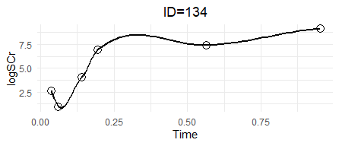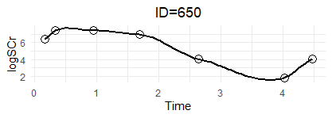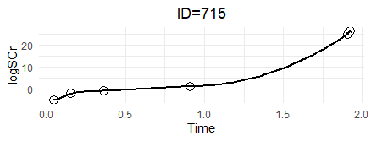
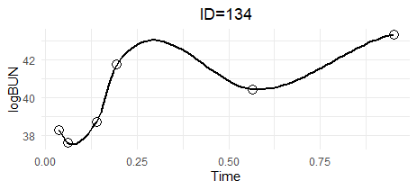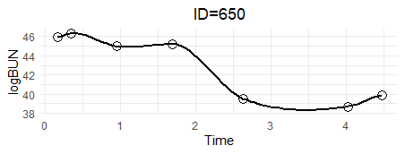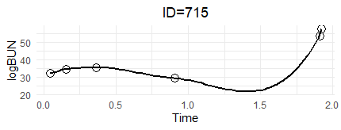
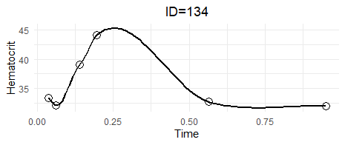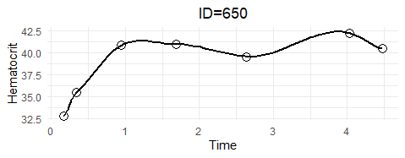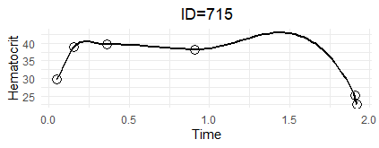
Figure S1. Subject-specific longitudinal profiles of log-creatinine, log-BUN, and hematocrit for three patients from the kidney transplant data.

Table S1. Cross-Validated Hazard Ratios for Log-Serum Creatinine, Log-BUN, and Hematocrit from a Multivariate Joint Model Adjusted for Baseline Covariates
Biomarker | Mean HR | SD | Min | Max
Log-creatinine(mg/dL) *10 | 1.415 | 0.128 | 1.305 | 1.605
Log-BUN (mg/dL) *10 | 1.134 | 0.089 | 1.048 | 1.266
Hematocrit (%) | 0.909 | 0.036 | 0.851 | 0.952
Model 3 was used for cross-validation; Model 3 was a multivariate joint model with three longitudinal biomarkers and baseline covariates* in the survival sub-model.
* Baseline covariates include: Recipient age, Recipient gender, Serum creatinine at transplant time (mg/dl), HTN, Donor type, time of dialysis (month), and Type of immunosuppressive drugs.
Abbreviations: BUN: Blood Urea Nitrogen; HR: Hazard Ratio; SD: Standard Deviation; Min: Minimum; Max: Maximum.

