Table of contents
Page 2. Supplemental Methods.
Page 3. Figure S1.
Page 4. Figure S2.
Page 5. Figure S3.
Page 6. Table S1.
Page 7. Table S2.
Page 8. Table S3.
Page 9. Table S4.
Page 10. Table S5.
Page 11. Table S6.
Page 12. Supplemental References.

Supplemental Methods
- Biopsy Morphometry
The following measurements were obtained from the sectioned renal biopsy scanned images (PAS-stained sections) and used for stereological analyses:
1) The area of cortex.
2) The number and total area of complete non-sclerotic glomerular (NSG) tufts.
3) The number and total area of partial NSG tufts. These are tufts on the section edge that have been bisected by the biopsy needle.
4) The number of missing complete NSG tufts. Missing complete NSG was counted when a complete intact Bowman’s capsule was present on the section, but without a tuft inside.
5) The number and total area of missing partial NSG tufts. Missing partial NSG was counted
when a bisected Bowman’s capsule was present at the edge of a biopsy section, but without a bisected tuft inside.

Calculations
- The total number of NSG was obtained by summing the numbers of all complete and partial NSG with or without a tuft. Partial NSG were counted as 0.675 NSG:
The total number of NSG = Number of complete NSG with tuft + Number of complete NSG missing tuft + 0.675 × Number of partial NSG with tuft + 0.675 × Number of partial NSG missing tuft

- NSG volumetric density was calculated using the Weibel-Gomez stereological models¹. To account for the missing glomeruli, the total area of NSG in the denominator was corrected by adding the mean observed NSG tuft area for each missing NSG tuft to the total area²:

Non-sclerotic glomerular volumetric density
= $\frac{1}{1.382}$ × $\sqrt[2]{\frac{{(\frac{Total number of NSG}{Area of cortex})}^{3}}{\frac{Total area of observed NSG + Number of missing NSG × Mean observed NSG area }{Area of cortex}}}$

- Correction factor for the loss of tissue perfusion (correction factor = 1.366) and volumetric shrinkage (correction factor = 1.365). NSG density were corrected by adding 1.77, for presence of capsule in needle biopsies³.

- Computed tomography of kidneys
We estimate cortical volume from total kidney volume, using the Sasaki’s formula⁴.
Estimated cortical volume (${cm}^{3}$) = −1.3 (intercept) + 0.71 × kidney volume (${cm}^{3}$)

- Nephron number
Nephron number = $\frac{Total estimated cortex volume × Standardized volumetric NSG density }{2 × 1.365 × 1.366}$

Supplemental Figures

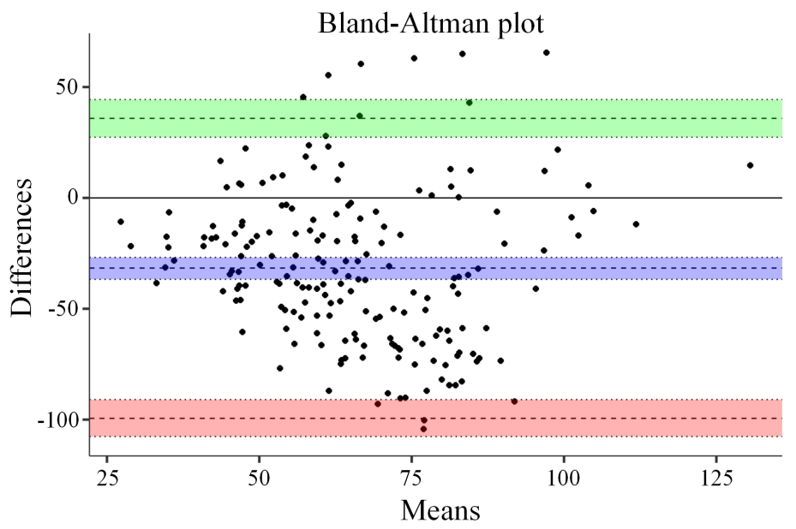
Figure S1. Bland-Altman method was used to assess the agreement between eGFR and single-nephron eGFR.

Figure S2. RASI treatment modifies the relationship between CKD stage and single-nephron eGFR.

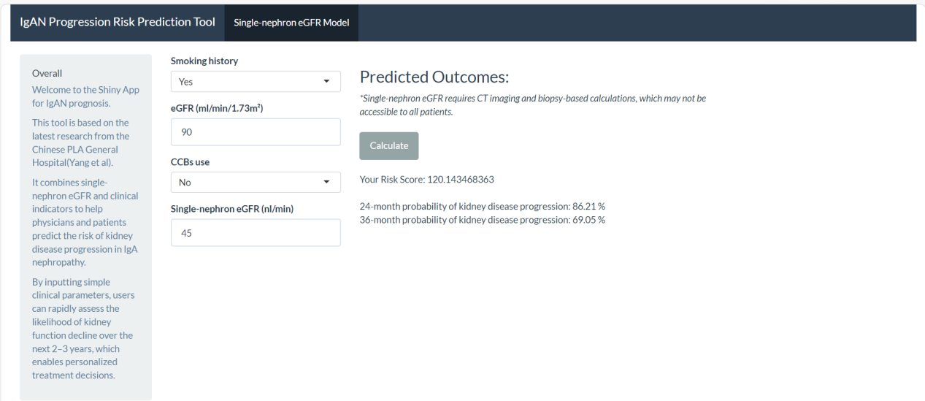Figure S3. The interface of the online tool developed herein, demonstrating the percentile risk calculated by the prediction model based on single-nephron eGFR over 24 and 36 months. Tool’s website: https://yangchenkay.shinyapps.io/IgAN/.

Supplemental Table
Table S1. Immunosuppressive Regimens in the Study Cohorts
Immunosuppressive Regimen | Total Cohort (n=190) |  | Training Cohort (n=133)
Any Immunosuppression, n (%) | 103 (54.2) |  | 69 (51.9)
Corticosteroids only, n (%) | 43 (22.6) |  | 27 (20.3)
MMF only, n (%) | 11 (5.8) |  | 7 (5.3)
Leflunomide only, n (%) | 18 (9.5) |  | 11 (8.3)
Hydroxychloroquine only, n (%) | 14 (7.4) |  | 10 (7.5)
Other immunosuppressive agents, n (%) | 5 (2.6) |  | 4 (3.0)
Combination Therapy, n (%) | 12 (6.3) |  | 10 (7.5)
Other immunosuppressive agents include tacrolimus (n=4) and tripterygium glycosides (n=2).
Table S2. Sensitivity Analysis: cox model results after excluding eGFR or single-nephron eGFR
Variable | Model 1: excluded eGFR |  |  | Model 2: excluded single-nephron eGFR
Variable | HR (95%CI) | P value |  | HR (95%CI) | P value
Smoking history | 2.84 (1.38-5.81) | 0.004 |  | 2.44 (1.22-4.88) | 0.01
eGFR | - | - |  | 1.02 (1.00-1.03) | 0.004
CCBs | 1.99 (0.99-4.02) | 0.05 |  | 2.15 (1.06-4.36) | 0.03
single-nephron eGFR | 1.02 (1.00-1.03) | 0.007 |  | - | -

Table S3. Sensitivity analysis: cox regression model results using only rapid eGFR decline as the endpoint​
Variable | Original Model (Composite Endpoint) |  |  |  | Sensitivity Model (Rapid eGFR Decline Only)
Variable | HR (95%CI) | P value |  |  | HR (95%CI) |  | P value
Smoking history | 2.62 (1.29-5.3) | 0.008 |  |  | 2.63 (1.26-5.52) |  | 0.01
eGFR | 1.02 (1.01-1.03) | 0.005 |  |  | 1.03 (1.02-1.05) |  | <0.001
CCBs | 2.03 (1.01-4.1) | 0.049 |  |  | 2.28 (1.07-4.84) |  | 0.03
Single-nephron eGFR​​ | 1.02 (1.01-1.03) | 0.01 |  |  | 1.02 (1.01-1.03) |  | 0.01
Model Performance​
C-index (Training cohort) | 0.76 |  |  |  |  | 0.80
C-index (Validation cohort) | 0.75 |  |  |  |  | 0.70

Table S4. Multivariable adjusted hazard ratios for the association of single-nephron eGFR with outcomes
Variable | Model 1 |  | Model 2 |  | Model 3
Variable | HR (95%CI) | P value | HR (95%CI) | P value | HR (95%CI) | P value
Male | 1.62 (0.86-3.05) | 0.13 | 1.83 (0.97-3.47) | 0.06 | 1.83 (0.96-3.52) |  | 0.07
UPE | 1.01 (0.76-1.35) | 0.93 | 0.89 (0.63-1.26) | 0.52 | 0.82 (0.57-1.19) |  | 0.3
eGFR | 1.02 (1.01-1.04) | 0.008 | 1.02 (1.01-1.03) | 0.02 | 1.02 (1.01-1.04) |  | 0.01
S | 2.31 (0.99-5.39) | 0.053 | 2.09 (0.90-4.89) | 0.09 | 2.19 (0.93-5.15) |  | 0.07
T | 1.05 (0.44-2.51) | 0.91 | 0.9 (0.38-2.12) | 0.82 | 1.08 (0.45-2.59) |  | 0.87
CCBs |  |  |  |  | 2.14 (1.01-4.51) |  | 0.046
Single-nephron eGFR​ |  |  | 1.02 (1.01-1.03) | 0.009 | 1.02 (1.01-1.03) |  | 0.01
Model Performance​
C-index (Training cohort) | 0.73 |  | 0.76 |  | 0.77
C-index (Validation cohort) | 0.48 |  | 0.51 |  | 0.57

Table S5. Sensitivity analyses excluding patients with advanced CKD
Variable | All (n=190) |  | CKD Stage 1-2 (n=145)
Events, n | 59 |  | 45
C-index (95% CI)​ | 0.76 (0.69-0.82) |  | 0.73 (0.67-0.8)
HR (95% CI)​ | - |  | 4.05 (2.04-8.05)
Log-rank P value | <0.001 |  | <0.001

Table S6. Subgroup Analysis of the Nomogram's Discriminative Performance
Subgroup | No. of Patients / Events | C-index (95% CI)
Overall | 190/59 | 0.75 (0.7-0.81)
Baseline eGFR​
eGFR ≥ 60 ml/min/1.73m² | 145/45 | 0.73 (0.67-0.8)
eGFR < 60 ml/min/1.73m² | 45/14 | 0.86 (0.77-0.95)
UPE
UPE < 1.0 g/day | 87/22 | 0.75 (0.66-0.84)
UPE ≥ 1.0 g/day | 103/37 | 0.75 (0.68-0.82)
Immunosuppression
Yes | 103/26 | 0.79 (0.72-0.87)
No | 87/33 | 0.71 (0.64-0.79)
RASI
Yes | 142/45 | 0.73 (0.67-0.80)
No | 48/14 | 0.77 (0.66-0.87)

Supplemental References
1. Weibel ER, Gomez DM. A principle for counting tissue structures on random sections. J Appl Physiol. 1962;17:343-348.
2. Denic A, Mathew J, Lerman LO, et al. Single-nephron glomerular filtration rate in healthy adults. N Engl J Med. 2017;376(24):2349-2357.
3. Denic A, Mullan AF, Alexander MP, et al. An improved method for estimating nephron number and the association of resulting nephron number estimates with chronic kidney disease outcomes. J Am Soc Nephrol. 2023;34(7):1264-1278.
4. Sasaki T, Tsuboi N, Okabayashi Y, et al. Estimation of nephron number in living humans by combining unenhanced computed tomography with biopsy-based stereology. Sci Rep. 2019;9(1):1-10.

